America and eastern Europe

End of an affair?
Sep 10th 2009
From The Economist print edition

The Atlantic alliance is waning in Europe’s east

Illustration by Peter Schrank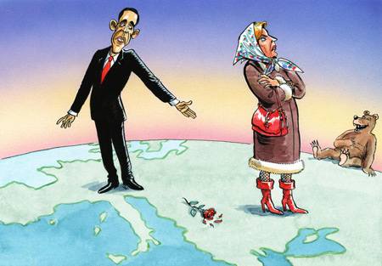
AFTER two decades of sometimes fervent Atlanticism in the ex-communist world, disillusionment (some would call it realism) is growing. At its height the bond between eastern Europe and America was based, like the best marriages, on a mixture of emotion and mutual support. The romance dates from the cold war: when western Europe was sometimes squishy in dealing with the Soviet empire, America was robust. When the Iron Curtain fell, ex-dissidents and retired cold warriors found they had plenty in common. America pushed for the expansion of NATO, guaranteeing the east Europeans’ security. In return, ex-communist countries loyally supported America, particularly in providing troops for wars in Iraq and Afghanistan.
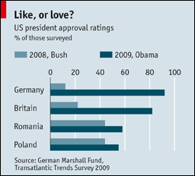
That relationship is now looking more wobbly. A new poll (see chart) by the German Marshall Fund, a think-tank, shows that western Europe is now much more pro-American and pro-NATO than the ex-communist east. Until last year, the eastern countries swallowed their misgivings about George Bush, while the west of the continent writhed in distaste at what many saw as his administration’s incompetence and heavy-handedness.
The ascent of Barack Obama has boosted America’s image in most countries, but only modestly in places like Poland and Romania. Among policymakers in the east, the dismay is tangible. In July, 22 senior figures from the region, including Vaclav Havel and Lech Walesa, wrote a public letter bemoaning the decline in transatlantic ties.
One reason is that the Obama administration is rethinking a planned missile-defence system, which would have placed ten interceptor rockets in Poland and a radar station in the Czech Republic, in order to guard against Iranian missile attacks on America and much of Europe. That infuriated Russia, which saw the bases as a blatant push into its front yard. Changing the scheme—probably using seaborne interceptors—risks looking like a climb-down to suit Russian interests.
Poland is also worried that a promised battery of Patriot air-defence missiles, originally to protect the interceptors, may now be only a temporary loan of dummy rockets for training purposes—“just a sales exercise”, says an official in Warsaw, crossly. America says it never intended to station real rockets there permanently.
The administration also botched its participation in Poland’s 70th anniversary commemoration of the start of the second world war on September 1st. Other countries, including Russia and Germany, sent top people. America, initially, offered only a retired Clinton-era official. William Perry, who was a notable sceptic about NATO expansion. After squawks of dismay, Jim Jones, the national security adviser, went too. But Poles sensed a snub.
Another sore point concerns leaks from America suggesting that Poland, Romania and Lithuania hosted secret bases for the “rendition” and interrogation of terror suspects. All three strongly deny this, but in at least some voters’ eyes, the American alliance is now tainted with connivance in kidnap and torture, followed by cover-ups. The next time American spooks want some secret help, they may find their allies less handy, an official notes.
NATO’s credibility is under scrutiny too. New members say that their voters will not support out-of-area expeditions—the alliance’s big focus just now—unless it is properly defending the home front against any threat from Russia. It does not help that Russia and its ally, Belarus, have just started a large joint military exercise, ostentatiously named “Zapad” (West).
At a big NATO advisory conference in Brussels in July, east Europeans were aghast to hear one prominent German academic describe Article V, the alliance’s cornerstone collective-security guarantee, as a “fiction”. In the event of a Russian threat, say to the Baltic states or Poland, would NATO act or merely consult? A worried easterner describes the alliance as “like an 18th-century Polish parliament, hostage to its most irresponsible member”.
NATO is trying to soothe those fears. A committee that writes the threat assessment has rejigged its view on Russia. Contingency planning, once taboo, is taking shape. The Obama administration has been more vigorous on this front than its predecessor. But what Poland wants, especially if the missile-defence base is cancelled, is practical preparations, such as regular manoeuvres, and fuel and ammunition stockpiles.
Part of the problem is the much-publicised attempt by the Obama administration to “reset” relations with Russia. Few in eastern Europe object to that in principle. But many worry about how it will work in practice. Will Russia demand greater sway in the region in return for help, say, in squeezing Iran? The State Department has tried hard to reassure America’s allies. But the official at the National Security Council directly responsible for Europe, Liz Sherwood-Randall, used to work for Mr Perry and shared his views on NATO expansion. East European officials flinch when her name is mentioned.
Admittedly, America has many other bigger problems than its relations with eastern Europe. Self-importance and public whingeing do not win arguments in Washington. The east Europeans may have been naive in their dealings with America in the Bush years. But for all that, even people inside the Obama administration agree that it could do better.

