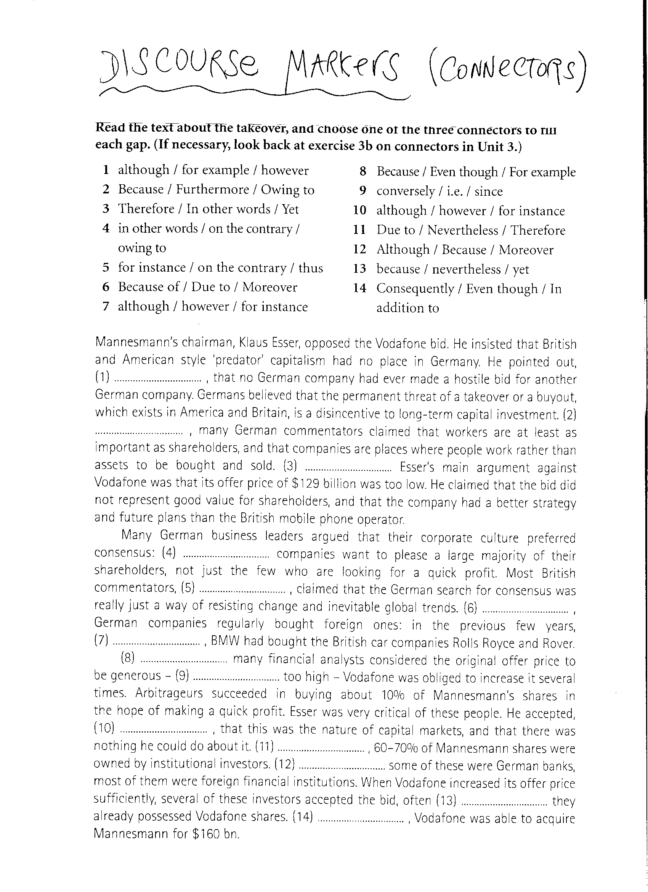
KEY

- for example
- furthermore
- yet
- in other words
- on the contrary
- moreover
- for instance
- even though
- i.e.
- however
- nevertheless
- although
- because
- consequently

