U7 - GRAMMAR – KEY

CB 64/Language check 1
1 b (active)
2 a (passive)

CB 64/Language check 2

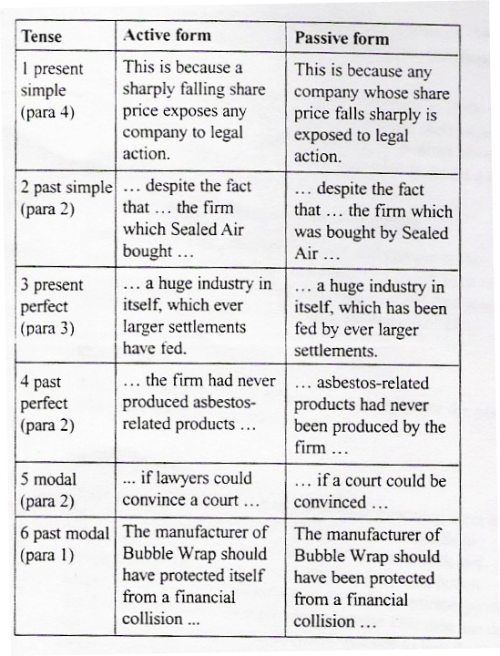
CB 64/Language check 3 – will be checked in class

CB – p.63/Practice
2 – compensation/damages 3 lawyer/attorney 4 law firm 5 legal action 6 plaintiffs/litigants 7 judge 8 awards 9 damages/compensation

10 Dec 2010 handout - GRAMMAR – KEY

1. Policy makers (are being forced to think) (force, think) of market pitfalls and (are considering developing) (consider, develop) profitable strategies. (PRESENT CONTINUOUS)
2. We (are used to being encouraged to improve) (be used, encourage, improve) our job performance on a daily basis. (PRESENT SIMPLE)
3. The recruitment staff (have objected to being submitted) (object, submit) the application form incomplete. (PRESENT PERFECT)
4. Unless they stop taking illegal steps, they (risk being revealed and found) (risk, reveal) and (find) guilty. (PRESENT SIMPLE)
5. We are cautious. We (prefer not to break, prefer not breaking) (break, not) safety regulations. (PRESENT SIMPLE)
6. His administration (has neglected to protect the citizens from being attacked) (neglect, protect, the citizens, attack) on their homeland. (PRESENT PERFECT)
7. The Secretary of the State (denied being involved in) (deny, involve) negotiations with AL-Kaida. (PAST SIMPLE)
8. His business associate (suggested not being committed to meeting) (suggest, commit - not, meet) humanitarian needs in the most corrupt areas. (PAST SIMPLE)
9. She is an admirable worker. She never (avoids being confronted) (avoid, confront) with the challenge. (PRESENT SIMPLE)
10. I will quit this job as I (cannot get used to being made, can't get used to being made) (can - not, get used, make) to promote faulty products. (PRESENT SIMPLE)

