Unit 2: ARTICLES
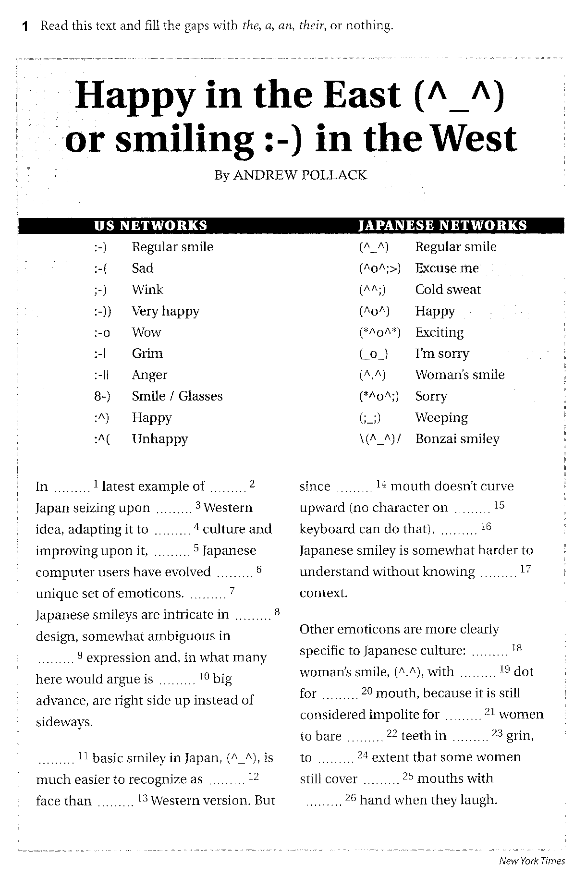

2 Complete the sentences with the, a/an or –.

1 ____ Masaryk University in ____ Brno was established in 1919.
2 ____ Faculty of Economics and Administration was founded on 1 January 1991 as the sixth faculty of ____ Masaryk University.
3 ____ Madagascar is an island nation in ____ Indian Ocean, off the southeastern coast of ____ Africa.
4 ____ Sears Tower is a skyscraper in ____ Chicago, ____ Illinois. It has been the tallest building in ____ United States since 1973.
5 ____ Fifth Avenue is a major thoroughfare in the centre of ____ Manhattan in ____ New York City.
6 ____ Aconcagua is the highest peak of ____ Andes, the longest mountain range of ____ South America.
7 Steve Jobs is the co-founder and CEO of ____ Apple and was the CEO of ____ Pixar until its acquisition by ____ Disney.
8 ____ Lake Victoria is the source of the longest branch of ____ Nile River, ____ White Nile.
9 ____ Balearic Islands are situated in ____ Mediterranean Sea.
10 My son is in ____ hospital and can’t go to ____ school.
11 On our trip to ____ UK we toured around ____ south-east and visited ____ Canterbury Cathedral.
12 ____ Danube is the main river in ____ Central Europe.

