Revision: Units 1 – 7

I. Phrasal Verbs

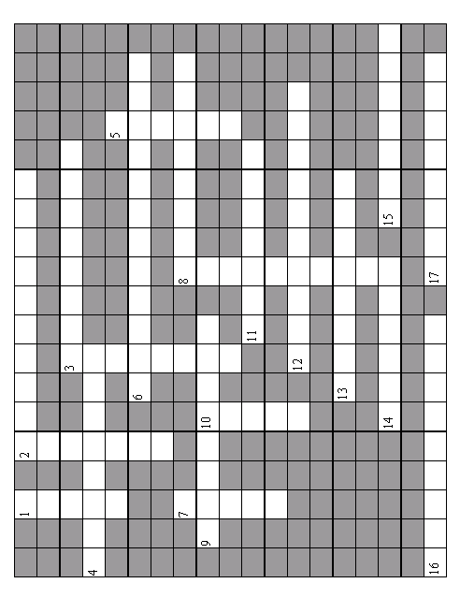
II. Wordbuilding

- Lowering interest rates could have ________________ consequences for the economy. (DISASTER)
- His ________________ that the system should be changed was rejected. (PROPOSE)
- We had a ________________ over the fee for the work. (AGREE)
- It is generally ________________ that stress is caused by too much work. (ASSUMPTION)
- They have considerable ________________ in dealing with oil spills. (EXPERT)
- The government has been ________________ in its response to the report. (CAUTION)
- Buying new furniture may prove too ________________. (COST)
- Millions of years ago, changes in the Earth's climate caused animal and plant life to ________________. (DIVERSE)
- Your experience and qualifications will be taken into ________________ when the decision is made. (CONSIDER)
- I can understand your ________________ – I’d be furious if she ever treated me like that. (ANNOY)
- These two causes are ________________ linked. (SEPARATE)
- Everyone desires to heave healthy ________________ hair. (SHINE)
- He remains confident and ________________ untroubled by his recent problems. (SEEM)
- The exercises are designed to ________________ your stomach muscles. (STRONG)
- The book provides ________________ information on recent trends. (VALUE)
- It is ________________ for all employees to wear protective clothing. (OBLIGATION)
- He was ________________ for a military career, like his father before him. (DESTINY)
- We need to work harder to remain ________________ with other companies. (COMPETITION)
- In November the temperatures drop and the days ________________. (SHORT)
- Which newspapers does the library ________________ to? (SUBSCRIPTION)
- There is some ________________ about what the correct procedure should be. (CONFUSED)
- She’s our ________________ in France. (REPRESENT)
- Fax machines were a wonderful ________________ at the time. (INVENTOR)

III. Transformations
Rewrite the sentences so that they mean the same as the sentence above.
- Where are the toilets?
Could you tell me ____________________________________________?
- How long does the film last?
Do you know ____________________________________________?
- This is a gift. The Japanese visitors gave it to me. They came yesterday. (relative clauses)
This is the gift ____________________________________________.
- I borrowed a friend’s laptop. He wants it back. (relative clauses)
My friend ____________________________________________ back.
- We went to a presentation yesterday. It was very interesting. (relative clauses)
The presentation ____________________________________________.
- Someone broke into our house last week.
Our house ____________________________________________.
- The council will ban all the traffic from the city centre.
All the traffic ____________________________________________.
- The organisers are postponing the meeting.
The meeting ____________________________________________.
- I expect the meeting will be finished by ten. (use a modal verb)
The meeting ____________________________________________ by ten.
- Perhaps you didn’t see the line we launched at the Munich fair. (use a modal verb)
You ____________________________________________ at the Munich fair.
- It was a bad idea for us to drop our prices so much. (use a modal verb)
We ____________________________________________ so much.
- I’m sure the warranty hasn’t expired yet. (use a modal verb)
The warranty ____________________________________________ yet.

