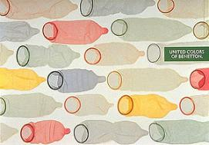



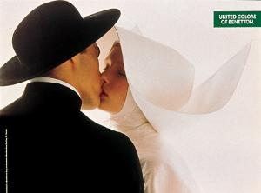

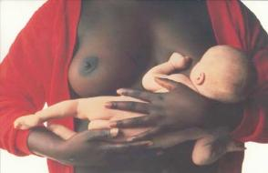

The comedian, Luca Rizo, a fair-skinned performer from northern Italy, loudly complained that he had had a tough day. "I came home unexpectedly early and caught by wife in bed, making love to a black man and an Asian man at the same time!" Rizo exclaimed. An accomplice in the audience shouted out: "What did you do about it?" "Oh," Rizo said, nonchalantly, "I took a photograph and sent it to Benetton ... you never know, right?"
According to corporate consultant and university sociologist Andrea Brocceti,
a joke like that works only when the company in question is so well known that
it needs no background explanation and when its reputation is uniform enough
to avoid confusion. "I would guess that in any given country, that status can be
held by only a dozen or so companies at the most," he says. "If you go any
deeper into a list than that and you start arriving at companies that certain parts
of the population are unaware of."
¨

I asked him if he believes advertising is art, and he didn't miss a beat:
"Sometimes advertising is art," he said. "But art is always advertising."
He paused to puff on a small cigar before returning to the theme. "The Renaissance was just advertising for the Vatican," he said. "The cross is the most effective logo of its time, like the Coca-Cola of another era. Even the swastika was a logo, a powerful logo."

Oliviero Toscani (born 1942) is an Italian photographer, best-known worldwide for designing controversial advertising campaigns for Italian brand Benetton, from 1982 to 2000. Most of these advertising campaigns were actually institutionals for the brand, always composed of rather controversial photography, usually with only the company logo "United Colors of Benetton" as caption.
One of his most famous campaigns included a photo (by Therese Frare) of a man dying of AIDS, lying in a hospital bed, surrounded by his grieving relatives. That picture was controversial due to its similarity to a pieta painting. Others include allusions to racism (notably one with three almost identical human hearts, which were actually pig hearts, with the words 'white', 'black', and 'yellow' as captions), war, religion and even capital punishment.
In the early nineties Toscani co-founded the magazine Colors (also owned by Benetton) with American graphic designer Tibor Kalman. With the tagline "a magazine about the rest of the world", Colors built on the multiculturalism prevalent at that time and in Benetton's ad campaigns, while remaining editorially independent from Benetton.
In 2005, five years after his resignation from Benetton following the controversy surrounding the death row campaign, he sparked controversy again with his photographs for an advertising campaign for the men's clothing brand 'Ra-Re'. Their portrayals of men participating in homosexual behavior angered groups such as the catholic fundamentalist parents' association 'MOIGE' who called the pictures 'vulgar'. The campaign came amidst on-going debate in Italy about gay rights.

