Unit 23: Describing Graphs
Complete the descriptions of the graphs. Several answers are possible.

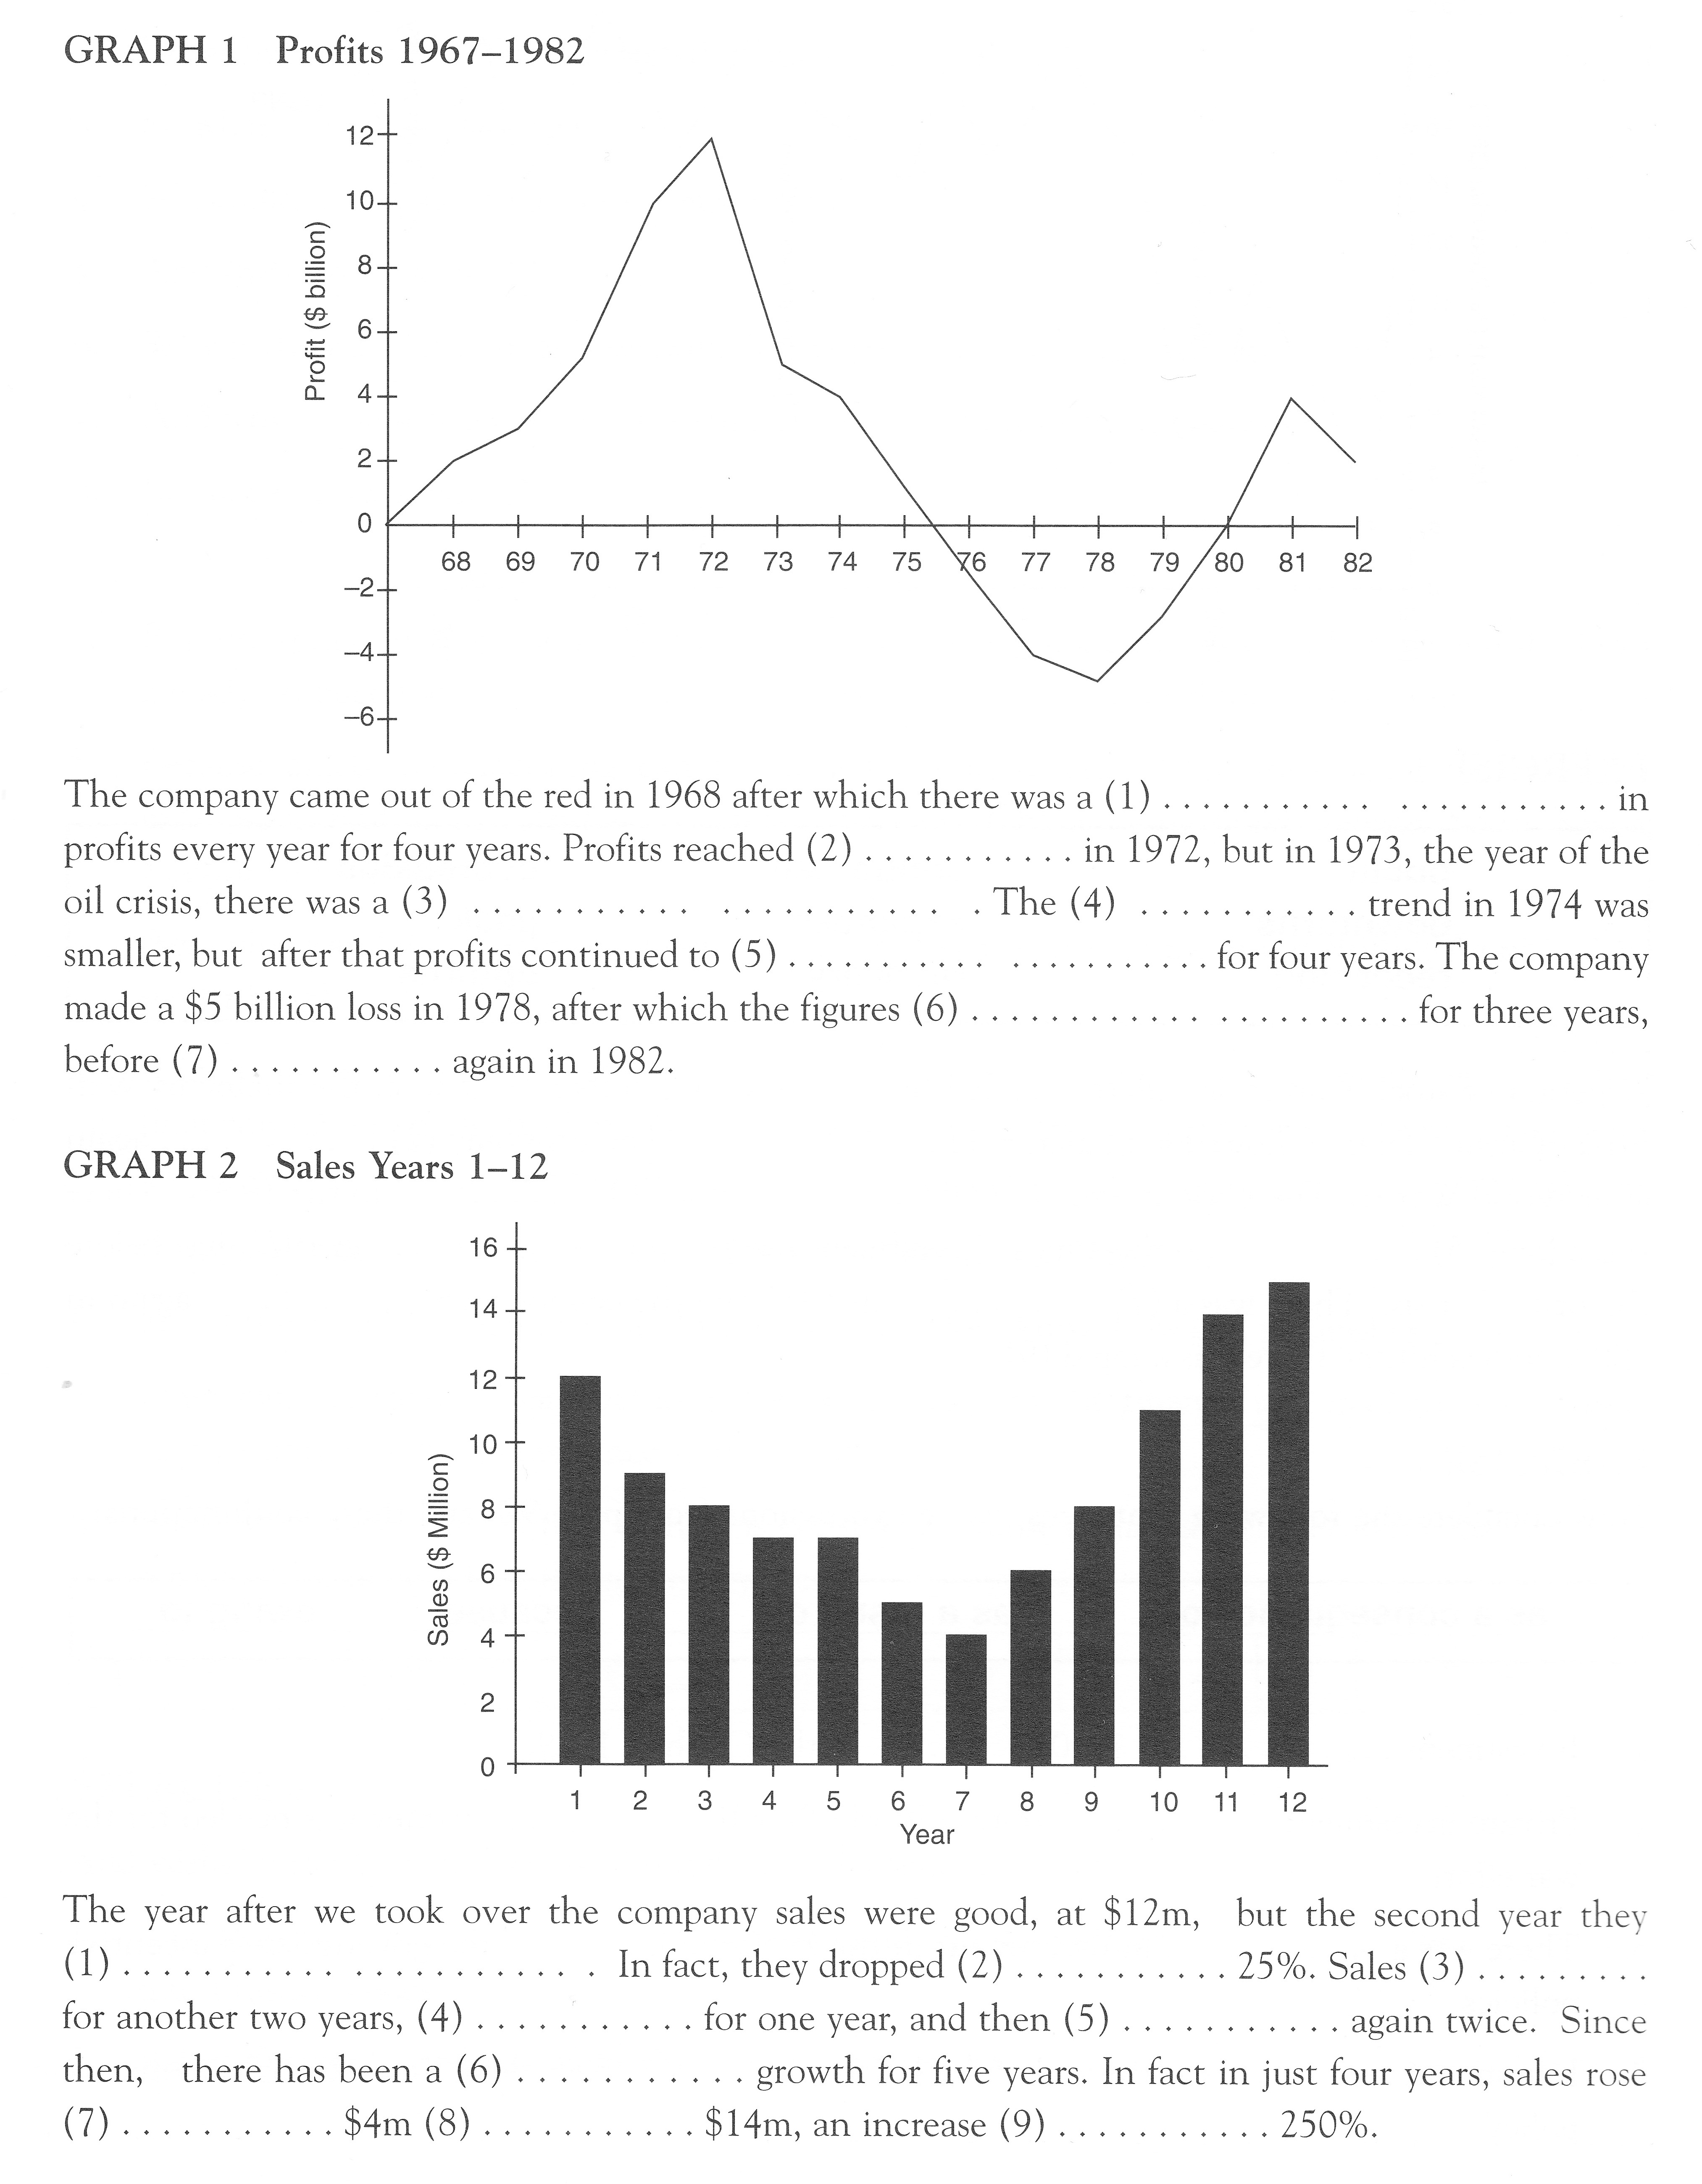

(from Financial English, p. 91)

