Theories of Motivation
EXERCISE 1 Complete the text using the verbs in the box:
achieve actualize avoid earn exist expect
maximize perform pursue require reward set
One of the most important elements of any manager’s job is to motivate his or her subordinates to do their jobs well and to be productive. Two very well-known theories of motivation among managers are those of Abraham Maslow and Frederick Herzberg.
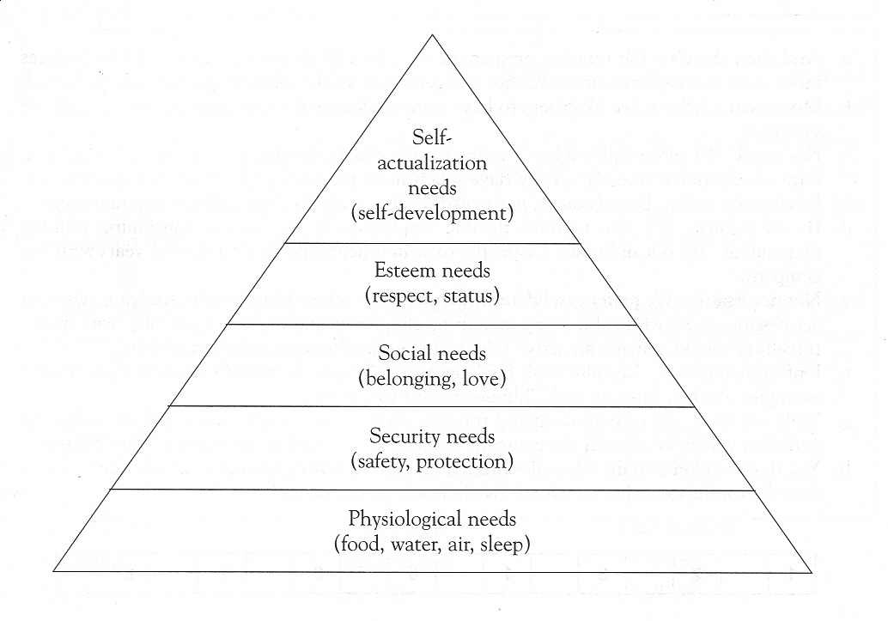
ln Motivation and Personality (1954), Maslow identified what he considered to be a hierarchy of basic human needs and classified them under five headings. First come physiological needs such as food, water, air and sleep. If these needs are not satisfied, people will not (1) ............... other needs. The second category is security needs: clothing, shelter, the necessity to be free from danger and physical pain, and — most relevant to management — to be free from the threat of losing one’s job.
Where these first two categories of needs are satisfied, people feel social needs: to belong to a group, to be liked and loved and accepted by others. Next come esteem needs: people do not only want to be accepted, they want to have self-respect and to be esteemed by others. Maslow believes that people all (2).............. power and status, respect and self-confidence.
The fifth and highest category concerns self-actualization needs: the desire to develop as a person, to (3).............. one’s potential, and to (4) ..............the goals one has (5) .............. for oneself. According to Maslow, employees will only be motivated if they are able to realize their goals (concerning creativity, responsibility or whatever) through their work.
As a need is satisfied, it becomes less important. For example, the more money one has, the less motivating it is to (6).............. more — although of course this doesn’t stop people wanting it! In fact, pay becomes a social or psychological matter rather than an economic one. When needs are satisfied, their capacity to (7).............. and to act as an incentive diminishes. In Work and the Nature of Man (1966), Frederick Herzberg argued that things like good salaries and fringe benefits, job security, status, good company administration and labour relations, cannot motivate workers. They are merely ‘satisfiers’ or, more importantly, ‘dissatisfiers’ where they do not (8) .............. . ‘Motivators’, on the contrary, include things such as having a challenging or interesting job, recognition, responsibility, promotion, and so on. ·
Clearly, not everybody in manufacturing industry or routine service industry jobs can (9) ............... challenging and interesting work or promotion to the highest positions of responsibility. For this reason, many people have disputed Maslow’s theory. For example, self-realization and self-actualizing needs are probably far more prominent among university graduates and at higher levels of a company than at lower levels, where social and security needs, and even a desire to (10).............. responsibility, might be dominant. Not everybody can (11).............. himself or herself at work. Yet even workers who cannot be, or do not want to be, involved in planning, decision-making, controlling and organizing, can be given a variety of tasks, rather than be expected to (12) ......... the same boring, repetitive, mechanical task eight hours a day or more.
Exercise 2
According to the text, are the following statements TRUE or FALSE?
1. The possibility of losing their job generally motivates people to work harder. TRUE/FALSE
2. Workers need to be accepted and respected by their colleagues and superiors. TRUE/FALSE
3. After a certain point, people are no longer motivated by money. TRUE/FALSE
4. According to Maslow, a good working environment will motivate and fulfil employees. TRUE/FALSE
5. According to Herzberg, providing good working conditions is unnecessary. TRUE/FALSE
6. Educated people are more likely to want to achieve things in their jobs. TRUE/FALSE
7. Managers have to ensure that everybody has an interesting job. TRUE/FALSE
8. Switching among several boring, repetitive tasks is better than doing only one. TRUE/FALSE

