BULGARIA
Economic growth – net material product and GDP (CIA estimation) in Bulgaria 1949-1989
 | 1949-52 | 1953-57 | 1958-60 | 1961-65 | 1966-70 | 1971-75 | 1976-80 | 1981-85 | 1986 | 1987 | 1988 | 1989
NMP | 8,4 | 7,8 | 11,6 | 6,7 | 8,8 | 7,8 | 6,1 | 3,7 | 5,3 | 4,7 | 2,4 | -0,3
HDP (CIA) |  |  |  |  |  | 7,5 | 1,0 | 0,9 | 4,8 | -1,0 | 0,9 | -0,1
Zdroj: Jeffries, Socialist Economies and the Transformation to the Market, 2003
Government incomes and expenditures in % of GDP in 1989
Country | Incomes | Expenditure
Czechoslovakia | 62.1 | 64.5
Hungary | 61.3 | 63.7
Poland | 46.8 | 48.7
Rumania | 45.7 | 40.7
Bulgaria | 57.7 | 60.1
Soviet Union | 43.8 | 50.7
USA | 34.3 | 36.5
Germany | 45.7 | 45.9
Canada | 40.3 | 43.9
France | 46.2 | 47.8
Table 1: External debt/exports of goods and services (in %)
 | 1985 | 1986 | 1987 | 1988 | 1989 | 1990
Bulgaria | 34.8 | 52.9 | 61.3 | 86.5 | 106.2 | 154.6
Czechoslovakia | 32.4 | 33.8 | 36.2 | 40.2 | 45.1 | 56.3
Hungary | 148.5 | 166 | 174.9 | 173.8 | 169.7 | 171.7
Poland | 252.1 | 259.5 | 294.8 | 254. | 261.7 | 251.5
Rumania | 63.5 | 66.1 | 57.7 | 20.3 | 4.3 | 6.1
Source: Jonáš, Ekonomická transformace v České republice, 1997
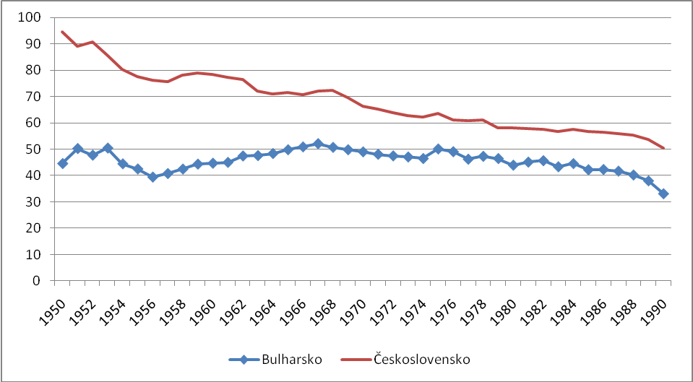
GDP per person in Bulgaria and ČSR (Austria = 100)
Zdroj: Maddison, Historical Statistics - http://www.ggdc.net/maddison/ (11. 10. 2008)
Table 2: Basic economic indicators at the beginning of the 1990s*
 | CR | HUN | POL | SLV | SLOVE | BUL | RUM | CROA | RUS | UKR
Inhabitants in mil. | 10.36 | 10.36 | 38.11 | 5.3 | 1.99 | 8.72 | 23.21 | 4.78 | 148.29 | 54.87
Economic activity in % | 51.6 | 52 | 42.7 | 37.9 | 46.2 | 47 | 46.9 | 32.8 | 50.8 | 48.7
Employment in industry % of total | 37.9 | 29.7 | 28.4 | 33.9 | 43.5 | 36.6 | 37.6 | 35.7 | 30.3 | 31
Investment in % | 37.9 | 29.7 | 28.4 | 33.9 | 43.5 | 36.6 | 37.6 | 35.7 | 30.3 | 31
GDP in mld $ PPP | 98.97 | 59.6 | 160.86 | 38.68 | 18.36 | 39.13 | 92.75 | 23.26 | 889 | 215.64
GDP/person $ PPP | 9550 | 5750 | 4221 | 7301 | 9225 | 4487 | 3996 | 4866 | 5995 | 4163
EX per person in $ | 873 | 922 | 376 | 545 | 2070 | 1541 | 249 | 841 | 480 | 218
IM per person in $ | 945 | 832 | 250 | 606 | 2377 | 1506 | 396 | 1086 | 551 | 230
Gross external debt per person | 686 | 2077 | 1270 | 561 | 977 | 1154 | 10 | 607 | 378 | 67
in % of GDP | 21.9 | 65.1 | 82.2 | 19.3 | 11.2 | 17.3 | 0.6 | 10.9 | 5.1 | 1.2

Table 3: Exports to COMECOM markets (mil. USD)
 | 1989 | 1990 | 1991 | 1992 | 1993 | % decline between 1989 and 1993
Czech Republic* | 5 103 | 3 422 | 2 045 | 1 103 | 1 009 | 80,2
Bulgaria | 7 967 | 5 887 | 1 892 | 1 103 | 1 009 | 87,3
Hungary | 4 009 | 2 933 | 2 710 | 2 981 | 3 122 | 22,1
Poland | 4 395 | 4 000 | 1 799 | 1 476 | 1 461 | 66,8
Rumania | 3 890 | 2 083 | 1 089 | 702 | 720 | 81,5
Slovakia | 1 827 | 1 169 | 1 376 | 1 200 | 1 130 | 38,1
* without inter Czechoslovak trade
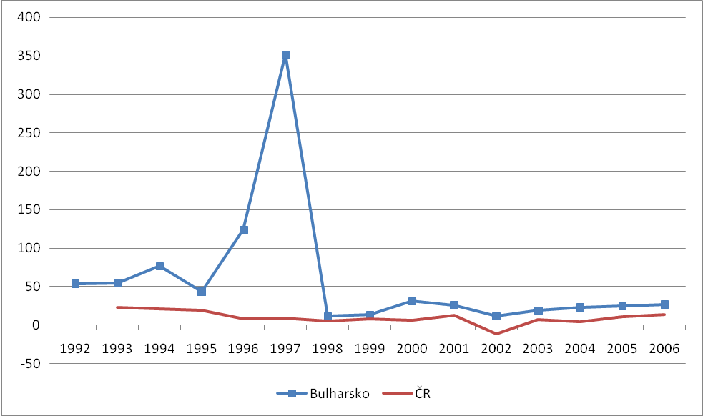
- Procentní změna měnového agregátu M2 v Bulharsku a ČR v letech 1992-2006
Zdroj: European Bank for Reconstruction and Development (EBRD): Selected economic indicators data, URL: http://www.ebrd.org/country/sector/econo/stats/index.htm (29. 4. 2009)

- Government expenditures in Bulgaria as % of GDP
 | 1989 | 1993 | change
Social welfare | 10,4 | 15,8 | 5,4
Subventions | 15,5 | 4,8 | -10,7
Capital spending | 5,5 | 1,9 | -3,6
Overall expenditures | 61,5 | 51,2 | -10,3
Zdroj: Coricelli, Macroeconomic Policies and the Development of Markets in Transition Economies, 1998
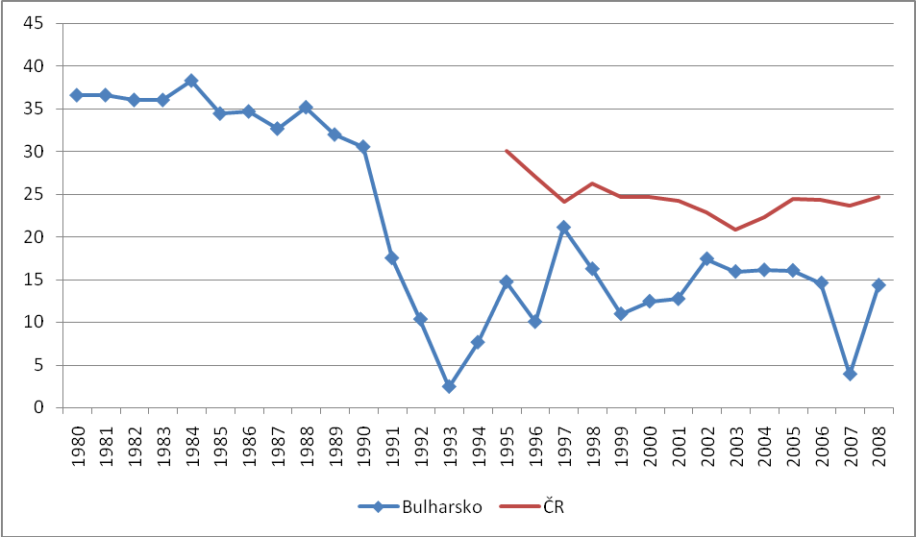
- National savings as percentace of GDP 1980-2008
Zdroj: MMF, World Outlook Database, http://www.imf.org/external/pubs/ft/weo/2011/01/weodata/index.aspx (12. 7. 2011)
- Změna důchodové nerovnosti – Giniho koeficient (založený na příjmu), 1987-88 versus 1993-4
Change in income unequality – Gini coeficient 1987/88 vs. 1993/4
 | 1987-88 | 1993-94
Czech Rep | 19 | 19
Hungary | 21 | 23
Poland | 26 | 31
Slovakia | 20 | 20
Bulgaria | 23 | 34
Slovenia | 24 | 28
Rumania | 23 | 29
All transitive countries | 24 | 32
Zdroj: Coricelli, Macroeconomic Policies and the Development of Markets in Transition Economies, 1998

- Vybrané statisticky ekonomického prostředí v Bulharsku a ČR v letech 1989-2006
Selected statistics of economic environment in Bulgaria and Czech Rep 1989-2006
 | 1989 | 1990 | 1991 | 1992 | 1993 | 1994 | 1995 | 1996 | 1997 | 1998 | 1999 | 2000-2006
Podíl administrativních cen na CPI
Share of administrative prices on CPI
Bulharsko | 100,0 | 70,0 | 24,0 | 16,0 | 26,0 | 43,0 | 46,0 | 52,0 | 14,4 | 15,8 | 17,2 | 20-24,7
ČR | na | na | 27,9 | 18,3 | 17,9 | 18,1 | 17,4 | 17,4 | 13,3 | 13,3 | 13,3 | 10,9-19,7
Výnosy z cel jako procento dovozů
Tariffs revenue as share of exports
Bulharsko | 5,3 | 2,5 | 2,2 | 4,5 | 16,0 | 15,3 | 13,5 | 8,0 | 9,7 | 13,9 | 10,2 | 8,0-10,6
ČR | na | na | na | na | 3,5 | 3,5 | 2,6 | 2,6 | 1,7 | 1,5 | 1,2 | 0,2-1,1
Zdroj: European Bank for Reconstruction and Development (EBRD): Selected economic indicators data, URL: http://www.ebrd.org/country/sector/econo/stats/index.htm (29. 4. 2009)

General government balance as % of GDP (1990-2000)
 | 1990 | 1991 | 1992 | 1993 | 1994 | 1995 | 1996 | 1997 | 1998 | 1999 | 2000 | Average
Bulgaria | -8.1 | -4.5 | -2.9 | -10.9 | -5.7 | -5.6 | -10.3 | -0.3 | 1.7 | 0.4 | -0.5 | -4.2
Czech R. | -0.2 | -1.9 | -3.1 | 2.6 | -1.2 | -1.1 | -3.3 | -3.8 | -5.0 | -3.7 | -3.7 | -2.2
Hungary | 0.0 | -2.9 | -6.1 | -6.0 | -7.5 | -6.7 | -5.0 | -5.9 | -8.0 | -5.5 | -3.0 | -5.1
Poland | 3.1 | -2.3 | -5.3 | -2.8 | -2.8 | -3.1 | -3.3 | -4.6 | -4.3 | -1.8 | -3.0 | -2.7
Source: EBRD: Selected economic indicators data, 26. 11. 2007.

- Celková rovnováha veřejných financí a financování centrální bankou 1992-1997 jako procento HDP
Overall government balance and share financed by the CB 1992-7 in % of GDP
Country | Celková rozpočtová rovnováha  Overall government balance |  |  |  |  |  | Financování centrální bankou  Financed by the Central bank
 | 1992 | 1993 | 1994 | 1995 | 1996 | 1997 | 1992 | 1993 | 1994 | 1995 | 1996 | 1997
Bulgaria | -5.2 | -10.9 | -5.8 | -6.3. | -13.3 | -2.6 | 6.0 | 11.0 | 5.5 | 4.9 | 14.5 | -0.1
CR | … | ... | -1.2 | -1.8 | -1.2 | -2.1 | ... | -2.1 | -2.4 | -1.0 | -0.8 | 0.7
Hungary | -6.9 | -8.5 | -8.3 | -7.1 | -3.1 | -4.6 | 16.5 | 13.2 | 11.2 | 7.5 | 7.3 | 1.7
Poland | -7.5 | -4.0 | -2.0 | -2.7 | -2.5 | -2.3 | 5.2 | 1.5 | 1.5 | 0.1 | 0.1 | 0.5
Dabrowski, Disinflation Strategies and thein Effectiveness in Transition Economies, 2003

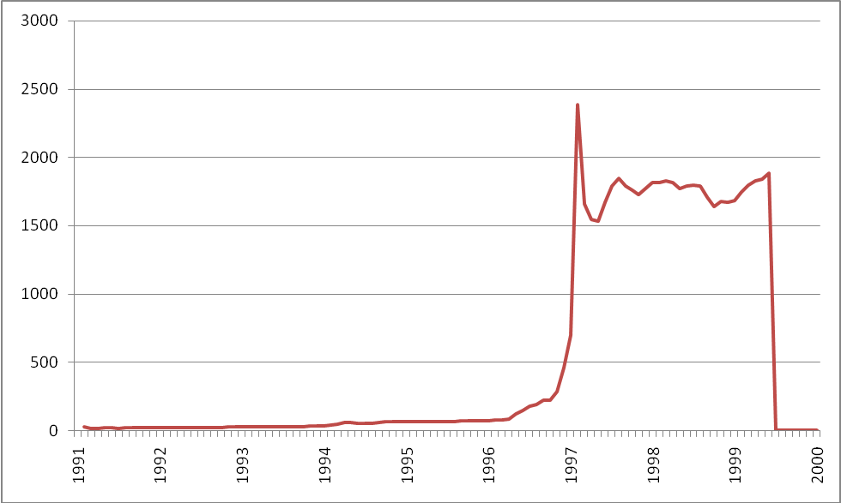
- Exchange rate leva/USD (leva per dolar) 1991-2000
1999 demonetization
Bulgarian National Bank, 12. 7. 2011, http://www.bnb.bg/bnbweb/groups/public/documents/bnb_download/s_monthly_exr_en.xls,

- Real income in Bulgaria 1989-1998 (1990=100)
1990 | 1991 | 1992 | 1993 | 1994 | 1995 | 1996 | 1997 | 1998
100 | 61,2 | 65,9 | 62,7 | 55,7 | 50,8 | 34,8 | 29,6 | 40,2
Zdroj: Stattev, Bulgarian Economic Transition, 2001
- EBRD index velké privatizace ČR a Bulharsko 1989 - 2006
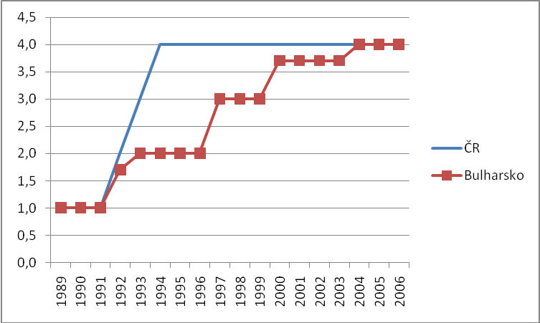
- EBRD index of mass privatization in CR and Bulgaria 1989-2006
Index nabývá hodnot od 1-4,3. Čím vyšší číslo tím se prostředí více blíží vyspělým ekonomikám.
Zdroj: EBRD: Selected economic indicators data, URL: http://www.ebrd.org/country/sector/econo/stats/index.htm (29. 4. 2009)

- Postup privatizace v Bulharsku – počet případů, procento privatizovaného majetku (dle ocenění z roku 1995) a privatizační výnos (v mil. dolarů)
 | 1993 | 1994 | 1995 | 1996 | 1997 | 1998 | 1999 | 2000 | 2001 | 2002 | 2003 | 2004 | 2005/8 | Celkem
Počet privatizačních případů | 63 | 161 | 318 | 513 | 584 | 1085 | 1211 | 590 | 231 | 103 | 118 | 208 | 70 | 5255
Procento privatizovaného majetku* | 0,4 | 1,6 | 1,1 | 4,1 | 18,4 | 4,5 | 17,0 | 4,4 | 1,0 | 1,2 | 1,4 | 2,6 | 8,0 | 65,5
Privatizační agentura a další státní orgány | 0,4 | 1,6 | 1,1 | 4,1 | 3,8 | 4,5 | 17,0 | 4,4 | 1,0 | 1,2 | 1,4 | 2,6 | 8,0 | 50,9
Masová privatizace |  |  |  |  | 14,6 |  |  |  |  |  |  |  |  | 14,6
Privatizační výnos (mil. $) | 72,2 | 232,8 | 181,9 | 418,8 | 607,6 | 613,1 | 1152,9 | 440,6 | 178,4 | 198 | 268 | 406
* – k roku 1995 byl odhadnut celý majetek určený k privatizaci. Uvedené údaje v jednotlivých sloupcích odpovídají procentu tohoto celkového majetku, který byl privatizován v jednotlivých letech. K této privatizaci konkrétně docházelo přes privatizační agenturu (resp. další státní orgány) a nebo formou masové privatizace. Tomuto rozdělení odpovídají další dva řádky tabulky, které blíže specifikují privatizační postup.
Privatization Agency (20. 7. 2011), http://www.priv.government.bg/apnew/Root/index.php?magic=0.0.0.0.2; MMF, 2002,

- Devizové rezervy (miliony USD), úrokové sazby na vklady v % (pravá škála) v Bulharsku 1991 - 2002
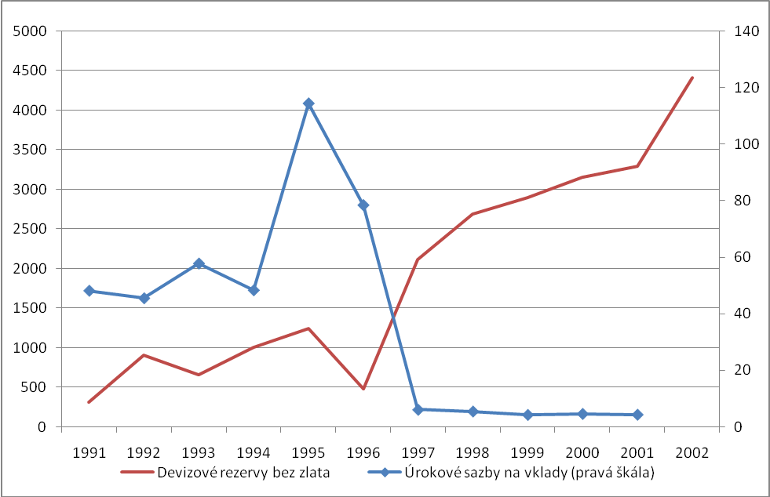
Foreign reserves (milions of USD), interest rates on savings in % (right scale) in Bulgaria 1991-2002
Zdroj: MMF, Databáze IFS

- Exports in USD in 1999; 1989 = 100
Country | Index
Bulgaria | 60
ČSR/ČR | 346
Hungary | 259
Poland | 187
Rumania | 105
Baltic countries(1992=100) | 358
Zdroj: Gros, Steinherr, Economic Transition in Central and Eastern Europe, 2004

- Strukturální rovnováha rozpočtu jako procento potenciálního produktu
Structural imbalance as percentage of potential product
 | 2001 | 2002 | 2003 | 2004 | 2005 | 2006 | 2007
Bulgaria | 0,835 | 1,233 | 1,378 | 2,27 | 1,932 | 1,823 | 0,414
ČR | -5,3 | -6,117 | -6,221 | -2,799 | -3,513 | -2,705 | -1,235
Zdroj: MMF, World Outlook Database, http://www.imf.org/external/pubs/ft/weo/2011/01/weodata/index.aspx (12. 7. 2011)

- Vládní dluh jako procento HDP v ČR a Bulharsku mezi 1991 a 2006
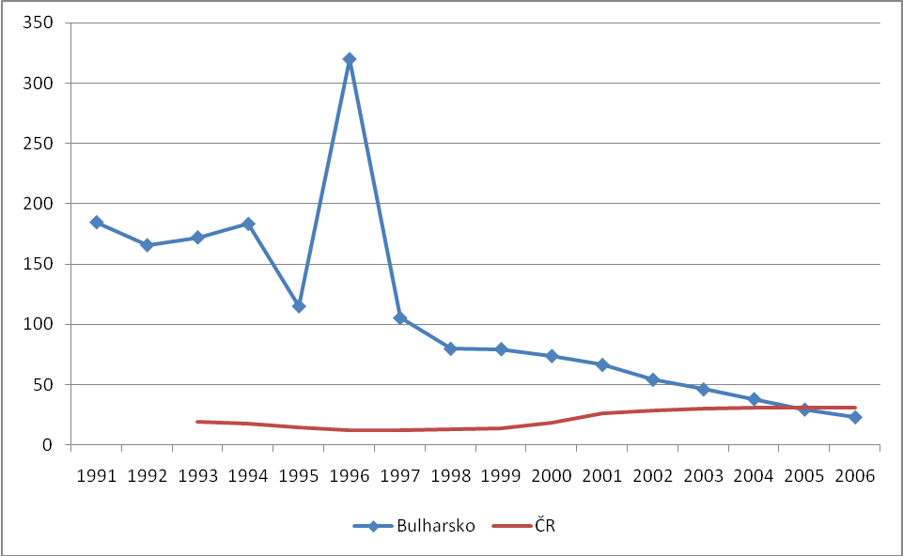
Government debt as percentage of GDP in Bulgaria and ČR 1991-2006
Zdroj: European Bank for Reconstruction and Development (EBRD): Selected economic indicators data, URL: http://www.ebrd.org/country/sector/econo/stats/index.htm (29. 4. 2009)

Real wages in Eastern Europe, the bottom and situation in 2005 in comparison to the pre-transformation year
Country | Year, when real wages reached the bottom | Cumulated growth of real wages against the bottom till 2005 (in %) | Cumulated change of real wages in 2005 against the pre-transformation year (in %)
Bulgaria | 1997 | 44 | -57
Czech Republic | 1991 | 98 | 38
Hungary | 1996 | 57 | 19
Poland | 1993 | 43 | 2
Slovakia | 1991 | 37 | -3
Slovenia | 1992 | 63 | -1
Russia | 1999 | 128 | -20
Ukraine | 1999 | 141 | -14
Source: Klaus, Tomsik: Makroekonomická fakta české transformace, 2007

- Ekonomický růst v Bulharsku a ČR v letech 1990 až 2006 v %
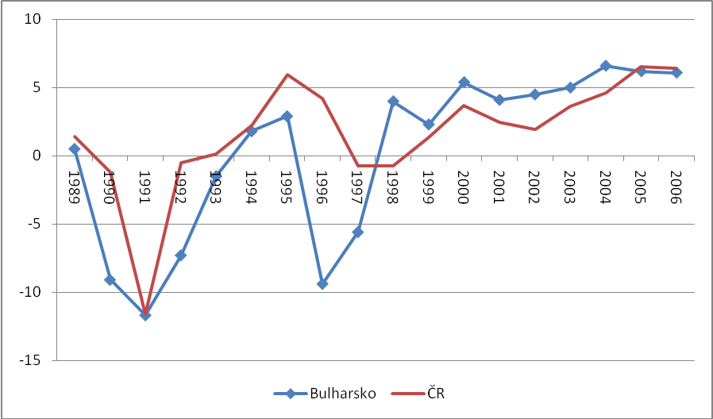
Economic growth in Bulgaria and CR 1990-2006 in percentage
Zdroj: European Bank for Reconstruction and Development (EBRD): Selected economic indicators data, URL: http://www.ebrd.org/country/sector/econo/stats/index.htm (29. 4. 2009)

- Kumulovaný vývoj HDP v Bulharsku a ČR v letech 1990 až 2006; 1989=100
Comulated development of GDP in Bulgaria and CR 1990-2006, 1989 = 100
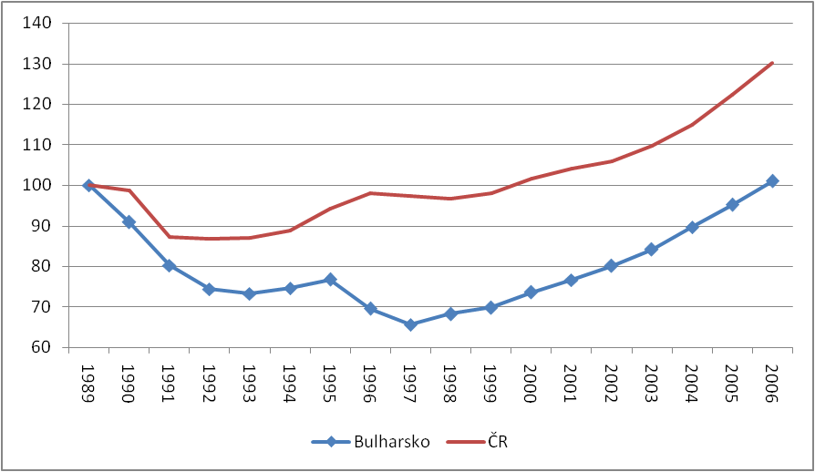
Zdroj: European Bank for Reconstruction and Development (EBRD): Selected economic indicators data, URL: http://www.ebrd.org/country/sector/econo/stats/index.htm (29. 4. 2009)

- Odhad šedé ekonomiky pro vybrané země na přelomu let 1999/2000 jako procenta oficiálního HDP
Share of grey economy in 1999/2000 as percentage of official GDP
Country | Rozsah šedé ekonomiky  Share of grey economy
Czech Rep | 19,1
Hungary | 25,1
Poland | 27,6
Bulgaria | 36,9
Austria | 14,3
Greece | 28,7
Zdroj: Schneider, Shadow Economies of 145 Countries all over the World, 2005

HDP na osobu dle parity kupní síly v běžných dolarech 1989-2007
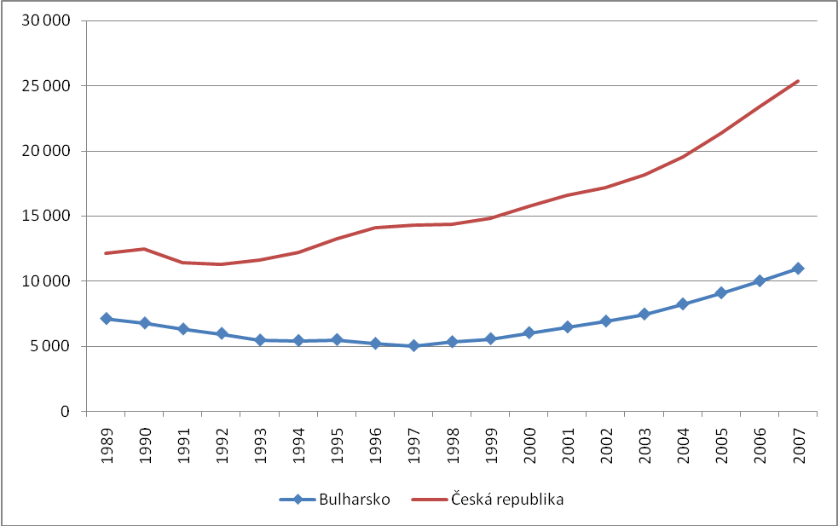
GDP per person in current USD 1989-2007
Zdroj: MMF, World Outlook Database (12. 7. 2011), http://www.imf.org/external/pubs/ft/weo/2011/01/weodata/index.aspx

- HDP na osobu dle parity kupní síly mezi lety 1991 a 2007 jako procento zemí eurozóny, běžné dolary
GDP per person dle PPT between 1991-2007 as percentage of eurozone
 | 1991 | 1992 | 1993 | 1994 | 1995 | 1996 | 1997 | 1998 | 1999 | 2000 | 2001 | 2002 | 2003 | 2004 | 2005 | 2006 | 2007
Bulgaria | 34,0 | 31,3 | 28,8 | 27,6 | 26,4 | 24,0 | 22,7 | 23,4 | 23,3 | 23,9 | 24,7 | 25,9 | 27,3 | 28,9 | 30,6 | 31,9 | 33,4
Czech Rep. | 61,6 | 59,3 | 61,4 | 62,4 | 63,8 | 65,4 | 64,6 | 63,5 | 62,3 | 62,5 | 63,4 | 64,3 | 66,4 | 68,4 | 71,9 | 74,5 | 77,1
Eurozone | 100 | 100 | 100 | 100 | 100 | 100 | 100 | 100 | 100 | 100 | 100 | 100 | 100 | 100 | 100 | 100 | 100
Zdroj: MMF, World Outlook Database (12. 7. 2011), http://www.imf.org/external/pubs/ft/weo/2011/01/weodata/index.aspx, vlastní výpočet
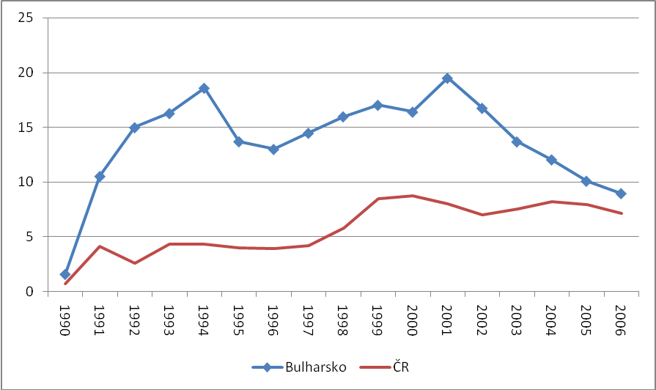
- Míra nezaměstnanosti v Bulharsku a ČR jako procento pracovní síly v letech 1990-2006 Unemployment rate in Bulgaria and CR as % of labour fource
Zdroj: European Bank for Reconstruction and Development (EBRD): Selected economic indicators data, URL: http://www.ebrd.org/country/sector/econo/stats/index.htm (29. 4. 2009)

- Kumulovaná změna míry zaměstnanosti v Bulharsku a ČR; 1989 = 100
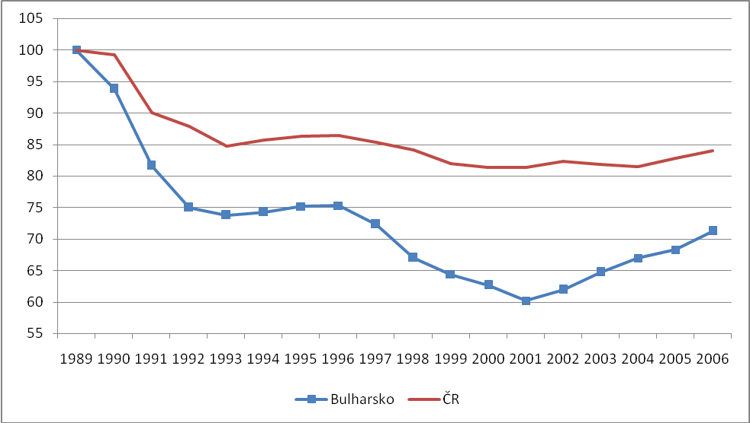
Cumulated changes in employment in Bulgaria and CR; 1989 = 100
Zdroj: European Bank for Reconstruction and Development (EBRD): Selected economic indicators data, URL: http://www.ebrd.org/country/sector/econo/stats/index.htm (29. 4. 2009)

- Tempo růstu inflace – roční průměr v % v letech 1990-2006
Inflation – year-to-year averages in %, 1990-2006
 | 1990 | 1991 | 1992 | 1993 | 1994 | 1995 | 1996 | 1997
CR | 9,7 | 52,0 | 11,1 | 20,8 | 9,9 | 9,6 | 8,9 | 8,4
Bulgaria | 26,3 | 333,5 | 82,0 | 73,0 | 96,3 | 62,0 | 123,0 | 1 082,0
1998 | 1999 | 2000 | 2001 | 2002 | 2003 | 2004 | 2005 | 2006
10,6 | 2,1 | 4,0 | 4,7 | 1,8 | 0,2 | 2,8 | 1,9 | 2,5
22,2 | 0,7 | 9,9 | 7,4 | 5,9 | 2,3 | 6,1 | 5,0 | 7,3
Zdroj: European Bank for Reconstruction and Development (EBRD): Selected economic indicators data, URL: http://www.ebrd.org/country/sector/econo/stats/index.htm (29. 4. 2009)

- Kumulované procento růstu cenové hladiny ve vybraných letech 1989-2006; 1989=100
Cumulate changes in price level between 1989-2006; 1989= 100
 | 1989 | 1990 | 1993 | 1996 | 2000 | 2003 | 2006
Bulharsko | 100 | 126,30 | 1 723,89 | 12 225,04 | 195 451,05 | 227 241,30 | 271 762,67
ČR | 100 | 109,70 | 223,79 | 293,60 | 373,91 | 399,54 | 428,99
Zdroj: European Bank for Reconstruction and Development (EBRD): Selected economic indicators data, URL: http://www.ebrd.org/country/sector/econo/stats/index.htm (29. 4. 2009)
- Export k HDP v Bulharsku a ČR 1989-2006 v %
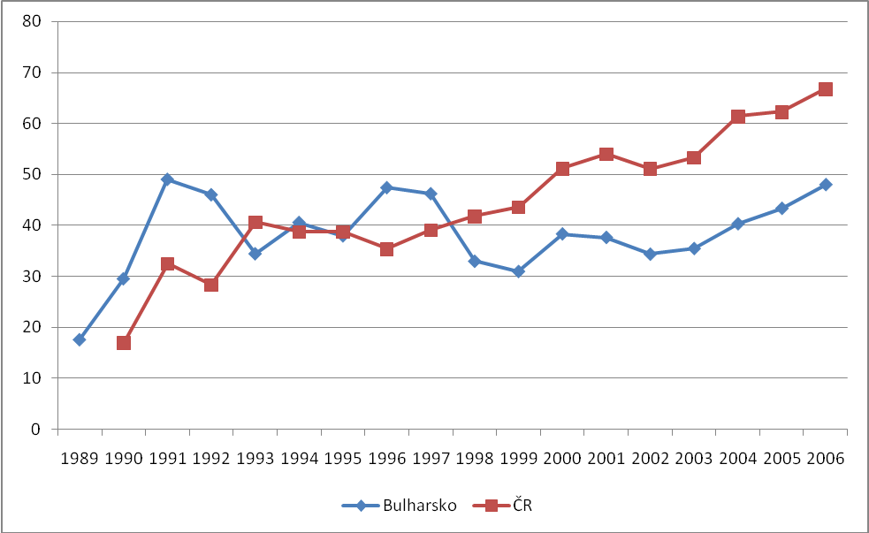
Exports to GDP in Bulgaria and CR in % 1989-2006
Zdroj: EBRD, Selected economic indicators data, URL: http://www.ebrd.org/country/sector/econo/stats/index.htm (29. 4. 2009), vlastní výpočet

- Běžný účet ku HDP v Bulharsku a ČR v letech 1990 až 2006 v %
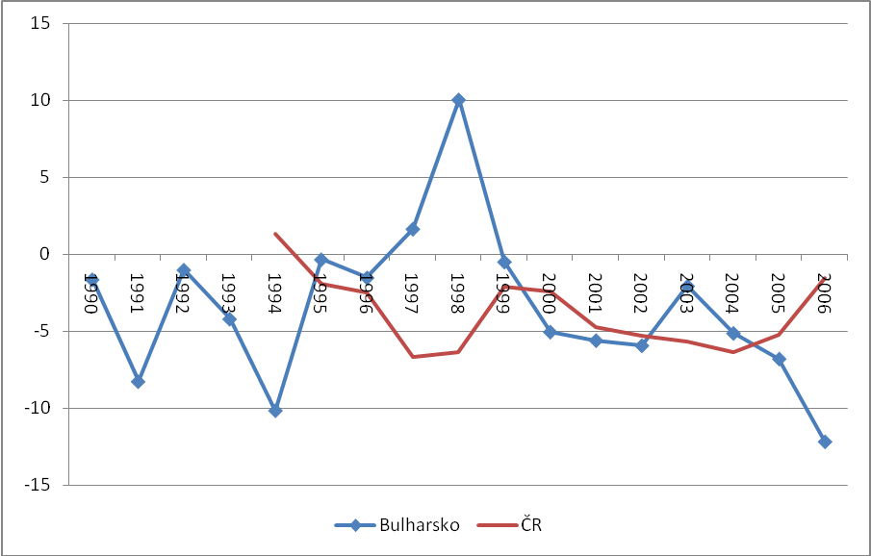
Current account to GDP in Bulgaria and CR 1990-2006 in %
Zdroj: EBRD, Selected economic indicators data, URL: http://www.ebrd.org/country/sector/econo/stats/index.htm (29. 4. 2009)

- Čistý příliv přímých zahraničních investic do Bulharska a ČR (jako % HDP) mezi lety 1990 a 2005
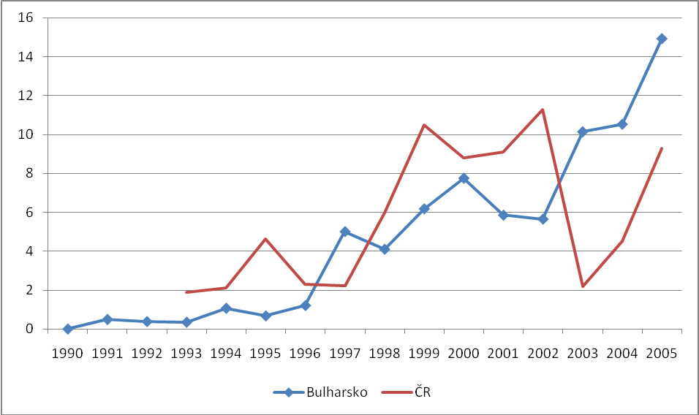
Net inflow of FDI to Bulgaria and CR (% of GDP), 1990-2005
Zdroj: World Bank dataset

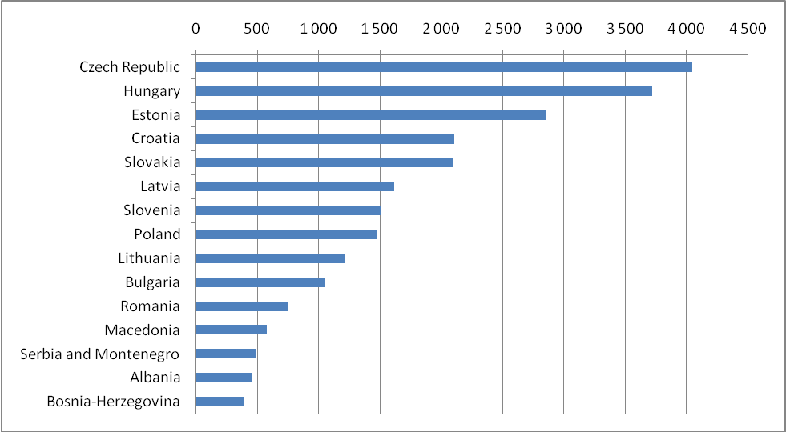
Chart 1: Cumulative FDI inflows per capita 1989-2004
Source: Berend, From the Soviet Bloc to the European Union, 2009

