Essay

Russia-Europe Energy Relations

Azim Dzhusupov
Business Management, Masaryk University
Brno, Czech Republic
Fall, 2012

Course Name: Finance
Course Professor: Ing. Luděk Benada

Abstract.
This paper shows the establishment of relationship EU and Russia in energy sector. I reviewed some statistical dates. In general there is positive tendency in relationship between EU and Russia. The EU-Russia Partnership and Cooperation Agreement gave to the begging of strong bond EU and Russia.

Content:

Introduction 3
The current condition and prospects of the EU energy 3
The main objectives of the EU and the mechanism of their implementation 3
Energy in foreign policy 3
Joint projects of EU and Russia 3
Conclusion 3
Annex:1: List of joint energy projects 3
Annex 2: List of Progress Reports 3
Annex 3: Nord Stream pipeline project 3
Reference 3

Introduction
The legal basis for EU-Russia energy relations is the EU-Russia Partnership and Cooperation
Agreement was signed in 1994. In 2000, the Russian Federation and the European Union felt the need the upgrade the cooperation on this key sector and decided, during the EU-Russia Summit in Paris of October 2000, to institute an Energy Dialogue, "which will enable progress to be made in the definition of an EU-Russia energy partnership and arrangements for it". Energy was considered as one of the most solid pillars of cooperation between the European side and Russia since the 60s, and as a key element for the further integration of the markets. The cooperation should include "the introduction of cooperation on energy saving, rationalization of production and transport infrastructure, European investment possibilities, and relations between consumer and producer countries".
The Joint Statement of the EU-Russia Summit noted the following priorities for future work:
"– improvement of the legal basis for energy production and transport,
– ensuring the physical security of transport networks;
– legal security for long-term energy supplies;
– the recognition of certain new transport infrastructures as being of "common interest";
– the importance of rational energy use and savings."
Moreover an important direction of Russia's foreign policy is a policy of integration with the European Union, the formation of the EU-Russia single energy, and then economic space. Cooperation between Russia and the EU is based on the Partnership and Cooperation, which was signed in June 1994, and entered into By December 1, 1997.
According to agreement the EU and Russia are interdependent energy partners. Moreover the Russian Federation is the 3rd biggest world trade partner of the EU (9.7%), following the US (15.2%) and China (11.4%). Energy represents 65% of total EU imports from Russia. Russia is the biggest oil, gas, uranium and coal supplier to the EU, and the third biggest electricity supplier. 31% of total EU’s gas imports, 27% of total EU’s crude oil imports, and 24% of total EU coal imports are supplied from the Russian Federation. In 2009, Russia supplied 30% of total EU uranium imports. 24% of total EU gas sources are supplied from Russia. For several EU Member States, Russia is the only gas source and supplier. At the same time, the EU is by far the largest trade partner of the Russian Federation: 45% of Russia imports originate from the EU, and 55% of its exports go to the EU, including 88% of Russia's total oil exports, 70% of its gas exports and 50% of its coal exports. The export of raw materials to the EU represents around 40% of the Russian budget, and the EU represents 75% of cumulative foreign investments in Russia. In terms of infrastructure, Europe is the natural destination for Russian energy exports.
Overall, the intensity of EU-Russia energy relations has been increasing over the past ten years. EU enlargements in 2004 and 2007 were a further step in the relations, as most of the new Member States fully relied on gas supplies from the Russian Federation. The EU 27 gas imports from Russia grew from 119 bcm in 2000 to 134 bcm in 2008. From 2000 to 2007, oil supplies from Russia to the EU increased from 112 Mt to 185 Mt. The import of hard coal is increased by a factor of 4 from 15 Mt to 56Mt in the same period. Russia is now the largest coal exporter to the EU. While as a consequence of the financial and economic crisis 2009 has seen a drop in imports, the year 2010 and 2011 again showed an upward trend.

The current condition and prospects of the EU energy
The EU does not have significant oil and gas reserves of the fuel. Gas field is expected to run out in the next two to three decades, and oil - even faster. Oil extracted in the EU, mainly UK and Denmark, gas - the UK and the Netherlands, in smaller amounts - Italy, Germany and Denmark. EU’s enlargement practically does not give for growth of oil and gas resource.
Relatively resources of coal are small. And his production is expensive. The price of coal mined in the EU, is 3-4 times higher than the price of imported coal. Such a large difference in prices has led to almost stop coal mining in Belgium, France and Portugal, to reduce its production in Germany and Spain. But the competitive position of EU’s coal increased after joining of advanced coal mining countries such as Poland and the Czech Republic. However, the overall situation has not changed.
The new EU member states, with the exception of Poland, the Czech Republic and Slovakia, mine a relatively large scale coal, but the dependence on energy imports is even higher. Almost all the new EU members consume up to 80-100% oil and gas, which comes from Russia. Russia, are the largest exporter of energy to world markets, has for many years been a key partner of the EU in providing fuel and energy. In 2003 Russian oil supplies to the EU provided 18% of their import requirements in this type of fuel. Important suppliers of oil to the EU are Norway, the number of countries in the Middle East and some African countries.
Particularly important is the role of Russia in ensuring EU natural gas supplied by pipeline. Its share of imports in 2003 amounted to 31.5%. (Table 1) the largest supplier of natural gas to the EU are Norway and Algeria. Of all the EU-15 countries, only Denmark self-sufficient in gas and export it to other countries. Needs EU's natural gas is provided by the supply to gas pipelines from Russia, Algeria and Norway.
Table 1. Supply of gas to the EU in 2003 via pipeline, billion cubic meters
 | From Russia | Total import value
Austria | 5,6 | 7,4
Belgium |  | 14,65
Denmark
Finland | 4,84 | 4,84
France | 9,7 | 31,8
Germany | 33,21 | 86,76
Great Britain |  | 7,51
Grecce | 1,5 | 1,5
Irland |  | 3,7
Italy | 19,73 | 55,92
Luxemburg |  | 1,2
Netherlands | 1,4 | 12,93
Portugal |  | 2,5
Spain |  | 8,69
Sweden |  | 1,25
Total | 75,98 | 240,65
Source: BP Statistical Review of World Energy, June 2004
In 2003, energy consumption in the EU amounted to almost 1,470 million tons oil equivalent, of which 43% was oil, 24% - for gas - 15% for coal, 13% nuclear fuel and 5% - to renewable energy.
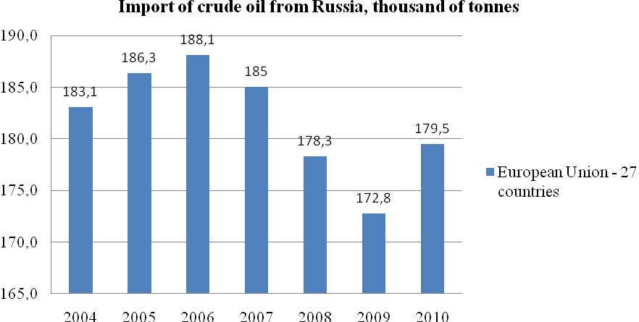
Source: Eurostat
So as we see the tendency of import of oil is has increased comparing to 2003. Thereby we can say that EU and Russia are moving to strengthen their relationship. Only in 2009 there was big decline because of World Crisis.
The EU-Russia Energy Dialogue made an important contribution to the better understanding of the functioning of the respective markets.

The main objectives of the EU and the mechanism of their implementation
EU energy strategy aims at achieving two main objectives: energy security and decrease of energy component in production cost for achieving competitiveness in world markets.
The focus of energy policy on energy security issues have been related to high dependence of EU on energy imports, which may increase from 50% to 70% in 2010. EU energy security has been important due to the fact that it allows to secure fuel and energy consumers. Security of supply does not mean maximizing of energy sufficiency or minimization of dependency. It aims at reducing the risks related this dependency. One of the important tasks of energy strategy is to ensure a reasonable balance between sources of supply and their diversification by type of energy and geographic regions.
The European Union takes measures to diversify energy sources (increases the number of foreign suppliers, uses renewable energy), to implement efficient use of energy, to strengthen cooperation with traditional suppliers of energy, primarily with Russia.
One of the most important mechanisms of energy security and reduction of energy component in cost of production is a liberalization of electricity and gas markets, meaning that oil and coal markets are open to competition. Joint directive of the European Parliament and the Council of Ministers EU electricity and gas taken, respectively, 1996 and 1999 contain general rules governing the internal market EU's electricity and natural gas, determine the conditions of liberalization of these markets. The Directive provides for the opening of EU energy markets to competition and freedom of choice by large consumers of their suppliers.

Energy in foreign policy
Czech Republic
On 9 July 2008, after signing an agreement between the United States and the Czech Republic to host a tracking radar for an antiballistic missile system, the flow of Russian oil through the Druzhba pipeline to the Czech Republic started to reduce. Although officially the linkage between reduction of oil supplies and the radar agreement was not claimed, it was suspected. Transneft denied any connections with radar agreement, saying that reduction was purely commercial as Tatneft and Bashneft started to refine more oil at their own refineries. Although Prime Minister Putin asked Deputy Prime Minister Igor Sechin to 'work with all partners to make sure there are no disruptions', in reality the supplies were reduced to 50%.
Lithuania
On 29 July 2006 Russia shut down oil export to Mažeikių oil refinery in Lithuania after an oil spill on the Druzhba pipeline system occurred in Russia’s Bryansk oblast, near the point where a line to Belarus and Lithuania branches off the main export pipeline. Transneft said it would need one year and nine months to repair the damaged section. Although Russia cited technical reasons for stopping oil deliveries to Lithuania, Lithuania claims that the oil supply was stopped because Lithuania sold the Mažeikių refinery to Polish company PKN Orlen in an effort to avoid the refinery and infrastructure being bought out by Russian interests. Russian crude oil is now being transshipped via the Būtingė Marine Terminal.
Poland
There has been rapprochement with Mr Tusk's government in Warsaw, after two years of tensions with the conservative government of Mr Kaczynski. The cooperation on the Yamal-Europe pipeline is continued without serious problems. Nevertheless, some disagreements concerning control of Yamal-Europe pipeline and transit pricing remain. Despite attempts to relive tensions, consecutive Polish governments strongly oppose the Nord Stream project bypassing Poland and favour further development of overland alternatives. It remains a contentious issue that as a result of Russian-Ukrainian gas dispute in 2009, Polish PGNIG Gas Company did not receive contracted supplies of Russian gas from Ukraine.

Joint projects of EU and Russia
The EU-Russia Energy Dialogue initiated and supported, among others, a large number of concrete joint EU Russia cooperation projects:
2001–2002: two CARNOT programme projects on technological actions promoting the clean and efficient use of solid fuels, including studies, visits, workshops and dissemination;
2003–2005: Energy Bridges – Bridging the gap between different energy management experiences in Kaliningrad, Lithuania and Italy;
2006–2007: round tables and a study on efficient use of associated petrol gas, removal of barriers and attraction of investment, technology cooperation;
2006–2007: Energy Efficiency at regional level in Archangelsk, Astrakhan and Kaliningrad regions;
2006–2010: several interregional cooperation projects such areas like: energy efficiency in buildings, district heating; sustainable energy management on municipal level, planning and integration of energy efficiency and renewable energy technologies in historic centres;
2007–2009: "EastWind"- Establishing wind energy use in the Russian Federation";
2007–2009: Renewable Energy Policy and Rehabilitation of Small Scale Hydro Power plants;
2008–2010: Energy Efficiency investment projects in Russia's regions;
2010: a project- study: "Addressing the Impact of the Financial Crisis on EU - Russia Energy Cooperation";
2010-2011: EU-Russia Cooperation on Energy Efficiency Indicators;

Conclusion
Development of the energy partnership between Russia and the EU in the format energy dialogue is the most important area Russia's cooperation with Europe. Dialogue aimed at creating appropriate safeguards and mechanisms to ensure the economic and energy security of the EU and Russia. For Russia energy dialogue with the EU - it is a way of attracting investments to increase oil and gas recovery and modernization of the energy infrastructure, creating favorable conditions for the transition of the economy to an innovative model of development. Dialogue will help to reduce and eliminate the market distortions barriers to competition in the energy sector, to form favorable environment for the restructuring of natural energy monopolies.
EU energy dialogue - is the ability to access Russian reserves, primarily for oil and gas. It provides conditions for the diversification of energy imports and increasing EU energy security. Energy Dialogue provides an opportunity within the EU and Russia to form a single energy market, which in the future can become part of a single global energy space.
The desire of many countries to address the problem of power supply together and technological progress has helped to create world system software oil. In the same direction are the markets of other energy. The energy dialogue between the EU and Russia could be the beginning global dialogue aimed at creating safe and effective energy systems of all mankind.

Annex:1: List of joint energy projects
1. Russia gas market liberalisation
2. Rationalisation of the Federal wholesale electricity and power market -
Forem - Russian Federation - at Moscow
3. Land registration in the gaz, oil and transport sectors: Roszemcadastr
4. Russia: Analysis of the legal status of reform process in the electricity sector
5. Harmonisation Of Energy Policies Of Russia And The EU (Energy Dialogue)
6. Study of the efficiency of heat supply for the purposes of market infrastructure
development - Key institutions, Russia n federation, KI 02-26
7. Keeping warmth. Realisation of European energy efficiency program goals in
Murmansk region.
8. PHOENIX - Introduction of international ESCO concept for energy saving and waste
utilisation for energy production
9. Energy Bridges - Bridging the gap between different energy management experiences
in Kaliningrad, Lithuania and Italy
10. Energy sector study - Russia
11. Institutional support to Kyoto protocol implementation (Energy Dialogue)
12. ESAPP - Energy saving at public premises
13. Energy Efficiency at Regional Level. Arkhangelsk, Astrakhan and Kaliningrad
Regions.
14. BSR Interreg IIIB neighbourhood Programme - Baltic Energy Efficiency Network for
the Building Stock
15. South-East Finland-Russian Neighbourhood Programme -Implementation of District
Heating Norms in Russia
16. Euregio Karelia Neighbourhood Programme - Karelian Villages - Intelligent Energy
Services
17. Baltic Environment and Energy
18. Euregio Karelia Neighbourhood Programme – Karelian Peat Harvesting and Export
19. BSR Interreg IIIB neighbourhood Programme - Baltic Energy Efficiency Network for
the Building Stock
20. Perspectives of Offshore Wind Energy development in marine areas of Lithuania,
Poland and Russia (POWER)
21. BSR IIIB Sustainable energy management on municipal level
22. BIO-INTEGRATION - Development of Innovation and Production Network between
Finnish and Russian SME in Bioenergy Sector
23. BSR IIIB Sustainable energy management on municipal level
24. Renewable energy policy and the rehabilitation of small scale hydropower plants
25. SR IIIB EastWind - Establishing wind energy use in the RF
26. Promoting investments into energy savings projects in Russia's regions.
27. Addressing the impact of the financial crisis on EU - Russia energy cooperation
28. Support to the creation of an energy efficiency management system in Russia
29. EU-Russia Cooperation on Energy Efficiency indicators in Russia
30. SPIN-Energy efficiency in urban development planning
31. Support to the development of new generation models to estimate and forecast GHG
emissions and efficiency of Russian climate change mitigation measures and policy

Annex 2: List of Progress Reports
Reports of the EU-Russia Energy Dialogue
- First joint Synthesis Report, October 2001
- Second progress report, 29 May 2002, Moscow
- Third progress report, 11 November 2002, Brussels
- Fourth progress report, 6 November 2003, Rome
- Fifth progress report, 25 November 2004, The Hague
- Sixth progress report, 4 October 2005, London
- Interim progress report, 25 May 2006, Sochi
- Seventh progress report, 24 November 2006, Helsinki
- Eighth progress report, October 2007
- Ninth progress report, October 2008
- Tenth progress report, November 2009

Reports are available on the website
http://ec.europa.eu/energy/international/russia/dialogue/dialogue_en.htm

Annex 3: Nord Stream pipeline project

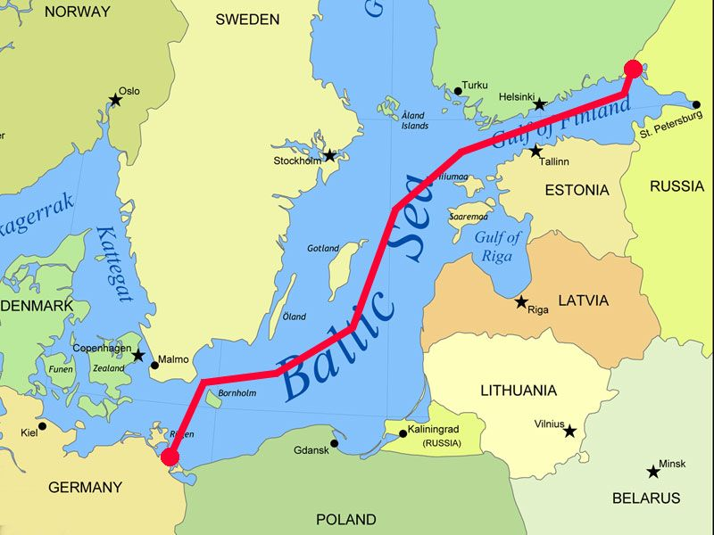

Reference:
Energy. (n.d.). Retrieved October 31, 2012, from http://ec.europa.eu/energy/index_en.htm
Energy policy of Russia. (n.d.). Retrieved October 31, 2012, from
http://en.wikipedia.org/wiki/Energy_policy_of_Russia
Lars-Christian U. Talseth. (2012). The EU-Russia Energy Dialogue.
Nord Stream AG. (n.d.). Retrieved October 31, 2012, from
http://ru.wikipedia.org/wiki/Nord_Stream_AG
EUROstat. (n.d.). Retrieved October 31, 2012, from
http://appsso.eurostat.ec.europa.eu/nui/submitViewTableAction.do
Russia in the European energy sector. (n.d.). Retrieved October 31, 2012, from
http://en.wikipedia.org/wiki/Russia_in_the_European_energy_sector

