Adeline BARON Finance

**Ageing population and the change of behaviour about financial savings**

[](http://www.google.fr/imgres?sa=X&biw=1366&bih=643&tbm=isch&tbnid=Uk9-7ZYa-R5CpM:&imgrefurl=http://www.maisons-teva.com/informations_prets,52,0.html&docid=fwPD_4_gh6a1uM&imgurl=http://www.maisons-teva.com/images/uploaded/PHOTOS/plan%20epargne%20logement.jpg&w=290&h=413&ei=5Qh1Urb2OYjo4QSmsIC4DA&zoom=1&iact=hc&vpx=2&vpy=33&dur=7892&hovh=268&hovw=188&tx=130&ty=72&page=2&tbnh=141&tbnw=89&start=21&ndsp=30&ved=1t:429,r:36,s:0,i:203)

Semester : Autumn 2013

**Table of contents**

Introduction

1. Terms explanation
2. Determinants of households savings
3. Savings theory
4. Interesting facts
5. Economics determinants
6. The ageing’s problem on the economy and the importance of savings in the Economy
7. Examples of savings in differents countries

**Introduction**

The Economy changes as the World is changing. In fact, some points from the Economy can be related to the changing of the World.

This essay will deal with the ageing of the population and the change of behaviour that occurs in their financial savings.

We can ask many questions about this fact :

* What does exactly mean « ageing of the population » ?
* Which are the determinants of households savings ?
* What reprent savings in the Economy ?
* How are savings in different countries ?

1. **Terms explanation**

First of all, this part will deal with the explanation of important terms which will be used, so as to understand the content of this essay.

In National Accounts Terms, **« saving »** is defined as the part of households available resources that is not spent on final consumption on goods and services. Saving is critically important in every economy, since it provides funds for financing investments in any spheres of the social and economic life, which is actually a key determinant of economic growth.

The behaviour of saving will principally focus on one agent : the household.

According to the INSEE (National Institute of statictics and economics studies) and the OECD (Organisation for economic co-operation and developement)[1], « **household saving** is estimated by subtracting household consumption expenditure from household disposable income ».

We can distinguish two aspects in the household saving. First, « the household consumption expenditure consists principally of cash outlays for consumer goods and services ». The second aspect concerns the household disposable income which « consists essentially of income from employment and from the operation of unincorporated enterprises, plus receipts of interest, dividends and social benefits minus payments of current taxes, interest and social contributions ».

We can obtain the **household saving rate** by doing the ratio of household saving to household disposable income.

According to Weil (David Weil, professor of economics), **population ageing** is defined as a shift in the distribution of a country’s population toward older ages. Aspects of population ageing include an increase in population’s mean and median age, decline in the youth, and rise in the elderly proportions of population.

**The dependency ration** consists of a measure showing the number of dependents (age 0-14 and over the age of 65) to the total population (aged 15-64). This ratio enables to have an insight into the amount of people of non-working age compared to the number of those of working age. A high ration means those of working age and the overall economy, face a greater burden in supporting the ageing population.[2]

As for now, we have seen the explanation of different terms, and now I will talk about reasons of saving of households.

1. **Determinants of households savings**

I will divide this part in three. First of all, I will talk about the savings theory, then I will show some interesting facts and the third part will be about the economics determinants.

1. **Savings theory**

Five mains theories had been identified :

* Life cycle hypothesis (Modigliani and Brumberg, 1954)

This theory enables to analyze savings behavior and retirement behavior of older people. This theory states that income and consumption need are often unequal at various points in the life cycle. In fact, younger people usually have more consumption than income because of the house and education. But at middle age, when people get work, they will have more income, which will be able to paid the debt they have accumulated and save some money. In the last cycle of life, which corresponds at the retirement, the older people use the saving they have accumulated.

This theory is also related to the theory of work-leisure choice. This theory deals with the fact that individuals want to maximize their utility derived from the consumption of goods and services, as well as from leisure. So when we put together these two theories, we can say that ageing means decrease of income or no income at all, and then the retirement decision is based on the point that the accumulation of savings has reached a level which will be sufficient to support consumption and leisure.[3]

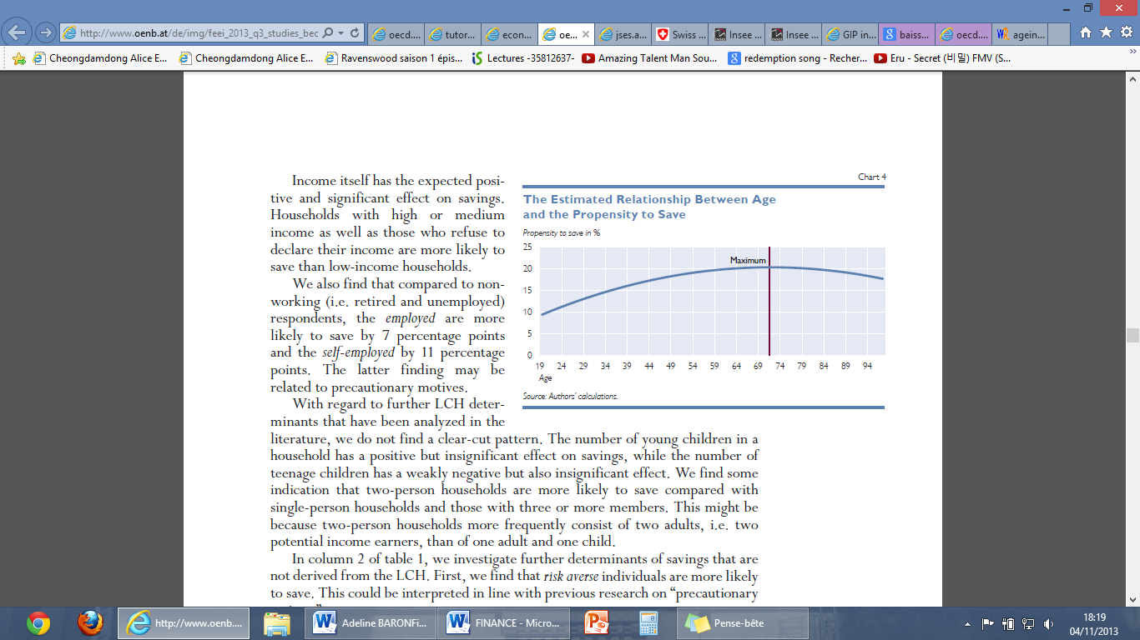

As we can see from this diagram (source :

OeNB), the life cycle hypothesis matchs

with it. Indeed, it’s clearly show that as we

getting older, we saving more and more,

but when we stop working because of

retirement, then the saving decreases

because we will use it.

* The permanent income hypothesis (Friedman, 1957)

This theory states that consumers will spend money at a certain level, which is compatible with their expected long term average income. This expected long term average income is also called « permanent » income that can be safely spent.[4]

* The relative income hypothesis (Dusenberry, 1949)

The relative income hypothesis is different from the two other. In fact, according to Dusenberry, individuals are less concerned with their absolute level of consumption than with their relative level : that the idea of « keeping up with the Joneses ».

This theory says that the level of consumption spending is determined by the households level of current income relative to the highest level of income earned previously. With this theory, people are reluctant to revert to the previous low level of consumption.[5]

* The « buffer stock » theory (Bewley, 1977)

This theory says that the major motive for holding and accumulating assets is to shield consumption against uncertainties, like unpredictable fluctuations, or disruption in income, or extraordinary health expenditures.[6]

* The « bequest » theory (Bernheim, Summers and Shleifer, 1985)

This theory says that it exists a multigenerational saving. In fact, it exists strong ties linking current generations to their descendants. Also, it means that individuals don’t only maximize their own utility, but also the future generational’s utility.[7]

1. **Intesresting facts**

I will tell some interesting facts, that I found in a survey of The OeNB’s Euro Survey.[8]

According to this survey, education influences the saving. In fact, respondents with university degrees or medium education are more likely to save.

Households with high or medium income as well as those who refuse to declare their income are more likely to save than low-income households.

They also find that compared to nonworking (retired and unemployed) respondents, the employed are more likely to save by 7 percentage points and the self-employed by 11 percentage points. The latter finding may be related to the « buffer stock » theory.

They find some indication that two-person households are more likely to save compared with

single-person households and those with three or more members.

1. **Economics determinants**

First of all, I will talk about some motivations for saving.

Households may want to save because :

* They want to buy a good (like a car, build an house,…)
* They want to save money for the next generations
* They save for precaution (like fear of unemployment, having an extraordinary expenditure,…)
* Stage of a person’s life cycle (for instance, a student won’t be able to save because he doesn’t have any income, on the contrary when he will get a job he will begin to save)

Now I will explain more precisely the economics determinants :

* Uncertainty against the economic crisis : in fact, the economic crisis in 2008 created a big shock for all the people who didn’t expect it. The most significant aspect is the unemployment rate. In the Euro zone, in January 2007, the unemployment rate was under 8%, but now in August 2013, the unemployment was 12%.[9]

According to Keynesian perspective, «the economic crisis and high unemployment will encourage households to build up precautionary savings that can be used in case of temporary financial troubles. »[10]

To conclude about this, we can say that the deterioration of the economic environment and the increase of uncertainty result in decline in consumption and increase in saving’s behavior.

* Growth of disposable income : when the income expands, rational people will save money instead of consumming everything.
* Consumption of public services : the public service will influence saving. In fact, the amount individuals pay for services such as education or health will have an impact on consumption and saving. For instance, if individuals need to pay admission fee for school, then they will put aside some money.[11]
* Income taxes : households saving will decrease if the taxes on income increase. Indeed, taxes on income are deducted in deriving household disposable income, and so the less disposable income households have, the less proportion of saving they will have.[12]
* Interest rate : interest rates determine the amount of interest payments that savers will receive on their deposits. We can also say that the Interest rate constitutes the reward for postponing consumption into the future. There is a subsitution effect which means that « if interest rates fall, the reward from saving falls. It becomes relatively more attractive to hold cash and / or spend. This is the substitution effect : with lower interest rates, consumers substitute saving for spending ».[13] But sometimes, the income effect dominates, and thus people save more in order to maintain their standard of living when there is lower interest rate.[14]

Now we will go to the third part which deals with the ageing’s problem and the importance of savings in economy.

1. **The ageing’s problem on the economy and the importance of savings in the Economy**

First of all, I will talk about the ageing’s problem on the economy.

Population ageing arises from two demographic phenomena :

* The increasing longevity : causes raise in the number of years when people are old relative to the years when they are young. It changes age distribution.
* The decreasing fertility : considered as a main explanation of growing ageing, because the reduction in the number of children changes the balance between youth and elderly, and thus causing society to age.

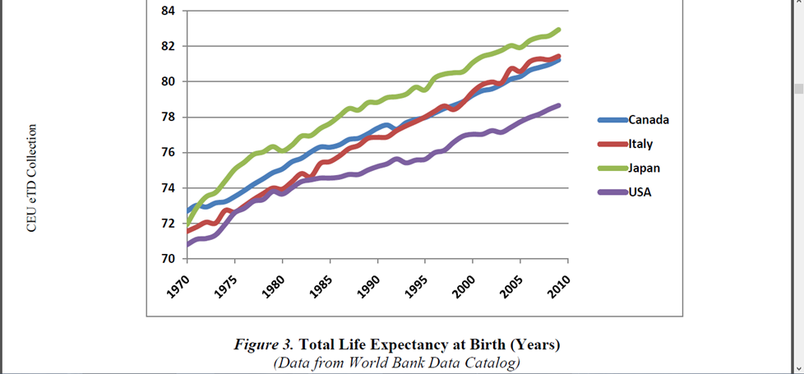

From this diagram, we can see that the life expectancy growing faster, and it will continue to grow because of new technology that enables us to live more.

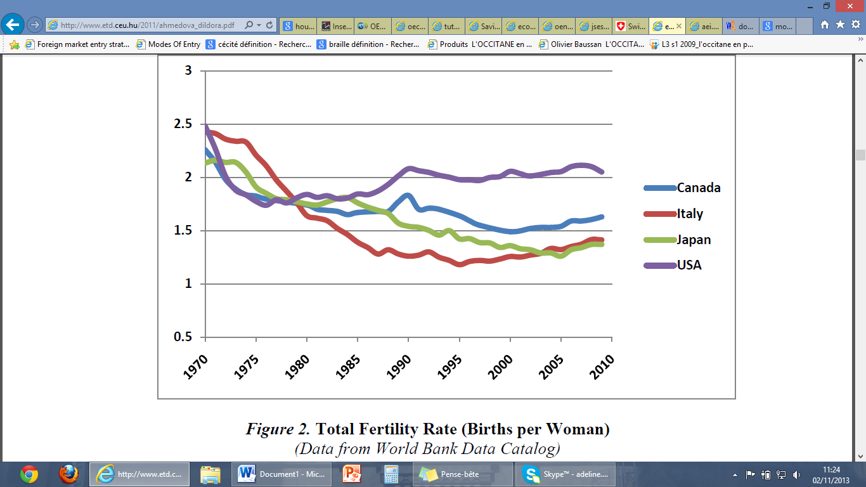

According this diagram, the fertility rate keep decreasing. Indeed, in 1970 women gave birth to at least two children, but in 2010 the women have rarely two children.

According to Horioka (American economist), population ageing is one of the most important factors in the decline of savings.

Population ageing causes social and economic effects :

* *Influences the labor market* : in fact, it’s changing his size and structure. Declining fertility causes a decrease in the growth of the working age population, implying that investments to supply new workers with capital will also drop.
* *Influences financing of public pensions, health care and social insurance* : because of the dislocation of age structure of the workforce. The deformation of the age structure of the population have a strong influence on the pension systems. Indeed, the most used system is the pay-as-you-go (system based on the solidarity between the generations. Every year, the total of the contributions paid by the active persons is distributed between the retired people. In return of this solidarity with the previous generations, the contributors acquire the same rights on the future generations, which will finance in their turn their pension when they will stop working.[15]) The efficiency of this system supposes the preservation of a demographic balance between the active persons and the retired people : if the ration between contributors and retired people decreases in a long-lasting and important way, then it’s necessary to see again the duration or the amount of the contributions.[16]

Another way to deal against this problem may be the development of a twopronged regime in which voluntary long-term savings plans compliment the basic pay-as-you-go pension system.[17]

The following paragraph will deal with the importance of savings in the economy.

First of all, we can say that households and government are linked together on that point. Indeed, if the saving of households is low, then it will badly influence the government for which it will be difficult to provide social services and limite government’s ability to spend money on physical infracstructures (roads, schools, hospitals, bridges,…). Thus the government could raise taxes to increase his revenue so as to covert the social and physical expenditures, but this tax’s augmentation will limit the spending and saving of money for households.[18]

According to the theory of marginal propensity to save, the increase of the income enables an increase in the savings. So following this theory, we understand that an economic growth is linked with the the increase of savings.[19]

Another benefit of savings in the economy is the investment. Indeed, saving is the major source for investment. The processus to transform saving into investment is the following : « when they buy newly-issued securities, those savers provide companies with the cash to purchase equipment, or buy factories and call centers via acquisitions. When they buy CDs or deposit money in savings accounts, the bank typically lends that money either to corporate customers that spend it to expand, or to the government by purchasing treasuries ». [20]

The last part of my essay will show the different savings rates in different countries.

1. **Examples of savings in differents countries**

The evolution of the net saving rate in the EU during 1995-2011 (source : OECD)



As we can see from this diagram, in 1995 the saving rate was great for the countries since there was low unemployment rate, an increase in GDP per capita, and less aged population. We can notice Austria, Belgium, France, Germany, Italy and Netherlands as countries with saving rates above 10%.

Then, between 1995 and 2000, all the countries faced a decrease in the saving rate. This could be explain by the outbreak of the internet, new mobile phone. As that time, the people prefered to use their income on consumption than on saving.[21]

Afterwards, the period between 2000 and 2007, all the countries faced a decline in the saving rate, with even some negative saving rate for some countries (as Portugal, Danemark, United Kingdom). This decline may be explain by an increase in household debts (« In the US, for example, household debt, as measured by the ratio of debt to personal disposable income, was more than 130% by 2007 »), increase in households borrowing, low interest rates.[22]

The economic crisis in 2008 made the saving rate decreased or stagnated.

The after crisis showed a short increased in the saving rate because the people fear the unemployment, feel incertain toward the economy so they try to save.

To conclude on this diagram, we can see that the saving rate is different in the countries, but they generally have the same trend over the period.

**Conclusion**

Through this essay, we understand now better the different terms used in the economy which are related to saving. Saving is a major source of investment and enables a growth in the economy.

However, the saving rates fluctuate over the different periods because of many factors, such as low unemployment (will decrease the saving rates), incertainty against the economy (will increase saving rates).

A major factor need to be count when we talk about saving is the demographic factor, more precisely the ageing population. Indeed, this problem causes abnormal structure in the ages which is refleted through an increase of older people and decrease in youth people.

**References**

In the order of appearance in this essay :

1. <http://www.oecd-ilibrary.org/sites/9789264067981-en/02/05/index.html?itemId=/content/chapter/9789264075108-10-en> , seen on 02/11/2013.
2. <http://www.insee.fr/en/methodes/default.asp?page=definitions/epargne-menages.htm> , seen on 02/11/2013.
3. <http://www.investopedia.com/terms/d/dependencyratio.asp> , seen on 02/11/2013.
4. <http://www.encyclopedia.com/doc/1G2-3402200229.html> , seen on 02/11/2013.
5. <http://www.investopedia.com/terms/p/permanent-income-hypothesis.asp> , seen on 02/11/2013.
6. <http://www.nber.org/chapters/c4408.pdf> , seen on 02/11/2013.
7. <http://www.econ2.jhu.edu/people/ccarroll/bufferstocktheory.pdf> , seen on 02/11/2013.
8. <http://www.nber.org/papers/w0619> , seen on 02/11/2013.
9. <http://www.oenb.at/de/img/feei_2013_q3_studies_beckmann_tcm14-257382.pdf> , seen on 02/11/2013.
10. <http://www.tradingeconomics.com/euro-area/unemployment-rate> , seen on 02/11/2013.
11. <http://economic-research.bnpparibas.com/Views/DisplayPublication.aspx?type=document&IdPdf=10588> , seen on 02/11/2013.
12. <http://www.oecd.org/std/na/32023442.pdf> , seen on 02/11/2013.
13. <http://www.oecd.org/std/na/32023442.pdf> , seen on 02/11/2013.
14. <http://www.economicshelp.org/blog/102/interest-rates/effect-of-interest-rates-on-savers-and-economy/> , seen on 02/11/2013.
15. <http://www.economicshelp.org/blog/102/interest-rates/effect-of-interest-rates-on-savers-and-economy/> , seen on 02/11/2013.
16. <http://www.info-retraite.fr/?id=repartition> , seen on 02/11/2013.
17. http://www.info-retraite.fr/index.php?id=glossaire#glossaire46 and <http://www.info-retraite.fr/?id=repartition> , seen on 02/11/2013.
18. <http://economic-research.bnpparibas.com/Views/DisplayPublication.aspx?type=document&IdPdf=10588> , seen on 02/11/2013.
19. <https://www.oldmutual.co.za/documents/SavingsMonitor/Economicpresentnotes.pdf> , seen on 02/11/2013.
20. <http://finance.mapsofworld.com/savings/account/economic-growth.htm> , seen on 02/11/2013.
21. <http://finance.fortune.cnn.com/2010/09/09/the-naked-stimulus-why-savings-stimulate-more-than-spending/> , seen on 02/11/2013.
22. <http://jses.ase.ro/downloads/current_issue/125.niculescu.pdf> , seen on 02/11/2013.
23. <http://www.gfmag.com/tools/global-database/economic-data/12065-household-saving-rates.html#axzz2jqfbr3vn> , seen on 02/11/2013.

1. Links : <http://www.oecd-ilibrary.org/sites/9789264067981-en/02/05/index.html?itemId=/content/chapter/9789264075108-10-en> and <http://www.insee.fr/en/methodes/default.asp?page=definitions/epargne-menages.htm> , seen on 02/11/2013.
2. Link : <http://www.investopedia.com/terms/d/dependencyratio.asp> , seen on 02/11/2013.
3. Link : <http://www.encyclopedia.com/doc/1G2-3402200229.html>, seen on 02/11/2013.
4. Link : <http://www.investopedia.com/terms/p/permanent-income-hypothesis.asp>, seen on 02/11/2013.
5. Link : <http://www.nber.org/chapters/c4408.pdf> , seen on 02/11/2013.
6. Link : <http://www.econ2.jhu.edu/people/ccarroll/bufferstocktheory.pdf> , seen on 02/11/2013.
7. Link : <http://www.nber.org/papers/w0619> , seen on 02/11/2013.
8. Link : <http://www.oenb.at/de/img/feei_2013_q3_studies_beckmann_tcm14-257382.pdf> , seen on 02/11/2013.
9. Link : <http://www.tradingeconomics.com/euro-area/unemployment-rate> , seen on 02/11/2013.
10. Link : <http://economic-research.bnpparibas.com/Views/DisplayPublication.aspx?type=document&IdPdf=10588> , seen on 02/11/2013.
11. Link : <http://www.oecd.org/std/na/32023442.pdf> , seen on 02/11/2013.
12. Link : <http://www.oecd.org/std/na/32023442.pdf> , seen on 02/11/2013.
13. Link : <http://www.economicshelp.org/blog/102/interest-rates/effect-of-interest-rates-on-savers-and-economy/> , seen on 02/11/2013.
14. Link : <http://www.economicshelp.org/blog/102/interest-rates/effect-of-interest-rates-on-savers-and-economy/> , seen on 02/11/2013.
15. Link : <http://www.info-retraite.fr/?id=repartition> , seen on 02/11/2013.
16. Link : <http://www.info-retraite.fr/index.php?id=glossaire#glossaire46> and <http://www.info-retraite.fr/?id=repartition>, seen on 02/11/2013.
17. Link : <http://economic-research.bnpparibas.com/Views/DisplayPublication.aspx?type=document&IdPdf=10588> , seen on 02/11/2013.
18. Link : <https://www.oldmutual.co.za/documents/SavingsMonitor/Economicpresentnotes.pdf> , seen on 02/11/2013.
19. Link : <http://finance.mapsofworld.com/savings/account/economic-growth.html> , seen on 02/11/2013.
20. Link : <http://finance.fortune.cnn.com/2010/09/09/the-naked-stimulus-why-savings-stimulate-more-than-spending/> , seen on 02/11/2013.
21. Link : <http://jses.ase.ro/downloads/current_issue/125.niculescu.pdf> , seen on 02/11/2013.
22. Link : <http://www.gfmag.com/tools/global-database/economic-data/12065-household-saving-rates.html#axzz2jqfbr3vn> , seen on 02/11/2013.