Masaryk University

faculty of economics and administration



financial reasons and consequences of adopting common currency in Euro Area

2013 Miroslav Krčmár

CONTENT

Introduction...........................................................................................................3

Common currency.................................................................................................4

Common strong currency......................................................................................4

Stabilization of prices............................................................................................5

Import and export..................................................................................................6

Weakness of common currency............................................................................7

Problematic country..............................................................................................8

Time development of Euro...................................................................................8

Time to enter.........................................................................................................9

Current situation in Euro Area..............................................................................10

Possible solutions..................................................................................................10

Forecast.................................................................................................................11

Conclusion............................................................................................................12

References ............................................................................................................13

ABSTRACT

in this research paper will be described problematic of common currency in Euro Area. We will focus on creating of common currency and her development in Euro Area. Problems which were created by wrong decision of some countries will be also mentioned. In the end will be small forecast about future of common currency.

introduction

In this research paper we will go through reasons which led to create common currency Euro (€) and also area “Euro Area” where is Euro used. In the following pages we will discuss about what were the main reasons why countries adopted Euro and entered Euro Area. Next we will talk about advantages and disadvantages (weaknesses) of having Euro in country. We will also analyse the time development of Euro from its beginning in 1998 until this hard time of debt crisis.

What the common currency brought to the countries and what were the main differences after adopting Euro will be mentioned in the first chapter, in second chapter will be analysed weaknesses and possible hide dangerous of common currency which could endanger whole Euro Area.

In third chapter we will go through time development of Euro and Euro Area from the first reference of Monetary Union in 1970 till present and what are the Maastricht criteria and why do we need them. Current situation in Euro Area and with that connected debt crisis in Greece plus small forecast will be mentioned in the last fourth chapter.

Euro and Euro Area play very important role in our lives since when in 1998 were created. From that time Euro has had to face lot of very difficult problems which were or not solved. But the main idea of creating common currency and Euro Area is to help all member states (and citizens) to have better conditions for not only trading but for basic economic being.

1. Common currency

Nowadays we have common currency in Euro zone, but it was not always like it is now. Some years before Euro was created every country had its own national currency. For example Germans had Deutsch Mark or French had French Frank. According to long and very though political and legislative process some countries came to an idea to create common currency Euro. This idea had to bring lot of advantages which should help these countries to reach better, faster and more flexible economies. Some of these advantages were for example more stable prices or better conditions in export and import in Euro zone. But on the other hand, common currency does not have only advantages but also as everything has some disadvantages. For example when one country has some financial problems these problems may influence the economies of other countries and bring Euro zone in situation in which will have to find some resolute solution.

* 1. Common strong currency

Every country which nowadays has Euro had to change their original currency for Euro. We can measure strength of currency with help of exchange rates of original currencies against Euro. We can consider strength of currency for example as a fluctuation of exchange rate against other currencies (ECB 2009). According to Financial Forecast Center (2012), Deutsch Mark was in 1989 -1999 against United States Dollar stable (Picture 1) and after adopting Euro in Germany, Euro was getting even more stronger against U.S. Dollar (Picture 2). It means that Euro is stronger currency as was Deutsche Mark because Euro is used in more stable economies and there are lower risks to endanger such currency as Euro.

Picture 1

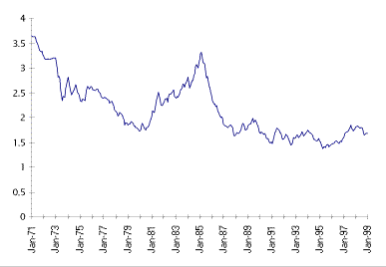

**Source**: <http://forecasts.org/data/markextrnd.htm>

Picture 2

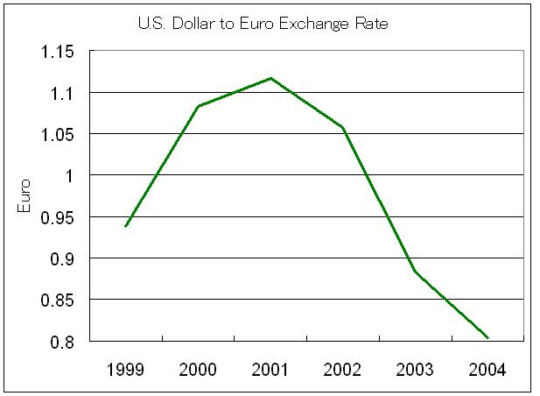

**Source** : <http://www.teachmefinance.com/Charts/US_Dollar_Euro_Exchange_Rate.html>

* 1. Stabilization of prices

Stabilization of prices is close-knit with prices of imported goods and services. Many countries had problems with holding prices of goods and services at stable level because of changes in exchange rates of their own currencies against currencies where goods and services were made. The average price level is according to Eurostat (2011) in last 10 years in Euro Area stable (Picture 3).

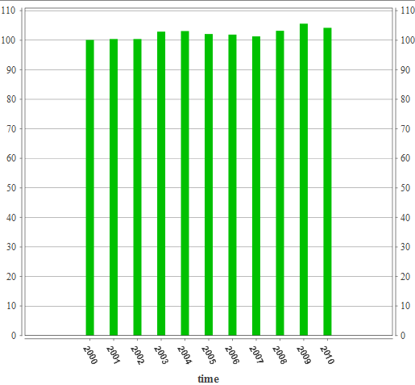 Picture 3 **Source**:<http://epp.eurostat.ec.europa.eu/tgm/graph.do?tab=graph&plugin=1&pcode=tsier010&language=en&toolbox=data>

* 1. Import and Export

Import and export are two of main tools of every economy. Each country needs to provide import and export with the best conditions. In these conditions belongs for example price or other costs connected with trading. For each country is much easier to compare prices of goods and services in same currency instead of calculating the exchange rates which could be changed every day. In small values are deviations made by different exchange rate negligibly but in values in which are trading countries each smaller different can make millions Euros different. According to research of Eurostat (2004-2010) trading in Euro Area was growing yearly by 100 mil. € approximately, except year 2009 when the crisis started (Picture 4)

Picture 4

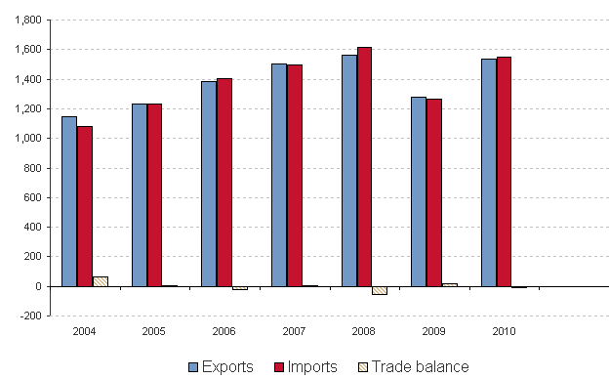

**Source**: <http://epp.eurostat.ec.europa.eu/statistics_explained/index.php/Extra-euro_area_trade_in_goods>

1. Weaknesses of common currency

Every connection or partnership brings lot of hidden dangerous which can influence not only single members but also safety of whole group. It is the same in the case of creating Euro Area. Each country has the responsibility not only for itself but also for whole Euro Area. Internal problems of each country which could possibly influence the running of Euro Area should be immediately solve by local government. The case of not solving these problems may lead to financial collapse of whole economy of Euro Area. According to Marsh and Butler (2012) “*The core problem, as Marsh makes clear, is that a single currency is impossible without a single government* “in practice it means that there are lot of countries which use Euro and do not have always same political and financial interests what may lead to not optimal integration and harmonization between economies of all countries.

Another problem which is connected with common currency is that, that part of power of national banks of countries is moved to European Central Bank. In other words it is loss of sovereignty of national banks. (ECB 2009) For example European Central Bank controls the key interest rates like the minimal acceptable value of interest rate or national banks had to transfer part of foreign exchange reserves to European Central Bank with which may ECB manipulates.

* 1. Problematic country

How we already mentioned before one country may influence running of Euro Area. Greek is that country these days. Everything but already started even before Greek entered the Euro Area and adopted Euro .To enter the Euro Area countries had to fulfil important financial and political criteria. These criteria are mentioned in Maastricht treaty. These criteria include for example high level of price stability or good conditions of public finance, stable exchange rate and low and stable interest rates (ECB, 2009). But Greek made lot of scams about important statistical and empirical indicators which should helped them to enter Euro Area. These scams were connected with change values of unemployment rate or disinformation about public finance which brought Greek in “green numbers”. On the first view Greek looked very stable a prepared country to enter Euro Area but after few years Greek started to have financial problems because Greek could not keep the financial criteria anymore. Greek started to have problems in public finance what lead to lose control over country. Greek economy could not be without external help anymore what forced other counties of Euro Area to react. We will talk about it more detailed later in part 3.

1. Time development of Euro

According to European Central Bank (2009) the first mention about monetary union (MU) was from year 1970 which suggested created MU in three stages till year 1980. But according to international recession in consequences of first oil crisis in middle seventies the contract about creating Monetary Union were never sign.

In second part of eighties the idea of Monetary Union was revived in Unified European Act (1986) in which came to create a common market. Advantages about using common market were strongly connected with created of common currency in all member states of Monetary Union. In 1988 were Delors commissioned to make a survey about possibility of creating Monetary Union. Delors report from 1989 lead to negotiation about Treaty European Union, which established European Union and changed and amend Treaty about establishment of European Community. The treaty about European Union was signed on February 2nd 1992 in Maastricht (executive form on November 1st 1993).

In research of European Central Bank (2009) is mentioned that creating Economic and Monetary Union was clustered of three stages. In first stage (1990 – 1993) was created unified European market, by adjusting all internal barriers in free movement of goods and services in European Union.

The second stage (1994 – 1998) started with created of European Monetary Institute, it was the time of preparing all member states to adopt common currency by avoiding of state deficits and stabilization of price level or cleanliness of public finance.

The third stage started on January 1st 1999 by setting irrevocable exchange rates of all participating currencies, transferring monetary policy on European Central bank and adopting Euro as single currency. On January 1st 2002 Euro notes and Euro coins became legal tender in all member states.

* 1. Time to Enter

Unnecessary condition for adopting Euro is that each country has to reach high rate of “sustainable convergence” (ECB 2009). Rate of convergence is rated on base of criteria set in Maastricht Treaty in which is set that each country has to:

* Have a high level of price stability
* Good conditions of public finance
* Stable exchange rate
* Low and stable long term interest rates

Aim of these criteria is to secure that in the third stage may come only these countries which support economic policy aimed to stability and reach good results in keeping price stability. Treaty also requires independence of National Bank (article108 of Treaty)

Summit of European Union on May 1998 in Brussels decided that criteria about adopting single currency fulfilled 11 of 15 member states:

* Belgium
* Germany
* Spain
* France
* Ireland
* Italy
* Luxemburg
* Holland
* Austria
* Portugal
* Finland
* In 2001 Greece
* In 2007 Slovenia
* In 2008 Malta and Cyprus
* In 2009 Slovakia

Map of Euro Area

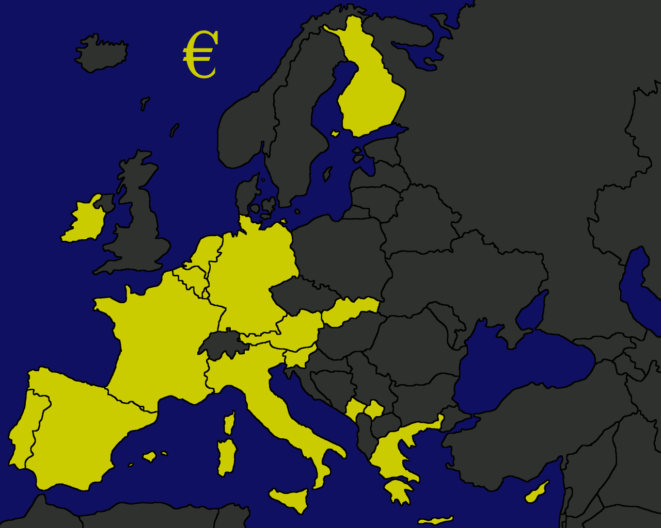

**Source** :http://www.google.sk/imgres?hl=sk&biw=1280&bih=803&gbv=2&tbm=isch&tbnid=sEySBW3-vHryzM:&imgrefurl=http://www.youreuropemap.com/europe_map_3.html&docid=aVcMgu8nJRKu4M&imgurl=http://www.youreuropemap.com/euro_area_map.gif&w=1280&h=1024&ei=QVGET_enJc7jtQbLj6XxBg&zoom=1&iact=rc&dur=123&sig=114613943548531629011&page=1&tbnh=135&tbnw=169&start=0&ndsp=24&ved=1t:429,r:0,s:0,i:65&tx=69&ty=70

1. Current situation in Euro Area

According to About.com (October 2011) the head bank of England stated that “*the most serious financial crisis at least since the 1930s, if not ever* „ on current situation in Euro Area. This situation is connected with so called “pigs” what means first letters of problematic countries **P**ortugal, **I**taly, **I**reland, **G**reece, and **S**pain. The European debt crisis is term for the regions struggle to pay debts which has built up in recent decades. These countries were unsuccessful to generate enough economic growth to have ability to pay back bondholders, what should be guaranteed. These “pigs” are under pressure of immediate danger of a possible default and possible consequences of crisis may have affect even across their borders.

The most insecure country is Greece. Because the Greece entered Euro Area already with bad figures the financial crisis which started in United States in 2008 only increased the deficit of Greece finance (about.com 2011). Current situation in Greece was reason to start lot of discussions about how and if to save the Greece. It is very hard situation for all member states of Euro Area because the risk from not supporting Greece is so high because effect of Greece bankruptcy may and surely will affect all states and their economies and one of possible results may be bankruptcy of other endangered countries like Italy, Spain or Portugal.

* 1. Possible solutions

In this situation Euro Area is endangered as a whole. All financial experts of Euro Area are looking after solutions which could possibly solve the Greece crisis and help Euro Area. In last days experts came up with few possibilities. One of the possibilities says that Greece should leave the Euro Area but all experts want to evade this possibility as long as possible. Another possibility says about reforms in Greece financial systems and cutting deficit as much as possible together with release of part of Greece loans against European Central Bank. None of these solutions are short-term what only increase the pressure on existence of common currency and Monetary Union.

In Los Angeles Times (2011) was stated that “*Things are forging ahead. We have yet to reach a final conclusion," Sarkozy told reporters at a news conference with Merkel. "We have to take all of the decisions at one and the same time* „ and “*The devil is in the details here," Merkel added.* „ so this part of article represents the chance of finding a solution in these hard times of debt crisis in Euro Area but as Angela Merkel rightly highlighted the hardest problem will be with details. Because in such a problem as financial debt crisis is, is very important to think on every little detail which may influences the whole procedure of renewal financial situation in Euro Area. That is why France as a one of the biggest economies in Europe decided that Germany as the biggest and the most powerful economy will have the opportunity of “calling the most important shots.”

* 1. Forecast

No one can imagine, how and when will the crisis be solved but without help of all members states it will not work. All member states have to participate on supporting plan for Greece even when not everyone agrees with that but possible consequences of bankruptcy will affect each economy. That is the main reason why should everyone participate on looking after solution. Possible consequences may affect bank system in Euro Area or strength of Euro in capital markets or possible increase prices of imported goods and services. Some economists think that situation in Euro Area may remind “domino” what means that when one country will collapse there will be more countries in problems. Hopefully financial experts who are interested in this problem will find the best solution for everyone (ECB 2011).

We already said that we live in these modern times where everything is connected with everything. Also economies in Euro Area are connected between each other, so when one country has problems all countries may and will feel it. But also economy of Euro Area is connected with others world’s economies as United States economy or Asian economy or other big economies. So Euro Area economy also influences Worlds economy. According to forecast of International Monetary Fund (2012) the Worlds global growth will decreases from 4% to 3.3% in 2012. So as one of the results of debt crisis we may consider decrease of World growth by 0.7%. That means that also other countries not only Euro Area countries should be interested in looking after solutions of debt crisis, because this crisis influences all of us.

Conclusion

We may say that everything started in 1998 when the euro was created (ECB 2009). For this 14 years Euro went through several smaller or bigger crisis. The main idea which stands for creating Euro and Euro Area is to make economic life even easier and more flexible for all member states. These states had to fulfil important criteria before entered the Euro Area. These criteria consist of some financial indicators which show country’s “health”. These criteria include for example stable value of exchange rate or unemployment rate around 9%. After enter the Euro Area these countries started to draw advantages of being in EA. Between these advantages belong for example drawing of euro founds or any similar projects sponsored by ECB (ECB 2009).

Being in Euro Area that means not only advantages connected with membership but also tolerate the possible disadvantages. These disadvantages showed up after few years of running. Greece, which entered Euro Area thanks to scams started to have problems. That is the time when each country found out that they have to also something to give not only get. Because of bad monetary policy of Greece, country got into financial crisis. This financial crisis will not be solved without help of other member states. Special committee made several possibilities as a solution of this crisis. One of these possibilities is that, that Greece will leave the Euro Area but this is considered as one of the latest possibility, another possibility describes the reforms of financial and political system in Greece together with clemency part of loans against European Central Bank.

Situation in Euro Area is very hard these days but most of “us” normal people believe that one day it will turn back into good way and Euro will be again one of the strongest currencies in the whole World and bring citizens of Euro Area more advantages as disadvantages.

Change of behaviour is one of the consequences of debt crisis. Many people do not even know what it is. As people hear about crisis from all kinds of Medias they started to save money respectively they started to spend less and what happen when people start to spend less? It is not needed to produce that much. So people are losing their jobs, there is higher unemployment and state economy could not rise. It may sound really strange but in these times of debt crisis people should spend at least that much as before because if not we may get in “magic circle”.

GLOSARY

EURO – common currency which was created in 1999 used in Euro Area

EURO AREA – area in which is Euro used (17 countries nowadays)

ECB – European Central Bank, is central bank for Europeans single currency Euro

IMF – International Monetary Fund, internationally finance organisation created in 1945(187 countries nowadays)

references page

BUTLER, Nick a David MARSH. A single currency needs a single government. *Www.tribunemagazine.co.uk* [online]. 2012, 1 [cit. 2012-02-13]. Available at : <http://www.tribunemagazine.co.uk/2011/10/a-single-currency-needs-a-single-government/>

*Európska Centrálna banka*: *Eurosystém Európsky systém Centrálnych bánk* [online]. Frankfurt nad Mohanom, 2009 [cit. 2012-02-13]. ISBN 978-92-899-0403-2. Availabe at : <http://www.ecb.int/pub/pdf/other/escb_sk_websk.pdf>

KENNY, Thomas. What is the European Debt Crisis?. *About.com* [online]. 2012[cit. 2012-02-13]. Availabe at: <http://bonds.about.com/od/advancedbonds/a/What-Is-The-European-Debt-Crisis.htm>

DARVAS, Zsolt; SZAPÁRY, György. Euro Area enlargement and euro adoption strategies. In EUROPEAN ECONOMY [online]. Brussel : Directorate-General for Economic and Financial Affairs, 2008 [cit. 2011-11-23]. Available at WWW: <http://ec.europa.eu/economy_finance/publications/publication12093_en.pdf>.

Eurozone. In Wikipedia : the free encyclopedia [online]. St. Petersburg (Florida) : Wikipedia Foundation, 17 February 2003‎ , last modified on 20 November 2011 [cit. 2011-11-23]. Available at: http://en.wikipedia.org/wiki/Eurozone

About.com: About.com.Bonds. THOMAS KENNY. [online]. 2012 [cit. 2012-01-10]. Available at : <http://bonds.about.com/od/advancedbonds/a/What-Is-The-European-Debt-Crisis.htm>

Bankofengalnd. BANK OF ENGLAND. [online]. 2012 [cit. 2012-01-10]. Available at : <http://www.bankofengland.co.uk/Pages/Search.aspx?k=2011>

KOLLEWE, Julia. Greece bailout package signed off by EU leaders: Eurozone ministers gathering in Brussels turn their attention to Spain after Madrid admits it will miss its budget deficit target. *The Guardian* [online]. 2012, s. 1 [cit. 2012-04-11]. Availabe at: <http://www.guardian.co.uk/business/2012/mar/13/greece-bailout-package-signed-off>

The Guardian: The World News. PHILLIP INMAN. *News* [online]. 2012 [cit. 2012-02-28]. Available at: <http://www.guardian.co.uk/world/2012/feb/24/greece-debt-swap-private-creditors>

CHU, Henry. No quick solution to Europe's debt crisis: France and Germany say that they have made progress in their intensive negotiations, but that the complexity of the task means it will take until midweek to finish their plans. *Los Angeles Times* [online]. 2011, s. 1 [cit. 2012-04-11]. Available at: <http://articles.latimes.com/2011/oct/23/world/la-fg-european-economic-summit-20111024>

IMF warns Euro zone crisis is dragging down the world economy: The Euro zone debt crisis is escalating and dragging down the world economy, the International Monetary Fund said on Tuesday, as it sharply cut its outlook for global growth and called for policies to restore confidence. *Merco Press* [online]. 2012, s. 1 [cit. 2012-04-11]. Available at: <http://en.mercopress.com/2012/01/25/imf-warns-euro-zone-crisis-is-dragging-down-the-world-economy>

IMF Marks Down Global Growth Forecast, Sees Risk on Rise: IMF Survey online. *IMF Survey Magazine* [online]. 2012, s. 1 [cit. 2012-04-11]. Availabe at: http://www.imf.org/external/pubs/ft/survey/so/2012/NEW012412A.htm

**pictures:**

picture 1

FINANCIAL FORECAST CENTER. *German Mark to U.S. Dollar Exchange Rate. 1971 to Present*. 2011. Available at : <http://forecasts.org/data/markextrnd.htm>

Picture 2

TEACHMEFINANCE.COM. *US Dollar Euro Exchange Rate Chart*. 2006. Available at: http://www.teachmefinance.com/Charts/US_Dollar_Euro_Exchange_Rate.html

Picture 3

EUROSTAT. *Comparative price levels*. 2010. Available at: http://epp.eurostat.ec.europa.eu/tgm/graph.do?tab=graph&plugin=1&pcode=tsier010&language=en&toolbox=data

Picture 4

EUROSTAT. *Euro Area trade, 2004-2010*. 2010. Available at : http://epp.eurostat.ec.europa.eu/statistics_explained/index.php/Extra-euro_area_trade_in_goods

Picture 5

EUROSTAT. *Map of Euro Area*. 2010 Available at : http://www.youreuropemap.com/europe_map_3.html