**Finance (basics)**

**Student: Elene Javakhia**

**Učo: 424244**

**Lecturer: Luděk Benada**

**IFRS**

**(International Financial Reporting Standards)**



**Table of contents**

1. Definition ………………………………………………………… 3
2. History …………………………………………………………… 3
3. About IFRS ………………………………………………………. 4
   1. IFRS assumptions …………………………………………… 4
   2. Financial statement ………………………………………… 4-7
4. IFRS standards …………………………………………………… 8
5. IFRS v.s GAAP …………………………………………………. 9-10
   1. GAAP ………………………………………………………… 9
   2. Differences …………………………………………………… 9-10
6. Adoption of IFRS ………………………………………………… 11

6.1 Different countries ……………………………………………12

**1. Definition**

International Financial Reporting Standards are designed as a common global language for business affairs so that company accounts are understandable and comparable across international boundaries.

They are a consequence of growing international trade and It should benefit users of financial statements, by improving the quality of financial reporting.

IFRS is particularly beneficial to large companies that have subsidiaries in different countries as investors are more willing to provide financing. These standards are replacing many different national accounting standards which should be followed by accountants to maintain books of accounts that is comparable, understandable, reliable and relevant both for the internal and external users.

**2. History**

IFRS began as an attempt to harmonize accounting across the European Union but the value of harmonization quickly made the concept attractive around the world. They are sometimes still called by the original name of **International Accounting Standards (IAS).** IAS were issued between 1973 and 2001 by the **Board of the International Accounting Standards Committee (IASC).**  On 1 April 2001, the new International Accounting Standards Board took over from the IASC the responsibility for setting International Accounting Standards, but it continued to develop standards calling them**: International Financial Reporting Standards (IFRS).**



**IFRS**

There are four underlying assumptions in IFRS: **accrual basis, going concern, stable measuring unit assumption and units of cost purchasing power.**

1. **1.Accrual basis:**The assumption that the financial effect of transactions and events are recognized as they occur, not when cash is received or paid.  
   **2. Going concern:**The assumption that a business entity will be in operation for the foreseeable future.  
   **3. Stable measuring unit assumption:** The assumption that financial capital in nominal monetary units should be maintained, assets and [liabilities](http://www.e-conomic.co.uk/accountingsystem/glossary/liabilities) are recorded at their originally acquired values; not generally restated for changes in values.  
   **4. Units of constant purchasing power:**The rejection of the stable measuring unit assumption in certain situations: Only constant real value non-monetary items are inflation-adjusted during low inflation and deflation. However, all non-monetary items are inflation-adjusted during hyperinflation as required under Constant Purchasing Power Accounting.

As we already know International companies should follow International Financial Reporting Standards in order to prepare financial statements (**financial statement** is a formal record of the financial activities of a business, person, or other entity).

A financial statement should reflect a true and fair view of the business affairs of the organization. As statements are used by various constituents of the society / regulators, they need to reflect a true view of the financial position of the organization, and they are very helpful to check the financial position of the business for a specific period.

The financial position of an enterprise is primarily provided in **the Statement of Financial Position**. The elements include:

**Asset**: An asset is a resource controlled by the enterprise as a result of past events from which future economic benefits are expected to flow to the enterprise.

**Liability**: A liability is a present obligation of the enterprise arising from the past events, the settlement of which is expected to result in an outflow from the enterprise' resources, i.e., assets.

**Equity**: Equity is the residual interest in the assets of the enterprise after deducting all the liabilities under the Historical Cost Accounting model. Equity is also known as owner's equity. Under the units of constant purchasing power model equity is the constant real value of shareholders´ equity.

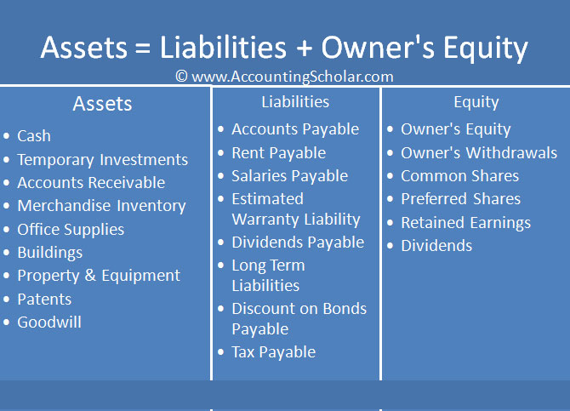

The financial performance of an enterprise is primarily provided in the **Statement of Comprehensive Income**(**income statement** or profit and loss account). The elements of an income statement or the elements that measure the financial performance are as follows:

**Revenues:** increase in economic benefit during an accounting period in the form of inflows or enhancements of assets, or decrease of liabilities that result in increase in equity.

**Expenses:** decrease in economic benefits during an accounting period in the form of outflows, or depletions of assets or incurrences of liabilities that result in decrease in equity.

Revenues and expenses are measured in nominal monetary units under the Historical Cost Accounting model and in units of constant purchasing power (inflation-adjusted) under the Units of Constant Purchasing Power model.

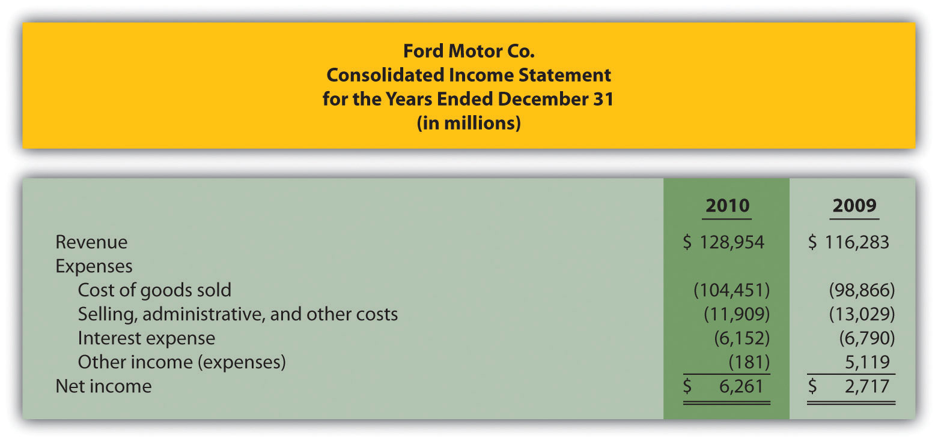

* **Statement of Changes in Equity (SOCE)**

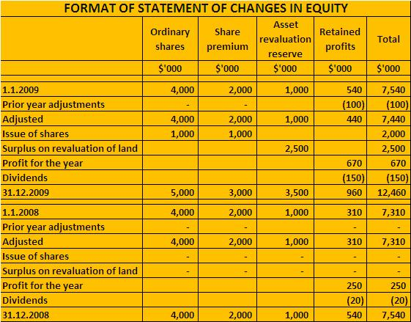

* **Statement of Cash Flows**

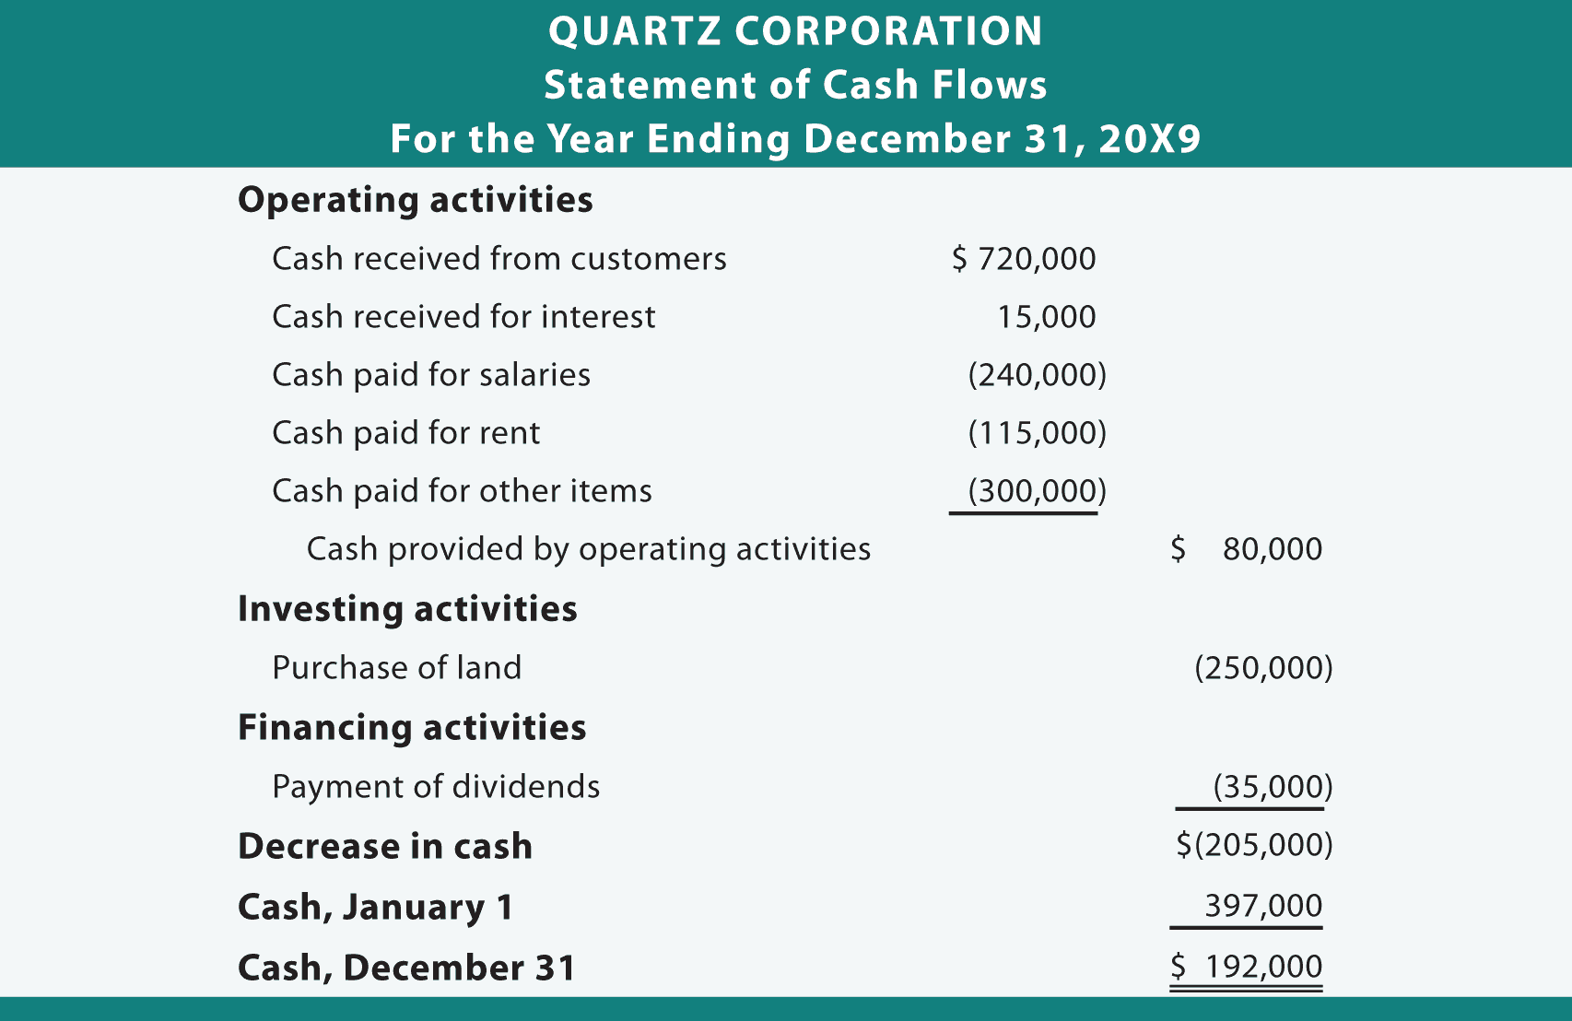

* **Notes to the Financial Statements**

**Qualitative characteristics of financial statement**

**Qualitative characteristics of financial statements include:**

* Relevance (Materiality)
* Faithful representation

**Enhancing qualitative characteristics include:**

* Comparability
* Verifiability
* Timeliness
* Understandability

**International Financial Reporting Standards**

**IFRS 1**: First-time Adoption of International Financial Reporting Standards

**IFRS 2:** Share-based Payment

**IFRS 3:** Business Combinations

**IFRS 4:** Insurance Contracts

**IFRS 5:** Non-current Assets Held for Sale and Discontinued Operations

**IFRS 6:** Exploration for and Evaluation of Mineral Assets

**IFRS 7:** Financial Instruments: Disclosures

**IFRS 8:** Operating Segments

**IFRS 9:** Financial Instruments

**IFRS VS GAAP**

**GAAP** (US Generally Accepted Accounting Principles) is the accounting standard used in the US, while **IFRS** (International Financial Reporting Standards) is the accounting standard used in over 110 countries around the world. GAAP is considered a more “rules based” system of accounting, while IFRS is more “principles based.” The U.S. Securities and Exchange Commission is looking to switch to IFRS by 2015.

What follows is an overview of the differences between the accounting frameworks used by GAAP and IFRS. This is at a broad, framework level; differences in accounting treatments for individual cases may also be added as this gets updated.

The International Financial Reporting Standards (IFRS) - the accounting standard used in more than 110 countries - has some key differences from the U.S. Generally Accepted Accounting Principles (GAAP). At the conceptually level, IFRS is considered more of a "principles based" accounting standard in contrast to U.S. GAAP which is considered more "rules based." By being more "principles based", IFRS, arguably, represents and captures the economics of a transaction better than U.S. GAAP. Some of differences between the two accounting frameworks are highlighted below:

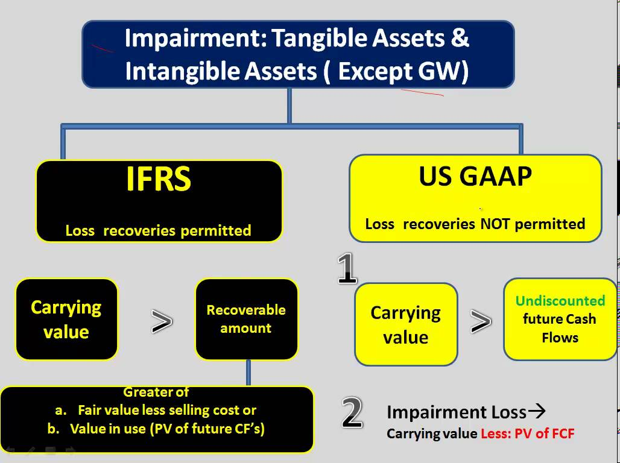

**Intangibles**  
The treatment of acquired intangible assets helps illustrate why IFRS is considered more "principles based." Acquired intangible assets under U.S. GAAP are recognized at fair value, while under IFRS, it is only recognized if the asset will have a future economic benefit and has measured reliability. Intangible assets are things like R&D and advertising costs.  
  
**Inventory Costs**  
Under IFRS, the last-in, first-out (LIFO) method for accounting for inventory costs is not allowed. Under U.S. GAAP, either LIFO or first-in, first-out (FIFO) inventory estimates can be used. The move to a single method of inventory costing could lead to enhanced comparability between countries, and remove the need for analysts to adjust LIFO inventories in their comparison analysis.   
  
**Write Downs**  
Under IFRS, if inventory is written down, the write down can be reversed in future periods if specific criteria are met. Under U.S. GAAP, once inventory has been written down, any reversal is prohibited. (To learn more, check out International Reporting Standards Gain Global Recognition)

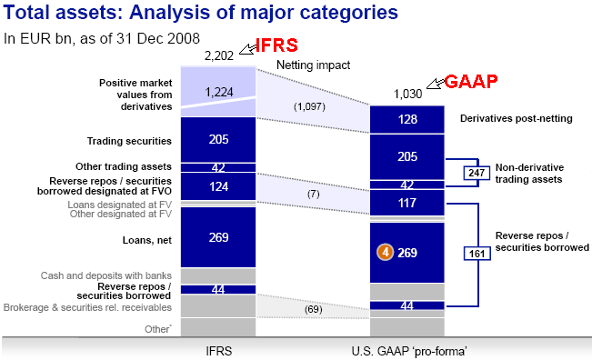

**Adoption of IFRS**

IFRS is used in many parts of the world, including the European Union, India, Hong Kong, Australia, Malaysia, Pakistan, GCC countries, Russia, Chile, South Africa, Singapore and Turkey. As of August 2008, more than 113 countries around the world, including all of Europe, currently require or permit IFRS reporting and 85 require IFRS reporting for all domestic, listed companies, according to the U.S. Securities and Exchange Commission.

It is generally expected that IFRS adoption worldwide will be beneficial to investors and other users of financial statements, by reducing the costs of comparing alternative investments and increasing the quality of information. Companies are also expected to benefit, as investors will be more willing to provide financing. Companies that have high levels of international activities are among the group that would benefit from a switch to IFRS. Companies that are involved in foreign activities and investing benefit from the switch due to the increased comparability of a set accounting standard.

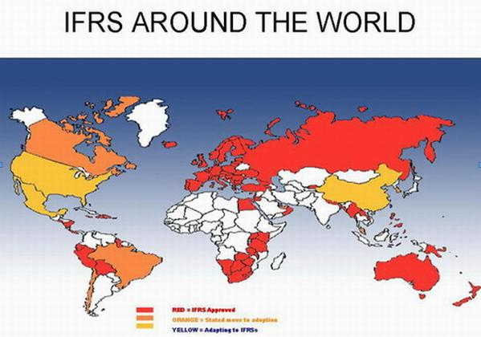

**Australia**

The Australian Accounting Standards Board (AASB) has issued 'Australian equivalents to IFRS' (A-IFRS), numbering IFRS standards as AASB 1–8 and IAS standards as AASB 101–141

**Canada**

The use of IFRS became a requirement for Canadian publicly accountable profit-oriented enterprises for financial periods beginning on or after 1 January 2011. This includes public companies and other "profit-oriented enterprises that are responsible to large or diverse groups of shareholders."

**European Union**

All listed EU companies have been required to use IFRS since 2005.

In order to be approved for use in the EU, standards must be endorsed by the Accounting Regulatory Committee (ARC), which includes representatives of member state governments and is advised by a group of accounting experts known as the European Financial Reporting Advisory Group. As a result IFRS as applied in the EU may differ from that used elsewhere.

**India**

The (ICAI) has announced that IFRS will be mandatory in India for financial statements for the periods beginning on or after 1 April 2012, but this plan has been failed and IFRS/IND-AS (Converged IFRS) are still not applicable. There was a roadmap as given below but still Indian companies are following old Indian GAAP. There is no clear new date of adoption of IFRS.

**Japan**

The minister for Financial Services in Japan announced in late June 2011 that mandatory application of the IFRS should not take place from fiscal year-ending March 2015; five to seven years should be required for preparation if mandatory application is decided; and to permit the use of U.S. GAAP beyond the fiscal year ending 31 March 2016.

**Pakistan**

All listed companies must follow all issued IAS/IFRS except the following:  
IAS 39 and IAS 42: Implementation of these standards has been held in abeyance by State Bank of Pakistan for Banks and DFIs  
IFRS-1: Effective for the annual periods beginning on or after 1 January 2004. This IFRS is being considered for adoption for all companies other than banks and DFIs.  
IFRS-9: Under consideration of the relevant Committee of the Institutes (ICAP & ICMAP). This IFRS will be effective for the annual periods beginning on or after 1 January 201

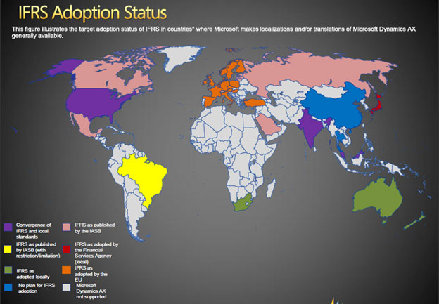

The main user companies of IFRS are audit firms, such as **BIG 4:**

* **Deloitte&Touche**
* **Ernst&Young**
* **KPMG**
* **PwC** (PricewaterhouseCoopers)

They are the auditors of 10,000 public companies worldwide.

**Sources of information:**

<http://www.ifrs.org/Use-around-the-world/Education/Pages/Education.aspx>

<http://www.ifrs.com/ifrs_faqs.html#q1>

<http://en.wikipedia.org/wiki/International_Financial_Reporting_Standards>

<http://www.accaglobal.com/en/qualifications/glance/Diploma-and-Certificate-in-IFRS.html>

<http://www.kpmg.com/Global/en/IssuesAndInsights/ArticlesPublications/IFRS-GAAP-comparisons/Pages/default.aspx>

<http://www.ey.com/GL/en/Industries/Financial-Services/Insurance/IFRS-insurance-insights>

<http://www.pwc.com/gx/en/ifrs-reporting/index.jhtml>

<http://www.iasplus.com/en/standards>

<http://www.icaew.com/en/library/subject-gateways/accounting-standards/ifrs>

<http://www.investopedia.com/ask/answers/09/ifrs-gaap.asp>

<http://www.e-conomic.co.uk/accountingsystem/glossary/ifrs>

**THANK YOU FOR YOUR ATTENTION!**