Bubbles

Vaibhav Verma a.k.a Vabs

MPF_AFIN- Finance (Basics)

UCO-440122

Faculty of Economics and Administration, Masaryk University

1. Introduction

A bubble is a run-up in the price of an asset that is not justified by the fundamental supply and demand factors for the asset. A bubble is an economic cycle characterized by rapid expansion followed by a contraction. Bubbles can occur in any traded commodity or financial instrument. In this essay I have compared the past financial bubbles and drawn similarities between them. The crises which led to the housing bubble have also been discussed in detail.

1. Similarities between South Sea Bubble (1720) and the Dotcom bubble (2000)

English speculators were purchasing stock in the South Sea Company. Formed in 1711 by Robert Harley, the South Sea Company was created to convert £10 million of government war debt (incurred during the War of Spanish Succession) into its own shares. In exchange, the company would receive annual interest payments from the government and a monopoly on trade with the South Seas and Spanish colonies of South America. The exchange was successful and although the expected trade riches never materialized, the company continued with several other debt conversions.

In 1720, the company proposed to take over the entire British national debt. As soon as the plan was announced to Parliament, the company's share prices began to rise as speculators gambled on the conversion plan due to the promise of untold riches in the new world of Americas. The House of Lords approved the plan on April 7, 1720, after government officials had been bribed with secret allocations of shares.

Similarly in 1990, another new world was on the horizon, the world of the internet. The US economy was struggling to recover from the recession. US national debt was high. By the time President Bill Clinton delivered his 1994 state of the union address, things were looking up. His praise of Congresses actions encouraged investor confidence. He said, “This Congress produced dramatic increase in high tech investments to move us from a defense to domestic high tech economy.” Although most didn’t know what it was everyone heralded the new economy as the financial savior and an opportunity of getting rich quick.

Around the time of South Sea stock bubble stock jobbers and traders took to the streets and into the coffee houses to sell speculative ventures. They used advertisements in newspapers, flyers and pamphlets which kept investors informed and help fuelled investor excitement. By the middle of 1720 the market was flooded with so many new ventures. During the dot com bubble, opportunities were everywhere spread via internet and email. The flood of information along with new technologies was trading drove market excitement which in turn caused markets to fluctuate wildly. The apparent success of the South Sea Company's scheme led to the appearance of many new joint-stock companies, which became known as "bubble" companies. Charles Mackay, in his definitive history of early financial bubbles, Extraordinary Popular Delusions and the Madness of Crowds (1841), described some of the new companies like encouraging the breed of horses in England and improving of glebe and church lands, and repairing and rebuilding parsonage and vicarage houses.

During both period stocks showed mediocre increases to be followed by spectacular collapses. The South Sea company stock rose from a modest amount of 128 pounds in January,1920 to 1050 pounds in June, 1920 before crashing to 175 pounds in September,1920. During the internet period even promising companies experienced characteristic bubble fluctuations. Amazon moved from USD 5.02 (December, 1997) to USD 106 (December,1999) before dipping to USD 10.82 in December 2001.

1. Tech Bubble 2014

The interest rates are basically at zero and have been for some time. When borrowers are paying close to zero interest on loans, that makes money cheap to get. People with money generally have a choice: save it in interest-paying, risk-free bank accounts or invest it in riskier assets that may pay more money over time. When interest is at zero, virtually any other kind of investment is likely to pay more because the risk-free alternative is so lousy. So investment asset bubbles get created. Stocks, and other investment assets, tend to go up.

The following are the parameters of assessment of the Tech Bubble 2014:-

* Number of deals and Total investment amount

The chart below from PwC measures the total dollars invested in software firms and the number of those deals. Note that the total investment amount is now back above $6 billion, where it was during the dot com crash of 2000. The number of deals is smaller. That could be a good thing — it might mean that investors are withholding dollars from companies they feel are weak. Or it may be a bad thing — more dollars chasing fewer companies could lead to a situation in which those companies are massively overvalued.

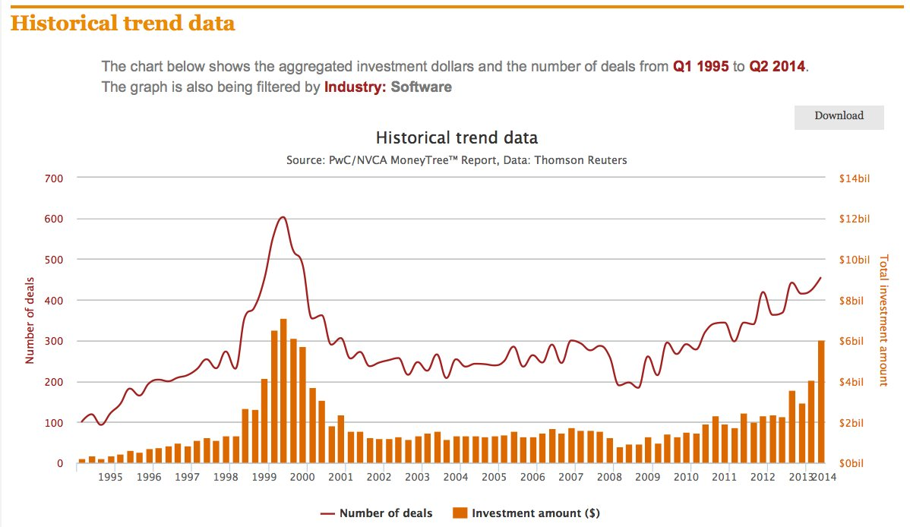

* Tech deals in a year

The chart below uses a different dataset from PwC. In 2014, we're likely to see more than 1,600 venture capital funding deals for software companies. Last year was also a record, there were 1,523 private investments in software tech startups, PwC says. Through Q2 2014, there have already been 877. (In 2000, a record 2,167 deals were done before the dot-com bubble collapsed.)

We're not quite at the same level as the year 2000, we're already way ahead of the year 1999 — which was the beginning of the end.

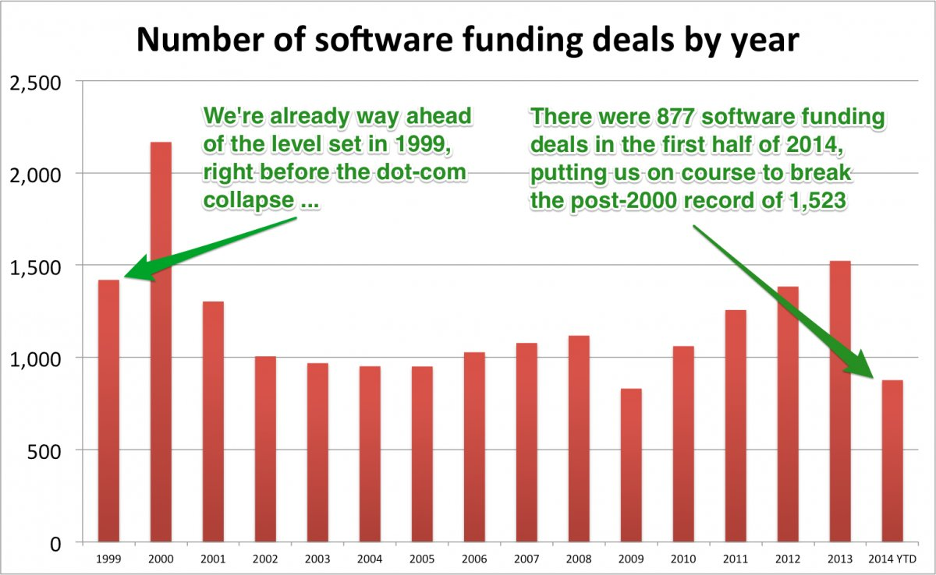

* A majority of IPOs are coming from companies that lose money

Tech companies tend to go public on NASDAQ, and that index has once again arrived at a notorious threshold indicating a bubble: The  percentage of companies filing initial public offerings with negative profits is nearly back where it was in 2000, and 2014 isn't even over yet. This data comes from Jay R. Ritter, a professor of finance at the University of Florida:

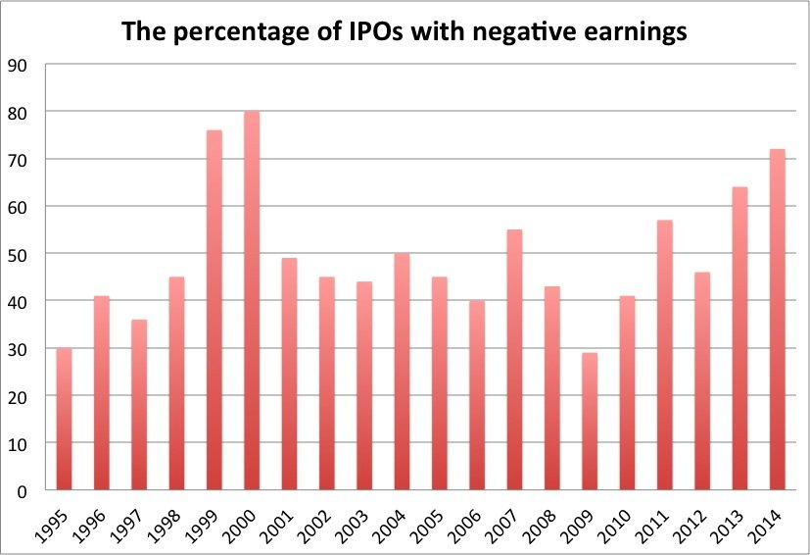

* David Einhorn investor letter

David Einhorn, a noted American Hedge fund manager, the founder and president of Greenlight Capital (AUM $ 10 billion) in Q1 investor letter noted that we are in a tech bubble pointing to the following things:-

* Rejection of conventional valuation methods. (tech stocks are disconnected from traditional valuation method since they have little to no earnings)
* Short- sellers forced to cover due to intolerable mark to market losses (Short selling the tech stocks. They have been rallying consistently. )
* Huge first day movement of IPO’s of tech companies. (Alibaba- up 38%)

He also remarked about the compensation paid in equity to the employees treated as “non cash” by the founders and the analysts. He questioned the ability of these companies to retain the highly talented employees if they stopped doling out large amounts of equity. He also noted that an equity holder trying to value the businesses as a multiple of profits cannot ignore the real cost of future dilution that comes from paying the employees in stock.

* Warren Buffet indicator

Market Cap to GDP is a long-term valuation indicator and according to Warren Buffet it is probably the best single measure of where valuations stand at any given moment.  
As the chart suggests the indicator is reaching towards level in year 2000.

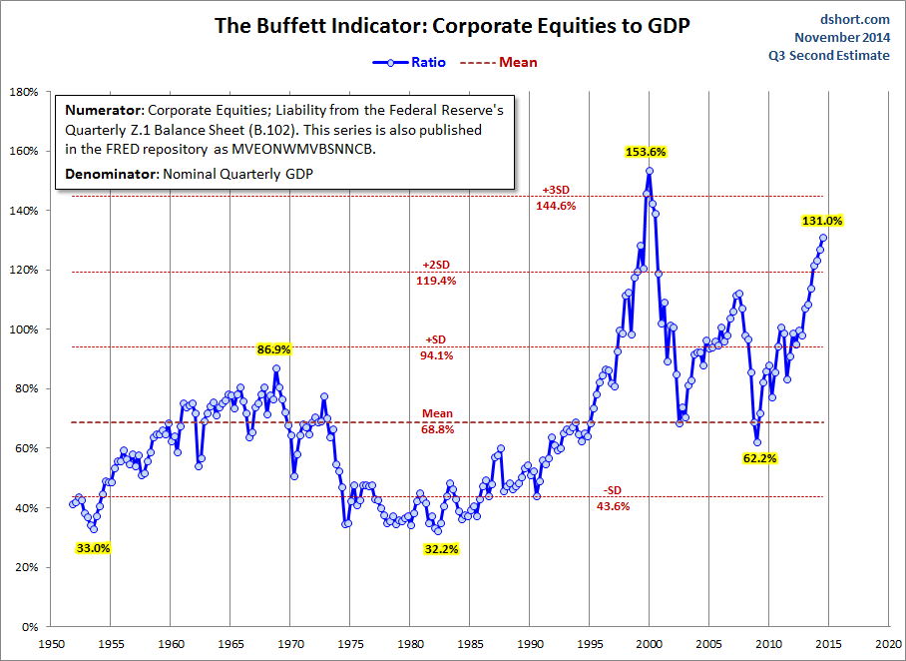

* Rent paid by tech companies

Tech startups who have received funding from investors are spending big on the rent in San Francisco area. The trend is especially pronounced in San Francisco, where venture capital is pouring in, competition among startups is fierce and rents are rising to dot-com-boom levels (Figure below). Commercial rent in San Francisco’s trendy South of Market neighborhood hit about $56 a square foot in the third quarter, its highest level since 2000

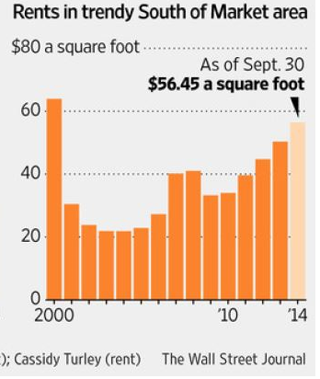

Startups with small teams looking for massive spaces are locking themselves in to long leases. Startups are signing five- to seven year leases on spaces that used to require two, and more landlords are pushing for 10-year leases on new construction. Those could become a burden if financing tightens.

Web-storage company Dropbox Inc. raised $850 million in financing this year and signed three leases in San Francisco in excess of 10 years each. Car-hailing service Uber Technologies Inc., which secured $1.2 billion in funding this summer, recently announced plans for new headquarters in the Mission Bay neighborhood that will consume a half-million square feet in a 15-year-lease.

1. The countdown to Housing Bubble (2008)

* S & L crisis (1980’s)

Savings and Loans were specialized banks that used low-interest, but Federally-insured, deposits in savings accounts to fund mortgages. In the 1980s, the popularity of money market accounts reduced the attractiveness of savings accounts, so the banks asked Congress to remove restrictions. The savings account rates were regulated by Regulation Q and money markets were offering better returns that savings accounts. In 1982, the Garn-St. Germain Depository Institutions Act was passed, which allowed S&Ls to raise interest rates on deposits, make commercial and consumer loans, and removed restrictions on loan-to-value ratios. At the same time, the Federal Home Loan Bank Board regulatory staff was reduced thanks to budget cuts.

In an attempt to raise capital, banks invested in speculative real estate and commercial loans. Between 1982 and 1985, these assets increased 56%. In Texas, 40 S&Ls tripled in size, some growing 100% each year.

By 1983, 35% of the country's S&Ls weren't profitable, and 9% were technically bankrupt. As banks went under, the state and Federal insurance began to run out of the money needed to refund depositors. However, S&Ls kept remained open, making bad loans, and the losses kept mounting. Because S&L deposits were insured by the Federal Savings and Loan Insurance Corporation (FSLIC), depositors continued to put money into these risky institutions. A complex web of these factors and others, combined with widespread corruption, led to the insolvency of the FSLIC.

By 1989, Congress and the president knew they needed to bail out the industry agreed on a taxpayer-financed bailout measure known as the FIRREA provided $50 billion to close failed banks and stop further losses. It set up a new government agency called the Resolution Trust Corporation (RTC) to resell Savings and Loan assets, and use the proceeds to pay back depositors. FIRREA also changed Savings and Loan regulations to help prevent further poor investments and fraud.

Between 1986-1995, over 1,000 banks with total assets of over $500 billion failed. By 1999, the crisis cost $153 billion, with taxpayers footing the bill for $124 billion, and the S&L industry paying the rest.

* Tequila crisis (1995)

In 1991 the Bank of Mexico effectively fixed the exchange rate by allowing the peso to move within a short range against the dollar. It would be abandoned by the end of 1994 as a series of events pushed the dollar peg to a breaking point. Between March - November, 1994 the crawling peg of the Mexican peso (figure below) is under fire. Not only does the US Federal Reserve raise its policy rate by 250 bps during this time span, Mexico also suffers from political homicides in the lead-up to the presidential elections later that year. Foreign exchange reserves therefore decline rapidly. In April, to stop the outflow of foreign currency, the Mexican government issues short term dollar denominated debt, called tesobonos. As investors buying the tesobonos are protected for a potential devaluation of the peso, the outflow of foreign currency stops, while the foreign exchange rate stabilizes. However, in November USD 3bn is pulled out of the country, of which USD 1.6bn on a single day (18 November).

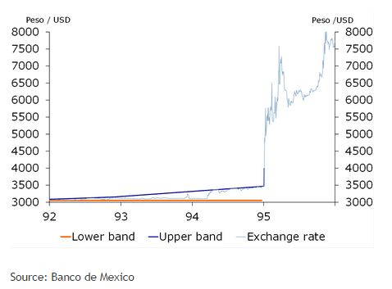

*Chronology of events*

1. December 1st, 1994 the new Mexican government, headed by President Zedillo, takes office.
2. December 15th, 1994 the Wall Street Journal publishes an interview with the new Finance Minister Jaime Serra Puche, in which he denies that Mexico will devalue the peso. The next day, USD 855 million leaves Mexico.
3. December 20th, 1994 the new cabinet concludes that the situation is unsustainable. Therefore, the Central Bank of Mexico announces a lift of the upper band of the exchange rate by 15%, an effective devaluation of the peso.
4. December 20-21th, 1994 in the two days after the announcement, USD 4.6 billion leaves the country, half of the foreign exchange reserves.
5. December 22th, 1994 the intervention on the foreign exchange market is lifted, and the peso is allowed to float freely. The total devaluation of the peso amounts to 35% by the end of December.
6. January 26th, 1995 the IMF announces a rescue package of USD 7.8 billion.

On January 31th, 1995 the US announces a USD 50 bn rescue package for Mexico, consisting of USD 20 bn from the US, USD 18 bn from the IMF (including the USD 7.8 billion already announced on January 26th), USD 10 bn from the Bank for International Settlements, and USD 3 bn from private commercial banks (Musacchio, 2012). Due to the credit line, Mexico is able to roll over its short term dollar denominated debt, although at considerable higher yields. Without the help Mexico probably would have defaulted on its tesobonos.

The US government and the Federal Rerserve bailed out because Goldman Sachs and other investment banks held large positions in Mexican bonds.

* Long Term Capital Management (LTCM) crisis- 1998

Long-Term Capital Management (LTCM) was a very large hedge fund ($126 billion in assets) that nearly collapsed in late 1998. It reached that size thanks to the stellar reputation of its owners.

The founder was a Salomon Brothers trader, John Meriwether, and the principal shareholders were Nobel prize-winning economists Myron Scholes and Robert Merton. These were all experts in investing in derivatives to make above-average returns and outperform the market.

Investors paid $10 million to get into the fund. They were not allowed to take the money out for three years, or even ask about the types of investments LTCM used. Despite these restrictions, investors clamored to get in, thanks to LTCM's spectacular annual returns of 42.8% in 1995 and 40.8% in 1996. This was after management took 27% off the top in fees. LTCM successfully hedged most of the risk from the 1997 Asian currency crisis, giving its investors a 17.1% return that year. However, by September 1998, the company's risky trades brought it close to bankruptcy. Its size meant it was too big to fail, and so the Federal Reserve took steps to bail it out.

Like many hedge funds, LTCM's investment strategies were based upon hedging against a fairly regular range of volatility in foreign currencies and bonds. When Russia declared it was devaluing its currency and basically defaulting on its bonds, this event was beyond the regular range that LTCM had counted on. The U.S. stock market dropped 20%, while European markets fell 35%. Investors sought refuge in Treasury bonds, causing long-term interest rates to drop by more than a full point.

As a result, LTCM's highly leveraged investments started to crumble. By the end of August 1998, it lost 50% of the value of its capital investments. Since so many banks and pension funds were invested in LTCM, its problems threatened to push most of them to near bankruptcy. In September, Bear Stearns dealt the final death blow. The investment bank, which managed all of LTCM's bond and derivatives settlements, called in a $500 million payment. Bear Stearns was afraid it would lose all of its investments, which were considerable since LTCM had been out of compliance with its banking agreements for three months.

To save the U.S. banking system, the Federal Reserve Bank of New York President William McDonough William J. McDonough convinced 15 banks to bail out LTCM with $3.5 billion, in return for a 90% ownership of the fund. In addition, the Fed started lowering the [Fed funds rate](http://useconomy.about.com/od/monetarypolicy/a/fed_funds_rate.htm) as a reassurance to investors that the Fed would do whatever it took to support the U.S. economy. Without such direct intervention, the entire financial system was threatened with a collapse.

A study by CATO Institute says the Federal Reserve didn't need to rescue LTCM because it would not have failed. An investment group led by Warren Buffett offered to buy out the shareholders for just $250 million and kept the fund running. The shareholders and management would have been replaced.

However, the Fed intervened and brokered a better deal for the LTCM shareholders and managers. This was the precedent for the Federal Reserve's bailout role with during the 2008 financial crisis. Once financial firms realized that the Fed would bail them out, they were more willing to take risks.

The major creditors of the fund included Bear Stearns, Merrill Lynch and Lehman Brothers, all of which went on to lend and invest recklessly and, to one degree or another, pay the consequences. But 1998 should have been the time to send a credible warning that bad loans to overleveraged institutions would mean losses, and that neither the Fed nor the Treasury would make these losses good.

Alan Greenspan the Federal Reserve chairman pumped money in the system and bailed investment banks like Bear Sterns & Lehmann Brothers. If he hadn’t done that they would have lost huge capital and would have gone bust. But this action set a precedent for the investment banks at Wall Street that whatever they do in the end Federal Reserve will act as their savior. If Bear Sterns and Lehman Brothers would have been allowed to fail after LTCM the system would have been safer. Eventually both of the banks failed in 2008 and markets went in to a turmoil when Lehmann Brothers filed for Chapter 11 bankruptcy on September 15, 2008. The filing remains the largest bankruptcy filing in U.S. history, with Lehman holding over $600 billion in assets.

* Community Reinvestment Act

The Community Reinvestment Act is intended to encourage depository institutions to help meet the credit needs of the communities in which they operate, including low- and moderate-income neighborhoods, consistent with safe and sound operations. It was enacted by the Congress in 1977 (12 U.S.C. 2901) and is implemented by Regulation BB (12 CFR 228). The regulation was substantially revised in May 1995 and updated again in August 2005.

According to this act the banks were under obligation to extend credit for mortgage even to the people who cannot pay them back. If they didn’t the banks were penalized. Thus people with poor credit history, with no income or job were extended mortgage facilities. This rule is the bed rock for extending subprime mortgage.

* Housing Bubble-2008

The housing bubble owes its origins to the securitization of loans. Few decades ago when an individual goes to buy the house and take a mortgage from a lender the monthly installments would go to the lender. Since the mortgage payments extend to decades the lenders were careful in offering mortgage & expected the home owner will pay the mortgage. The lender carries the risk of mortgage. Since the development of securitization the lender no longer runs the risk if the home owner defaults on his mortgage. The securitization of loans has created a chain. In this chain the principal lender sells the loans to an investment bank. The investment bank combines multiple loans and mortgages namely car loans, student loans, credit card debt, commercial mortgages, and corporate buy out debt to create complex derivatives called collateralized debt obligation or CDO. The investment bank sold the CDO’s to investors. Now when the home owners paid their mortgage payments it went to investors who bought CDO’s spread all over the world. The investment banks paid credit rating agencies to evaluate the CDO’s. The rating agency gave them AAA rating, the highest rating. This made CDO’s popular with pension and retirement funds which can only invest in securities with high grading.

Due to securitization the lenders didn’t care if the borrower could repay. So they started making riskier loans. The investment banks didn’t care either. The more CDO’s they sold the higher their profits. The rating agencies which were paid by investment banks had no liability if their ratings of CDO have proved wrong. There were no regulatory constraints and thus it was easy to pump out more & more loans. Sub-prime loans were being given to people with poor credit history.

But the investment banks were betting against the CDO’s they were selling to their investors by buying CDS (Credit Default Swaps) issued by AIG. CDS were derivatives which were like an insurance against the failure of CDO’s.

The people in USA were being brainwashed by the economists and the Federal Reserve that the home prices have never gone down in US history. This fact is true except only once they went down in after 1990 in California.

The academia had also a role to play in this housing bubble. A study titled “*How Capital markets enhance Economic Performance and facilitate Job Creation*” conducted in November 2004, jointly by William C Dudley, Chief Economist Goldman Sachs and R. Glenn Hubbard, Chief Economic Advisor, George Bush administration & Dean-Columbia Business School propounded the theory how regulation has benefitted the market and the economy as a whole.

In 2005, Raghuram Rajan then the Chief Economist, IMF (2003-2007) and current Governor of Reserve Bank of India (India’s central bank) delivered a paper at the annual Jackson Hole symposium (the most elite banking conference in the world) titled “*Has Financial Development Made the World Riskier*”. Rajan’s paper focused on incentive structures that generated huge cash bonuses based on short term profits which imposed no penalty for later losses. He argued that these incentives encouraged bankers to take risks that might eventually destroy their own firms or even the entire financial system. The profits of the investment banks soared with the high risks taken by it.

Finally when the housing prices tanked the CDO’s went from AAA to junk securities bursting the housing bubble. As soon as the CDO’s went bust the CDS were exercised by its holders. The big investment banks namely Lehman Brothers, Bear Sterns went bust and other banks such as Goldman Sachs, Citigroup, Morgan Stanley who were sitting on these junk securities were bailed out by the Federal Reserve. Also AIG which issued CDS was bailed out. The Federal Reserve like in previous crisis bailed these banks and the financial system.

TARP- Troubled Asset Relief Plan. Treasury established several programs under TARP to help stabilize the U.S. financial system, restart economic growth, and prevent avoidable foreclosures. Congress authorized $700 billion for TARP in October 2008 to buy the troubled assets of the investment banks.

To counter the looming recession the Federal Reserve adopted “Quantitative Easing”. It is an unconventional monetary policy in which a central bank purchases government securities or other securities from the market in order to lower interest rates and increase the money supply. Quantitative easing increases the money supply by flooding financial institutions with capital in an effort to promote increased lending and liquidity. Quantitative easing is considered when short-term interest rates are at or approaching zero, and does not involve the printing of new banknotes. The rates have been kept at 0.25% since December, 2008 (chart below). This approach was used by Federal Reserve to revitalize the economy. It has resulted in $ 4.5 trillion bond buying by the Federal Reserve.

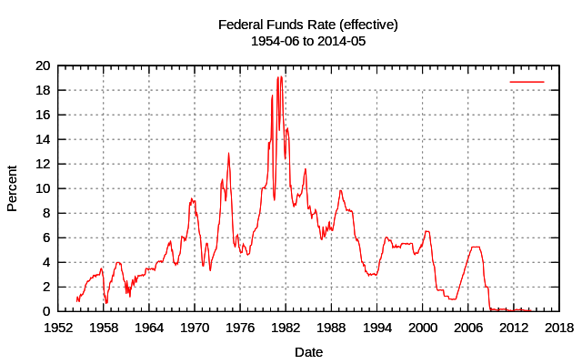

By theory if Federal Reserve pumps money in the US economy there should be inflation in USA (chart below). But the reality is different. If there is almost constant inflation in the US economy it means the cheap money policy of the Federal Reserve has resulted in flow of funds somewhere else. What is the result of this kind of quantitative easing on other economies? The answer lies in the next part.

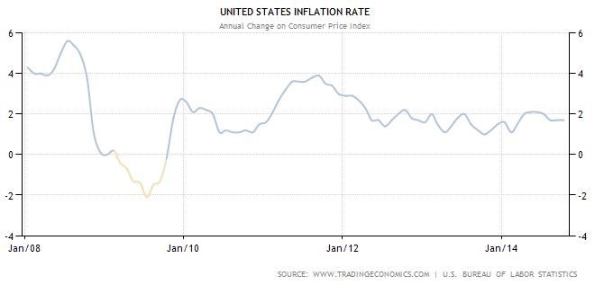

1. Formation of Bubbles- Current scenario

In 2009, CLSA compiled a basket of goods of different goods and services in Singapore. As of 19 September 2014 the basket is 85% more expensive than 2009.

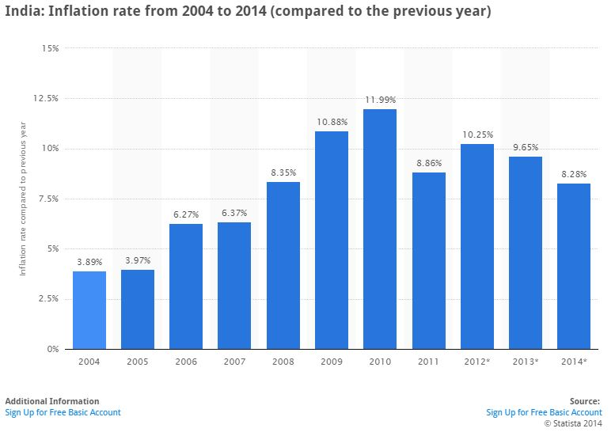

From January 2008 till December 2014 there has been net inflow of $ 127 billion in equity and debt markets of India. The inflation post 2008 crises has only increased except in the year 2011 and in 2014 year on year basis (chart above). The money printing in USA & Europe doesn’t lead to inflation in those countries but has led to inflation in developing markets like India & China.

* Chinese bubble

The quantitative easing in USA & Europe has led to bubbles being formed in the developing markets. The credit bubble in USA was built on consumption. The debt level on household and government went up dramatically to finance in consumption. The bubble in the China is fuelled by the cheap money policy of the developed markets. But the Chinese market have shown sign of weakness lately. Chinese economy is different that the economy of USA. It finances investments in infrastructure, research and development among others. If capital spending bubbles downturn can be severe. There are already overcapacities in the Chinese economy. If more money is printed it will produce more overcapacities. Since China’s data is not reliable we look at other sources of data.

* Taiwan & South Korea- Largest exporter to China

Taiwan Export Data

|  |  |
| --- | --- |
| Year | % increase (y-o-y) |
| 2013 – 2014 | 2.48 |
| 2012 – 2013 | 1.18 |

South Korean exports totaled $46.3 billion in August, down 0.1 percent on-year while imports rose 3.1 percent to $42.9 billion. Analysts said South Korean exports would continue to be volatile and depressed until China's economy starts to recover solidly from a slowdown at the start of the year. Kim Jong-Su, an economist at Taurus Investment and Securities said “It will be difficult for exports to post a strong recovery without improvement in exports to China, because they take up a quarter of our exports”.

* China’s power output

China’s power output, a bellwether for economic activity, posted its first annual decline in more than four years in August, adding to evidence that the world's second-largest economy is losing momentum after a brief rebound in the second quarter. Power output in the world's top consumer fell 2.2 percent to 495.9 billion kilowatt hours (kWh) in August from a year earlier. While the annual fall was in part due to the high reading last summer, when many cities were struck by a record heat wave, overall electricity production also posted its first fall in three months - a sign of slackening demand from major industrial users. Headline data showed China's factory output grew at the lowest pace in nearly six years in August while growth in retail sales and investment also cooled, adding to signs of fragility in the economy that may prod Beijing into fresh policy measures to prevent a sharper slowdown.

* Shanghai REBAR Steel Futures

Shanghai REBAR Steel futures is the world’s most traded steel futures. It fell to a record low on 8 October 2014 as the bearish mood in China's steel market continues.

A sluggish property sector and a slowdown in China's overall economy had weakened steel demand in the world's top consumer of the alloy, with domestic consumption shrinking this year.

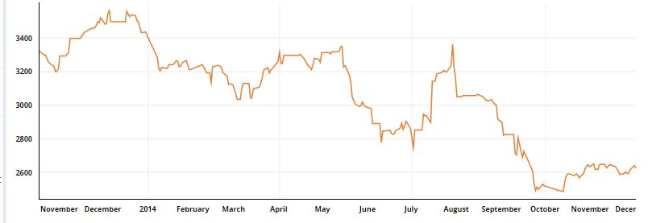

The fall in the steel futures means the sluggish demand for steel which is used by the industries in China as a secondary product to produce the primary product. Thus the export which constitutes 27 % of the GDP, it surely is going to impact given the sluggish demand for Chinese products in the developed markets due to their weak economies.

* Other factors

1. One Party system & social unrest

The one party system uses its iron fists to rule. The recent unrest in Hong Kong over the proposed electoral reform which would take the democracy away from the Hong Kong residents is an example how the Chinese government works. The proposed changes were to disallow civil nominations for the elections.

1. Corruption

High level of corruption is prevalent in China. China slipped in ranking in the Transparency International’s 2014corruption perception index. It is ranked 100 out of 175 countries.

If the Chinese economy slows down it will have huge impact on other economies. According to the IMF’s April 2014 “World Economic Outlook” analysis, the emerging market’s share of global GDP hit 50.4% in 2013, up from 31% in 1980. China’s slowdown will deeply affect the global economies.

1. Conclusion

The cheap money policy adopted by ECB, Federal Reserve and now by Japanese Central bank has led to inflation of asset prices across asset classes not only developed but also in developing markets. The cheap availability of money has been funneled in to the developing economies resulting in inflation. The central banks should be the ones to quash these bubbles. In the near term the strong dollar and rise in interest rates due to QE ending will signify international liquidity tightening which isn’t good for asset markets.

References

*Le Monde, LTCM, a Hedge Fund Above Suspicion, November 1998*

*The Independent, Bear Stearns Call Triggered LTCM Crisis, September 26, 1998*

*IMF, World Economic Outlook, Interim Assessment, "Chapter III: Turbulence in Mature Financial Markets December 1998; IMF Report: International Contagion Effects from the Russian Crisis and the LTCM Near-Collapse, April 2002; European Central Bank, Financial Stability Report December, 2006.*

*Inside Job- a documentary*

<http://cus93.trade.gov.tw/ENGLISH/FSCE/>

<http://www.metal.com/newscontent/64913_shanghai-rebar-slides-to-record-low-more-pressure-on-iron-ore>

<http://uk.reuters.com/article/2014/09/13/china-economy-output-commodities-demand-idUKL3N0RE06320140913>

<http://www.businessinsider.com/the-us-economy-has-reached-a-turning-point-2014-10>

<http://www.japantimes.co.jp/opinion/2014/10/07/editorials/a-resurgent-u-s-economy/>

<http://www.reuters.com/article/2014/09/01/us-southkorea-economy-trade-idUSKBN0GW12S20140901>

<http://www.cnbc.com/id/102016166>

<https://www.tradingfloor.com/posts/will-the-dollar-rise-last-its-only-just-getting-started-1830831>

<http://www.nytimes.com/2008/12/28/business/economy/28view.html>

<http://useconomy.about.com/od/themarkets/f/LTCM.htm>

<http://www.pbs.org/wgbh/pages/frontline/shows/dotcon/historical/bubbles.html>

<http://www.library.hbs.edu/hc/historicalreturns/fb/movie.html>

<http://www.arpinvestments.com/downloads/Absolute-Return-Letter/2014/The%20Absolute%20Return%20Letter%201114.pdf>

<http://useconomy.about.com/od/grossdomesticproduct/p/89_Bank_Crisis.htm>

<http://www.investopedia.com/terms/s/sl-crisis.asp>

<https://economics.rabobank.com/publications/2013/september/the-tequila-crisis-in-1994/>

<http://www.investopedia.com/terms/t/tech_bubble.asp>

<http://www.investopedia.com/features/crashes/crashes8.asp>

<http://www.thinkadvisor.com/2014/05/09/emerging-markets-dominate-global-gdp>

<http://www.theguardian.com/world/2014/dec/03/corruption-china-turkey-rise>

<http://data.worldbank.org/indicator/BX.KLT.DINV.CD.WD/countries/CN?display=graph>

<http://www.businessinsider.com/evidence-that-tech-bubble-is-at-a-peak-2014-10>

<http://www.moneynews.com/MKTNewsIntl/stock-market-crash-warren-buffett-indicator/2014/10/03/id/598461/?dkt_nbr=ufos34vz&utm_source=taboola&utm_medium=referral>

<https://www.streetaccount.com/FileLinkHandler.axd?filename=STORYID1475487_Greenlight%20Capital%201Q14%20letter.pdf>

<http://www.businessinsider.com/warren-buffett-stock-market-indicator-2014-9>

<https://www.youtube.com/watch?v=Fx6ALdBgeDI>

<http://thebubblefilm.com/cast/jim-rogers/>

<http://thebubblefilm.com/cast/marc-faber-gloom-boom-doom-report/>