Rinat Oshakbayev

441 097

Oil and Gas industry in Kazakhstan

Over the last ten years mineral wealth has played a significant role in the economic development of resource-rich Commonwealth of Independent States (CIS) countries. Kazakhstan has been emerging as an important energy producer in Euro-Asia and greatly benefited from its hydrocarbons sector.

A number of academic papers have analysed economic development in the Caspian Sea Region, and Russia since its independence (Pomfret, 1995, 2003, 2006; Kaser, 1997, 2003; Kalyuzhnova, 1998, 2002, 2008). All of these highlights that Kazakhstan rely heavily on mineral wealth, and have a high degree of dependency on it. The last 20 years have brought significant changes to Kazakhstani economy development. So that Kazakhstan became strategically important to world energy markets.

The oil and gas industry of Kazakhstan plays an important role in the economic development of the republic. It is one of the main drivers of gross domestic product (GDP) growth and an important source of national budget revenue. According to BP’s *Statistical Review of* *World Energy June 2013,* Kazakhstan hasproven reserves estimated at 30.0 billion barrels (3.9 billion tons) of oil and proven natural gas reserves of 45.7 trillion cubic feet (1.3 trillion cubic meters), which represent 1.8% and 0.7% of total global reserves.

Kazakhstan is the second largest oil producer among the former Soviet republics after Russia and is heavily reliant on oil export revenues. Total production of oil and gas condensate in 2013 amounted to 81.8 million tons, up 3.2% year-on-year, of which 72.1 million tons, up 5.1% year-on-year, were exported. The government expects total production to rise to 90 million tons in 2015 and 110 million tons in 2018. According to the International Energy Agency’s *World Energy Outlook* *2010,* by 2020 Kazakhstan will join the top10 oil and gas exporters.

The oil and gas industry has increased from 10.9% in 2001 to 25.2% in 2012, plays a vital role in Kazakhstan’s GDP structure. Consistent development of the oil and gas industry would not be possible without foreign direct investment (FDI). The annual volume of FDI has been increasing year by year since 1998 and the share of investments in the oil and gas industry in total volume of FDI remains high.

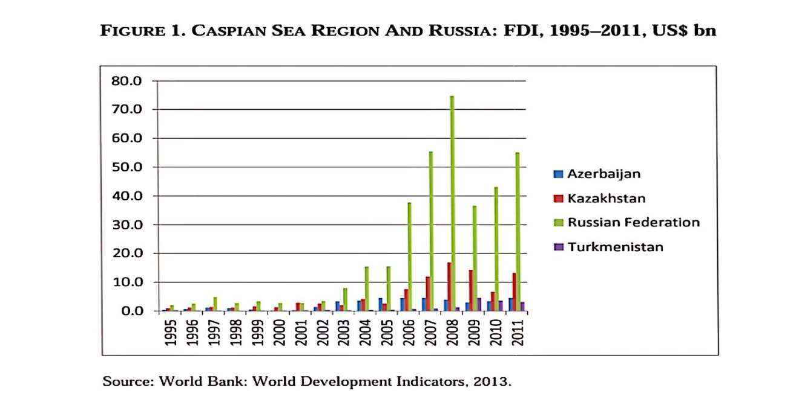

This graph shows us that, Kazakhstan has attracted the largest amount of FDI in the Caspian Region. That is because of the government’s attempt to adopt a policy of continuous improvement of the laws on investment and taxes. As a result, at the present time, considering the “Doing Business in Kazakhstan” index, the country ranks 49th in the world in terms of favorable conditions for that (whereas Russia is in 112th position; Azerbaijan in 67th position).In terms of investor protection, Kazakhstan is among the top ten.

Overall, since 1993, US$ 171.2 bn of FDI has been raised in Kazakhstan with an FDI growth rate of 27% on average for the last 20 years. In 2012, $US 22.5 bn of FDI was recorded. The geographical composition of the FDI in Kazakhstan is represented by 120 countries, among them the main contributors are the Netherlands ($US 7.4 bn, or 33% in 2012); China ($US 2 bn, or 9.1% in 2012); Switzerland ($US 1.9 bn, or 8.7% in 2012); the USA ($US 1.3 bn, or 5.9% in 2012); and France ($US 1.04 bn, or 5% in 2012).This impressive picture is mainly due to investment into Kazakhstan’s natural resources, So, overall, during 1993–2012, 34.76% (US$ 59.5 bn) of FDI was invested in geological surveys and exploration; and 30.22% (US$ 51.8 bn) in the production of raw materials, with the largest share in hydrocarbons. Only 10.2% (US$ 17.5 bn) were invested in final manufacturing production. At the present time, the government at all levels are working together with foreign investors from 80 countries on more than 400 initiatives; 81 projects (with a value of US$ 8.8 bn)

For the last two decades the Kazakhstani economy has been through two distinct periods. In the first half of the 1990s, the country’s GDP dramatically limited, by 1995 it had decreased by 39%. In 1996, the production decline stopped and GDP remained flat until 1999. Since 2000, Kazakhstan’s GDP has been growing consistently. Due to increase in proven oil reserves, and an upturn in oil prices, Kazakhstan experienced spectacular economic growth, and economic growth was very strong till 2007. Since 2007 till 2009, due to serious financial crisis banking sector was affected heavily, and due to this there was not any increase in development. However, due to anti-crisis measures, the Kazakhstani economy rebounded sharply starting from 2010 with 7.0% overall growth, and 10.2% growth in the non-oil sectors. Strong anti-crisis measures, improved global conditions, revival in external demand for oil and minerals, and bank restructuring. The stimulus measures have helped lessen the impact of the crisis on income and employment. The growth continued in 2011 by 7.5% by strong performance of the agriculture and services sectors, and continued public investment spending. The main drivers of this growth were extractive industries and net export, with private consumption and trade also contributing, but investment has remained weak. In 2012 Kazakhstan’s economic growth slowed to 5% because of the general instability of the global economy and unfavourable market conditions. Despite of this, the government continued to make efforts and by 2013 growth had increased again by 6%. Furthermore, according to the latest GDP forecast by the Ministry of Economy and Budget Planning of Kazakhstan in 2013, the average annual growth from 2014 to 2018 will be 6.5%.

Oil and Energy is a certainly a very important sector in Kazakhstan, that nourishes and contributes as a largest part to the GDP and economic wealth of the country. The production of oil leads to the production of various by-products and therefore the oil producing and exporting companies in Kazakhstan earns great revenue. At the same time, country earns most of its export earnings from oil and gas sector.

References:

1. FDI into Kazakhstan on the increase but perception gap remains

<http://emergingmarkets.ey.com/fdi-into-kazakhstan-on-the-increase-but-perception-gap-remains/>

1. Kazakhstan oil industry facts and features

<http://aboutkazakhstan.com/about-kazakhstan-economy/oil>

1. US Energy Information Administration

<http://www.eia.gov/countries/cab.cfm?fips=kz>

1. Oil and gas sector

<http://www.kmgep.kz/eng/about_kazakhstan/oil_and_gas_sector/>