Ponzi Scheme

Finance (basics)

Student: Vildana Karalić ; 440126  
Professor: Ludek Benada

Table of Contents

Ponzi scheme 2

Defining the scheme 2

Faces of Ponzi scheme 2

Characteristics of Ponzi scheme 3

Example of a scheme 5

Collapse of a Ponzi scheme 5

Bernie Madoff Case 6

List of images and figures 7

Literature 7

# Ponzi scheme

## Defining the scheme

“A fraudulent investing scam promising high rates of return with little risk to investors. The Ponzi scheme generates returns for older investors by acquiring new investors. This scam actually yields the promised returns to earlier investors, as long as there are more new investors. These schemes usually collapse on themselves when the new investments stop.”[1]

So, as we see A Ponzi scheme is a fraudulent investment operation where the operator, an individual or organization, pays returns to its investors from new capital paid to the operators by new investors, rather than from profit earned by the operator. Operators of Ponzi schemes usually entice new investors by offering higher returns than other investments, in the form of short-term returns that are either abnormally high or unusually consistent.

Ponzi schemes occasionally begin as legitimate businesses, until the business fails to achieve the returns expected. The business becomes a Ponzi scheme if it then continues under fraudulent terms. Whatever the initial situation, the perpetuation of the high returns requires an ever-increasing flow of money from new investors to sustain the scheme.

## Faces of Ponzi scheme

How did Ponzi schemes get their name? The schemes are named after Charles Ponzi, who duped thousands of New England residents into investing in a postage stamp speculation scheme back in the 1920s. At a time when the annual interest rate for bank accounts was five percent, Ponzi promised investors that he could provide a 50% return in just 90 days. Ponzi initially bought a small number of international mail coupons in support of his scheme, but quickly switched to using incoming funds from new investors to pay purported returns to earlier investors.

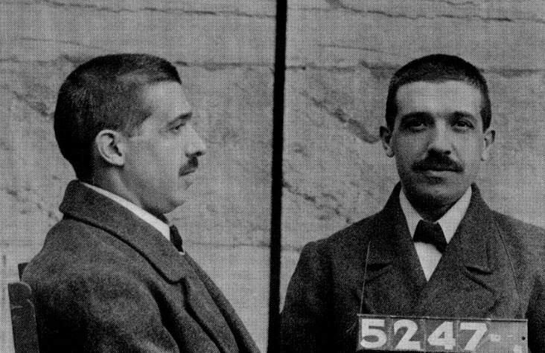

Image – Charles Ponzi

Even though this scheme got its name by Charles Ponzi, the most famous Ponzi scheme perpetrator is Bernard Bernie Madoff.

Bernard Lawrence "Bernie" Madoff is an American convicted of fraud and a former stockbroker, investment advisor, and financier. He is the former non-executive chairman of the NASDAQ stock market, and the admitted operator of a Ponzi scheme that is considered to be the largest financial fraud in U.S. history.

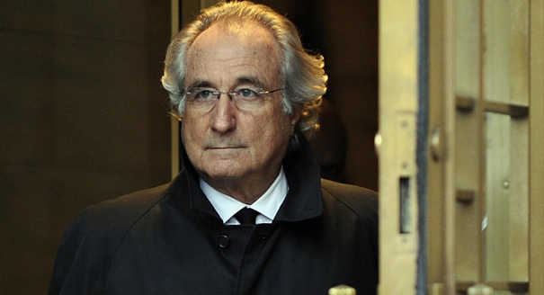

Image – Bernard Bernie Madoff

## Characteristics of Ponzi scheme

In Figure 1 are plotted main characteristics of this type of financial scheme.

Typically, extraordinary returns are promised on the original investment. The promoter sells shares to investors by taking advantage of a lack of investor knowledge or competence, or using claims of a proprietary investment strategy which must be kept secret to ensure a competitive edge.

Ponzi schemes sometimes commence operations as legitimate investment vehicles, such as hedge funds. For example, a hedge fund can degenerate into a Ponzi scheme if it unexpectedly loses money (or simply fails to legitimately earn the returns promised and/or thought to be expected) and if the promoters, instead of admitting their failure to meet expectations, fabricate false returns and (if necessary) produce fraudulent audit reports.

A wide variety of investment vehicles or strategies, typically legitimate, have become the basis of Ponzi schemes.

Initially the promoter will pay out high returns to attract more investors, and to lure current investors into putting in additional money. Other investors begin to participate, leading to a cascade effect. The "return" to the initial investors is paid out of the investments of new entrants, and not out of profits. Often the high returns encourage investors to leave their money in the scheme, with the result that the promoter does not have to pay out very much to investors; he simply has to send them statements showing how much they have earned. This maintains the deception that the scheme is an investment with high returns.

Promoters also try to minimize withdrawals by offering new plans to investors, often where money is frozen for a longer period of time, in exchange for higher returns. The promoter sees new cash flows as investors are told they cannot transfer money from the first plan to the second. If a few investors do wish to withdraw their money in accordance with the terms allowed, their requests are usually promptly processed, which gives the illusion to all other investors that the fund is solvent.

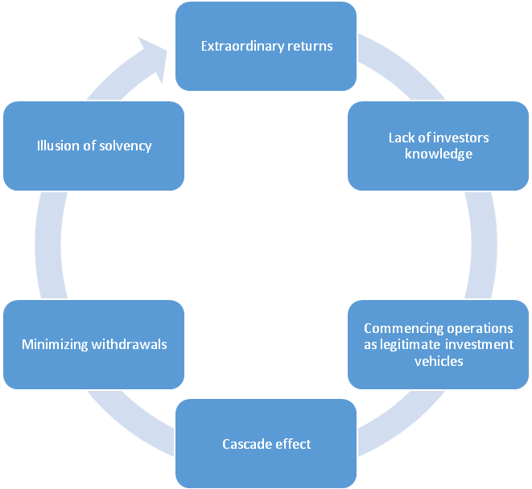

Figure – Main characteristics of Ponzi scheme

## Example of a scheme

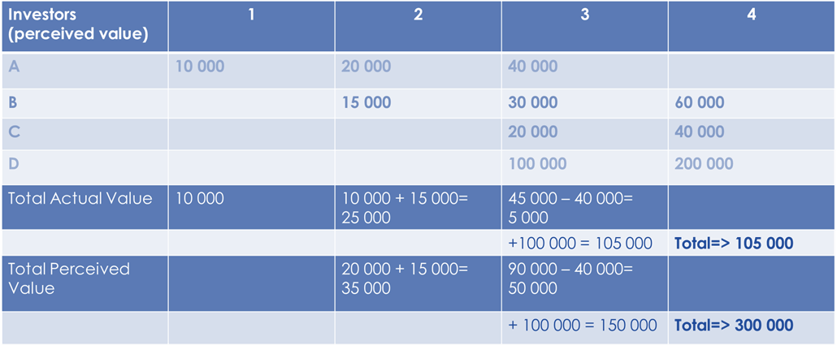

Figure – practical example of Ponzi scheme

## Collapse of a Ponzi scheme

With little or no legitimate earnings, Ponzi schemes require a consistent flow of money from new investors to continue. Ponzi schemes tend to collapse when it becomes difficult to recruit new investors or when a large number of investors ask to cash out.

When a Ponzi scheme is not stopped by the authorities, it sooner or later falls apart for one of the following reasons:

* The promoter vanishes, taking all the remaining investment money (which excludes payouts to investors already made).
* Since the scheme requires a continual stream of investments to fund higher returns, once investment slows down, the scheme collapses as the promoter starts having problems paying the promised returns (the higher the returns, the greater the risk of the Ponzi scheme collapsing). Such liquidity crises often trigger panics, as more people start asking for their money, similar to a bank run.
* External market forces, such as a sharp decline in the economy (for example, the Madoff investment scandal during the market downturn of 2008), cause many investors to withdraw part or all of their funds.

## Bernie Madoff Case

Bernie Madoff is well-known for being the orchestrator of the largest Ponzi scheme yet. His fraudulent machination crossed continents. The Madoff investment scandal broke in December 2008, when Bernard Madoff admitted that the wealth management arm of his business was an elaborate Ponzi scheme.

Madoff founded the Wall Street firm Bernard L. Madoff Investment Securities LLC in 1960, and was its Chairman until his arrest. At his firm he employed his brother Peter as Senior Managing Director and Chief Compliance Officer (Peter has since been sentenced to 10 years in prison), Peter's daughter Shana Madoff as the firm's rules and compliance officer and attorney, and his sons Andrew and Mark (Mark committed suicide by hanging exactly two years after his father's arrest).

Much of Madoff's scheme is unclear and poorly documented because it stretches several decades. Most of the information that is known about Madoff comes from reports and word of mouth.

What can be guessed is that Madoff started off small. He gathered money from local establishments like country clubs and charity events. Investors would be present at these gatherings and they would question Madoff for advice, as he was already a well-known “investor” who was able to make seemingly magic returns. From there, these investors would entrust him with his savings, which only fueled the principal that Madoff needed to make his Ponzi scheme continue to work.

By 1992, the United States Securities and Exchange Commission caught up with one of the companies Madoff was using to feed his massive Ponzi empire, Avellino & Bienes. Since 1962, the firm, which had formerly been known as Alpern, Avellino and Bienes, funneled funds to Madoff by recommending that clients invest in a highly success but anonymous man who was able to generate high returns.

The interesting part comes at the point when the allegations of SEC shut down the firm. Instead of liquidating all the assets related to Avellino & Bienes, they were transferred to Bernard L. Madoff Securities LLC, a company owned by Madoff. The chief reason that this happened was because Madoff claimed he had no knowledge that the firm was operating illegally and that Madoff had a reportedly legitimate investment returns portfolio for the prior 10 years. Between 1999 and 2006, the SEC investigated Madoff's company several times. In the first two investigations performed by the SEC in 1999 and 2000, there were reportedly no fraudulent practices in Madoff's business. In 2004, articles began to appear in popular business journals alleging that Madoff's business was a fraud. One article went so far as to say that Madoff's hedge fund was the “biggest fraud in the world.”

In 2005, the SEC investigated Madoff's business again. This time, they found that he was in violation of doing business as an asset manager while he was registered as an investment adviser. While no serious fines were brought up against Madoff, he was forced to register as an asset manager. In 2005, Madoff's company was investigated as being an alleged Ponzi scheme. The SEC ruled that they found no evidence and no legal action was taken.

The amount of principal that was being introduced to Madoff's Ponzi scheme wasn't enough to cover the returns previous investors were promised. This, along with the fact that investors were moving to begin withdrawing their funds from Madoff's care, caused parts of Madoff's scheme to collapse.

It wasn't until 2007 when the Financial Industry Regulatory Authority reported that parts of Madoff's business didn't add up. The problem was that parts of Madoff's firm had no customers, which is what finally caused the SEC to arrest Madoff.

Originally, Madoff stated that his company had liabilities that topped out at US$50 billion. Prosecutors of his case, however, stated that the size of his scheme's fraud was around $64.8 billion and that it affected over 4,800 of Madoff's clients.

Alerted by his sons, federal authorities arrested Madoff on December 11, 2008. On March 12, 2009, Madoff pleaded guilty to 11 federal crimes and admitted to operating the largest private Ponzi scheme in history. On June 29, 2009, he was sentenced to 150 years in prison with restitution of $17 billion. According to the original federal charges, Madoff said that his firm had "liabilities of approximately US$50 billion”. Prosecutors estimated the size of the fraud to be $64.8 billion, based on the amounts in the accounts of Madoff's 4,800 clients as of November 30, 2008. Ignoring opportunity costs and taxes paid on fictitious profits, half of Madoff's direct investors lost no money. This makes the Bernie Madoff scandal the largest case of international fraud yet.

## List of images and figures

|  |  |  |
| --- | --- | --- |
| Number | Name | Source |
| 1. | Image 1 – Charles Ponzi | Google.com |
| 2. | Image 2 – Bernie Madoff | Google.com |
| 3. | Figure 1 – Main Characteristics of Ponzi scheme | Wikipedia.com |
| 4. | Figure 2- practical example of a Ponzi scheme | Khanacademy.org |

## Literature

* US Securities and Exchange Commission - http://www.sec.gov/answers/ponzi.htm (last visit: 19.11.2014. ; 12:02 PM)
* Investopedia - http://www.investopedia.com/terms/p/ponzischeme.asp (last visit: 19.11.2014. ; 12:03 PM)
* HowStuffWorks - http://money.howstuffworks.com/ponzi-scheme.htm (last visit: 19.11.2014. ; 12:03 PM)
* The Bernie Madoff Scandal: A Short Overview of the World’s Largest Ponzi Scheme; Gerald Kenneth; *February 12th, 2013*
* Wikipedia; Ponzi scheme article – www.wikipedia.com (last visit: 19.11.2014. ; 12:06 PM)
* Khan Academy; Ponzi scheme – www.khanacademy.org (last visit: 19.11.2014. ; 12:07 PM)

1. Investopedia