Prepared: Mark C Ratilla (UCO:440120)

**AGRICULTURE IN THE PHILIPPINES**



**Geography**

The Republic of the Philippines is located in Southeastern Asia, an archipelago between the Philippine Sea and the West Philippine Sea and East of Vietnam. It consists of 7,107 islands that are categorized into three main geographical divisions: [Luzon](http://en.wikipedia.org/wiki/Luzon), [Visayas](http://en.wikipedia.org/wiki/Visayas), and [Mindanao](http://en.wikipedia.org/wiki/Mindanao). Its total land area is around 300,000 square kilometers by which 99% percent constitutes land and the remaining 1% is water. From this, the estimated total land area devoted to agriculture reached 9.671 million hectares or 32% from the country’s total land area. Of this, 51% and 44% were arable and permanent croplands, respectively.

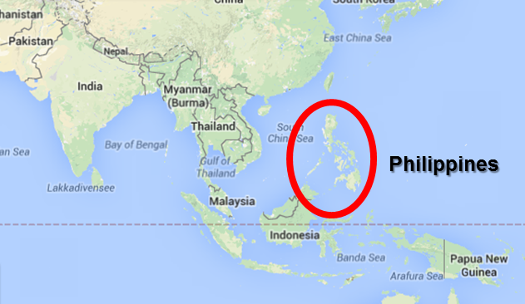

Figure 1. Geographical Map of the Philippines

**Agriculture in the Economy**

According to World Bank Statistics (2013), the country’s GDP reached $291.799 billion and ranked 39th among all other economies of countries throughout world. In terms of percentage share to the country’s nominal GDP, services sector accounted more than half of the country’s GDP at 56% and was followed by the industrial sector at 30% and lastly the agricultural sector at only 14%.

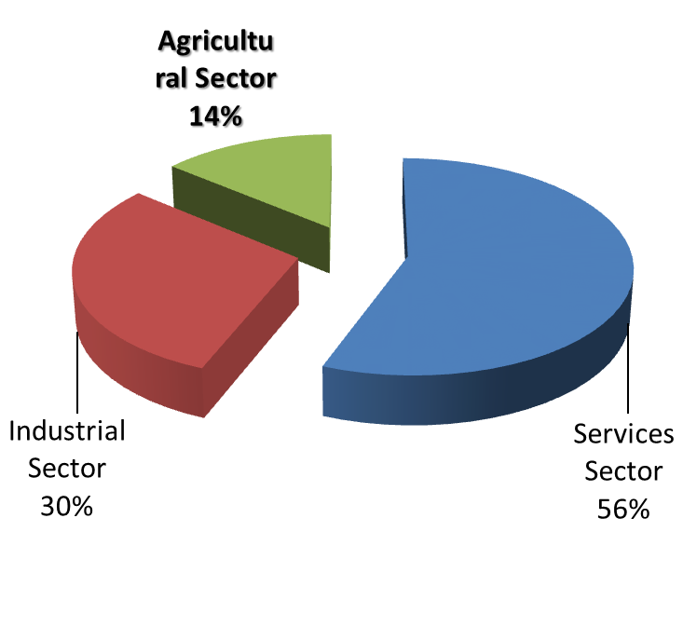

Figure 2. Percentage Contribution to GDP, by Sector

Several decades ago, the Philippine economy and employment was used to be dependent to its agricultural sector. However, this continues to decline up to present due to the government’s plan to industrialize the country as well as the reason that the population becomes less dependent on farming. As a result, the country’s agriculture sector’s importance has continuously dropped over the past decades from 29.7 percent in1946 to 14 percent in 2013 in terms of percentage share to the country’s GDP.

There are 4 sub-sectors that made up the whole agricultural sector of the country:1) crop farming, 2) fisheries, 3) livestock, and 4) forestry. The size of the activity ranges from small (backyard) activity for farmers’ subsistence to large (commercial) scale with focus on exports. Crop farming activities contribute around 50% of the share of agriculture in GDP. Meanwhile, other sectors contribute the following: 13% in livestock, 11% in poultry, 19% in fishery and 7% for other agricultural activities and services.

**Production**

Major farming activities in the country mainly include rice (21%) and corn production (6%). Rice production reached 18.44 million metric tons in 2013, 2.26 percent in the previous year. Meanwhile, corn production decreased to 7.38 million metric tons, 0.40 percent lower than the former year. Output declines were also noted for other major crops such as coconut, sugarcane, banana, coffee, abaca and calamansi. This decline was brought about by undesirable climatic conditions as well as the devastations of typhoons (e.g. Typhoon Bopha and Haiyan) in crop producing areas. Overall, the crops subsector failed to record output increment during the year. However, production in the livestock subsector showed improvement than the previous year. Hog and cattle production rose by 1.95 percent and 1.76 percent, respectively. Dairy had a 5.58 percent output gain. The poultry subsector came up with a 4.29 percent growth in production. All poultry components posted output increments. Chicken had the biggest expansion at 5.11 percent. The fisheries subsector recovered from the previous year's decline with a 1.24 percent increase in production in 2013. In totality, output increased by 1.76 percent.

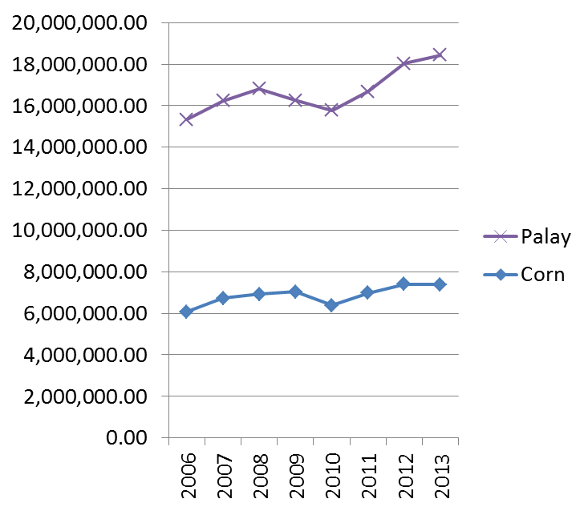

Figure 3. Rice and Corn Volume of Production

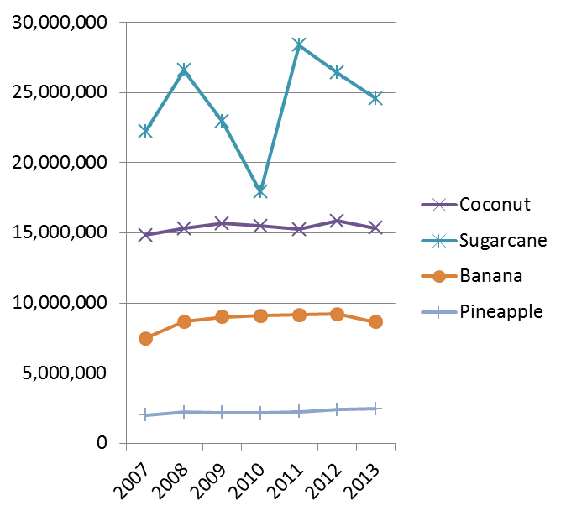

Figure 4. Top Export Commodities Volume of Production

**Agricultural Employment**

Based on records, the country had a total of 38.12 million employed people in 2013. From this, around 31% (11.84 million persons) were employed in the agricultural sector which was 1.93% lower than year 2011. In terms of nominal wage rates, farm workers were paid PhP 231.28 per day or per 8-hours of work.

**External Trade**

The total value of the country’s exports was US$ 6,318 million f.o.b. (*25.42% higher than previous years),* approximately 12% of the country’s total exports in 2013. The significant drop in 2012 were brought about by continued scarcity of supply of essential raw materials which are vital inputs for crop production and reduced crop productivity showing yields below global average. Despite these, coconut oil and fresh banana remained as top earners with a combined share of 30 percent in the total value of agricultural exports. Major markets for coconut oil were the United States of America and the Netherlands and for fresh banana, Japan and China. Meanwhile, tuna and pineapples constitute 18% share in the country’s total value of agricultural exports. Tuna products were mainly exported to USA and Germany while the markets of pineapples include USA and Japan.

On the other hand, expenditures on agricultural imports dropped by 4.49 percent. Wheat and meslin, soyabean oil/cake meal, and milk and cream and products, together, comprised 30 percent of the country's total value of agricultural imports. The United States of America was the leading supplier of wheat and meslin and soyabean oil/cake meal. New Zealand and USA were the primary sources of milk and cream and products. The country sustained agricultural trade deficit in 2013. Deficits were noted in the country's trade with Australia, USA and ASEAN countries.

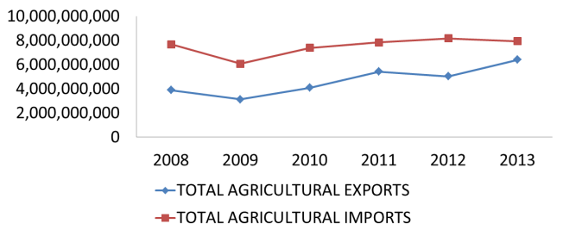

Figure 5. Total Value of Exports and Imports

**Prices**

On the average, farmers gained 2.18 percent from the prices they received for their produce in 2013. Meanwhile, prices for agricultural commodities have increased compared to the previous year. As an example, the price for cereals which include rice and corn rose by an average of 3.17 percent. Likewise, prices for crops and tubers, as well as fruits also increased. Poultry and livestock products posted the biggest price gains at 12.86 percent and 7.48 percent, respectively. Prices of fishery products went up by 1.03 percent. On the other hand, price cuts were registered for commercial crops at 4.62 percent and vegetables and legumes at 0.25 percent. Meanwhile, prices paid by consumers for food and non-alcoholic beverages were up by an average of 2.79 percent in 2013.

In totality, inflation rates were 3.0 percent for all items and 2.8 percent for food and non-alcoholic beverages in 2013. Producer price index in agriculture and consumer price index were 140.9% and 133.9%, respectively.

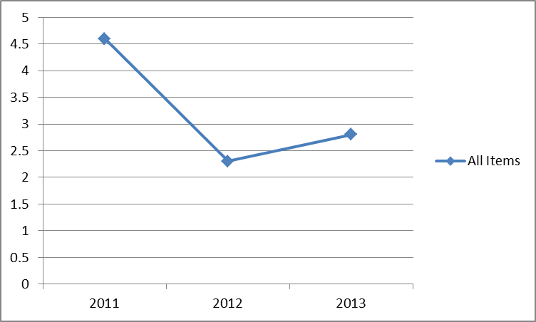

Figure 6. Annual Inflation Rates (All Items)

**Agricultural Support Services**

From the total national expenditure, around 5.54 % was accounted for agricultural expenditure. In 2013, the government expenditures for the agriculture sector amounted to P111.14 billion, higher by 26.03 percent from the 2012 record. This amount was mainly spent for irrigation facilities, farm to market roads, post-harvest facilities, agriculture and fisheries modernization and many others. The government has also sought to improve access to agricultural loans through the Agricultural Credit Policy Council (ACPC) Agricultural production loan, a mechanism that helps farmer finance their inputs to the process of production.

However, governance is still a huge block to attain significant progress in the Philippine agricultural sector. The ineffectiveness of the bureaucracy that is tasked with implementing agricultural development initiatives are among the major concerns. Analysts have pointed out that these implementing institutions are having difficulties on the following: over-centralization, politicization of the bureaucracy, lack of clear organizational framework, fragmentation/weak coordination, weak technical and managerial capability, unclear communication lines, unstable budget and corruption.

**References**

Albert, J. R. (2013). *How Important is Agriculture in the Economy?* . Retrieved from National Statistical Coordination Board Website: http://www.nscb.gov.ph/beyondthenumbers/2013/04122013_jrga_agri.asp

Bureau of Agricultural Statistics. (2013). *Overview of Philippine Agriculture*. Retrieved from CountrySTAT Philippines Website: http://countrystat.bas.gov.ph/?cont=9

Bureau of Agricultural Statistics. (2013). *Philippine Agriculture In Figures*. Retrieved from Philippine Statistics Authority Website: http://countrystat.bas.gov.ph/?cont=3

Central Intelligence Agency. (2013). *The World Fact Book: Philippines*. Retrieved from Central Intelligence Agency Website: https://www.cia.gov/library/publications/the-world-factbook/geos/rp.html#Econ