Public revenues and tax theory

1. **Public revenues**

* What we can include to public revenues? Try to enumerate several categories of public revenues and include various sources of public revenues to the each group.
* Which group of public revenues makes up the largest part of public revenues?
* What is the importance of public revenues for public finance and what is it for?
* What is the planned amount of public revenues for 2014 in your country (in % GDP)? How an economic crisis influenced the public revenues (mainly 2008-2012).
* Compare the size of public revenues with the size of public spending
* Compare the amount of public revenues in % GDP with other countries.
* What can you deduce from identified data?

Source: Eurostat (2015)

1. **Tax system**

* Try to define tax. What in relation to tax revenues means these principles - non-recovery, non-equivalency, non-voluntarily ?
* What functions do taxes perform? For each function, tell at least one example. (allocation, redistribution and stabilization)
* What is the difference between a tax and fee? Try to define the main differences. What fees do you have in your country? *(administrative, judicial, local)*
* Describe tax system in your country. Characterize individual taxes.

*Each tax has certain characteristics and according to them we can categorize taxes:*

* + *According to a linkage to taxpayer – direct and indirect taxes*
  + *According to a subject – wealth tax, income tax, excise tax, lump sum tax etc.*
  + *According to a tax rate– fixed and percentage (progressive, proportional, regressive)*

*Give an example from your tax system for each cases.*

1. **Tax revenues**

* What is the share of tax revenues in public revenues in your country?
* Which tax has the largest share in public revenues in your country? (try to find out shares for each taxes)
* Why do we rank social security and health insurance to the tax revenue?
* What does it mean tax quota? What is a difference between simple and compound tax quota?

**Tax quota – international comparison (2012, % GDP)**

Source: OECD.stat. (2014)

* Can we deduce according to the tax quota a characteristic of tax revenues and tax system in certain coutry?

1. **Tax efficiency and tax burden**

* Are there costs associated with tax collection? What additional costs except the actual tax payment you perceive?
  + Direct administrative costs (ie. connected with tax collection)
  + Indirect administrative costs (private sector bears)
* Deadweight loss = Excess burden
  + Imagine – taxes don´t exist. On a market with cigarettes is equilibrium – consumer buy what they want and producer sell what they are able to produce. Than government impose taxes (1,50$ for each package) to cigarettes because of citizens´ health. Because it is indirect tax – producers transfer this “additional cost” to consumers and price of cigarettes go up. People are forced to decrease a cigarettes consumption because of limited incomes and part of consumer replace it ie. tobacco, electronics cigarettes which are cheaper. Producers sell fewer cigarettes and limit their production.
  + To what losses and benefits and on what side (consumer, producer, state) in this situation come about? 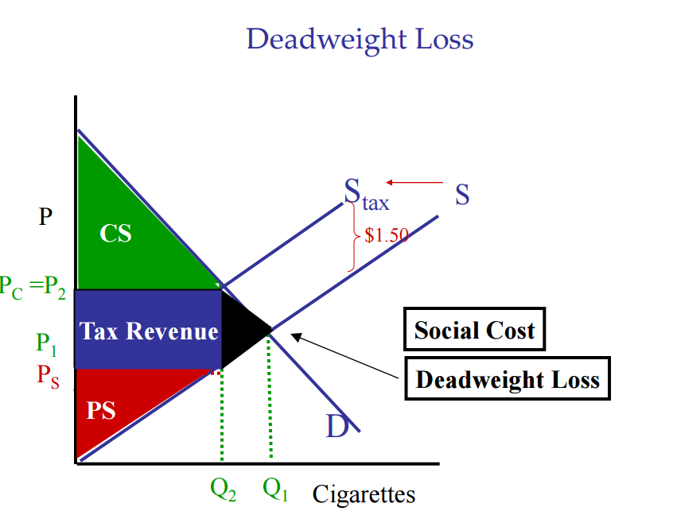

**Tax burden = tax + excess burden + administrative costs**

1. **Tax incidence**

* In other words – who bears the burden of taxes?
* An important distinction:
  + - Formal Incidence: Who is legally obliged to pay the tax.
    - Effective Incidence: Who actually bears the burden of the
* What is the difference between formal and effective incidence? What plays the most important role in effective incidence?
* Can you control, respectively. prevent effective tax incidence?

1. **Tax equity**

How can we judge the tax equity and fairness?

According what principles taxpayer should contribute to government (in form of taxes)? *Benefits-received principle, ability-to-pay principle*

What is more important – EFFECIENCY OR FAIRNESS????