**Marshall Plan** “European recovery program”

***Preface:***

The world economy has changed significantly during the 20th century, suffering two world wars and other major events. After the World War 2 (1939-1945) we witnessed a transformation in power in favor of the United States over the participating countries in that war.

Not only was Europe severely damaged after the war, but regulations regarding trade among countries were restricted, communism was still being spread, and needed to be contained by Capitalism –from the USA point of view-… those were the main reasons behind the Marshall plan which took place after the second world war and was in operation for four years beginning in April 1948.

***The launch of the project:***

The plan was basically created by State Department officials, and had bipartisan agreement by Republicans controlling the congress and Democrats controlling the white house with Harry S. Truman as a president. Secretary of state George Marshall addressed the urgent need to help Europe rebuild their economy in his speech in Harvard University (1947) drawing attention to what the USA is about to do, and proposing that the United States is willing to aid countries in need after the war.

Meanwhile, European countries had different perspectives and interests regarding the project, France for example wanted to make sure that Germany is not developing in a way to be a threatening power the way it was before the war, whereas the United Kingdom claimed that it can’t be treated equally to other countries as it had a long-lasting statues of being involved in the war, and if it were, it would receive too little aid.

In order to make the Project applicable, the Truman administration represented by William L. Clayton promised the concerned countries that they will be free to designate the plan themselves; nevertheless it would still have to be approved by the congress upon implementation. Agreement was reached and a proposal with 22$ billion was sent to Washington, president Truman however made the amount 17$ billion on the bill he sent to the congress, and after a long study the congress allocated 12.4$ billion to fund the project.

The USSR was offered to be included in the plan, although it was obviously destined to be turned down by Stalin, but not offering the Soviets any aid would have been regarded as a sign of distrust by the United States. Hence, Soviets were actually invited to negotiate the plan in Paris and soon enough rejecting to participate. On the other hand Soviets created another plan called “Molotov Plan” which can be considered as the Communist version of the Marshall plan, a plan that included countries not involved in Marshall’s aid and here we are talking about East European countries of course.

***The project in practice:***

On December 17th 1947 and before the plan was in effect, Italy France and Austria asked for immediate aid and the congress approved sending 40$ million in total to those countries and China also received money as well.

Turkey and Greece were the first countries to benefit from the plan, with strategic aspects being on the front line in the capitalism-communism dispute, the total amount spent over four years reached approximately 13$ billion and from this money $3.4 billion had been spent on imports of raw materials and semi-manufactured products; $3.2 billion on food, feed… $1.9 billion on machines, vehicles, and equipment; and $1.6 billion on fuel, most of the above mentioned products and commodities were imported from the United States <*Hogan>.

Financial aid was given to countries on a per capita basis; more money however was allocated to major industrial powers assuming that the revival of those countries will be in advantage of whole Europe, the table below shows Marshall Plan aid by country and year (in millions of dollars) from The Marshall Plan Fifty Years Later:

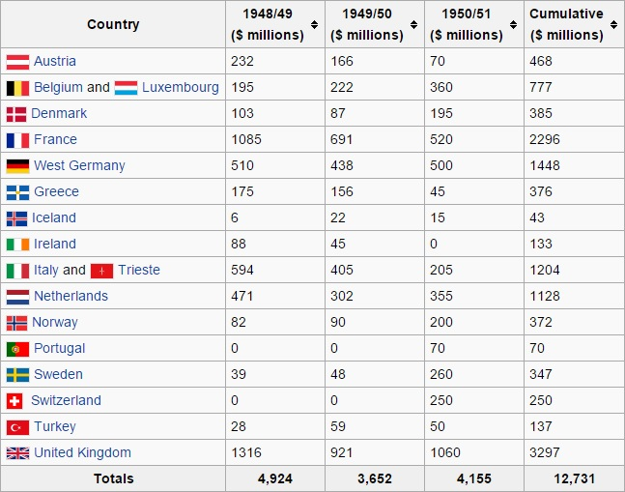

***Results:***

The project was criticized by many; some argued that the economic recovery must be based on capital accumulation, savings and private enterprise. Others suggested that the United States had already helped enough paying around 9$ billion in other forms and adding 13$ billion is simply too much! And many regarded the project as an attempt from the United States to dominate Western Europe as the Soviets controlled the Eastern part.

The question remains, did Marshall Plan work?

If we take a look at the countries participating in the project we can tell that those countries were able to make up for the drop in GDP per capita caused by the war, moreover, the years between 1948 and 1952 witnessed the fastest growth in the European history. And of course, all of the countries that accepted the plan never turned to the Soviet Union later on.

The graph below illustrates the GDP per capita for the most important countries related to the plan over the 90s:

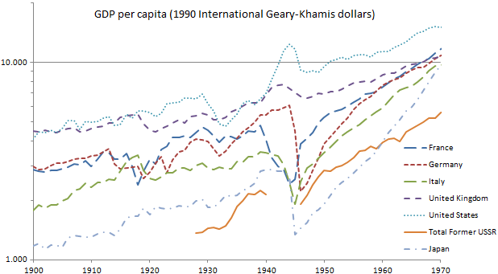

All in all, the Marshall plan is still regarded as one of the most important financial plans in modern history and its effects can be seen clearly over Europe.