MASARYK UNIVERSITY
FACULTY OF ECONOMICS AND ADMINISTRATION

Management of Change
The study text for the course Management 2
Ondřej Částek

Brno 2015
CONTENT:
1 Introduction 3
1.1 Need for change 3
Basic terms 4
1.2 Approaches to gradual changes 5
PDCA cycle 6
DMAIC, Six Sigma 8
Kaizen 10
Reengineering 13
1.3 Adoption of changes 18
1.4 Further and interesting reading 20
Literature 22

Introduction
The variability of economic reality at the turn of the 20th and 21st centuries, increasing globalization, efforts to find comparative advantages and changes in the internal environment of each society led to the overcoming of yet persistent management paradigms and raised pressure on the implementation of the changes. It is obvious that those companies that are not engaged in innovation of their production and remain on traditional management approaches may already have serious problems with their competitiveness and, as a result of that, even with their economic prosperity in the medium term.

Need for change
The environment in which businesses operate is changing. Many authors claim that it is changing even faster and more fundamentally. If we use the Toffler’s general framework (The Third Wave, 1980), then we can see these changes categorized according to similarities in three time periods – the waves. The first wave according to Toffler lasted thousands of years, the second wave of about 350 years, and the third wave, in most of the world, is just taking place in most of the world. Another respected author, Peter Drucker, writes about the so-called turbulent times (Managing in Turbulent Times, 1980) and about the age of discontinuity (The Age of Discontinuity, 1969). These changes are reflected in the creation and application of a series of approaches and methods of contemporary management practice. These are the approaches and methods that originated and developed in the last two decades of the 20th century and at the threshold of the 21st century as a response to dynamic changes in the external and internal environment of the enterprises.
For companies, it is not possible to remain constant in a changing environment. In strategic management, there are important concepts such as "alignment" and "adequacy". Internal environment of the company, its strategy and its environment have to be aligned (e. g. Scholz, 1987, Cameron and Quinn, 1999). Because the environment is largely beyond the control of the company and is changing (see the previous paragraph), the strategy and internal environment have to respond to these changing conditions continuously. This response can then mean the difference between the success and failure of the company on the market.
Changes play an important role not only at the corporate level, but also at the level of the whole economy. Joseph Alois Schumpeter (1883-1950) already previously expressed the idea that innovations play an important role in the economic development of market economies because they disturb the existing balance and, then again, they restore the balance on a qualitatively higher level. According to him, the innovation brings a profit to the innovator. It is necessary to invest this profit in increasing productivity, i.e. to capitalize it so that it is possible to remain in the given industry.

Basic terms
Change/innovation - positive, but also negative quantitative or qualitative movement of elements of the economic organism, or the relationships among them. According to the object to which the changes are related, there are material changes that focus either on the products (services), or on the technology (the elements and procedures of production), and changes in management, which are related to management approaches (e.g., organizing, motivating, communication, etc.).
Management of change (management of change, MoC) - this school of thought strives for a preparedness of reaction to external or internal stimuli (passive aspect) and is also focused on the choice of the subject of change, flexible preparation and implementation of the change and use of the changed subject (active aspect).
Invention - a qualitative change in the structure of the knowledge of the individual or company.
Nonconformity - failure to meet the specified requirement.
Correction - immediate, often temporary, measures to address the negative consequences of nonconformity.
Corrective action - the measures taken to eliminate the causes of an existing nonconformity, defect or another undesirable situation, in order to prevent their repeated occurrence.
Preventive action - the measures taken to eliminate the causes of possible nonconformity, defects or an undesirable situation, in order to prevent their occurrence.
Objective evidence - the information from which veracity can be demonstrated on the basis of the information obtained by observation, measurement, testing or other means.
As is evident from the previous text, changes are becoming an essential part of the functioning of each organization and for ensuring its prosperity. If the considerable effects are to be achieved, it cannot rely on spontaneous development or on the spontaneous initiative of employees. An important role of managers at all levels of management is the management of activities associated with the monitoring, preparation and, especially, the implementation of changes. The processes of management of change usually have the following steps:
- the determination of the need of change;
- the preparation and implementation of change;
- the adoption, stabilization of change.
These steps are sometimes called "Unfreezing – Changing – Freezing" (known as the Lewin-Schein Change Model). But there is a whole series of more or less general management of change methodologies. They are usually divided into two categories, which is approaches to gradual changes and approaches to radical changes. We will pay attention to some of them in the following text.

Approaches to incremental changes
Approaches to incremental changes rely on individual changes, that are rather small, but continuous. The essence of these improvement activities is usually the finding of a solution to a specific problem and the removing/correction of this problem. They are usually displayed as follows:

Figure 1: Incremental changes
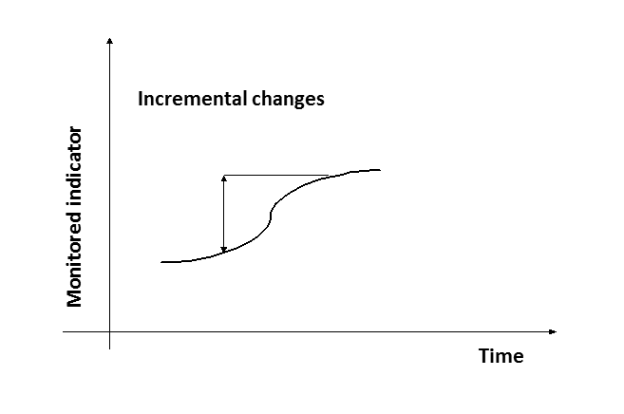
Source: VEBER, J. et al., 2000, adjusted.
We can encounter a wide range of procedures in literature and practice. Here, we mention the PDCA cycle, DMAIC and Kaizen. As an attentive reader may have noticed, all three of these terms are usually mentioned under the heading Lean Management. However, other courses deal with this term in a larger scale and more comprehensively, therefore, we will focus only on aspects closely related to the management of change.

PDCA cycle
Simple and often cited in the literature is the Deming improvement cycle (also known as PDCA cycle). As the name suggests, the authorship is attributed to American W. E. Deming (1900-1993), who is considered as one of the pioneers of quality management. However, the creator of the concept is Deming’s teacher W. A. Shewhart, who is considered as the spiritual father of the statistical regulation of processes. Deming popularised the PDCA cycle. The PDCA cycle is performed as the repeated sequence of four activities:
P Plan - plan a specific improvement intention;
D Do - make, carry out the planned intention;
C Check - verify the results achieved with regard to the intentions of the plan, etc.;
A Act - act in the sense of implementing any corrective measures or further introduction of improvements in practice.
A Finished PDCA cycle should be followed by a new cycle; the improvement activities should be continuous. The improvements do not have to be focused only on the manufacturing processes, but may focus on any activity carried out in the organization, whether commercial or non-profit.
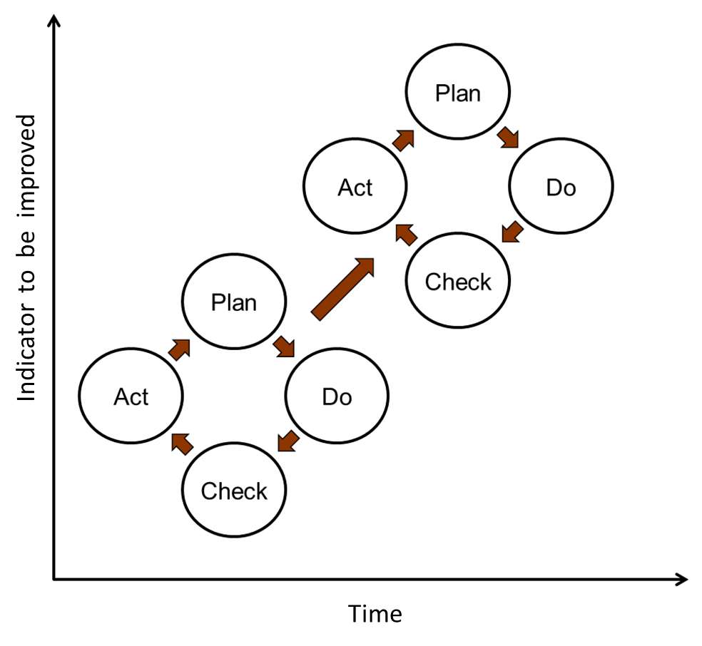
The Deming improvement cycle represents a transparent, but not very detailed instruction for improvement. That is why many companies (Xerox, Ford, VW, etc.) have created their own detailed improvement methodologies. As can be seen from the following examples, the greatest emphasis is put on the planning stage. You can also notice Deming’s focus on the statistical control of processes (e.g., steps 3.3 and 3.4).
Tab. n. XXX: PDCA cycle in detail
Plan | 1 | Define the opportunity for improvement
Plan | 1.1 | Select the process
Plan | 1.2 | Identify the customers and the suppliers of the process
Plan | 1.3 | Identify other interested parties
Plan | 1.4 | Map the process
Plan | 2 | Depict the current process
Plan | 2.1 | Describe the ideal output
Plan | 2.2. | Identify the nonconformity
Plan | 2.3. | Design real and ideal diagrams of inputs and outputs
Plan | 2.4. | Find the root causes (starters) of the activities and processes
Plan | 3 | Measure the current process
Plan | 3.1 | Ask questions
Plan | 3.2 | Collect the data
Plan | 3.3 | Describe the variability of selected check points of the process
Plan | 3.4 | Describe the patterns in the variability
Plan | 4 | Plan the change
Plan | 4.1 | Design the improvement
Plan | 4.2 | Summarize the proposed changes
Plan | 4.3 | Suggest people, who will be responsible for the implementation of these improvements
Plan | 4.4 | Design a plan for an improvement project
Do | 5 | Execute the plan
Do | 5.1 | Implement the improvement project according to the plan
Do | 5.2 | Monitor the implementation of the project
Check | 6 | Verify the achieved results
Check | 6.1 | Verify the methods for obtaining data about the new process
Check | 6.2 | Study the impact of changes
Act | 7 | Act on the basis of the findings
Act | 7.1 | Update the documentation
Act | 7.2 | Compile the next procedure on the basis of the executed improvement: If the change was successful, stay with it, if not, reject it. Will you build another PDCA cycle based on this executed improvement or not?

DMAIC, Six Sigma
The abbreviation, DMAIC, is similar to a PDCA cycle. Repeated performance is assumed with this method too. It means that after the performance of one cycle, another one should follow. And even this method is based on a significant use of statistical methods. It belongs to a set of techniques and tools for quality improvement called Six Sigma.
Six Sigma (sometimes denoted by the symbol 6σ) uses the instruments belonging to the more general set of quality management. The tools selected for Six Sigma methodology then create a comprehensive complex, whose task is to reach the desired quality level. The name Six Sigma refers to the level of 3.4 defects per million opportunities for defects (the so-called DPMO unit). Such a level (0.00034%) is reached if the variability of the process, compared to the set requirements on the process (or the quality of his output), is so low that twelve standard deviations (six on each side of the mean) of the measured properties of the process will still fit into the requirements on the value of the measured property. In other words, six sigma level is met as long as a process is set up in such as way as there are six standard deviations between the mean and the specified process limits (Tennant, 2001).
Example: The requirements are typically set by the upper and lower limit. So consider a process where it is necessary to drill a hole, and the hole diameter is the measured property. Because the drill bit is wearing out, the diameter is gradually shrinking. Further, the diameter is dependent on the clamping of the drill bit; if the drill bit is clamped badly, the diameter may also be bigger. Let's say that the desired diameter by a customer is 10 mm, while the customer accepts a smaller hole from 9.9 mm and a bigger one to 10.1 mm. The following graph shows forty consecutive measurements.
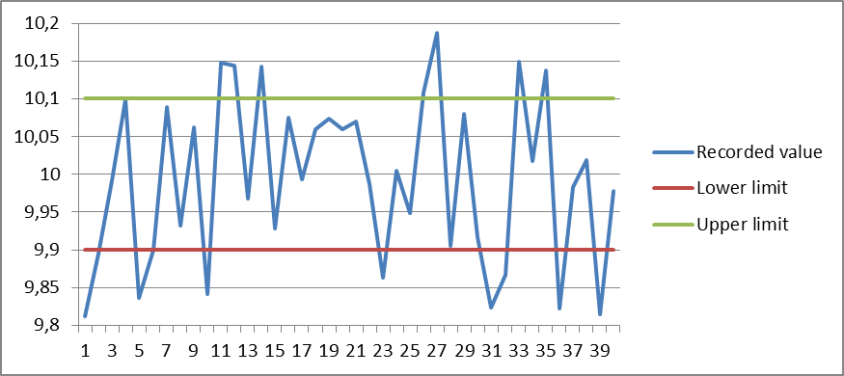

It shows that many measurements do not fit to the customer's requirements. This is, for example the very first measurement, but also the fifth, tenth, and many subsequent. Each such measurement means a reject was produced. There is a total of 16 rejects. The average diameter of the hole is currently 9.9933, the standard deviation is 0.109. Even +- one standard deviation does not fit the requirements of the customer, so it does not correspond to 1σ.
However, the name of the Six Sigma method does not mean that it is necessary to strive for the above-mentioned maximum, 0.00034% of nonconformity, (six standard deviations of the variability of the process within the upper and lower limit). Six Sigma offers an opportunity to strive for the level of quality that is required.
Let's get back to the DMAIC improvement cycle. It is one of many tools of the Six Sigma method, one of the most important, but this does not mean that it cannot be used as a more general framework for gradual improvement. It consists of five consecutive steps:
- Define
Define the goal and the problem that must be overcome in order to achieve the objectives (compare with the overall decision-making process, the phases of defining/identifying the problem, see, e.g., Blažek, 2014, p. 98 and further or Robbins, Coulter, 2009, p. 121 and further). Define the process that will be the subject of improvement, its activities, inputs, outputs, and customers. Also define the expectations of customers. The goal is to understand the problem, its context and the requirements related to it.
- Measure
Specify the appropriate indicators for measuring the key characteristics of the process. These are typically the dimensions that characterize the performance of the process. As was said above, Six Sigma is a set of tools based on statistical methods. These, of course, need the data that will measure what needs to be improved. Typical metrics (measured properties) are the time needed to carry out the activities/process, cost, flexibility (how fast the changes can be made), the variability of the process, or the quality (the degree of conformity with the requirements).
- Analyse
Analyse the acquired data: understand the causes of observed phenomena, especially the causes leading to the nonconformity and variability of the activities/process, or the causes of other phenomes that are not satisfactory. The use of the affinity diagram, the ishikawa (fishbone) diagram or the 5 Whys tools can be appropriate for a better understanding. The first two instruments are used especially for sorting of a bigger amount of data or ideas and building their causal relations. The 5 Whys tool is used for the systematic acquisition of data and ideas.
- Improve
Design a solution for the problem. When there are multiple possible variants of the solution, the general framework for decision making can once again be used, see Blažek, 2014, p. 107 and further or Robbins, Coulter, 2009 p. 121 and further. It is appropriate to model this solution and, if possible, to perform a simulation to verify whether the solution is feasible and beneficial. Further design the plan of implementation. The PDCA cycle can run within this step.
- Control
The word control here has the meaning not only check, but also, more generally, manage; it means manage the improvement operation (improvement process) in its new form. Furthermore, the main idea of this phase is to "keep the improving mood" and continue in the effort to achieve better results. In essence, it counts with the fact that the entire cycle will take place not once, but repeatedly – as with the PDCA cycle. Therefore, this phase gives a basis for the day-to-day management of the activities/process, so for the run of the new cycle. It is necessary to, e.g. document the new state of the activities/process, review metrics, whether they are still appropriate, revise the values of these metrics, etc.

Kaizen
Kaizen (Japanese for "improvement") is another method for gradual improvement. This method originated in Japan after the Second World War, and can be considered one of the reasons why Japanese production, then characterized by its very low price and very low quality, got to, at least in the context of the quality, its first-class level. Kaizen is, especially in English-language materials, known as a philosophy. It originates primarily from the fact that it is not just about the sequence of steps that should be followed, but it is rather a way of thinking. This aspect is, on the one hand, the source of the great success of Kaizen, on the other hand, it is often the reason why the implementation of this method lags behind management expectations.
Kaizen assumes that every member of an organization is involved in the improvement. Therefore, it is not a matter of the management of an organization and selected improvement team or the project team, but actually a matter of all the staff from operative employees, through the middle management to the top management. The involvement has, in practice, a form of proposals of improvement, however small they may be. It is even assumed that, unlike the previous two approaches (PDCA, DMAIC) or unlike reengineering (see below), the majority of the proposals will emerge from the operative employees. So this requires such a way of thinking, when workers should also take notice of the possibilities of how to improve their work and the work of others. This is related with attitude to work, with the inner motivation of each employee and, more generally, with the culture of the organization, which stems heavily from the country’s culture. More about these differences follows.
A common way of applying Kaizen looks like this: a formal mechanism is established, through which each worker can file a proposal for an improvement. It is even common that these proposals are not only expected, but also required. The number of such proposals per worker for a year might be additionally determined. The mechanism organizes the collection of proposals and their evaluation, usually either through senior staff of positions affected by the proposal or through the so-called "quality circles". Here are two possible approaches: either each member of organization is a member of a quality circle, or the quality circles are assembled from the best staff. The appropriate size of one quality circle is 5 – 10 workers. The quality circles typically meet regularly. It may be normal to meet even outside working hours in Japan or where line production is used.
With the proper application of Kaizen, every small proposal is considered. If the proposal is not recommended for implementation, the reasons must be explained.
The second way to obtain a proposal for change is a simple stopping of production as soon as a nonconformity, abnormality or error is spotted. Lighting devices indicating status of production lines/workstations are usually used for this purpose. Thanks to this, it is clearly visible if everything is working as it is supposed, or if it is necessary to stop work, and, in that case, also due to which workstation. Therefore, if an abnormality (nonconformity, error) is observed, the work of the entire line or workshop is stopped, staff gathers there, where the abnormality has occurred, and everybody looks for a way how not only to provide an immediate correction, but also how to ensure that this abnormality never occurs again. Thanks to the fact that the problem is dealt "now and here" and negotiations are attended by all involved workers, a solution is, at that moment, known to all and may be applied immediately. Compare with the typical behaviour in a Czech company: If there is nonconformity, the worker at whose working-place it occurred, deals with it. If possible, the worker addresses everything on his/her own, for one thing not to delay the others and for another that he/she would not be ashamed that the nonconformity occurred at their station. If the worker solves this nonconformity, the result is a) nobody takes care about prevention (“yet it is not their responsibility to prevent this nonconformity to happen again”) and b) the found solution is not generally known, so when this nonconformity occurs again, another worker will again wonder about how to solve this problem. But it is not just the Czech-Japanese cultural difference. One American author described the Japanese way as a great humiliation for the worker at whose workplace the nonconformity has occurred – because all the others were invited to go and see this incompetent person. This author did not examine whether the worker felt guilty, whether he was viewed like that by the others, nor did he deal with the positive effects of the publication of the mechanism by which the nonconformity was fixed and prevented for the future.
The ideal environment for Kaizen’s application is an organizational culture where staff comes with suggestions for improvement voluntarily. It means that the staff thinks about their work beyond the direct commands, they are not afraid to develop an individual, and are supported by management and other colleagues. We can observe significant differences in Kaizen in different countries because organizational culture is strongly determined by national culture. In first place is stated Japan, where Kaizen originated. Authors mention absolutely smooth application here, employees are committed to their work, they come with improvement proposals frequently and voluntarily, support of management is unreserved. If the employees are somehow rewarded for implemented suggestions, the reward is rather symbolic, for example lunch in the employee canteen, without regard to the effect the improvement actually brought. In the USA, it is common to motivate staff to propose improvements with a reward that represents the percentage of saved costs. This approach produces a high number of proposals, but the disadvantage of such reward is that these proposals are trying to maximise savings. While maintaining the essence that the majority of the proposals come from the operative employees, it happens that the vast majority of the proposals are not feasible: operative employees do not have a good enough knowledge of all parts of the process on which their proposals focus in an attempt to maximise the effect. While the Japanese proposals aim to improve the activities and processes with which the proposer is very familiar – they usually carry them out – the American proposals cannot be so successful with these settings. Another chapter is an implementation of Kaizen in the Czech Republic. The idea to introduce Kaizen itself must come out from the top management, but the whole organization must then be involved, of course. However, the typical organizational culture at the level of the operative employees in the Czech Republic is not open to voluntary activity beyond the scope of an exactly prescribed task. So it happens that the proposals for improvement become part of these prescribed tasks: for example a minimum number of proposals is set for a worker for a year and there are even (financial) penalties for failure to comply with these numbers. The low quality of the proposals then comes from the fact that it is an obligation.
The great advantage of changes initiated with Kaizen is that it comes from the people that have the best knowledge of the activities/process that should be improved. These people will be also affected by these changes. If we add the fact that these are continuous but small changes, we can get the reasons why changes driven by the Kaizen method are very well received by staff. Some authors even claim that our brain is "programmed" in the way that any, even positive, changes cause concern and fear. The brain tries to resist the changes, but when we start with small steps, as Kaizen says, we will effectively reshape our nervous system, because we reduce the brain's response to fear. The disadvantages of this method usually arise from the bad support of management or a wrong implementation or non-compliance of this "philosophy" within the organizational culture.

Reengineering
Business Process Reengineering (BPR) is the branch of the management of change that looks for an opportunity to succeed in the radical changes that are oriented mainly towards the field of management. The aim of the reengineering project is not to realize a small improvement, but fundamental changes that will not lead to shifts of 5-10%, but, e.g., to a reduction in the losses from scrap and claims by 50%, shortening the production periods by about 80%, an increase in the use of available capacity by 30%, reducing storage times by 40%, cost savings of 10 to 20%, etc.
Reasons for the use of BPR
Reason | % | Reason | %
Costs cutting | 84 | To outperform competitors | 50
Quality improvement | 79 | Organizational structure change | 35
Capacity increase | 62 | Other | 9
Source: Thorton research.
The origin of reengineering dates back to the early 1990s. An article by Michael Hammer Reengineering Work: Don't Automate, Obliterate (1990), is determined as being the first work on this topic. Followed by a great development in the first half of the 1990s with a certain sobering up in the second half, the first phase was, to a certain extent, non-critical, the rest of the decade was, on the contrary, maybe too critical of this method. Reengineering is at the edge of interest today, but you cannot dismiss it completely. Many elements from reengineering can be today found in the currently very popular Business Process Management methodology.
The creation of reengineering was largely made possible by the advancement of information technology, with which reengineering projects were subsequently usually connected. Information technology allowed the achievement of existing targets by completely new ways. It has also become the essence of reengineering.
Using the definition of Hammer and Champy (1993): reengineering is "the fundamental rethinking and radical redesign of business processes to achieve dramatic improvements in critical contemporary modern measures of performance, such as cost, quality, service, and speed." When defining reengineering, in first place, its focus on radical improvements tends to be emphasized. However, this itself does not give an instruction on how to achieve such an essential improvement. Another characteristic is that reengineering projects should not try to improve existing processes, but they should to try to design completely new processes, they should build on a "green field". The third characteristic is a focus on processes.
Practical instruction on how to work with processes was the main benefit of the authors dealing with the reengineering concept. One has to realize that the paradigm of functional management, with all its disadvantages, dominated in the early 1990s. Although there were earlier efforts to make organizational structures more flexible, reengineering has put processes in the first place. Its principle is not to be bound by the way processes are carried out now, but to start from what is supposed to be the output of the process. Totally new ways of setting up processes were often found due to the rapid development of information technology and due to the extensive application of the principle of the functional specialization in the previous period. The way of setting up teams should help this as well. In a good team executing a reengineering project there should be, in addition to people with perfect knowledge of the current state and, if possible the customers of the process, also people who do not know the original state at all. An advantage is, if they are not even from another part of the company. This prevents so-called organizational blindness. This role is often performed by external consultants from companies engaged in advisory services.
A reengineering project should consist of three phases: 1. analysis of the current state, 2. planning a new state and how to achieve it, and 3. realization. Although reengineering is put in contrast with PDCA, DMAIC models or Kaizen methodology, which are called methods of continual improvement , it does not mean that a company should resign from its efforts on further improvement after finishing a reengineering project. On the contrary, even the authors of this concept state that, after the completion of a reengineering project, it is possible to implement the above-mentioned method (PDCA, Kaizen, ...) for incremental improvement and use them until a time when it will be an appropriate situation for another reengineering project.
The company should stay focused on the processes management after the implementation of the reengineering project. A role of process owner should be created for this purpose. The process owner takes care of the implementation of changes of “his/her” process during the reengineering project, and continues to control the process after the completion of the project: authorizes process variants, updates the documentation, monitors the defined process metrics and deals with other possible improvements of the process.
The above-mentioned characteristics of reengineering (a focus on processes, "green field"), which should lead to "dramatic" improvements, are still too general to be of a practical use. Therefore, Hammer and Champy (1993) summarize some of the principles observed in companies during implementation of actual reengineering projects:
- several tasks are joined into one – compare to Taylorism, a high specialization and resulting advantages and disadvantages,
- workers are deciding – decisions should be delegated as closely as possible to the place where the decision is executed. Authority and responsibility should be delegated. Compare with Blažek, 2014 – Rozhodování pp. 90 a 181 or Robbins, Coulter, 2009, pp. 188-189). It is also an enrichment of work, which can have motivational effects. However, the knowledge of X and Y theory must be considered (see Blažek, 2014, p. 175 or Hersey et al., 2001, pp. 59-60 or Robbins, Coulter, 2009, pp. 342-343),
- steps of the process shall be carried out in a natural sequence – this principle comes instead of a sequence of tasks according to the principle of functional specialization. Again, this is opposite to higher specialization, with all its advantages and disadvantages. At the same time, pursuing "de-linearization" must be ensured. That is, the tasks that are possible to carry out parallelly, without waiting for finishing another task (linear work).
- processes can be executed alternatively – end of standardization, the same process may have more variants, depending on the requirements of customers,
- work is carried out where it is the most reasonable – the most reasonable does not mean the cheapest per one operation/product, but optimal from the standpoint of the monitored metrics, which can be not only costs, but also time or quality. Again, this is a suppression of functional specialization,
- quality checks and conciliation procedures are reduced – this is, for example, one of the points of lean management: To produce in the required quality at first go, so there is no need for quality check, since these do not provide a value to the customer,
- the manager of the "case" is the single contact point —a new managing position is created, and so, in cases where the tasks of a process are so scattered and complicated, that it is not in the power of one person to integrate them. The manager then acts as an mediatorbetween the process and the customer,
- the hybrid centralized/decentralized operation prevails – neither the principle of centralisation/decentralisation or functional/product specialization gets a prejudicial preference. For each process or its part are always considered all options.
Although there are no exact statistics, it is reported that many of the projects (often more than 50%) end in failure. The causes can be found in the low involvement of senior management in the reengineering projects, or even in the sabotaging of reengineering efforts that could change the status of specific managers. The cause, however, may be also the hurriedness during project implementation, the lack of explanation and justification of the need of reengineering to workers, etc.
One can see that these causes are primarily related to the human factor. Part of the criticism of BPR also focuses on work with human resources. Reengineering efforts often result in a significant reduction of human resources. Some authors state that the reengineering label served to justify the mass dismissal. Also, as we have said above, reengineering projects were connected with the introduction of new technologies. These often replaced people and formed the basis of new processes (often were new processes adjusted to IT, not IT to processes). Last but not least, problems lay in communication. While, for example, with the Kaizen method, we positively assessed the fact that those that proposed the change are also the subject of this change, and therefore adopt it better, this does not apply to BPR. While top management usually initiates BPR, workers are involved in the planning, but not all of them. In addition, for many of them it means termination of employment or a fundamental change in their job description. This requires that the initiators and executors of changes explain these changes very well, defend them, expand awareness about them, and also explain the reasons for the change, its urgency and, of course, the benefits that a BPR project will bring. In reality, it did not always happen in an ideal way.
Further criticism claims that reengineering does not bring anything new; it just introduces a new word for what has already been done many times. Also, that this is a fashion method, whose popularity rises not from its benefits, but from the fact that a number of consulting companies, which play the role of external members of the BPR teams, are capitalizing on it.
Furthermore, it is necessary to add that reengineering is often focused on streamlining the middle management. It claims that middle management is only delaying and distorting the communication between top management and operational management, and that not only can the organization survive without the middle management, but it will even increase its effectiveness. The opposite to this is the opinion that middle management is a place of aggregation of knowledge in the organisation and middle management passes this knowledge between the top management and operational management. It is important to note that the development of Management Information Systems (MIS) really allowed the transfer and data aggregating from the lowest levels of organizational hierarchy to the top management in a whole new way. On the other hand, it is also important to note the differences between the concepts of data and information, with which MIS works, and concept of knowledge (CURLEY, K. F., KIVOWITZ, B., 2001, pp. 21 - 29).
However, despite all the difficulties that BPR brings and the criticism that BPR takes, there are studies that stand up for BPR. For example, W. Hamsher (1993) states that 60 % of companies from Fortune 500 reported using BPR in 1993.
Comparison of BPR vs. Kaizen
 | Reengineering | Kaizen
Who carries out | Usually, outside consultants, top management, teams made up of the members of various departments. | The people that actually do the work being improved.
Duration | This is a project with a fixed start and fixed end. | Long-term, never-ending.
The type of appropriate processes | Processes, which go across various departments, with a complex relations to other processes or with complex relations between the tasks of given process. Processes that include comprehensive and integrated technologies. Processes with at least some degree of repetition. | Well bounded processes, whose majority is under the control of the Kaizen team (or the quality circle), that include a little IT, or this IT is not complexly linked , with short, often recurring cycles.
Scope | The whole value chain. | In theory, the whole valuechain, but a specific improvement is usually focused on one task or a few tasks.
Degree of changes | Radical changes, usually affect the whole process. | Incremental changes (but can also be radical) that usually affect just one task or a few tasks.
Speed | Common is to strive for "big bang", however, due to the scope, the typical duration is more than a year (including the phase of analysis and planning), or a duration of months, in case of implementation. | Typical for Japanese management methods is not to hurry. However, due to the small size of the changes, they can be quickly implemented and their effect can be quickly measured.
Acceptance | A high risk of project failure, for example because workers return to old procedures as soon as the door close behind the consultants. | High – people are proposing changes to something they do themselves and that are related to them.
Costs | Typically high costs of new IT systems, consultants, etc. | Usually either low or zero.
Technology | In the first phase (1990s) a large reliance on technology, it is difficult to estimate to what extent this remains today. | It rather relies on the elimination of technology, it prefers simplification and visualisation.

Adoption of changes
However well intentioned the change may be, it is quite usual that it meets with disapproval or a rejection of those who are involved. In English, there is even the saying "better the devil you know than the devil you don't". How is it possible? Any change, and therefore a change for the better, requires increased efforts. We can imagine several variants of an existing state. With variant a), the worker can consider the method of the process or the activity’s execution as ideal, with variant b), as acceptable/reasonably good, and with variant c), as rather poor. It is obvious that with variant a), almost nobody is willing to accept the change or strive for it, with variant b), similar applies and still it is not surprising. However, especially the initiators of change (e.g., top management) will be surprised that even with state c) the change is not taken positively. Just for this situation, the mentioned English saying fits, which expresses that we do not have to be completely satisfied with what we know or what we do, but it still represents less risk or stress than going into a complete unknown.
Another factor of negative attitudes can be the thinking style "if it worked until now, why should it not continue working" – without thinking about how market environment, available technologies, customer requirements and infrastructure have changed. Such a limited perception is typical for operative employees. However, in some situations, this negative attitude can also arise from deeper values and basic assumptions. Compare Lukášova (2010, pp. 19-29) or Schein (2010, pp. 23-33).
There are multiple models of human response to change. We will present one of them, based on the work of Kübler-Ross, E. (1969) On Death and Dying. This model, sometimes called The Change Curve (which is a general name for these models) identifies the four typical phases of the response to a change:
- Status Quo: Shock, denial
- Disruption: Anger, fear
- Exploration: Acceptance
- Change: Submission/commitment
These phases do not all have to occure, do not have to last the same time and do not have to have an equally strong impact on the human psyche, because each person is different. It may happen that in the same situation one person stagnates in one of these stages, while another overcomes them relatively quickly. Somebody else can skip, for example, the first or second phase. Everyone may need a different impulse for movement to the next phase. Notice the word “fear” in the second phase. Even a well-intentioned change may induce fear of the unknown, or fear of loss of control over what is happening or will happen. Often this happens subconsciously, so it is harder to argue against such a fear, overcome it or help to overcome it.
As long as people that are affected by the change remain in the second phase, the change will not be successful. In the third phase, people stop focussing on what was and what they lost, instead they begin to explore a new status, see what good or bad it actually brings, and also discover how to adapt to the new status. In the fourth phase, people move from "reconciliation" with a change to its actual "adoption", i.e., identification with the new state, its legitimacy and contribution. Here the risk of returning to the original state before the change is minimized, therefore it should not happen what we described as "as soon as the door close behind the consultants, we'll do it again our way" in the chapter on management.
The negative consequences of the changes may even be not only psychological but also physical. An example is so-called cultural shock, which is caused by a change of cultural environment. In some cases, it may result in increased sickness rate, etc. Because this is a specific kind of change, there are also specific corrective measures (see "culture shock treatment", etc.). Another example is mentioned by A. Toffler in his work (Future Shock, 1970): the increased pace of change in our environment and its deepening severity are contributing to an increased sickness rate of sensitive or more-involved individuals.
How can employees be helped with the acceptance of changes? The simplest seems to be a situation where the changes are small and those, who are affected by the changes, participated in their planning. These are also the characteristics of Kaizen. But there is no consensus on the following. While constant changes (the aim of Kaizen) are defended in a way that the human brain gets used to them and they do not have to raise fear or stress, some authors state that it is better to wait with another change even after a small change.
What all authors agree on is the need for communication. The changes must be explained not only well and in time, but also justified. For the affected staff, it must be clear why they have to leave the existing status and spend increased efforts on reaching of a new state. It is necessary to present facts, examples and arguments for the change and against it. It is necessary to give people the time to absorb the given information, so in some cases it needs to be given in doses. It is also necessary to take into account that each personality is different, is motivated by something else and, therefore, other stimuli will be effective, that everybody has different values, which manifest in their behaviour and work.
Support to verbal communication may be so called "walk the talk", i.e., "to perform actions consistent with one's claims", which is especially useful for changes of organizational culture. Additional support may be the highlighting of achievements or setting the remuneration system in accordance with the desired new behaviour. In this last case, it is necessary to pay attention to the fact that the remuneration system can lead to changes in behaviour, but may not change the deeper elements of personality – attitudes, values, basic assumptions. In the long run, for people that behave in disharmony with their values (attitudes, base assumptions), there is growing dissatisfaction, subconscious tensions and discomfort, which may entail to higher illness rate or higher fluctuation.

Further and interesting reading
In Czech:
The system of elements of the organizational culture, the characteristics of these elements. From this, difficulties result in the implementation of changes in general, and in the implementation of changes to the organizational culture.
In particular p. 19 – 29: LUKÁŠOVÁ, R. Organizační kultura a její změna. 1. vyd. Praha: Grada, 2010, 238 s. ISBN 9788024729510.
An interesting method of innovation management. It deals rather with the content of the changes – how to find a solution to a problem on the basis of a solution found previously for similar problems.
Michal Jirásek - Implementace inovační metody TRIZ v podniku. Diplomová práce, MU, Brno 2015.
A practical view on process management with regard to the implementation of the changes.
In particular, p. 15 – 68: ŘEPA, V. Podnikové procesy: procesní řízení a modelování. 2. updated and extended pritn Praha: Grada, 2007, 281 s. ISBN 978-80-247-2252-8.
In particular, p. 20 – 28: ŘEPA, V. Procesně řízená organizace. 1. vyd. Praha: Grada Publishing, 2012, 301 s. ISBN 9788024741284.
In English:
An investigation of reengineering projects' effects.
ALTINKEMER, K., OZCELIK, Y, OZDEMIR, ZD. Productivity and Performance Effects of Business Process Reengineering: And Firm-Level Analysis. Journal of Management Information Systems. 27, 4, 129-162, 2011. ISSN: 07421222.
An article about reengineering from one of its founding authors.
DAVENPORT, TH; STODDARD, DB. Reengineering: Business Change of Mythic Proportions?. MIS Quarterly. 18, 2, 121-127, June 1994. ISSN: 02767783.
An article about continuous improvement: how to build highly sustainable involvement of employees. Based on qualitative research.
BESSANT, J., CAFFYN, S., GALLAGHER, M. An evolutionary model of continuous improvement behaviour. Technovation. 21, 67-77, Jan. 1, 2001. ISSN: 0166-4972.
An article about actual Kaizen implementations in several Japanese companies of the steel and automotive industries.
BRUNET, A., NEW, S. Kaizen in Japan: An empirical study. INTERNATIONAL JOURNAL OF OPERATIONS & PRODUCTION MANAGEMENT. 23, 11-12, 1426-1446, 2003. ISSN: 01443577.
A study about factors of employee acceptance of Kaizen events, based on 65 events in 8 manufacturing organizations.
GLOVER, W. J., et al. Critical success factors for the sustainability of Kaizen event human resource outcomes: An empirical study. International Journal of Production Economics. 132, 197-213, Jan. 1, 2011 ISSN: 0925-5273.

Literature
Some of the titles listed below are available in new editions. The older editions are listed here because they are available in our faculty library.
- ANDERSON, Ch. How Are PDCA Cycles Used, Bizmanualz.com, June 7, 2011, available at http://www.bizmanualz.com/blog/how-are-pdca-cycles-used-inside-iso-9001.html.
- BLAŽEK, L. Management. 2nd ed. Praha: Grada, 2014. 211 p. ISBN 978-80-247-4429-2.
- CAMERON, K. S.; QUINN, R. E. Diagnosing and changing organizational culture : based on the competing values framework. Addison-Wesley series on organization development. (1999): ISSN: 0201338718.
- CURLEY, K. F., KIVOWITZ, B. The Manager's Pocket Guide to Knowledge Management. Amherst, Mass : HRD Press, 2001. ISBN 9780874256413.
- DRUCKER, P. Managing in turbulent times. Harper & Row New York, 1980. ISBN 0060110945.
- DRUCKER, P. The age of discontinuity; guidelines to our changing society. New York: Harper & Row, 1969.
- HAMMER, M. Reengineering Work: Don't Automate, Obliterate. Harvard Business Review. 68, 4, 104-112, July 1990. ISSN: 00178012.
- HAMMER, M., CHAMPY, J. Reengineering the Corporation: A Manifesto for Business Revolution. Harper Business, 1993. 223 p. ISBN 0887306403.
- HAMSCHER, W. AI in Business-Process Reengineering. AI Magazine, Volume 15, Number 4, 1994.
- HERSEY, P., BLANCHARD, K. H., JOHNSON, D. E. Management of organizational behaviour: utilizing human resources. 7. ed. New Jersey: Prentice-Hall, 1996. xxv, 627 s. ISBN 0-13-244112-8.
- KÜBLER-ROSS, E. On Death and Dying. Routledge, 1969, ISBN 0-415-04015-9.
- LUKÁŠOVÁ, Růžena. Organizační kultura a její změna. 1. vyd. Praha: Grada, 2010, 238 s. ISBN 9788024729510.
- ROBBINS, S.P., COULTER, M. K Top Management 10th ed. Upper Saddle River: Pearson Prentice Hall, 2009. xiv, 565 s. ISBN 9780132090711.
- SCHEIN, E. H. Organizational culture and leadership. 4th ed. San Francisco: Jossey-Bass, 2010, xvi, 436 s. ISBN 9780470185865.
- SCHOLZ, C. Corporate culture and strategy— The problem of strategic fit. Long Range Planning. 20, 78-87, Jan. 1, 1987. ISSN: 0024-6301.
- TENNANT, G. Six Sigma: SPC and TQM in Manufacturing and ServiceS. Gower Publishing Company, Burlington, 2001. ISBN 0-566-08374-4.
- TOFFLER, A. Future Shock. Bantam Books, 1970. ISBN 0-553-27737-5.
- TOFFLER, A. The Third Wave. Bantam Books, 1980. ISBN 0-553-24698-4.
- VEBER, J. et al. Management. Základy, prosperita, globalizace. PRAHA : Management Press, 2000. ISBN 80-7261-029-5.

Pragmatic approaches, focusing managers on the practical benefits of innovation prevail in connection with innovation in the current management literature. It also reflects in the pragmatic definitions, when the term innovation refers to practical applications of ideas that focuses the organization resources more effectively.
P. Drucker states that "we cannot control the changes ... Change is out of control, chaotic, unpredictable. It can subvert all plans and turn the organization upside down. Instead of worrying about the inevitable chaos, you should expect it and face it. "
See also so called Schumpeter's ”Triad”: invention – innovation – imitation.
“Deming preferred to call it PDSA or Plan, Do, Study, Act because he felt that “check” emphasized inspection over analysis.” ANDERSON, Ch. How Are PDCA Cycles Used, Bizmanualz.com.
Sigma is from the Greek designation for the standard deviation.
Paradoxically, this issue is handled in more detail in an earlier version of this book, for example, in the 7th edition, available here: http://sirpabs.ilahas.com/Management,%207e,%20Robbins-Coulter%20 (Student% 20Ed.). pdf
Allegedly used, e.g., in first half of 20th century in Baťa’s factories.
See the cultural differences and the different perceptions and different interpretations of the same reality by different persons (compare: basic assumptions).
It is possible that this is a somewhat idealised idea.
Available from MU network or through proxy settings here: http://search.ebscohost.com/login.aspx?direct=true&db=nlebk&AN=135977&site=ehost-live
Do not mix it up with the well-known DABDA model from the same author, describing the stages of grief. The DABDA model laid the foundations for the here-presented model, used in management.

