**MASARYK UNIVERSITY**

**FACULTY OF ECONOMICS AND ADMINISTRATION**

**BPH_EPS1 Enterprise Resource Planning Systems 1**



Operations Management: seminar work

*Utilization (application) of the Theory of Constraints (TOC), Critical Chain Project Management (CCPM) as a Project Management Methodology based on TOC principles.*

Evanthia Vatsika, [452425@mail.muni.cz](mailto:452425@mail.muni.cz)

eva.vatsika@gmail.com

Brno

20/4/2016

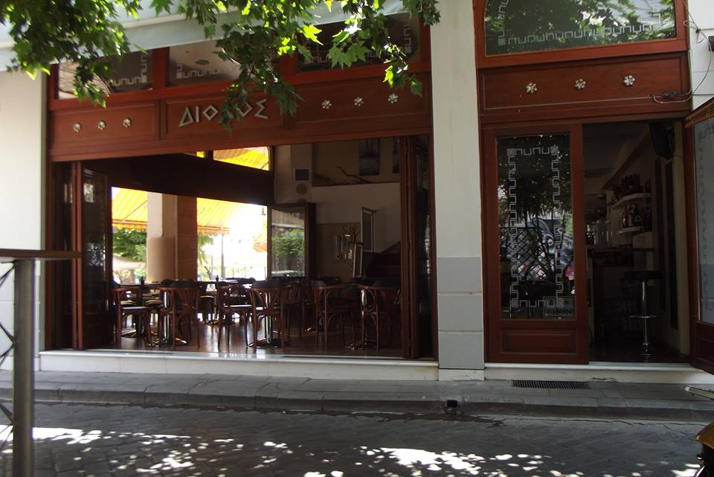

Contents

1) The Project 3

2) How would you apply CCPM and TOC tools (e.g. CRT=Current Reality Tree) for the planning of your own dissertation work (writing the dissertation is in fact a project)? Can you name the main project risks? Do you know how to diminish (to reduce) these risk factors (to avoid obstacles)? 3

3) What kind of effects do you expect by possible using buffers (time buffers) during the working out of your thesis (dissertation or other chosen project)? Can you explain what the time buffer is. How you can measure reached results (used metrics such as time, resource capacity, costs, goodwill and so on). 9

4) Can you specify by use of Thinking Process Tools your personal bottleneck as far as studying processes or writing a work or working on assigned school tasks (by other tutors) is concerned? Create CRT (see full meaning above) and create a list of Undesirable Effects (named by you as it was mentioned already in clause 1) 10

5) Create with use of already existing set of UDE´s Ishikawa fishbone diagram and put some weights meaning numbers specifying an importance of assign reasons. It was clearly shown in Ishikawa FBD power-point presentation. Based on the set of assigned score create Pareto Lorenz curve. The principle is also show in just mentioned presentation. Specify most important reasons. Compare with root problem found by use of Current Reality Tree. 12

6) State clearly your suggestions how to improve your dissertation writing (or any other chosen project) and related benefits. 15

References 15

Appendix 16

# The Project

The project which will be analyzed in this assignment is based on a family business, a cafeteria located in a city of western Greece. The owner, seeing that the clientele is declining, he wants to make a change in his business in order to introduce something new and attract more customers. For this reason, he thinks that a renovation of the cafeteria will catch their notice and ultimately the profits will be increased. The owner is willing to spend no more than 20.000€ and he expects that the time that the cafeteria will be closed will not exceed the 20 days. The pay-off period for the renovation is expected to take 6 months.

# How would you apply CCPM and TOC tools (e.g. CRT=Current Reality Tree) for the planning of your own dissertation work (writing the dissertation is in fact a project)? Can you name the main project risks? Do you know how to diminish (to reduce) these risk factors (to avoid obstacles)?

The initiator of the TOC and CCPM Eliyahu M. Goldratt, begins his theory with a question: what is the goal of a company? Every company is built to achieve a purpose and for a profit oriented company, the goal is nothing else than “to make money in the present as well as in the future”. He also states that every goal carries some necessary conditions that must be satisfied before the goal can be accomplished. Some potential necessary conditions could be: (1)

* Quality
* Competitive advantage
* Technology Leadership
* Cash flow
* Satisfied employees

In our case, taking into consideration that the city has a big number of cafeterias, the owner must think of something that distinguishes his business from the others. The quality can be seen by the quality of the products he sells, for example one of the best brands of coffee, fresh juices, fresh snacks and trusted brands of alcohol and other drinks.

The company’s competitive advantage could refer to something that distinguishes his cafeteria from others. For example, he can serve piece of cake to his customers for free with their coffee. This will distinguish him from other ordinary cafeterias and customers are going to receive it as better quality of service and a more caring and friendly place to visit for their coffees and meetings.

The technology leadership can be found in the machines that are used for the coffee preparation and every other product.

As far as the cash flows are concerned, the owner acquires another cafeteria operating while the other is being renovated, therefore he will diminish the cash flow problems. Furthermore, he has also taken a loan of 20.000€ to invest only on this project.

The most important factor of working in a cafeteria is the day-to-day interaction with people. Subsequently, all the employees should have a friendly, helpful and polite approach to the customers. If they are satisfied with their working conditions and with their employer, this positive behavior will be apparent in their everyday work.

In addition to the goal, we need some measurements which will enable us to evaluate the progress and the results of our decisions. Some measures of the financial impact could be:

* Net profit
* Cash flow
* Return on Investment

If we want to measure the impact of the day-to-day action to the goal, we can use the following:

* Throughput: the rate at which the systems generates money through sales. We should note that the throughput doesn’t correlate with the output which is the inventory that may be sold or stored in a warehouse.
* Inventory: All the money that the system invests in purchasing things it intends to sell.
* Operating Expenses: All the money the systems spends in turning inventory to throughput.

**The Theory of Constraints**

According to Goldratt, organizational performance is governed by constraints which prevent an organization from maximizing its performance and reaching its goals. These constraints, or restrictions, can involve people, supplies, information or even policies(2). The theory continues suggesting, that every system has at least one constraint that limits its performance- this is the system’s “weakest link” or its bottleneck. We can identify and deal with the bottleneck by applying the TOC which includes the implementation of the following “preparatory” steps, as they apply to our case:

* 1. Identify the goal of the system/organization.

Do a renovation of the cafeteria which will attract more customers and ultimately increase the profits. The machines should be kept the same, but the furniture, their arrangement, the colors and the decorations will be changed. The budget of this work is 20.000€.

* 1. Establish a way to measure progress to goal.

During the renovation period, the owner can measure the progress by the phases that are being completed, as they are presented next. The follow up of the schedule is the main source of estimating the progress of the project. When this period is finished and the cafeteria is open, the progress can be measured by the customers that are now coming to buy coffee and other refreshments both by sitting in the area of the cafeteria or taking the products “on the go”. In other words, the sales should depict how far from the goal we are, as well as the information gained from the day-to-day interaction with customers about their opinions and overall attitude for the new environment.

1. Identify the system’s constraint.

In order to identify the system’s constraint, an overview of the workplan should be made. The work plan for the renovation includes the following activities:

1) Sales forecast and Marketing research

2) Search for a contractor specialized in businesses’ renovations

3) Do some research (pictures from internet for ideas, visit other cafeterias to avoid implementation of similar ideas)

4) Finalize the contactor and the design

5) Inform the closest cooperating partners of the renovation and the temporary closing of the company

6) Find a place or a way to dispose the old furniture

7) Closing of the cafeteria

8) Vacate the room

9) Color

10) Bring the new furniture

11) Define an opening date with an opening party

12) Communicate the opening and spread the news

13) Daily operation of the cafeteria

The constraints of our project are:

* No 5) Finalize the contractor and the design: This activity is likely to take more time than expected due to many unforeseen factors. For example, the owner may not be able to reach an agreement with them as far as his available budget is concerned, or it would take longer to find a design to be satisfied with. Unless they reach an agreement or the final design is being agreed, the later activities cannot be started.
* No 11) Bring the new furniture: Even if the owner with the cooperating company agree on a design, the furniture may come from the warehouse or from the factory with a delay. In addition, the number of the chairs or tables that the owner wants may exceed the number of the available pieces which will also delay the renovation procedure.

2.,3. Suggestions for exploiting and subordinating the constraints.

* No 5) If the factor that prevents the agreement is the price of the renovation, then the owner should be more persistent and make clear that he cannot go above his budget. He can also find a contractor which is recommended from an acquaintance so the relationship between them will be less strict. Finally, since the owner sees that the change of his decoration is an important part of his business as it has an impact on the clientele, he can make an agreement that he will cooperate with the same company for its next renovation or buy furniture from them in a scope of the next 3 years. With a contract like this, he can achieve a better price for the current project.

On the other hand, if an issue occurs in finding a satisfactory design, he can spend more time with the contractor to give more detailed feedback and ideas. He can also search more intensively in websites, magazines and books or even visit cafeterias in other cities.

* No 11) If both parts agree on a design in which the furniture will take longer time than expected, they can find alternatives with similar ones, or if possible, holding less reserve pieces in the cellar of the cafeteria. BUFFERS

4. Elevate the constraint:

* No 5) In order to elevate the constraint, we should increase its capacity. In our case we can add a human resource, the owner’s wife to help him with the designs and the ideas. Indeed, she has an artistic talent and she has done beautiful decorations in the garden of the cafeteria. In this way not only can we decrease the time of finalizing the designs, but we can also decrease the price of the renovation services as she can take up some work to do on her own.
* No 11) In case of the renovation period takes longer due to the furniture arrival, the contractor can search for other suppliers who can offer the similar furniture in shorter time. In addition, if the owner has available money from his budget he can pay for a faster delivery.

5. Dealing with inertia:

Once we solve all the limitations that are generated from the budget and the time restrictions, we shouldn’t forget and ignore them for the rest of the project. We have to pay constant attention to the activities and if they are still in the financial and chronological scope that the owner has defined. Therefore, we will avoid creating more constraints, delays, financial inefficiencies and we will make sure that the project is running smoothly.

**Critical Chain Management**

In order to create the Critical path, we need to define once more the task with their resources, the time scope and the order that they will follow.

|  |  |  |  |
| --- | --- | --- | --- |
| Tasks | Resources | Time | Dependences, Prerequisites |
| 1. Sales forecast and Marketing research | Owner | 1 month |  |
| 1. Search for a contractor specialized in businesses’ renovations | Owner | 3 weeks | 1 |
| 1. Do some research (pictures from internet for ideas, visit other cafeterias to avoid implementation of similar ideas) | Owner/Wife | 2 weeks | 1 |
| 1. Finalize the contactor and the design | Owner/ Contractor | 1 week | 2,3 |
| 1. Inform the closest cooperating partners of the renovation and the temporary closing of the company | Owner/Wife | 1 week | 4 |
| 1. Find a place to store or a way to dispose the old furniture | Owner/Wife | 2 days | 1 |
| 1. Closing of the cafeteria | Owner | 1 day | 5 |
| 1. Define an opening date with an opening party | Owner/Contractor’s team | 1 days | 5 |
| 1. Communicate the opening and spread the news | Contractor’s team | 15 days before the opening | Depending on 13 |
| 1. Vacate the room | Contractor’s team | 2 days | 5 |
| 1. Color | Owner/ Wife | 5 day | 10 |
| 1. Bring the new furniture | Owner/ Wife | 4 days | 11 |
| 1. Opening | Owner/ Wife/ Employees | Event | 12 |

*Figure 1: Tasks of the project*

Taking into consideration that the owner works in average 15 hours per day, he will dedicate 3 hours per day to the activities that have to do with the project management such as the research, before the closure of the cafeteria. His wife will also work the same hours in order to cooperate and advise him. During the renovation period, the contractor’s team takes action. It consists of 4 people working 8 hours per day. The Gantt Chart of the project is found at the appendix.

**Possible Risks**

The undertaking of the renovation project carry some risks. These are the following:

1. Inability to reach an agreement with a contractor for a price under the owner’s budget.

2. Not many ideas for the decorations.

3. The owner’s schedule is more busy than expected and he has less time to work on his project.

4. Fear of money loss during the period that the cafeteria is closed.

5. Delays in the furniture delivery.

6. Inability to sell the old furniture.

7. Strikes and external factors that may affect the delivery of the pieces.

8. Illnesses of the owner, the wife or of the employees.

9. The employees may oppose to the fact that they will lose some money from not working the days of the renovation

10. The renovation of the cafeteria will not increase the customers and the sales.

11. Inadequate advertising of the opening.

**Ways to diminish the risks**

* Ask for recommendations from friends for good and trusted renovation offices.
* Be open minded and search as many sources of ideas as possible.
* Ask the accountant that takes care of the books of the cafeteria, to go back to the financial results of the period when the previous renovation was done. This will help to avoid over optimistic expectations from the current renovation.
* The implementation of time reserves, buffers, after the activities of high risk.
* If the owner doesn’t find buyers for the old furniture or the renovation company cannot provide any solution, he can store everything in the premises of his old house which he used before for similar reasons.
* If some of the employees argue that they need their salary, he can keep them occupied in his second cafeteria and reduce the time that his wife works there or give day-offs if some of the other employees want. He can also use the unoccupied employees in case his schedule is busy and keep the working hours on the project along with the plan.
* As stated above, in case of furniture delay apart from strikes and external factors, he can persuade the company to find more suppliers or, if the budget allows it, pay for faster delivery.
* Further research after the project is finished to determine its success or the parts that didn’t go according to the plan.
* Show the designs to some friends of the field or colleagues in order to get feedback before the renovation.

# 3) What kind of effects do you expect by possible using buffers (time buffers) during the working out of your thesis (dissertation or other chosen project)? Can you explain what the time buffer is. How you can measure reached results (used metrics such as time, resource capacity, costs, goodwill and so on).

The Critical Chain Management approach uses buffers to add safety time to the project baseline schedule and to guarantee the timely completion of the project with a high probability. Buffers are sized according to the properties of the path or chain feeding those buffers, such as the length of the path, its total variance or the number of activities it contains. The insertion of the buffers, also create a buffered project baseline schedule that can act as a tool to measure performance as well as prepare the next step (3). The buffers can be placed at the end of the project (project buffer time) or at the end of each individual task (task buffer time).

For our project, we will put a task buffer after the activities that constraint the system, that is, the delay of reaching an agreement with a contracting company. Furthermore we will put a buffer for the group of activities that are included in the renovation period in case something diverts from the plan because of manufacturing factors. The new Gantt Cart is found at the appendix. Consequently, the project will take one week longer, but the cafeteria will be closed only 3 days more (17days in total than 15 before) which is still in the time expectations of the owner.

# 4) Can you specify by use of Thinking Process Tools your personal bottleneck as far as studying processes or writing a work or working on assigned school tasks (by other tutors) is concerned? Create CRT (see full meaning above) and create a list of Undesirable Effects (named by you as it was mentioned already in clause 1)

The Current Reality Tree (CRT) is one of the Thinking Processes logical tools which uses time-tested rules of logic in order to gain a deep understanding about what really matters in any given situation. It describes, in a simple visual (cause-and-effect network) diagram, the main perceived symptoms of a problem scenario and ultimately the apparent root causes or core conflict. The benefit of building a CRT is that it is much easier to identify the connections or dependencies between perceived symptoms (effects) and root causes (core problems or conflicts). If core problems, for example in complex situations or crises, are identified, prioritized, and tackled well, multiple undesirable effects in the system will disappear (4).The starting point of designing the CRT is the documentation of the Undesirable Effects (UDE).

Some undesirable effects of our project of the renovation are:

1. Longer duration.

2. Expenses exceed budget.

3. The renovation doesn’t affect the clientele.

4. Longer period to pay-off the renovation expenses.

5. Conflicts with the employees.

6. Busy schedule of the owner.

7. Conflicts with contractors about designs and price.

8. Wrong estimations from the marketing research.

9. Strikes and external hindrances.

The Current Reality Tree is as follows:

Longer period to pay-off the renovation expenses

Strikes and external hindrances

The renovation doesn’t affect the clientele

.

Busy schedule of the owner

Conflicts with the employees

Longer duration

Conflicts with contractors about designs and price

Wrong estimations from the marketing research

Expenses exceed the budget

*Figure 3: Current Reality Tree*

What we notice from the above figure, is that the core problem that can result in negatively unexpected results, is the busy schedule of the owner. Following the 5 steps of dealing with the bottlenecks, is to either subordinate the system to the capacity of this constraint or elevate its resources. In other words, we can extend the duration of the project in order to make it easier for the owner to deal with all the activities, or to add the help from his wife or from another employee to more activities than the original plan. We consider that the addition of one human factor would have a better impact, as the renovation includes subjective factors such as taste and attraction of people. Therefore, it would be useful to have some ideas and the feedback from one more person during the project.

# 5) Create with use of already existing set of UDE´s Ishikawa fishbone diagram and put some weights meaning numbers specifying an importance of assign reasons. It was clearly shown in Ishikawa FBD power-point presentation. Based on the set of assigned score create Pareto Lorenz curve. The principle is also show in just mentioned presentation. Specify most important reasons. Compare with root problem found by use of Current Reality Tree.

Ishikawa Fishbone Diagram is a tool for visualizing the root causes of problems in the system using the cause and effect method. The spine and branches of the diagram are made of straight lines which represent the major causes of the problem. Afterwards, we make questions such “Why is this happening?” so that we can brainstorm more reasons of this problem in each category (branch). The Ishikawa diagram based on our project, on the predefined UDEs and the numbers we have given them above, is the following:

Methodology

People

5

8 6

Environment

Management

4. Longer period to pay-off the renovation expenses

7

9 1

3 2

*Figure 4: Ishikawa Fishbone Diagram*

The creation of the Pareto Lorenz curve requires the estimation of the weight of each reason of our problem. The following table, shows the scores of our numbers ordered from the highest to the lowest.

|  |  |  |  |
| --- | --- | --- | --- |
| **Reasons** | **Weight** | **%** | **Accumulative %** |
| 8. Wrong estimations from the marketing research. | 10 | 15,75% | 15,75% |
| 2. Expenses exceed budget. | 9,5 | 14,96% | 30,71% |
| 6. Busy schedule of the owner. | 9 | 14,17% | 44,88% |
| 3. The renovation doesn’t affect the clientele. | 8,5 | 13,39% | 58,27% |
| 7. Conflicts with contractors about designs and price. | 8 | 12,60% | 70,87% |
| 1. Longer duration. | 7,5 | 11,81% | 82,68% |
| 9. Strikes and external hindrances | 6 | 9,45% | 92,13% |
| 5. Conflicts with the employees. | 5 | 7,87% | 100,00% |
| **Total** | **63,5** | **100,00%** |  |

*Figure 5: Evaluation table*

*Figure 6: Pareto Chart*

*Pareto analysis results and conclusions:*

The Pareto Chart represents the most common sources of defects or the most frequent reasons of the system’s problem that is being analyzed. All the design elements that fall to the left of the 80% line are the few key design elements accounting for most of the problems reported. As we can see from the above chart, the Pareto principle of 80|20 doesn’t apply in our case and it’s a little modified. Nevertheless, we can detect the causes that are the most likely to affect the problem of not being able to pay-off the renovation principles in time. Although the CRT depicted that the root problem is the busy schedule of the owner, the Pareto analysis showed that it lays 3rd, with the wrong estimations from the marketing research being the biggest threat of that delay. This point was the only one in the category of “Methodology” on the Ishikawa Fishbone Diagram and someone would think that it is not worth the attention. However, the Ishikawa offers only a categorization of the possible causes without their importance so it would be a mistake to discontinue our research with other tools. Overall, the implementation of many analytic tools will help to give a more adjective and realistic view of the problem and a deepest investigation.

# 6) State clearly your suggestions how to improve your dissertation writing (or any other chosen project) and related benefits.

The renovation project can be improved by a number of ways. To begin with, the manager has to make a thorough research of if the renovation will affect his clientele. He has o take into consideration the market possibilities and opportunities, the time that this project will be carried as there are big holiday periods in Greece that affect the population of the city. The recommendations of renovating companies could also be a key factor, as the city is small and he could find reviews for all the companies operating there. Furthermore, he has to ensure that he will give effective and efficient focus on his project and that he will not be distracted from its implementation. The communication of the opening is also an important factor and generally the marketing approach of this project is crucial to its success.

Benefits of the implementation of our conclusions:

* The project doesn’t exceed the financial budget
* The cafeteria doesn’t stay closed for more than 20 days
* Manager will have better control of all the activities
* Time buffers will help to avoid the effect of unexpected factors
* Better estimations and marketing research
* The renovation achieves the goal and more customers are attracted
* Increased profits

The expenses are paid-off in 5 months

*Figure 7: Future Reality Tree*

Time buffers for the renovation period

The renovation increases the clientele

.

The project follows the time scope

Expenses don’t exceed the budget

Recommendations and beneficial contract for better cooperation with the company

Realistic estimations from the marketing research

The owner reschedules the work ours of the employees

The owner spends efficient time on the project

The implementation of our corrective actions suggests bigger flexibility against undesirable factors that affect the project. The future situation that we want to target is presented by the above Future Reality Tree (FRT) which was created based on the CRT after some injections on the methodology and on human resources. Starting from the root problem that we concluded from the CRT, if the manager spends adequate time on the project, meaning at least 3 hours daily, he will eliminate problems such as conflicts with the contracting company by his closer cooperation with them and the communication of guidelines and details that he wants in the designs. He will also be able to conduct a more thorough marketing research which will diminish the risk of wrong estimations and unexpected results. The relationship with the employees shouldn’t be ignored neither, as we want them to stay in the working force of the cafeteria and be satisfied. For the strikes and other delays that may occur, we have implemented time buffers to make sure that they have the least possible effect on the project. For all the above reasons, we expect that the project will follow the time schedule and it will not exceed the budget. Ultimately, the vision is that we will succeed in attracting more customers, making our cafeteria a pleasant place for them to spend their free time and undoubtedly increase the profits

# References

(1) <https://www.spcforexcel.com/knowledge/process-improvement/theory-constraints>

(2) <https://www.mindtools.com/pages/article/toc.htm>

(3)<http://www.pmknowledgecenter.com/category/project-management-tags/buffer-management>

# Appendix

Gantt Chart from question No 2.

|  |  |  |  |
| --- | --- | --- | --- |
| **Tasks** | **Starting Date** | **Duration (days)** | **Finishing Date** |
| 1. Sales forecast and Marketing research | 1/9/2016 | 30 | 1/10/2016 |
| 2. Search for a contractor specialized in businesses’ renovations | 1/10/2016 | 20 | 21/10/2016 |
| 3. Do some research (pictures from internet for ideas, visit other cafeterias to avoid implementation of similar ideas) | 1/10/2016 | 15 | 16/10/2016 |
| 4.    Finalize the contactor and the design | 21/10/2016 | 7 | 28/10/2016 |
| 5.    Inform the closest cooperating partners of the renovation and the temporary closing of the company | 28/10/2016 | 7 | 4/11/2016 |
| 6.   Find a place or a way to dispose the old furniture | 1/10/2016 | 2 | 3/10/2016 |
| 7. Closing of the cafeteria | 4/11/2016 | 1 | 5/11/2016 |
| 8. Define an opening date with an opening party | 4/11/2016 | 1 | 5/11/2016 |
| 9. Communicate the opening and spread the news | 5/11/2016 | 15 | 20/11/2016 |
| 10. Vacate the room | 5/11/2016 | 2 | 7/11/2016 |
| 11. Color | 7/11/2016 | 5 | 12/11/2016 |
| 12. Bring the new furniture | 12/11/2016 | 4 | 16/11/2016 |
| 13. Opening | 19/11/2016 | 1 | 20/11/2016 |

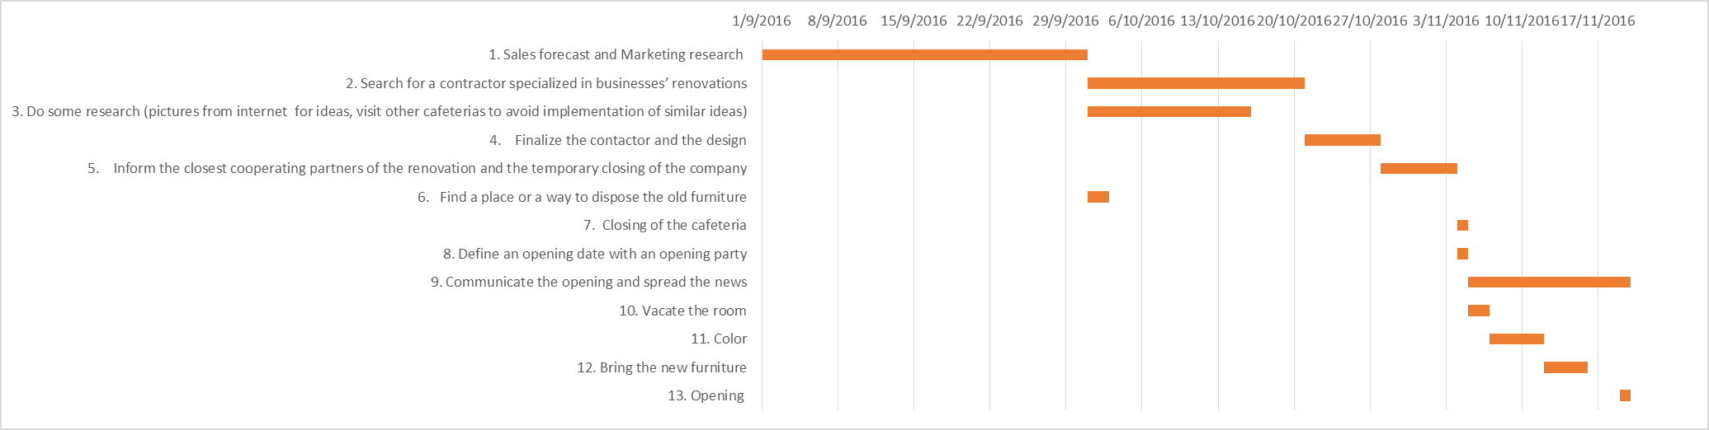

Gantt Chart after the implementation of buffers:

|  |  |  |  |
| --- | --- | --- | --- |
| **Tasks** | **Starting Date** | **Duration (days)** | **Finishing Date** |
| 1. Sales forecast and Marketing research | 1/9/2016 | 30 | 1/10/2016 |
| 2. Search for a contractor specialized in businesses’ renovations | 1/10/2016 | 20 | 21/10/2016 |
| 3. Do some research (pictures from internet for ideas, visit other cafeterias to avoid implementation of similar ideas) | 1/10/2016 | 15 | 16/10/2016 |
| 4.    Finalize the contactor and the design | 21/10/2016 | 7 | 28/10/2016 |
| Buffer | 28/10/2016 | 5 | 2/11/2016 |
| 5.    Inform the closest cooperating partners of the renovation and the temporary closing of the company | 2/11/2016 | 7 | 9/11/2016 |
| 6.   Find a place or a way to dispose the old furniture | 1/10/2016 | 2 | 3/10/2016 |
| 7. Closing of the cafeteria | 9/11/2016 | 1 | 10/11/2016 |
| 8. Define an opening date with an opening party | 9/11/2016 | 1 | 10/11/2016 |
| 9. Communicate the opening and spread the news | 10/11/2016 | 17 | 27/11/2016 |
| 10. Vacate the room | 10/11/2016 | 2 | 12/11/2016 |
| 11. Color | 12/11/2016 | 5 | 17/11/2016 |
| 12. Bring the new furniture | 17/11/2016 | 4 | 21/11/2016 |
| Buffer | 21/11/2016 | 3 | 24/11/2016 |
| 13. Opening | 26/11/2016 | 1 | 27/11/2016 |

