**SEMINAR 1 – TRANSPORT MARKETS**

1. Transport economics problems?

Listed below are nine major transport related issues facing society today. Your task is to identify which ones are related to “the economics of transport”, in other words those you believe to be economic issues, as opposed to being related to other dimensions such as political or social factors. Although you should always try to come to a clear answer for each issue, what you may find is that for some the division is not always entirely clear or in other cases there may be several different factors present. Where you find this to be the case you should consider those other factors and thus where the economics of the issue “fit” in the wider picture.

1. The privatisation of the railways.
2. The negative impact on the natural environment of all transport related activities.
3. Increasing levels of traffic congestion in towns and cities.
4. The high levels of subsidy required to sustain public transport industries.
5. The increasing amounts of land that are being given over to support transport activities.
6. The role of transport in “unifying” the European Union.
7. The subsidisation of public transport services in rural and socially deprived areas.
8. The role of education in changing travel behaviour to reduce local and unnecessary journeys.
9. The impact of an ageing population and the changing transport needs that this presents.

2. Increasing the use of the railways

Almost without exception European governments have as one of their main transport policy objectives an increase in the use of passenger rail travel. The simple question is, using your  
new-found knowledge of economics, how can these governments assist the market to achieve this aim? If we assume from attached figure that the government wished to see the quantity used of rail services increase from the current position of to the level indicated by , for environmental and social reasons.

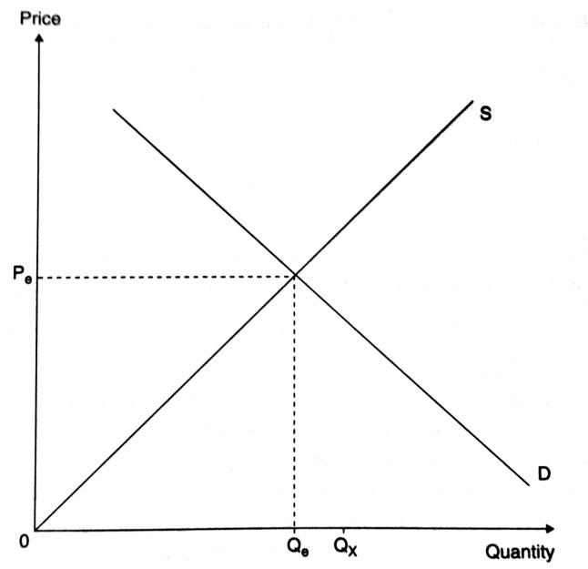

Then you should use this diagram as a basis to outline the various options available and consider both direct government intervention in this market as well as intervention in other transport markets that will bring about such a change. Further assume however that the aim would be to increase the level of rail travel without causing a major modal shift from other public transport markets. You should illustrate each of your scenarios with a relevant diagram. You should also consider all of the implications of your decisions, particularly with regard to the political logic of some of the options. (HINT – there are three basic possible scenarios, although you may come up with more!)

Of the scenarios that you have devised, which do you consider would be the most effective?

3. The US highway interstate system was started in 1950 and completed in 1973.

1. Use market demand and supply curves to characterize the effect that the completed interstate system had on the market for intercity motor vehicle passenger trips. Similarly, illustrate with market demand and supply curves how the completed system affected shippers’ transportation rates.
2. What effect, if any, would you expect the interstate system to have upon rail rates?

4. The June 29, 1993 issue of the *Wall Street Journal* states: “Two decades after 1970s energy crisis sparked ambitious, costly efforts to move commuters from gas-guzzling cars to subway, trolley, and bus systems, something odd has happened: Americans are less likely than ever to use public transit.” Use market demand and supply curves to evaluate this statement. In your discussion, comment on the effects of changing employment patterns, commuting patterns, public transit subsidies, income, and the price elasticity of demand.

5. Evaluate the following statement: “When transportation markets are functioning well, the opportunity cost of transportation will primarily reflect monetary costs. To the extent that time costs are present, they will be small.”

6. Suppose that you have a sample of identical travellers – that is, consumers whose incomes are identical, prices of travel and all other goods that are identical, and preferences for travel and all other goods that are identical. Why do the observed travel demands of consumers generally differ from that predicted by economic theory? Does this imply that our economic theory is not very useful? Explain your answer.

7. Public transportation is oftentimes argued to be an inferior good.

1. Identify why this might be so.
2. Is public transportation an inferior good at all levels of income? If so, why; and if not, why not?

8. Consider the following observations: (1) between 1978 and 1988 real per capita income increased by 25%; (2) during the same time span there was a decrease in the average number of hours spent working; (3) there was an increase in the number of single households and households with unrelated members. Why might you expect each of these factors to increase the demand for air travel?

9. Suppose that we have a simple economic model that shipper demands for transportation services depend upon the transportation rate charged.

1. Identify the cause and effect relationship in this model.
2. Why is this model a qualitative model of shipper demands?
3. How would you transform this economic model into an econometric model of shipper demand?
4. In your econometric model, how would you test the hypothesis that demand depends upon transportation rate charged?

10. Consider the following econometric model of *T* individual bus demands:

(Bus Trips)*t*= *α* + *β* (Fare)*t* + *γ* (Income)*t* + *εt*

where (Fare)*t* is the fare (in dollars) per bus trip paid by individual *t* and (Income)*t* (in dollars) is individual *t*’s income.

1. What sign would you expect *β* and *γ*,respectively, to have, and why?
2. From the econometric model, what impact will a 50-cent increase in bus fare have upon ridership? What impact will a $1 increase in household income? What about a $1000 increase in household income?

**SEMINAR 2 – TRANSPORT DEMAND ELASTICITY**

1. Is the price elasticity of demand for airline industry in short-haul markets more or less than long-haul markets? Why?

2. What are the factors that influence the elasticity of demand for pilots?

3. Suppose the income elasticity of demand for good is -4. Is this good a normal good or an inferior good? If it is a normal good, then is it a luxury or a necessity? Why?

4. With changes in fuel prices what kind of effects should we see in the market for travel?

5. Various studies indicate that the price elasticity of demand for automobile usage lies above –0.5 (that is, below 0.5 in absolute value). What does this say about the potential success of policies designed to reduce urban congestion by monetary disincentives?

6. The price elasticity of demand for Amtrak, the nation’s rail passenger service, among vacation travellers has been estimated as –1.20. Given that Amtrak faces the market demand for rail passenger trips, what effect will a 15% increase in fares have upon market demand? What effect will the fare increase have upon revenues? (Hint: convert the formula for the effect of a price increase on total revenues to an elasticity.)

7. Suppose, in a binary logit model, that the “own-” and “cross-” price elasticities of demand for mode “a” are –0.34 and +0.15 respectively. Interpret these numbers.

1. What is the effect on the demand for mode “a” of a 15% increase in its price? Does this represent a change in demand or a change in quantity demanded?
2. What is the effect on the demand for a mode “a” when the price of mode “b” increases by 15%? Does this represent a change in demand or a change in quantity demanded?

8. According to demand theory, the market demand curve for transportation is downward-sloping.

1. You are a transportation economist for Amtrak and you are asked to estimate the price elasticity of demand for Amtrak services. Describe in some detail what steps you would follow to obtain the price elasticity of demand.
2. Suppose that your analysis found that the price elasticity of demand for Amtrak services was

–0.78. What impact would a 10% increase in price have upon the quantity of Amtrak services demanded? Do you know whether Amtrak revenues would rise or fall?

9. Elasticity and the tax take – why all good things in life are taxed!

In order to finance a considerable improvement in public transport provision, the government needs to raise significant levels of public finance. Increasing income tax is not seen as a realistic option due to the unpopularity of such taxes with the electorate. The government therefore decides to raise this finance through an expenditure (as opposed to an income) tax. What type of good (price elastic or inelastic) should the government impose this tax upon? In order to help answer this question, you should draw two illustrations in the form of the basic market graph, which illustrate the shift in the supply curve as a result of the increase in tax and then note the effect this would have on an elastic and an inelastic good. Note also that the resultant change in revenue would be the effect on the total tax take, as all additional revenue raised is tax. What does this exercise tell us about general taxation policies; are, for example, cigarettes taxed purely for health reasons or petrol taxed purely because of environmental/conservation concerns?

10. Income, own and cross price elasticities

This is a totally artificial exercise; however, it is designed to try to get you to think about own price, cross price and income elasticities. Presented below are some completely hypothetical passenger figures for public transport services in a hypothetical city somewhere near you!

|  |  |  |  |  |
| --- | --- | --- | --- | --- |
| Transport mode: | Rail | Bus | Underground | Total |
| Annual usage (millions): | 38 | 90 | 23 | 151 |

For this hypothetical public transport market, the following elasticities apply:

|  |  |  |  |  |  |  |  |
| --- | --- | --- | --- | --- | --- | --- | --- |
|  | | | *Rail* | | *Bus* | | *Underground* |
| Income elasticity of demand: | | | 0.41 | –0.50 | | | 0.32 |
|  | | | Price | | | | |
| *Own & cross price elasticities* | | | *Rail* | | *Bus* | | *Underground* |
| *Quantity* | Rail | –0.45 | | –0.40 | | –0.30 | |
| Bus | | 0.08 | –0.40 | | | 0.10 |
| Underground | | 0.02 | | 0.05 | –0.20 | |

*Note*: modes listed on rows relate to the quantity change in demand, those listed in columns relate to change in price

Using all of these values you should be able to answer the following questions – as a side note, if you have the necessary skills you may find a spreadsheet useful to assist with this exercise.

1. If there is a 5 per cent rise in income, what would be the new daily modal splits and the new total daily usage?
2. Using your answer for the new total daily usage from part (a), what is the overall income elasticity to travel?
3. How does your answer from part (b) compare with the results presented in Case study 3.1 in Chapter 3 and what might be the reason for any such differences? (Hint: you will need to calculate a rough elasticity from the values presented in the case study.)
4. Calculate the effect on modal splits and the new monthly usage of the impact of the following factors (each should be considered on its own) and from your answers highlight which modal fare has the largest impact on the overall demand for travel in this city.
   1. a 15 per cent increase in the level of rail fares
   2. a 15 per cent increase in the level of bus fares
   3. a 15 per cent increase in the level of underground fares
5. What might be expected to happen to the cross price elasticity of the train across all other modes if the level of rail travel was to significantly increase? Why would this happen?
6. Roughly speaking, why have we got the answers that we have got for part c and what does this underline with regard to own and cross price elasticities of public transport services?

**SEMINAR 3 – TRANSPORT DEMAND ISSUES**

1. In 1983, 87.4 % of household trips to work were by private motor vehicle, 4.6 % by public transit, and 8.0 % by other modes of travel (for example, bicycle or walk). For private transportation, the average length of work trip (one way) was 8.5 miles, with an average commute time equal to 20 minutes. The operating cost per mile for private transportation was 8.36 cents. For public transit, the average commute time was 46.1 minutes per one-way trip, with an average fare equal to 60 cents. For other work-trip modes, the average one-way trip length was 5.6 miles, with an average trip time equal to 30 minutes.

1. For each of the three modes, what is the monetary cost per trip?
2. Assuming an average hourly wage rate equal to $10.00, what is the total cost pet work trip on each mode?
3. Given the work-trip prices in (b) and the modal percentages, graph representative demand curves for each of the three modes.

2. Most studies of modal choice find that the value of in-vehicle travel time is less than the value that travellers place upon waiting time.

1. What do these results tell us about the marginal disutility of in-vehicle travel time in comparison with the marginal disutility of out-of-vehicle travel time?
2. Discuss why the value-of-time estimates derived from discrete choice models are oftentimes interpreted as marginal rates of substitution.
3. Suppose that you’re an economist for a commuter railroad system. The manager of the agency is considering either of two policies: adding additional stops, with the expected result of reducing on-line speeds but also reducing the headway (that is, the average time between trains); or removing some stops, which would increase on-line speeds but also entail longer headways. Overall, both policies are predicted to have the same effect on total travel time for the average consumer. Discuss how you would use information on riders’ values of time in your police recommendation.

3. Mulíček – Osman – Seidenglanz (2016) constructed frequency distribution of bus services in Brno during th day in 1989 and 2009. Discuss the reaons why the distribution has changed.

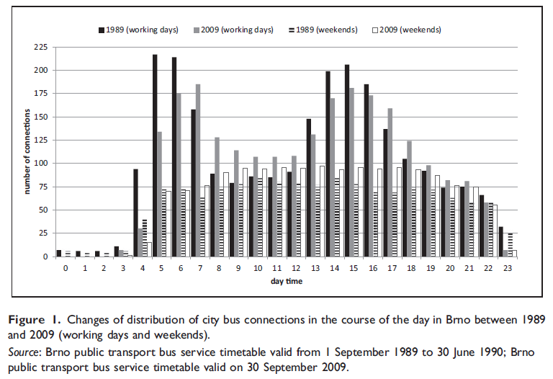

4. Regression analysis review

1. Explain how dummy variable can improve accuracy of a forecast model?
2. What is multicollinearity and autocorrelation in a regression model?
3. Explain the difference between seasonal and cyclical variations. Give an example how airlines respond to cyclical variations.
4. If a regression analysis had a R2 of .89, what does this mean?
5. In a regression analysis how would you incorporate seasonal varaitions and other important

5. Data exercise (Bus_travel). The first data application relates the number of people who travel by bus to various factors that affect it. Bus_travel contains cross-section data for 40 cities across the United States. The variable are as follows:

BUSTRAVL = Demand for urban transportation by bus in thousands of passenger hours

(range 18.1 – 13103)

FARE = Bus fare in dollars (range 0.5-1.5)

GASPRICE = Price of gallon of gasoline in dollars (range 0.79–1.03)

INCOME = Average income per capita (range 12349-21886)

POP = Population of city in thousands (range 167-7323)

DENSITY = Density of city in persons per square mile (range 1551-24288)

LANDAREA = Land area of the city in square miles (range 18.9 – 556.4)

Identify determinants of bus travel and interpret the results.

6. One would expect that the demand for automobile ownership in metropolitan areas would be influenced by population density. Holding all else constant, the denser the area, the more public transit will be provided. Also, the denser the area, the more traffic congestion will be present.

1. Assuming that the public transit fare remains constant, explain why an increased supply of public transit in denser areas would reduce the opportunity cost of public transit.
2. Assuming no change in the per-mile monetary cost of automobile travel, explain why increased congestion will increase the opportunity cost of automobile travel.
3. Based upon 65 large US central cities in 1970, Kain (1983) assumed that the demand for automobiles depended upon median household income and population density. He obtained the following linear regression results:

Autos per Household = 0.224 + 0.069 (Median Income) –

(6,1)

(6,1)

– 0,013 (Population Density) *R2* = 0,77,

(-13,9)

where Median Income is in thousands of dollars and Population is in thousands of persons per square mile. *t*-statistics are in parenthesis.

1. Are these results consistent with expectations?
2. What effect will a $1,000 increase in median family income have upon automobile ownership? From these results, what difference in automobile ownership would you expect to see between a household earning $50,000 per year and one earning $20,000 per year?
3. Assume that Median Income is $25,000. According to Kain’s model, how many automobiles will a typical household own if it resides in a low-density area characterized by 50 persons per square mile? Compare this with a high-density city that has 100 persons per square mile.
4. Throughout the 20th century, we saw population movements away from rural areas and into urban areas. At the same time, household median income rose steadily. Using Kain’s empirical model, what can you say about the net effect of these changes on automobile ownership? From the above results, which has the greater effect – a $1,000 increase in median income or a 1,000-person increase in population density?“‘’” “”

**SEMINAR 4 – COSTS**

1. Identify reasons why airlines would want to take over other airlines.

2. Please provide one particular industry as an example to illustrate that MC is not U shaped.

3. Please provide one particular industry as an example to illustrate that MC is U shaped.

4. What is the difference between economies of scale and economies of density?

5. What is the difference between economies of scale and economies of scope?

6. For many airlines in the short run, a major portion of the cost of production such as aircraft and terminal space are fixed. Should these very large FCs be ignored when the revenue managers are making output and pricing decisions? Why?

7. Fuel costs are important inputs to any transportation activity. Suppose that real energy prices fall. Graphically depict the impact that this would have upon a firm’s total short-run and long-run cost structure. Would you expect a firm’s long-run response to a fall in energy to be greater, less, or equal to its short-run response to a fall in energy prices? What does this suggest about the firm’s short-run input price elasticity of fuel relative to its long-run input price elasticity of fuel?

8. Critically evaluate the following statement: “All constraints on behaviour are costly, which explains why the short-run total cost curve lies above the long-run total cost curve.”

9. Suppose that you are given the following information on All Around Airlines:

1. The average variable cost of producing airline trips varies between 11.5 cents a mile when 50,000 trips per year are produced and 16.7 cents per mile when 500,000 trips per year are produced. Its lowest value is 11.5 cents a mile when 250,000 trips are produced.
2. The average total cost of producing trips varies between 15.3 cents per mile when 250,000 trips are produced and 17.3 cents per mile when 500,000 trips are produced. The minimum short-run average total cost is 13.0 cents when 300,000 trips are produced.
   1. Approximately, how many trips will be produced in the short run if the fare is 15.4 cents per mile?
   2. Will any trips be produced if the fare is 12.1 cents per mile? If so, why; and if not, why not?
   3. Will any trips be produced if the fare is 10 cents per mile? If so, why; and if not, why not?

10. Viton’s 1981 study of urban transit costs found that urban transit firms operating in small cities (where fewer than 1 million vehicle-miles are produced annually) operate under increasing returns to scale, in medium-sized cities (which produce between 1 million and 5.5 million vehicle-miles annually) they operate under decreasing returns to scale.

1. Assuming that fares are set at marginal cost, what do these results imply about the possibility of small-scale profitable entry in small, medium, and large cities?
2. Based upon Viton’s results, are there any benefits to decentralizing urban transit systems in the largest cities?

11. The July 7, 1993 *Wall Street Journal* provides the following information: “Northwest Airlines averted – at least for now – a threatened federal bankruptcy-law filling after its pilots’ union agreed to a last-minute pact to save the carrier $365 million over three years.” Using Northwest’s short-run cost curves, depict where Northwest was operating before and after the agreement with the pilots’ union.

12. Economies of scale in railway operations

1. List what you believe to be the main sources of economies of scale in the rail industry. Once you have produced this list, indicate which arise as a result of returns to scale and which are cost savings.
2. What on the other hand do you believe are the main sources of diseconomies of scale in larger integrated railways?
3. If you were a rail industry regulator in Britain today, what other factors apart from economies of scale would you take into account when deciding on the number of operators to have in the market?

13. In 1968, Keeler (1971) identified the per seat-mile costs (shown in table 5.14) associated with four major intercity modes of travel: rail, air, automobile, and intercity bus.

**Table 5.14** Intercity modal costs, 1968

|  |  |
| --- | --- |
| Mode | Cost Per Seat-Mile (cents) |
| Intercity Bus (200-mile trip) | 1.44 |
| Air (Lockheed 1,011, 256-seat configuration, 250-mile trip) | 3.00 |
| Automobile (two occupants) | 4.5 |
| Rail (three-car train seating 240 passengers) | 1.5 |

*Source*: Reprinted from Keeler (1971), table 7, p. 160,

What does this table tell us about the cost competitiveness of rail in comparison with the other three intercity modes?

Consider the following sets of statistics for 1990:

Intercity modal costs

|  |  |  |
| --- | --- | --- |
| Mode | Per-Mile Cost | Average Length of Trip |
| Certificated Air Carrier | 13.02 | 803 |
| Rail | 12.85 | 274 |
| Intercity Bus | 11.55 | 141 |
| Automobile | 13.33* | 115* |

* Per mile costs of operating vehicle occupant: assumes 1.62 occupants per vehicle in 1990.

Average Length of Trip for automobile is based upon intercity vacation trips.

Based upon this information, can you conclude that rail trips are competitive with air trips? How about intercity bus and automobile trips? Use the concept of economies of distance to argue that rail trips *will be more competitive* with shorter-haul air trips, but *will be less competitive* with longer-haul intercity bus and auto trips.

**SEMINAR 5 – EFFICIENCY**

1. Explain what the concept of opportunity cost means in transport economics.

2. List types of perceived market failures in the transport industry.

3. Why can it be generally assumed that the supply curve for the airline industry is relatively inelastic?

4.

a) In perfectly competitive markets, identify and briefly discuss the three conditions for economic efficiency.

b) Based upon your current knowledge of intercity rail, bus, and airline passenger modes, in which sector do you believe resources are more efficiently allocated today? Would your answer change if the same question were asked for the year 1975?

5. Nolan (1996) used data from a group of midsized bus transit agencies in the United States. He measured technical efficiency with non-parametric frontier analysis (DEA). The analysis is supplemented by a second stage Tobit regression of agency characteristics on the technical efficiency scores. The results are in the table and you should interpret them.

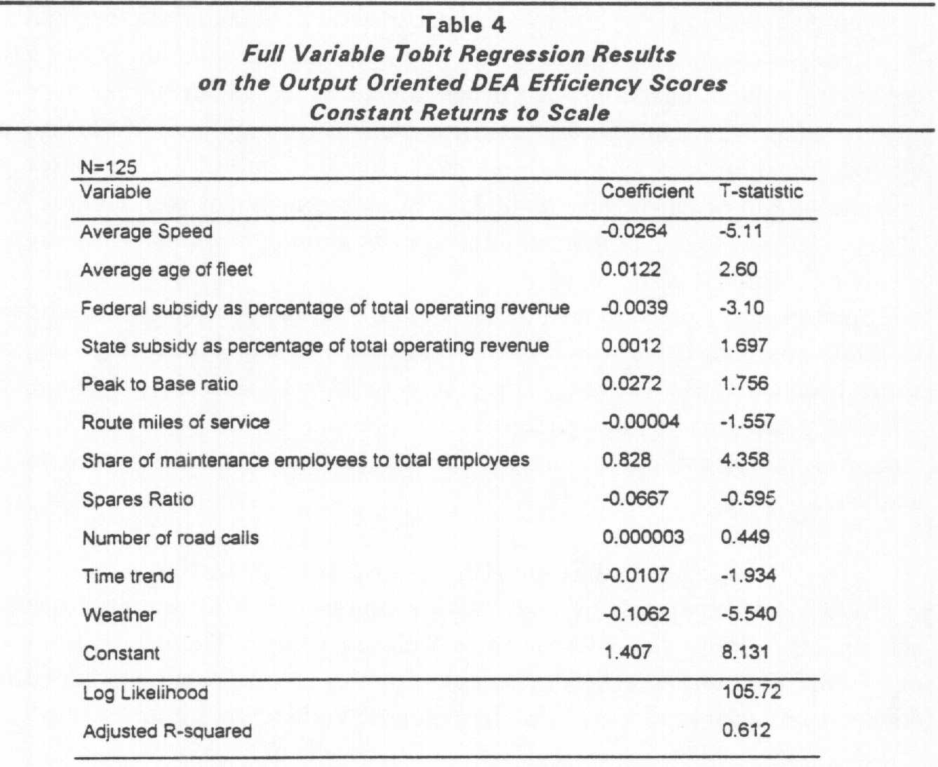

6. Jurikovič – Tomeš (2016)analysed differences in efficiency between private and public operator. The operation of rail commuter line Bratislava – Komarno used to be provided by the state-owned incumbent ZSSK. In 2012, the operation has begun to be provided by a private operator RegioJet. Quickly after the change, the ridership has increased substantially. The paper analyses the reasons of success of RegioJet’s operations. The consumer survey was made in 2014 on Bratislava railway station and travellers were asked questions relating to their travel behaviour, price sensitivity, satisfaction with rail transport. There were two critical questions included comparing performance and satisfaction before and after the entrance of RegioJet on this market:

* *Q1: Have you travelled on this line by train before the entry of RegioJet? (yes/no) (Usage)*

The aim of this question was to distinguish “old” and “new” customers on this line and therefore to identify which groups of customers were attracted to railway transport. On the subsample of passenger that travelled both with ZSSK and RegioJet there was the second question:

* *Q2: Were you satisfied with services of ZSSK? (yes/no)*

*(Satisfaction)*

The answers to these questions were regressed on explanatory variables. The results of Tobit regressions are in the table and you should identify which travellers were not satisfied with services of public operator and where potential for increased ridership may be.

Table: Tobit regression for Bratislava – Komarno line.

|  |  |  |  |  |
| --- | --- | --- | --- | --- |
|  | Usage  (Q1) | Usage  (Q1) | Satisfaction  (Q2) | Satisfaction  (Q2) |
|  |  |  |  |  |
| const | -0.82 (0.83) | -0.44 (0.42) | 0.57 (1.17) | 0.11 (0.23) |
| Male | 0.56 (0.25) ** | 0.52 (0.25) ** | 0.67 (0.33) ** | 0.65 (0.32) ** |
| Age | 0.13 (0.07) ** | 0.13 (0.07) ** | 0.08 (0.08) |  |
| Student | -0.88 (0.67) | -0.78 (0.38) ** | -1.48 (0.92) | -1.12 (0.45) ** |
| Pensioner | -1.46 (0.76) * | -1.38 (0.56) ** | -1.40 (0.99) |  |
| Employed | -0.13 (0.59) |  | -0.65 (0.75) |  |
| Frequency | 0.39 (0.26) |  | 0.25 (0.36) |  |
| By foot | 0.98 (0.49) ** | 0.75 (0.24) *** | -0.44 (0.78) |  |
| By car | 0.50 (0.53) |  | -2.43 (0.90) *** | -1.95 (0.53) *** |
| By PT | 0.27 (0.53) |  | -0.53 (0.84) |  |
| No. | **335** | **337** | **181** | **181** |

In the following table there is a comparison of basic operational data of RegioJet and ZSKK on Bratislava – Komarno line. Based on this evidence, try to resolve the question whether in this particular case, the private operator is more efficient than the public one.

Table: Table: Comparison of performance

|  |  |  |  |
| --- | --- | --- | --- |
|  | **RegioJet 2012/2013** | **ZSSK 2011/2012** | **Change** |
| Passengers (thousand) | 1 511 | 764 | +98% |
| Passenger kilometres (thousand) | 54 516 | 21 851 | +150% |
| Average length of the trip (km) | 36 | 29 | +26% |
| Trainkm (thousand) | 1 204 | 719 | +68% |
| Number of trains | 17 475 | 9 127 | +91% |
| Average number of passenger/trainkm | 45 | 30 | +49% |
| Average number of passenger/train | 86 | 83 | +3% |
| Train utilization (%) | 29 | 17 | +72% |
| State subsidy (total) | 7 015 | 4 875 | +44% |
| State subsidy/trainkm | 5,82 | 6,78 | -14% |
| State subsidy/pass-km | 0,13 | 0,22 | -42% |
| State subsidy/passenger | 4,64 | 6,38 | -27% |

Source: RegioJet; Mašek (2013)

**SEMINAR 6 – COMPETITION**

1. What is a normal profit?

2. Does perfect competition exist in the real world?

3. What happens when markets do not have enough competition?

4. What are barriers to entry in the airline industry?

5. How is price established in an oligopoly market?

6. Examine the extent to which you believe that the low cost airline market meets the conditions of the contestable market.

7. *Barriers to entry.* For the following transport industries: a) Bus production b) Provision of rail services c) Provision of the rail infrastructure d) Road haulage e) Air services f) Parcels markets; identify the main barriers to entry into each of these markets for a potential market entrant under the headings of structural and strategic barriers. Then place these industries on a scale, where 1 represents the industry with the lowest barriers to entry and 6 the industry with the highest. What does this tell you?

8. *Open access passenger rail competition on line Prague – Ostrava.* The impact of open access competition on market development can be summarized as follows (Tomeš – Kvizda – Jandová – Rederer, 2016):

* Prices of regular tickets (2nd class) have fallen by 46%. The spread of prices is greater than it used to be depending on departure and reservation times. The fall in prices was more moderate in 1st class, where prices fell by only 14%. The on-line booking and yield management techniques developed substantially;
* All three operators are heavily unprofitable on this route. With stagnating prices and a saturated market, they have difficulty reaching the break-even point. RegioJet achieved better profitability than LEO Express due to higher occupancy, lower costs and arguably better marketing and management. The incumbent, České dráhy, has not revealed its results on this particular line; however, there are many indices that its economic results are probably the worst;
* Open access competition has increased the frequency of daily service (from 23 in 2010 to 34 in 2014); however, the seat capacity of the average train has decreased, and service is more concentrated during peak hours;
* The train occupancy rate in 2013 was 92% for RegioJet, 50% for LEO Express, and an estimated 40% for ČD SC and 40% for ČD IC service. We estimate that ridership between 2010 and 2013 increased by 40%. Our estimation of market shares in 2013 is 45% for ČD, 38% for RegioJet, and 17% for LEO Express;
* The entry of private operators brought about a massive increase in quality, standardization and innovation in services. The intensive price competition is forcing all three operators to seek continuous innovation in their services.

Evaluate the impact of open access competition on demand, supply and total market welfare.

9. Hunold – Wolf (2013) investigated competitive tendering design in regional passenger services in Germany.Regional passenger railway services in Germany have been procured by regional public agencies. A central goal is the establishment of a competitive transport market. In this article they study the competitive awarding procedures. The procurement agencies design the awarding procedures in different manners such that the question arises which design yields better awarding results. Among others, the design includes the contract duration as well as the revenue risk sharing between agency and operator. The authors investigate how the design parameters influence how many railway companies participate in a tender, which of them wins the contract and which price the agency has to pay. Despite liberalization, the incumbent operator Deutsche Bahn (DB) remains in strong position. The authors investigated which factors in competitive tenders design reinforce or weaken the position of DB. Authors formulated following hypotheses:

***Hypothesis 1.*** *DB is more likely to win when profit risks are high.*

***Hypothesis 2.*** *DB is more likely to win if used vehicles are admitted.*

***Hypothesis 3.*** *DB is more likely to win if no financial support for new vehicles is offered.*

***Hypothesis 4.*** *DB is more likely to win a contract if the contract volume is large.*

***Hypothesis 5.*** *DB is more likely to win a contract if it is the incumbent.*

***Hypothesis 6.*** *DB is more likely to win a contract if the number of bidders is low.*

In the following table you can see their results. Identify which hypotheses were confirmed and which were rejected. Interpret the results!

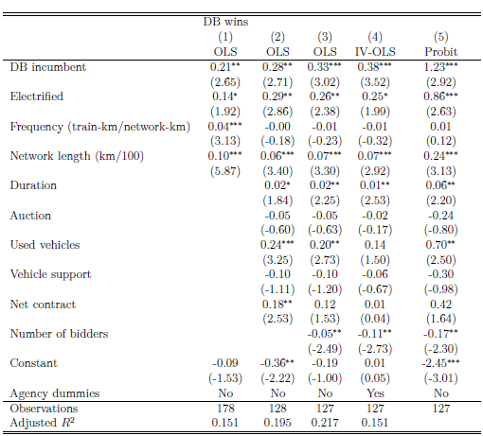

**SEMINAR 7 - OWNERSHIP**

1. In what sense can it be said that the government controls the means of production for the airline industry?

2. What do you see as the main advantages and disadvantages of public ownership in transport markets?

3. What do you see as the main advantages and disadvantages of involving the private sector in the provision of public transport services?

4. What are benefits and risks of privatization?

5. Boitani – Nicolini - Scarpa (2010) investigated whether competition and ownership matter in local public transport in Europe. This paper investigates how the ownership and the procedure for the selection of firm operating in the local public transport sector affect their productivity. In order to compare different institutional regimes, they carried out a comparative analysis of 72 companies operating in large European cities. This allows them to consider firms selected either through competitive tendering or negotiated procedures. The analysis of the data on 77 European firms over the period 1997-2006 indicates that firms operate under constant returns to scale. Retrieving the residuals they obtain a measure of total factor productivity, which they regress on firm and city characteristics. Their results are in the table. You task is to identify whether competition or ownership has higher impact on their productivity. Based on their results, what are other important determinants of productivity?

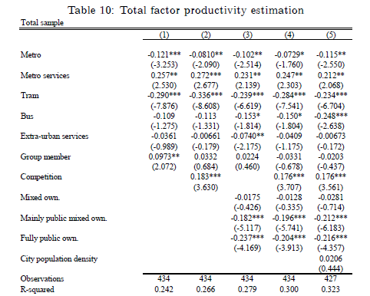

6. **Competition or privatization?** European transport strategy aims to increase modal share of railways. Its principal reform measures are vertical separation and competition entry. However, there are other possible reform strategies (horizontal separation, privatization) and it is not clear whether European reforms actually increase modal shares of railways. Based on the regression analysis performed on 27 European countries in the period 1995 – 2013, following results were obtained (Tomeš, 2016):

Table 3 Effects of Reform Variables on Railway’s Modal Shares. (fixed effects)

|  |  |  |  |  |  |  |
| --- | --- | --- | --- | --- | --- | --- |
|  | MODAL SHARE  FREIGHT  -------------------------------  (1) (2) | | | MODAL SHARE  PASSENGER  -----------------------------------  (3) (4) | | |
| Const | 58.90***  *(10.98)* | 59.68***  *(9.70)* | | 7.78*  *(4.57)* | 8.34*  (4.45) | |
| VERTICAL SEPARATION | -3.10*  *(1.74)* | -1.18  *(1.64)* | | -1.59**  *(0.75)* | -1.36**  *(0.60)* | |
| COMPETITION ENTRY | -1.70*  *(0.98)* | -0.39  (1.25) | | -0.53  *(0.63)* | -0.37  *(0.67)* | |
| *Cross term VS x CE* |  | -3.46**  (1.49) | |  | -0.67  (0.98) | |
| HORIZONTAL SEPARATION | 2.62*  *(1.42)* |  | | 0.30  *(0.56)* |  | |
| *HS with privatization* |  | 3.41**  (1.54) | |  | 0.93  (0.69) | |
| *HS without privatization* |  | 1.88  (2.21) | |  | -0.72  (1.44) | |
| WEST*TREND | 0.31***  *(0.12)* | 0.30***  *(0.11)* | | 0.18***  *(0.04)* | 0.17***  *(0.04)* | |
| EAST*TREND | -0.86***  *(0.23)* | -0.86***  *(0.23)* | | 0.04  *(0.09)* | 0.04  *(0.10)* | |
| ln GDP_pc | -13.67***  *(3.58)* | -14.22***  *(3.06)* | | -6.91***  *(1.94)* | -6.96***  *(1.89)* | |
| EMPLOYMENT RATE |  |  | | 0.24**  *(0.12)* | 0.23**  *(0.10)* | |
| INFRASTRUCTURE | 0.08  *(0.07)* | 0.08  (0.07) | | 0.06*  *(0.03)* | 0.06*  (0.03) | |
| R2 (within) | 0.75 | 0.76 | | 0.55 | 0.57 | |
| # observation | 513 | 513 | 513 | | | 513 | |
| # countries | 27 | 27 | 27 | | | 27 | |

*\*\* significant at 10 % level*   *\*\* significant at 5 % level *** significant at 1 % level (based on robust standard errors)*

where, VERTICAL SEPARATION variable measures whether or not a country has carried out a complete institutional separation of infrastructure manager and incumbent operator. COMPETITION ENTRY variable measures whether there was significant competition entry into railway market. The benchmark for competitive entry was chosen as 1% and more of market share of non-incumbents operators. There were two variables: one for freight, and one for passenger market. HORIZONTAL SEPARATION measured whether country has made a complete institutional separation of the freight and passenger operations of the national incumbent operator. FREIGHT PRIVATIZATION measured whether country has privatized horizontally separated freight division. There is an important difference between railway systems of countries in Western and Eastern Europe. Therefore, it has been explicitly control for differences between these two groups of countries (EAST x WEST). There were three other control variables: GDP per capita (GDP_pc), which was meant to capture the effect of different economic levels among countries. INFRASTRUCTURE measured as length of railway lines to the sum of length of railways lines and highways in the country. EMPLOYMENT RATE measured as ratio of employed people in total population. Interpret the results and based on them formulate recommendations for European transport policy!

**SEMINAR 8 - REGULATION**

1. What are some of the main problems associated with government regulation of transport industries?

2. What are some of the ways in which the effects of an airport monopoly might be countered in the marketplace?

3. If monopolies are social undesirable why does a government actually support having some?

4. Provide examples illustrating how markets change from one structure to another when technology or other market conditions change.

5. What are the implications for the regulatory authorities of the existence of contestable markets?

6. Outline the main role and responsibilities of a regulator in the transport industries.

7. Following table reports the estimation results of an empirical model of the average daily consumption of gasoline per month in California during the period 1970–1975.

Dependent variable – average daily consumption of gasoline per month (‘000s)

|  |  |  |
| --- | --- | --- |
| Explanatory Variable | Coefficient Estimate | *t*-statistic |
| Constant | –25,193.1 | –3.38 |
| Real Gasoline Price ($) | –18,552.8 | –5.34 |
| Real Income (billion $) | 277.3 | 6.29 |
| Population (millions) | 1,567.9 | 2.92 |
| DEC73 | –1,801.5 | –2.84 |
| JAN74 | –1,629.7 | –2.57 |
| FEB74 | –2,313.1 | –3.60 |
| MAR74 | –2,524.1 | –3.88 |
| APR74 | 162.7 | 0.25 |
|  |  |  |

*Source*: Lee (1980), table 2, p. 40.

1. Two significant by-products of automobile use are air pollution and traffic congestion. In order to reduce the extent of each, suppose that the federal government raises the gasoline tax by $.25. From table 3.2, what effect will this have on gasoline consumption in California? Use budget lines and indifference curves to demonstrate the effect of the tax on consumer welfare.
2. Wanting to increase the price of gasoline *but not reduce economic welfare*, suppose that, in addition to the $0.25 cent tax on gasoline, the government also provides consumers with an income tax rebate amounting to $16.7 billion dollars.
   1. According to the empirical model, what would be the effect of the gasoline tax and income tax policies?
   2. According to economic theory, would the gasoline tax rise combined with the welfare-offsetting income tax rebate produce any reduction in the demand for gasoline?
   3. Given your analysis in parts (i) and (ii), is it possible to implement a policy that is consistent with the goals of environmentalists and yet not reduce the economic welfare of consumers?

8. Larson (2013) analysed deregulation of US rail industry that happened after 1980. Based on the table would you call this deregulation success or failure?

|  |  |  |  |  |  |  |  |  |  |
| --- | --- | --- | --- | --- | --- | --- | --- | --- | --- |
|  | CDRR | BTM | TnC | Haul | TM/EH | Track | Class I | Oil | Prime |
| 1970 | 5.96 | 765 | 2.363 | 490.4 | 605 | 336.3 | 71 | 3.35 | 7.91 |
| 1980 | 5.94 | 919 | 3.059 | 615.8 | 863 | 270.6 | 40 | 37.38 | 15.26 |
| 1990 | 3.69 | 1034 | 6.207 | 725.7 | 1901 | 200.1 | 14 | 24.49 | 10.01 |
| 2000 | 2.54 | 1466 | 9.177 | 843.3 | 3293 | 168.5 | 8 | 30.30 | 9.23 |
| 2007 | 2.82 | 1771 | 12.027 | 912.8 | 4182 | 161.1 | 7 | 72.36 | 8.05 |

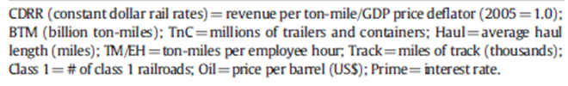

9. The evaluation of British rail reform is not easy. On the positive side there are impressive growth of transported passengers and goods. On the negative side there are growth of subsidies, costs and prices. The more rigorous attempt to measure the impact of reform was Preston – Robbins (2012) that tried to evaluate the British rail reform. Their model specification was:

*ln PKMt = α + βRPKMt + γTKMt + δGDPt + θPRIV + μHAT + ρSTRIKE*

where PKM = Passenger Kilometres in year t, RPKM = Real Revenue per Passenger Kilometre in year t, TKM = Train Kilometres in year t, GDP = Real Gross Domestic Product in year t, PRIV = Privatisation Dummy Variable (1992/3 to 2005/6), HAT = Hatfield Dummy Variable (2000/1 to 2006/7) and STRIKE = Strikes Dummy Variable (1982/3 and 1991/2). The estimated coefficients of equation, using data from 1979/80 to 2008/9, and some diagnostic statistics are given in following table. You should interpret them and evaluate the results of the British rail reform.

|  |  |  |
| --- | --- | --- |
| Coefficient | Value | t-statistics |
| Const | 2,92 | 17,1 |
| RPKM | -5,69 | -2,82 |
| TKM | 0,0024 | 7,09 |
| GDP | 3,69E-07 | 3,61 |
| PRIV | -0,092 | -8,58 |
| HAT | -0,051 | -3,12 |
| STRIKE | -0,063 | -3,28 |
| Adjusted R2 | 0,983 |  |
| Durbin - Watson | 1,453 |  |

Preston – Robbins (2012)

1. What are weak points of this analysis?
2. Do you have any ideas how to improve Preston-Robbins model?
3. How would you evaluate supply side of the British reform?

**SEMINAR 9 – SUBSIDY**

1. Discuss the following simple statements, which should help to build on and develop some of the issues discussed in this chapter:

* Low subsidy is “good” and high subsidy is “bad”
* Transport should only be subsidized on the basis of what can be afforded by the relevant authorities
* Public transport is a public good, therefore should be subsidized
* Road networks, because they are provided and maintained by the state, are therefore provided free of charge

2.

1. In 1991, public transportation in the USA received $9.79 billion dollars in operating subsidies from federal, state and local government. Use budget lines and indifference curves to identify the economic welfare and public transit consumption effect of the subsidy.
2. The price elasticity of transit demand has been estimated in the range of –0.2 to –0.4. Suppose that the transit authority seeks to increase demand through a 10% reduction in fares. What impact will this have on transit demand, and what impact do you think it would have on the operating subsidies?

3. Options in payment of subsidy

A transport authority seeks to produce a modal shift from the car to public transport services in order to encourage local economic development and reduce traffic congestion. Outline in a variety of diagrams the main options that are open to the authority to achieve this aim and come to a conclusion as to which you believe to be the `best’ approach or combinations of approaches that should be used. Where subsidy features in your solutions, you should outline the main drawbacks that stand in the way of a successful outcome and what measures you propose to take to minimise the impact of these drawbacks.

4. Which type of contract to use

As the recently appointed leader of your local transport authority, you are given a blank sheet of paper with which to re-organise urban public transport services in your local area. Assume that the national legislation allows for any of the models of delivery outlined to be used, but nationalisation is out of question. Consider for each of the following scenarios which `model’ of ownership would be most suitable for the particular situation:

1. A pro public transport council that has a strong policy stance on encouraging more people to use public transport.
2. A council that is facing possible budget cuts in the medium to longer term and seeks to reduce its budget for public transport services.
3. A council that is expecting strong economic growth in the medium and long runs and is concerned that the current public transport provision, which is mainly bus based, will limit this economic growth.
4. Where public transport services have been run directly by the local authority department, however, the last ten years have seen a significant decline in patronage and low investment levels.
5. Public transport services are currently run by private sector companies; however, the overall perception is of poor quality services that have seen signicant passenger declines in the last ten years.
6. A publicly owned and run urban rail metro that is badly in need of refurbishment; however, budget constraints means that the local authority do not have the funds available to undertake the investment required.

Then consider under what type of the following contracts should be used in delivery of these services:

1. Complete deregulation with contracts only for socially necessary services
2. Tender all services on a full cost basis
3. Tender all services on a relative cost basis

**5. In the foll**owing graph you can observe the development of subsidies into British railway sector. How would you interpret it? One of crucial goals of British railway reform was to decrease rail subsidies. Was the reform successful in this respect?

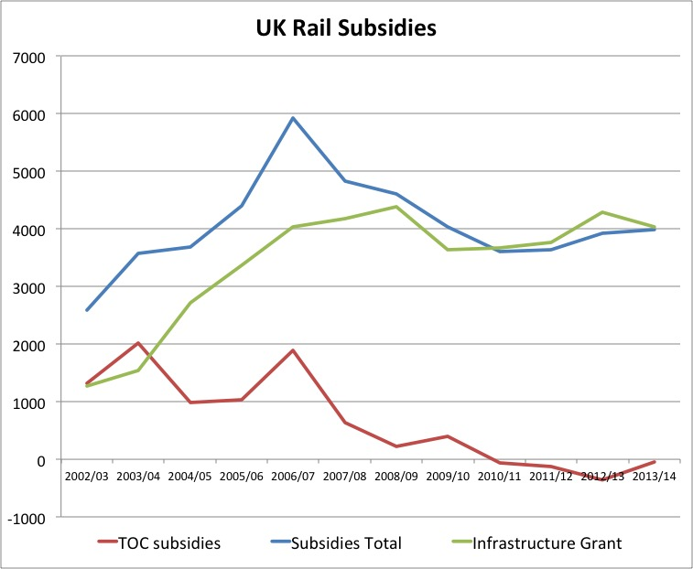

6. Crossmann – Mause (2014) analysed determinants of railways subsidies in the member countries of the EU. Their results are in the following table. Interpet them.

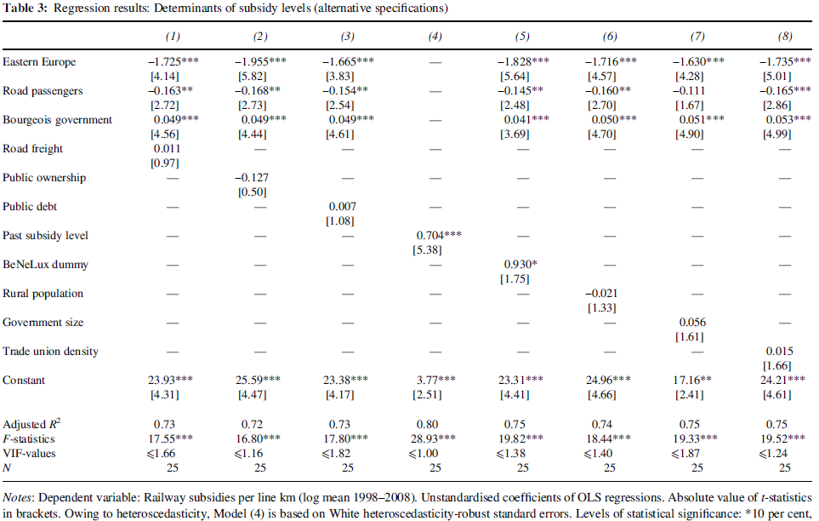

The principal result is that right-wing (bourgeois) parties tend to subsidize railways more than left-wing parties. How would you explain such a surprising result?

**SEMINAR 10 - PRICING**

1. Transport operators in oligopolistic markets practise predatory pricing and price fixing from time to time. Outline what you perceive to be the benefits to transport operators of such practices and the reasons why they are illegal in many countries world-wide.

2. You are the manager of the Airline and unable to determine whether any given passenger is a business or leisure traveller. Can you think of a self-correction mechanism that would permit you identify business and leisure?

3. Suppose that a transport carrier is accused of price discriminating in two separate markets. The carrier replies that he can’t be price discriminating, since he is charging the same price in each of the markets. Do you agree or disagree with the carrier’s response?

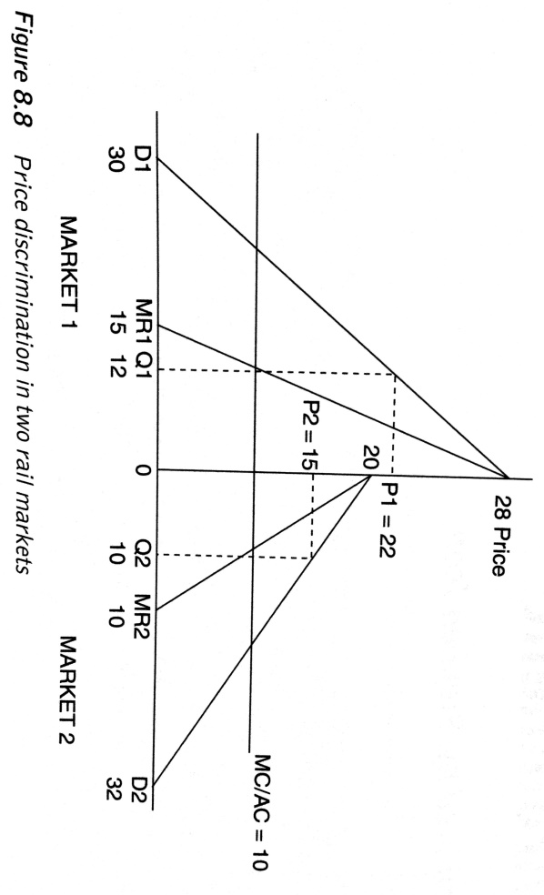4. Business travellers have more inelastic demands for air services in comparison with vacation travellers. If an airline charges business and vacations travellers the same route fare between Chicago and Los Angeles, does this necessarily imply that the airline is not price discriminating? Under what conditions would this be consistent with price discrimination?

5. Price discrimination

Figure refers to a rail operator that is practising price discrimination, charging a different price to the passengers in market 1 compared to those in market 2. It is assumed that costs are constant, therefore MC = AC.

1. What does Figure reveal about the type of passengers using the service and their relative elasticities?
2. Calculate the abnormal profit earned by the rail operator by price discriminating.
3. Based on the information presented in Figure 8.8 sketch out the diagram for the rail operator if it were not to price discrimination.
4. Are there any beneficiaries from price discrimination and what happens to consumer surplus when price discrimination is practised?

6. *Predatory bidding.* A similar practise to predatory pricing is a predatory bidding that relates to predatory pricing in competitive tenders. The competitive tendering occurs when firms bid for right to run service or gain a certain contract. The competitive tender is often utilized to choose the provider of subsidized rail passenger services. Why? Do you think it is a good idea to choose the operator in such tender on the base of only one parameter – lowest price? Do you think that predatory pricing (bidding) or price fixing may be a problem here? Do you think a moral hazard is a relevant issue?

7. In 2006 Czech Ministry of Transport opened two competitive tenders for rail lines Pardubice – Liberec and Plzeň – Most. The tenders' results caused great controversy and did not open the market to competition. This was because České dráhy won the tenders with a price that aroused suspicion that itwas set under the level of the incumbent costs. The anger of other operators was caused by the incumbent's winning price, which was as low as 18.28 CZK/train kilometre for Plzeň-Most and 41.39 CZK/train kilometre for Pardubice - Liberec. To assess whether the accusation of predatory pricing was valid is not easy because there were no competitive tenders in long-distance transport and only a handful of competitive tenders in regional transport at the time. ČD used to claim much higher subsidies for directly awarded long-distance transport, usually as high as 80 CZK per train kilometre. It is also worth noting the results for a small regional tender in 2005 in western Bohemia for a route connecting the spa towns of Carlsbad, Marienbad and Bečov, when Viamont was declared the winner with a price of 64.60 per train kilometre. ČD was second with an offer of 80.40 CZK per train kilometre, and Railtrans finished in last with an offer of 85.20 CZK *(Tomeš, Kvizda, Nigrin, Seidenglanz, 2014*).

1. Do you think predatory bidding took place?
2. What is the motivation of České dráhy to resort to predatory pricing?
3. What are the possibilities of Ministry of Transport to limit predatory pricing or price fixing in competitive tenders?

8. Bel – Fageda (2010) examined factors determining airport charges. Their empirical model was formulated as: 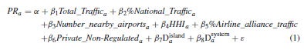

*PR* is he price charged by the airports to airlines fo traffic within EU. *Total_Traffic* is the airport‘s total volume of traffic. *%National_Traffic* is the domestic traffic as a percentage of the airport’s total traffic. Number_nearby_airports is the number of airports that lie fewer than 100 km away. *HHI* is the the Hirschman-Herfindhal index of concentration at the airport in the terms of the number of flights offered by the airlines operating out of it. *%Airline_alliance_traffic* is the percentage of traffic channelled by the airlines integrated within international alliances. *Private_Non_Regulated* is the dummy for private and non regulated airports. *Disland* is a dummy for airports with an island location. Dsystem is a dummy for airports in countries that operate a price fixing system.

1. What signs do you expect for the explanatory variables?
2. Which estimation method would you use?
3. Do you think endogeneity may be a problem here?

**SEMINAR 11 – TRANSPORT AND DEVELOPMENT**

1. Supply and demand led transport initiatives

a) Listed below are nine major transport projects from the very old to the very new and even those that are currently still at the planning stage. Whilst it is difficult to clearly define such projects as either demand led or supply led, some will display more characteristics of the former whilst others will be more akin to the latter. In this exercise you are asked to simply divide these into these two categories and to consider the reasons why you came to that particular view. Note that in many cases you do not need to know the specifics regarding the particular transport project to come to an educated guess.

* CrossRail – this project is to build two new railway connections under central London. CrossRail 1, approved in 2007, will run east–west and is due to open in 2017. It will complement Thameslink services, which commenced north–south rail services through the re-opened Snow Hill tunnel in 1989.
* The Channel Tunnel that was opened in 1995 and links Britain to France
* The opening of the M6 Toll motorway around Birmingham in December 2003, thus effectively providing a Birmingham by-pass and considerably reducing through journey times.
* The Great Belt Link, opened in 1995 between the island of Zeeland and (in effect) the rest of Denmark, and providing a road and rail link.
* The Skye Bridge – this linked mainland Scotland to the island of Skye and was opened in 1995 originally with a highly controversial toll (i.e. only slightly cheaper than the former ferry fare) that was eventually abolished at the end of 2004
* The Golden Gate Bridge across the opening of San Francisco Bay completed in 1937, which provided the first fixed link northwards out of San Francisco.
* The opening of phase one of the high-speed train line (the TGV Est) from Paris to the west of Nancy in June 2007. The line is also served by Germany’s Inter City Express (ICE) high-speed trains. Phase two, which will take the line all the way to Strasbourg near the German border, will not be completed until around 2014. TGV Est is sometimes referred to TGV EstEuropéen.
* The construction of a container terminal at the port of Mundra on the Gujarat coast in North West India. This will be the port’s first container terminal.
* The Jubilee line extension, opened in 1999, which connected the London Underground system to the developing Docklands area in London

b) From the examples listed, what overall conclusions can you draw regarding supply led and demand led transport initiatives, particularly the balance between the two?

c) In the case of the Skye Bridge, did the imposition of a high toll make a difference as to which effect was stronger?

2 Transport and your local economy

1. Think of your own local business environment, and the main transport initiatives or projects that have been undertaken over the last 50 years. As a side note, you do not need to be over 50 to do this exercise (!), simply consider all projects undertaken in what could be considered to be the modern era. These should not be too difficult to identify. Think of the extent to which these are demand or supply led initiatives, firstly at the (rough) time of construction and secondly in the present day. As an example, the Forth Road Bridge cited in the above case study, would have been mainly supply led at the time of construction in 1964 in order to create a more direct link from Edinburgh to the north. Now, however, the bridge would undoubtedly be demand led due to the resulting increased commuter belt zone that its construction created in the longer term.
2. Probably a valid criticism of transport planning is that too much onus is given to the potential impact of grand schemes and not enough attention paid to smaller initiatives. In this part of the exercise, therefore, you should consider the role played by individual transport modes, both in terms of public/private and passenger/freight, to the functioning of your own local economy/wider society. You should consider the role played by each mode and the `function(s)’ that it fulfils with regard to economic activity and society interaction. How do you see these roles or functions changing over the next 20 years?
3. Re-visit part (b), except in this case draw comparisons with another area or city that is familiar to you. Do you come to any different conclusions regarding the functions of particular modes of transport? If so, why so, if not, why not?

3. What impact will have the nearness of railway line or railway station on house prices?

4. What are benefits and risks for medium sized cities when they are/are not connected with major cities by speedy highways and high speed rail lines?

5. In the following graph you can observe developments of rate of growth in GDP and rail freight in socialist Czecholsovakia 1951–1988. What can you say about decoupling of economic and transport growth in socialist Czecholsovkia? What can you say about structural development of the economy?



6. One would expect that demand for automobile ownership in metropolitan areas would be influenced by population density. Holding all else constant, the more dense the area is, the more public transport will be provided. Also, the denser the area is, the more traffic congestion will be present. Assuming that the public transit fare remains constant, explain, why an increased supply of public transit in denser areas reduces the opportunity cost of public transit. Assuming no change in the per mile monetary cost of automobile travel, explain why increased congestion increases the opportunity costs of automobile travel.

7. What are agglomeration economies and how do urbanization economies differ from labor market economies? “The stronger are agglomeration economies, the steeper is the urban area’s land rent function.“ Do you agree or disagree and why?

**SEMINAR 12 - APPRAISAL**

1. The value of time

Decide which values of time you should use for a person who is travelling by underground train on works’ business; and for a person who is travelling to work by bus. Why do you think that values of time when travelling in working time are highest for travellers on the underground and lowest for those on the bus?

2. The effect of the discounting rate and project time period

First, discount the following stream of benefits from a project and derive a total NPB for price base year 2002. Use a discount rate of 3.5 per cent.

|  |  |
| --- | --- |
| *Year* | *Benefit (undiscounted) (£)* |
| 2003 | 35,000 |
| 2006 | 60,000 |
| 2008 | 100,000 |
| 2010 | 25,000 |
| 2014 | 40,000 |
| 2017 | 70,000 |

Secondly, do the exercise again but use a discount rate of 2 per cent. What effect does this have on the NPB? Thirdly, if the majority of a project’s costs were incurred in its first few years, but benefits continued to accrue for many years afterwards, over how many years would you wish to appraise the project if you were trying to get it approved for funding? Can you think of any reasons why in the UK the appraisal period changed in 2006, along with the discount rate, from 30 years to 60 years and from 6 per cent to 3.5 per cent, respectively?

3. Suppose you are interested in operating a taxi and you are considering purchasing a taxi operating certificate form an existing operator. You estimate that the current operator makes annual excess profits equal to 100.000 CZK. At a 5% rate of interest, what is the maximum price you are willing to pay for this license? Would you be willing to pay this same price if the interest rate were 10%?

4. Critique the following statement: “We currently do not have sufficient airport capacity to meet the continuing growth in airline traffic. In order to avoid gridlock at our nations airport, we need to build additional airports”.

**SEMINAR 13 – DEMAND FORECASTING**

1. Explain the difference between qualitative and quantitative foreactsing and provide an advantage and disadvantage of each.

2. Assume that three transportation alternatives are available: airline, rail, and automobile. Holding all else constant, and assuming a multinomial logit model of transportation mode choice, what will be the effect upon, airline, rail and automobile demands from a small increase in air fares? Demonstrate that the sum of these effects equals zero. Does this make sense? If so, why; and if not, why not?

3. Hilton (1980) reports the following empirical demand model that Amtrak, the nation’s passenger rail service, used in forecasting service changes. The model is based upon a sample of 71 observations of annual ridership changes on 39 routes served between 1974–5 and 1975–6:

*R*% = –0,38 + 1,109*F*% + 0,319*E* + 0,073*T*% + 4,963*P*% – 18,325*ED* *R2* = 0,978,

(–5,73)

(2,10)

(1,80)

(4,58)

(51,2)

where *R*% is the annual percentage change in ridership on a route; *F*% is the annual percentage change in frequency [(train mile days)/(route miles)]*365 on a route; *E* is the absolute change in the percentage of train days having new equipment; *T*% is the annual percentage change of Amtrak on-time performance on a route; *P*% is the annual percentage change of population in states along the routes; and *ED* is a dummy variable that equals one for recovery from energy shortage and zero otherwise.

1. Interpret the results and discuss whether they are consistent with your expectations.
2. When Amtrak was first formed, its proponents forecasted a demand for service that fell far short of that realized. Part of the reason for this was Amtrak’s inability to attract bus passengers, due to a generally lower service frequency. Are the results in the table consistent with this?
3. Since its inception, Amtrak has dropped a variety of luxury services. Is this behaviour consistent with the above empirical model? (Hint: assume that newer equipment is also more luxurious.)
4. Graphically identify the effect that an energy shortage has on ridership.
5. Although the model explains over 97% of the variation in ridership changes, why might the coefficient estimates be biased? (Hint: what important economic variable is missing from the empirical model?)

4. A local transport authority is interested in developing Park and Ride facilities. In the short term this could be a dedicated bus service from an out-of-town shopping estate to the city centre. In the longer term there is the possibility of a new `parkway’ station, funded by the local authority. The station would provide both access to main-line services from the city and a park and ride facility to the city centre. The rail operator is worried about rush hour overcrowding and wants to institute a peak hour supplement for travellers. The local authority has extensive road and bus data on a peak/off peak basis and can access more data from outside the region. It has some data from other parkway rail schemes.

1. For the bus service an intentions survey has been suggested
   1. Suggest an appropriate sample frame
   2. Discuss the strata that might be used in a stratified random sample
2. Identify how we might forecast in five years time
   1. Vehicle flows at 8.30am on a Tuesday morning in October
   2. Vehicle flows at 3pm on a Saturday
   3. Why the month might be an important factor
3. Explain why a gravity model would be of little use in this problem
4. You are interested in building a model of the number of people who might switch to the bus
   1. Identify the factors that you would want to include in your model
   2. Discuss the associated data requirement and where such data might be found (or obtained)
   3. Explain how a choice experiment might be used to assess the comparative impact of the price of the bus service and of bus priority lanes
5. Discuss in general how you might set about forecasting usage of the new station
   1. By those going `out’ from the city on mainline inter-city services
   2. By those using it as a park and ride facility going into the city
   3. The impact of peak price supplements

5. The high speed rail is a promising and suported transport mode in the EU. Its travel speed enables to effectively compete with cars and airplanes on medium size distances. On the other hand their bulid up is an extremely expenisve. In the following tables you have some basic information about cities in Central Europe.

Table: Demography and economy

|  |  |  |  |  |
| --- | --- | --- | --- | --- |
|  | **Population (city), 2013** | **Population (functional urban areas)** | **Population (metropolitan area)** | **GDP (metropolitan area; EUR)** |
| **Berlin** | 3 375 222 | 4 951 687 | 5 005 216 | 28562.34 |
| **Wien** | 1 741 246 | 2 374 720 | 2 680 667 | 42049.38 |
| **Budapest** | 1 735 711 | 2 915 426 | 2 965 413 | 16182.26 |
| **Warszawa** | 1 724 404 | 3 078 489 | 3 304 641 | 20275.53 |
| **Prague** | 1 243 201 | 2 176 995 | 2 545 537 | 22725.29 |
| **Bratislava** | 415 589 | 612 682 | 618 380 | 32281.55 |

Table: Distance

|  |  |  |  |  |  |
| --- | --- | --- | --- | --- | --- |
|  | **Berlin** | **Wien** | **Budapest** | **Warszawa** | **Prague** |
| **Berlin** | x | 524.14 | 688.81 | 517.76 | 281.45 |
| **Wien** | 524.14 | x | 214.28 | 556.14 | 251.16 |
| **Budapest** | 688.81 | 214.28 | x | 545.36 | 442.89 |
| **Warszawa** | 517.76 | 556.14 | 545.36 | x | 517.65 |
| **Prague** | 281.45 | 251.16 | 442.89 | 517.65 | x |

Based on gravity model what are most perspectives routes for high speed rail in Central Europe?