**CRT construction task 3**

It takes some experience to build a robust Current Reality Tree, which should not be done by a single person by the way (for the sake of robustness), and the best is to get used to read them first. A CRT has more or less a V shape with the topmost and numerous UDEs on the top, other UDEs that are causes from topmost UDEs and their own causes, and so on down to the few critical root causes, usually located (near or) on the base of the CRT. Once a tree is completed, it can be read either top-down or bottom-up. The construction is always top-down, from symptoms to causes to critical root causes.

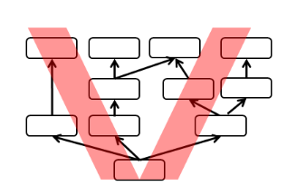

**List of UDE (Undesirable Effects) –**It looks like there may be more than one root problem!! Start always with final problems (impacts) harming your depressing situation!

1. I do not have girl (boy friend)
2. I am alone (loneliness bothers me)
3. I am very shy because of my figure
4. I am killing anxiety having reason in solitude by eating and drinking liquors
5. Oversupply of calories
6. I'm fat a pig (it bothers me very much)
7. I am shy to negotiate dating
8. I cannot manage my time
9. Surfing on internet too much
10. No time to cook and eat healthy food
11. Visiting often fast foods