**CRT construction task 5**

It takes some experience to build a robust Current Reality Tree, which should not be done by a single person by the way (for the sake of robustness), and the best is to get used to read them first. A CRT has more or less a V shape with the topmost and numerous UDEs on the top, other UDEs that are causes from topmost UDEs and their own causes, and so on down to the few critical root causes, usually located (near or) on the base of the CRT. Once a tree is completed, it can be read either top-down or bottom-up. The construction is always top-down, from symptoms to causes to critical root causes.

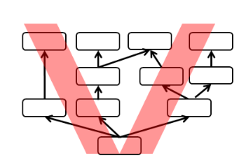

**List of UDE (Undesirable Effects) –**It looks like there may be more than one root problem!! Start always with final problems (impacts) harming your depressing situation!

1. Performance of manager are based on budget (they are remunerated only if budget is not which exceeded)
2. Existing salespeople are overloaded
3. Sales managers do not hire new sales people
4. Demand to sale force personnel capacity is greater than real capacity of current personnel in sales department
5. Salespeople do not call on existing customers to frequently
6. Sales are reduced
7. Overloaded people are not happy and some of the quit (filed notice)
8. Customers do not like to wait for get their orders (they quit)