MPH_AOPR (Operations Management and ERP) – Questions Autumn _ Winter 2019

Created by : Ing. J.Skorkovský,CSc. KPH ESF MU BRNO, Czech Republic ; 1730@mail.muni.cz;skorka@cmail.cz; jaromir.skorkovsky@navertica.com, miki@econ.muni.cz , tel : +420 731 113 517
Date : 19.11.2019
Version : V.

All questions have to be studied with the help of related study materials handed over to students during lessons held in Brno (Autumn-Winter 2019). It is valid for the MPH_AOPR course, which has separate study material folders.

Will be shortly reviewed (explained) during two remaining lessons (25.11.2019 and 27.11.2019), taking into consideration, that some of these days or part of it might be devoted to seminar work presentation. Next week starting on 9.12.189 are so far assigned for the final exams (preliminarily). Another exam dates will be published on www.is.muni.cz and will also be presented by your professor. Essential parts of below-specified questions (TOC and CCMP) should be described in your Seminar works assigned to you, and I hope handed over, presented and defended, and remarked (revised) by your professor.

Resources (actual status to the date 19.11.2019). All files in the below-presented study material list were used during theoretical and practical lessons or will be still used till the end of course MPH_AOPR. The other files related to the session, which will be given on 20.11.2019, 25.11.2019, 27.11.2019, and possibly 2.12.2019 and 4.12.2019, will be added to this material and can be accessed directly from Study materials after upload.

Below listed material corresponds to all MS Dynamics NAV 2018w1 functions and its impact on operation management during practical lessons. This list has to be used for MS Dynamics NAV 2018w1 studies.

Mind you, that access to MS Dynamics NAV 2018w1 English version (British local currency and English database) is enabled on all computers in the library and galleries of the ESF. From this table mentioned below, it is visible and apparent, that all listed passages trained and shown during the MS Dynamics NAV 2018w1 system hands-on seminars were uploaded.

There you can also find material related to the home installation of MS Dynamics NAV 2018w1 to your PC. It is highly recommended to upload this material and to install ERP now or any time later

For the MPH-AOPR course, it represents all in all slides from below mentioned table. The number of slides in the theoretical part was not calculated so far.

All students are kindly asked to check if all listed files have been uploaded to Study material folders. If not, report immediately to the tutor.

Listing of Practice Resources (ERP MS Dynamics NAV 2018w1
(mapping questions-resources – see a list of questions below)

Statistics of the slides for MPH_AOPR course
PWP Examples used for training and tuition printed and handed over to all students

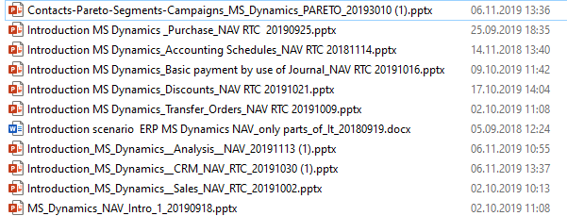

The last file related to MS Dynamics NAV 2018w1 (Intro_Production-Main concept) was uploaded 20.11.2019

Examples printed and handed over to students
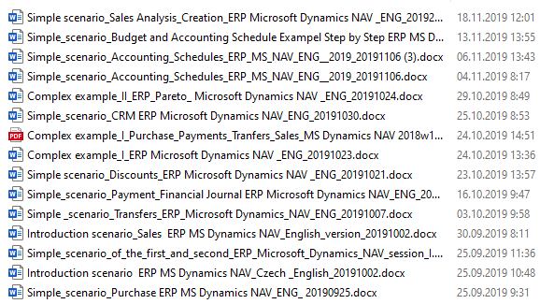

Practice Questions MS Dynamics NAV 2018w1 (RTC) for course MPH_ AOPR)

- The modularity of the ERP systems. What areas can be controlled by ERP MS Dynamics NAV 2018w1?
- Use of searching window to find application areas.
- Main windows (forms) used in ERP and syntax for Debits and Credits (posted General Ledger Entries) – card window, line window, matrix window (e.g. Item by location from Item cards) header and line window (form and sub-form, which is basic structure for every NAV document (Sales Order, Purchase Order, Contact Card (CRM), Transfer Order,..)
- Main tables (Item, Customer and Vendor- primary data field such as Balance, a Basic unit of measure, the Payment condition, Costing Methods, and so on. G/L account- where these accounts can be found ? You can use any time Help, which can be accessed by the icon on the upper-right corner window.
- Purchase of an item and impacts of F9 (posting) -> Item and Vendor entries, G/L entries. Create a new Purchase Order and show all impacts (Item ledger entries, General Ledger entries and Vendor Ledger Entry!
- Sale of an item and impacts of F9 (posting) -> item and customer entries, G/L entries Create new Sales Order and show all impacts (Item ledger entries, General Ledger entries, and Customer Ledger Entry!
- The payment of the open entry (Customer or Vendor) by use of the Financial Journal and impacts. Show how to get payment from the chosen Customer with non-zero Balance on Customer Card. Explain what the meaning of Open entry is!
8. All presented discounts (price, line in %, and invoice discount) and the use of these incentives! What kind of discounts do we have in MS Dynamics NAV 2018w1? Show setup of discount specified by examiner and impact of applied discount in sales lines!
9. Contact Card and its profile and use of it. The connection of the contact card to the Customer (Vendor) card. What is the use of a contact card profile? How is the contact card connected to the Customer?
10. What is an Opportunity and Sales cycle? (Show from the Contact card or Salesperson card) and how to create a new interaction from the contact card (use of wizard)? Use already created Opportunities, where you can easily access Sales Cycles from the opportunity lines (see main hotkeys short-hands). Explain how you can create a profile, which can split up customers into 3 levels (A,B, and C- a simple example of Pareto analysis- this can also be used in question 18 in the theoretical section)-this was presented during theoretical sessions. )
11. Transfer Order (Present to examiner transfer of a chosen item from Blue to Red Location). After Transfer Order is posted (F9) show by use, Ctrl-F7 created item entries! How many item entries are created during the transfer?
12. Account schedule. Start the chosen Account schedule. Name of the analysis and its template and how to edit it and see data by overview). Explain the benefits and use of it.
13. Explain and show the primary use and benefits of Budgets.
14. Explain the primary use of dimensions and sales analysis already created
15. Explain basics of production (delivered on 20.11. or possibly on 27.11.)
(Bill of material, Routings, Production order). It is not necessary to create during the exam a new production order. You have to show only data structures and by use of related PWP you can explain basic principle) –delivered on 20.11.2019 and 27.11.2029
16. Explain basics of dimensions (used for instance in the example related to budgets)

Listing of Theory Resources – will be used below to show you mapping knowledge –resources.

A. Operation Management Introduction.
B. Theory of Constraints
C. Critical Chain (CCPM)
D. Boston Matrix and Product Life Cycle (PLC)
E. Ishikawa fishbone diagram and its combination with Pareto Analysis
F. Pareto Analysis Simplified
G. Reserve clause (not used so far)
- OLAP and Business Intelligence
- Magic Quadrant Matrix from Gartner company
- Kepner -Tregoe Methodology
- Total Quality Management - (if delivered)
- Drum-Buffer-Rope (will be uploaded after tuition) - (if delivered)
- CONWIP principles
- Reserve clause (not used so far)
- Balanced Scorecard
- Linear programming basics
- Yield management
- Decision trees
- Little´s law
- EOQ basics
- Break-even- point analysis (basics)

Theory Questions (resources A-U):

Structure of the theory question:

Comment: Indicative questions, which are written below in italics, are only ancillary issues!
It is assumed that Your answers might be more involved! OM=Operation Management.

Number Description: Resource (slides if required )

- Name key OM activities and use of OM: A
- Name critical skills, which should be part of the OM knowledge portfolio: A
- What is a Deming cycle? What supposed to be the main task to improve company processes? : A, B.
4. The evaluation of the project result (e.g. your project from seminar work). How can we know that the project was successful? Consider time, due date, capacities of resources, budgets limits, required knowledge portfolio, project changes- also use possible parts of your seminar work including risk analysis: A, B, and C
5. Reserve clause (not used so far)
6. Specify the basic concept of the Theory of Constraints: B and C
Very complex question! It covers among other questions 7,8,9 and also 10.
7. TOC metrics: B
Name three main metrics and their trends, explain the benefits of using these metrics. How to calculate NET Profit and ROI by using these metrics?
8. Cost World and Throughput World: B
Define and explain differences
9. TOC five steps: B
10. Drum-Buffer-Rope (explain only principles): L (if delivered)
11. Primary trees (Thinking process tools) – Current Reality Tree, Evaporating Cloud Tree, and Future Reality Tree: B
Explain the primary use and how these trees are constructed. This question is more and less also related to your seminar work!
12. What is bad multitasking? : C
13. Critical path and Critical Chain differences: C
Specify differences between CP (Critical Path and CC (Critical chain)!
14. Use of project buffer (buffer management concept and graph with three zones): C
Specify the use of buffers, how the size of the buffer is set.
15. Total Quality Management Basics: K (only if delivered)
16. Ishikawa fishbone diagram: E
17. Boston matrix and Product Life Cycle (PLC). State some examples of PLC: D
18. Pareto analysis and its applications (use of PWP presentation Ishikawa allowed): E –You can
show already created PARETO example in 2018w1 (see PWP NAV number 6 –CRM- and related text (example)
19. OLAP (Business Intelligence): H
Basic principles and use of using BI (Business Intelligence). What is the N-dimension cube?
20. Basic principles of Kepner –Tregoe method supporting decision making: J
Must-to-have and Nice-to-have criteria and its use, principles of WHO, WHAT, WHEN, WHERE, and EXTENT and Why to distinguish between It Is and It Is Not.
21. Magic Gartner Quadrant Matrix: I
22. Balanced Scorecard (BSC) basic principles and use. What is KPI? Name all four sections of BCS: N
23. The primary use of Linear programming : P ( Target function and constraints. Reason of using Solver Explain by use of PWP)
24. Basic rules of Yield management: Q (areas where this part of revenue management methodology can be used, show and no-show, Cu Co, calculations – presented examples in PWP can be used during the exam
25. Little´s law formulation and use: S
26. Decision tree – essential use: R
27. CONWIP principles: M
28. EOQ (Economic Order Quantity): T
29. Break-even- point analysis: U

