**CRT construction task 4**

It takes some experience to build a robust Current Reality Tree, which should not be done by a single person by the way (for the sake of robustness), and the best is to get used to read them first. A CRT has more or less a V shape with the topmost and numerous UDEs on the top, other UDEs that are causes from topmost UDEs and their own causes, and so on down to the few critical root causes, usually located (near or) on the base of the CRT. Once a tree is completed, it can be read either top-down or bottom-up. The construction is always top-down, from symptoms to causes to critical root causes.

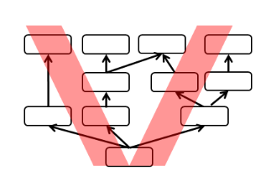

**List of UDE (Undesirable Effects) –**It looks like there may be more than one root problem!! Start always with final problems (impacts) harming your business.

1. Value of the stock is higher and higher and warehouse turnover is low and lower
2. Not good data in time (on line data in right time and right place- late information )
3. Unable to maintain proper balance supply-demand (requirement from customers or forecasts)
4. Bad decision making
5. Unable to plan correctly capacity of my resources (time capacities of machines and personnel)
6. Frequent delays in production
7. Due date performance is low
8. No good ERP system
9. We have lot of components in stock which we do no need a lot of needed components are missing