**INTERNATIONAL TRADE (MPH_AINT)**

**SAMPLE TEST**

1. Trade between two countries can benefit both countries if

A) each country enjoys superior terms of trade.

B) each country has a more elastic demand for the imported goods.

C) each country has a more elastic supply for the exported goods.

D) each country produces a wide range of goods for export.

E) each country exports that good in which it has a comparative advantage.

1. 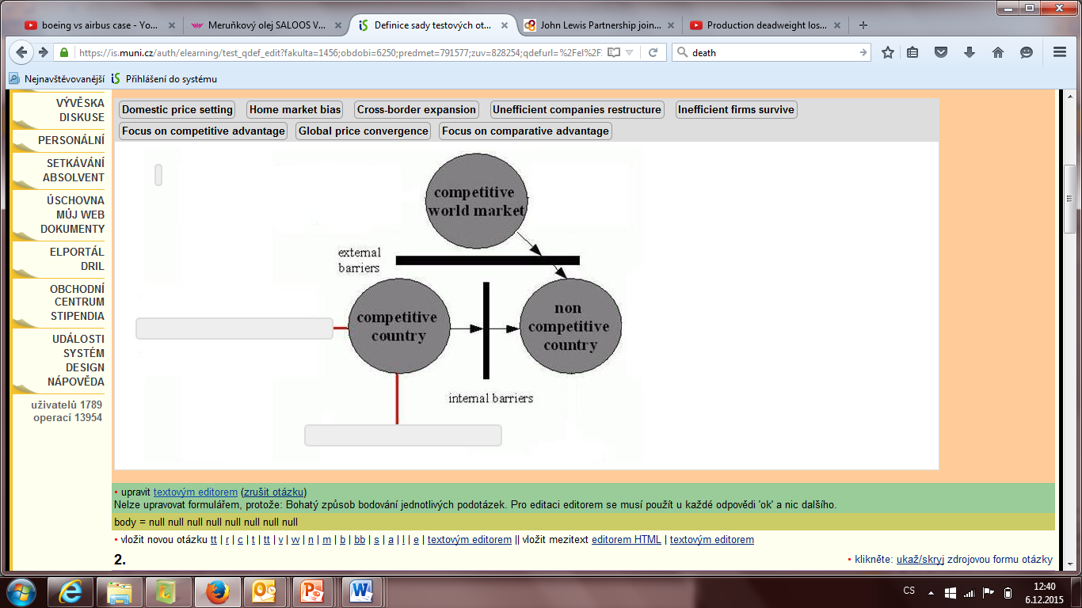Find two typical **characteristics of a competitive country** in the model below.
2. Use the information in the table below to answer the following questions.

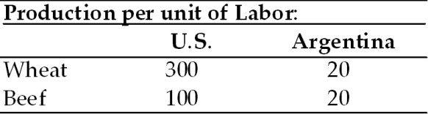

(a) Does either country have an absolute advantage in the production of wheat or beef? Explain.

(b) What is the opportunity cost of wheat in each country?

(c) What is the opportunity cost of beef in each country?

(d) Analyze comparative advantage and opportunities for trade between the U.S. and Argentina.

1. Specific tariffs are

A) import taxes calculated based solely on the origin country.

B) import taxes calculated as a fraction of the value of the imported goods.

C) the same as import quotas.

D) import taxes calculated as a fixed charge for each unit of imported goods.

E) import taxes stated in specific legal statutes.

1. What is a TRUE statement concerning the imposition in the U.S. of a tariff on cheese?

A) It raises the price of cheese internationally.

B) It lowers the price of cheese domestically.

C) it leads to higher domestic demand for cheese.

D) It will always result in retaliation from abroad.

E) It raises revenue for the government.

1. The General Agreement on Tariffs and Trade and the World Trade Organization have resulted in

A) termination of export subsidies applied to manufactured goods.

B) termination of international theft of copyrights.

C) termination of import tariffs applied to agricultural commodities.

D) termination of import tariffs applied to manufactures.

E) a number of rounds of multilateral trade agreements.