Exercise session 5

1. A paper plant produces water pollution during the production process. If the government forces the plant to internalize the negative externality, then the
   1. supply curve for paper would shift to the right.
   2. **supply curve for paper would shift to the left.**
   3. demand curve for paper would shift to the right.
   4. demand curve for paper would shift to the left.
2. The following table shows the private value, private cost, and social value for a market with a positive externality.

|  |  |  |  |
| --- | --- | --- | --- |
| ***Quantity*** | ***Private Value*** | ***Private Cost*** | ***Social Value*** |
| 1 | 27 | 6 | 34 |
| 2 | 24 | 10 | 31 |
| 3 | 21 | 14 | 28 |
| 4 | 18 | 18 | 25 |
| 5 | 15 | 22 | 22 |
| 6 | 12 | 26 | 19 |

1. What is the equilibrium quantity of output in this market? **Where Private value=private cost =>** **4 units**
2. What is the socially-optimal level of output in this market? **Where Social value=private cost => 5 units**
3. How large would a subsidy need to be in this market to move the market from the equilibrium level of output to the socially-optimal level of output? **The difference between private value and social values is 7 dollars at each level of output, meaning that external benefit is 7$, therefore, subsidy of 7 dollars would internalize the positive externality.**

**You could also plot a graph in excel to come up with the solutions**

1. Which of the following is true of markets characterized by positive externalities?
   1. Social value exceeds private value, and market quantity exceeds the socially optimal quantity.
   2. Social value is less than private value, and market quantity exceeds the socially optimal quantity.
   3. **Social value exceeds private value, and market quantity is less than the socially optimal quantity.**
   4. Social value seldom exceeds private value; therefore, social quantity is less than private quantity.
2. Which of the following activities, if any, represents an external cost?

|  |  |  |
| --- | --- | --- |
|  | a. | ​The reduction in the incidence of chicken pox when children are inoculated against the disease. |
|  | **b.** | **​The damage to a person's health from second hand smoke.** |
|  | c. | ​The increase in local property values when the city creates a neighborhood park. |
|  | d. | ​The price you pay for the prime rib that you consume at a local restaurant. |

. ​5. Over the air television signals are ____________ ; television signals available through cable are __________

|  |  |  |
| --- | --- | --- |
|  | a. | Public goods, public goods |
|  | **b.** | **​Public goods, private goods** |
|  | c. | Private goods, private goods |
|  | d. | Private goods, public goods |

1. In the following figure

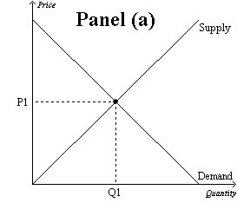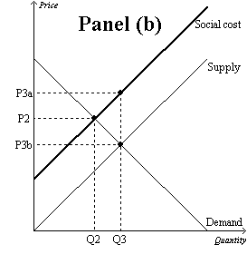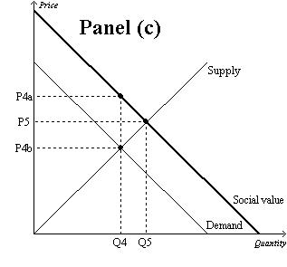

1. Which graph represents a market with no externality? **Panel A**
2. Which graph represents a market with a positive externality? **Panel C**
3. Which graph represents a market with a negative externality? **Panel B**
4. How much is the market equilibrium price and quantity in **Panel (b)? Q3 and P3b**
5. The overuse of antibiotics leads to the development of antibiotic-resistant diseases.

Therefore, the market for antibiotics is shown in… **Panel B**

1. The installation of a scrubber in a smokestack reduces the emission of harmful chemicals from the smokestack. Therefore, the market for smokestack scrubbers is shown in… **Panel C**
2. Which of the following is correct?
   1. A tax would move the market in Panel (b) and the market in Panel (c) closer to the socially optimal outcome.
   2. A subsidy would move the market in Panel (b) and the market in Panel (c) closer to the socially optimal outcome.
   3. **A tax would move the market in Panel (b) closer to the socially optimal outcome, but a subsidy would move the market in Panel (c) closer to the socially optimal outcome.**
   4. A subsidy would move the market in Panel (b) closer to the socially optimal outcome, but a tax would move the market in Panel (c) closer to the socially optimal outcome.
3. In the following figure:

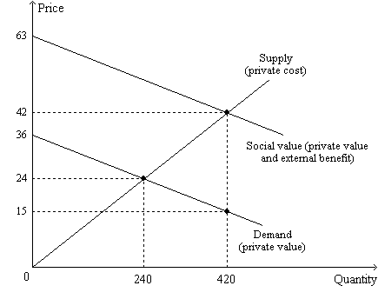

1. What type of market is represented? **Market with positive externality**
2. Which of the following statements is correct?
   1. The private value of the 420th unit of output is $15.
   2. The social value of the 420th unit of output is $42.
   3. The external benefit of the 420th unit of output is $27.
   4. **All of the above are correct.**
3. “The social value of the last unit produced exceeds the private cost of the last unit produced by $13.50.” This statement is correct at which quantity of output?

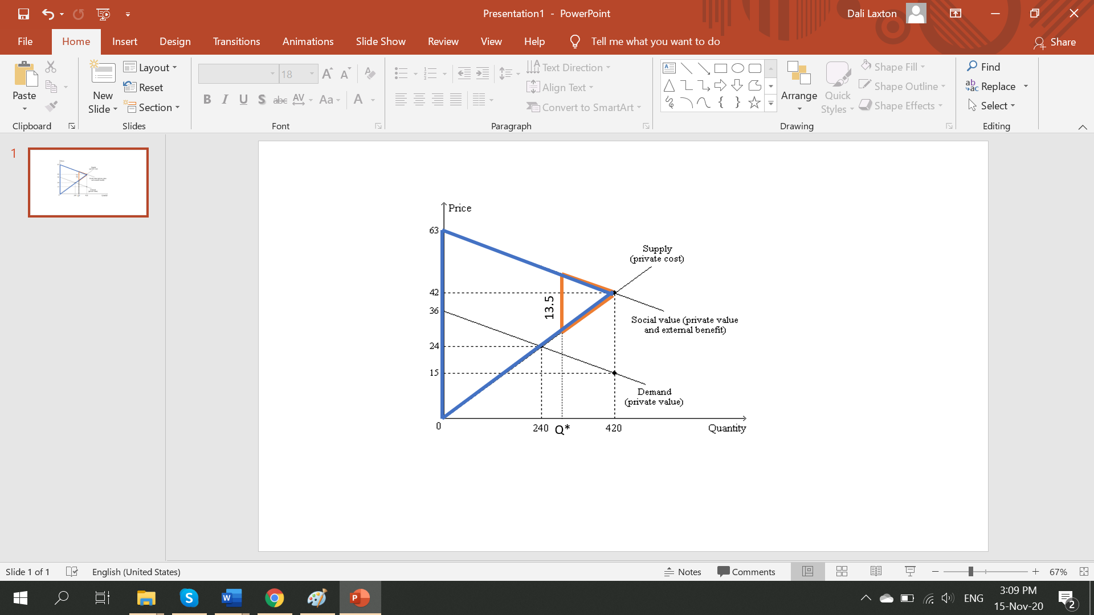

**Think of the blue and orange triangles as similar triangles. With the proportion method of triangles we have:**

1. On the
   1. 390th unit of output, private value exceeds private cost.
   2. 390th unit of output, private value exceeds external value.
   3. 450th unit of output, private value exceeds social value.
   4. **450th unit of output, private cost exceeds social value.**
2. Taking into account private value *and* external benefits, how much is the maximum total surplus that can be achieved in this market? 420*63/2=13230
3. Consider the town of Springfield with only three residents, Sophia, Amber, and Cedric. The three residents are trying to determine how large, in acres, they should build the public park. The table below shows each resident’s willingness to pay for each acre of the park.

|  |  |  |  |
| --- | --- | --- | --- |
| **Acres** | **Sophia** | **Amber** | **Cedric** |
| 1 | $10 | $24 | $6 |
| 2 | 8 | 18 | 5 |
| 3 | 6 | 14 | 4 |
| 4 | 3 | 8 | 3 |
| 5 | 1 | 6 | 2 |
| 6 | 0 | 4 | 1 |
| 7 | 0 | 2 | 0 |

1. Suppose the cost to build the park is $24 per acre. How many acres should the park be to maximize total surplus from the park in Springfield? **3 acres because at two acres total willingness to pay equals to cost of building the park, while at 4 acres, total benefit is less than the cost of adding one more acre**
2. Suppose the cost to build the park is $9 per acre. How large should the park be to maximize total surplus from the park in Springfield? **5 acres**
3. Suppose the cost to build the park is $24 per acre and that the residents have agreed to split the cost of building the park equally. If the residents vote to determine the size of park to build, basing their decision solely on their own willingness to pay (and trying to maximize their own surplus), what is the largest park size for which the majority of residents would vote “yes?” Answer the same question when the cost per acre is 9$. **2 acres, 4 acres. *The logic is that at 24$ per acre, each of them will have to pay 8 dollars with equal split. Sophia will be willing to say “yes” up until 2 acres, Amber will be willing to say “yes” up until 4 acres and Cedric will not be willing to say yes at all, Therefore, majority votes will be “yes” to 2 acres. With 9$ per acre, the cost for each will be 3 dollars and in that case majority will vote for maximum 4 acres.***
4. Suppose the cost to build the park is $24 per acre and that the residents have agreed to split the cost of building the park equally. To maximize his own surplus, how many acres would Cedric like Springfield to build? **0**
5. Suppose the cost to build the park is $24 per acre and that the residents have agreed to split the cost of building the park equally. If the residents decide to build a park with size equal to the number of acres that maximizes total surplus from the park, how much total surplus will Sophia receive?What about Amber? **0$; 32$.**

**Total surplus is maximized when 3 acres are built. At that allocation Sophia pays 8$ per acre, while receives 24$ as benefit (10+8+6), therefore, her surplus is 0. At 3 acres Amber pays 24$ in total while receives 24+18+14 dollars as benefit, hence her surplus is 32$**

1. The privately-owned school system in Smalltown has a virtually unlimited capacity. It accepts all applicants and operates on both tuition and private donations. Although every resident places value on having an educated community, the school's revenues have suffered lately due to a large decline in private donations from the elderly population. Since the benefit that each citizen receives from having an educated community is a public good, which of the following would *not* be correct?
   1. The free-rider problem causes the private market to undersupply education to the community.
   2. The government can potentially help the market reach a socially optimal level of education.
   3. A tax increase to pay for education could potentially make the community better off.
   4. **The private market is the best way to supply education.**
2. Highway engineers want to improve a dangerous stretch of highway. They expect that it will reduce the risk of someone dying in an accident from 5.3 percent to 2.1 percent over the life of the highway. If a human life is worth $10 million, then the project is worth doing as long as it does not cost more than

a. $53,000.

b. $210,000.

**c. $320,000.**

d. $2.1 million.

**10000000*(5.3-2.1)/100=320000**