**Exercise session 8**

1. Laurel and Janet are competitors in a local market and each is trying to decide if it is worthwhile to advertise. If both of them advertise, each will earn a profit of $5,000. If neither of them advertise, each will earn a profit of $10,000. If one advertises and the other doesn't, then the one who advertises will earn a profit of $12,000 and the other will earn $2,000. In this version of the prisoners' dilemma, if the game is played only once, Laurel should
   1. advertise, but if the game is to be repeated many times she should probably not advertise.
   2. advertise, and if the game is to be repeated many times she should still probably advertise.
   3. not advertise, but if the game is to be repeated many times she should probably advertise.
   4. not advertise, and if the game is to be repeated many times she should still not advertise.
2. This table shows a game played between two firms, Firm A and Firm B. In this game each firm must decide how much output (*Q*) to produce: 2 units or 3 units. The profit for each firm is given in the table as (Profit for Firm A, Profit for Firm B).

|  |  |  |  |
| --- | --- | --- | --- |
|  |  | **Firm B** | |
|  |  | *Q=2* | *Q=3* |
| **Firm A** | *Q=2* | (10, 10) | (8, 12) |
| *Q=3* | (12, 8) | (6, 6) |

1. Does any of a firm have a dominant strategy? Which one?
2. Find a Nash equilibrium.
3. Tony is the owner of Tony’s Taqueria. Tony is a profit­maximizing owner whose firm operates in a competitive market. An additional worker costs Tony $200 and has a marginal productivity of 40 tacos. Assuming no other variable costs, what is the marginal cost of a taco?
   1. $200
   2. $8
   3. $5
   4. There is insufficient information available to answer this question.
4. Diane's Auto World installs tires on automobiles, light trucks, and sport utility vehicles. She is a profit-maximizing business owner whose firm operates in a competitive market. The marginal cost of installing a tire is $20. The marginal productivity of the last worker that Diane hired was 2 tires per hour. What is the maximum hourly wage that Diane was willing to pay the last worker hired?
   1. $10
   2. $20
   3. $40
   4. There is insufficient information to answer this question.
5. Omega Custom Cabinets produces and sells custom bathroom vanities. Assume that labor is the only input that varies for the firm. The firm has determined that if it hires 10 workers, it can produce and sell 20 vanities per week. If it hires 11 workers, it can produce and sell 22 vanities per week. It sells each vanity for $800, and it pays each of its workers $1,000 per week. Which of the following is correct?
   1. The firm is maximizing its profit.
   2. If the firm is employing 11 workers, then its profit would increase if it cut back to 10 workers.
   3. For the 11th worker, the marginal profit for the firm is $600.
   4. For the 11th worker, the marginal revenue product is $2,000.
6. On the graph, *L* represents the quantity of labor and *Q* represents the quantity of output per week.

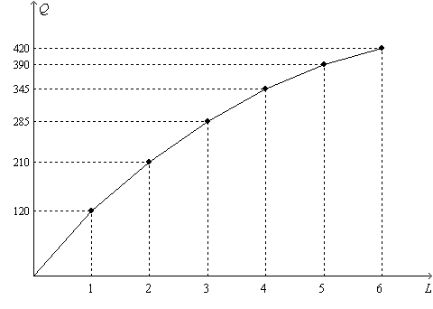

1. The figure illustrates the
   1. demand for labor.
   2. supply of labor.
   3. production function.
   4. wage function.
2. How much is the marginal product of the second worker?
3. Suppose the firm hires each unit of labor for $600 per week, and each unit of output sells for $9. What is the value of the marginal product of the third worker?
4. Suppose the firm hires each unit of labor for $700 per week, and each unit of output sells for $9. How many workers will the firm hire to maximize its profit?
5. Suppose the firm sells its output for $15 per unit, and it pays each of its workers $750 per week. When output increases from 210 units to 285 units, the
   1. marginal revenue is $5 per unit of output.
   2. value of the marginal product of labor is $4,275
   3. firm’s profit decreases.
   4. marginal cost is $10 per unit of output.
6. Suppose the firm sells its output for $10 per unit, and it pays each of its workers $400 per week. When the number of workers increases from 4 to 5, the
   1. marginal revenue is $450 per unit of output, and the marginal cost is $400 per unit of output.
   2. value of the marginal product of labor is $3,900, and the marginal cost per unit of output is $400.
   3. value of the marginal product of labor is $450, and the marginal cost per unit of output is about $8.89.
   4. firm’s profit decreases.
7. Suppose the firm sells its output for $25 per unit, and it pays each of its workers $1,000 per week. Also, the firm’s non­labor costs are fixed and they amount to $2,000. How many workers should the firm hire to maximize profit?