**Exercise session 7**

**Problem 1**: For each of the following characteristics, say whether it describes a perfectly competitive firm (PC), a monopolistically competitive firm (MC), both, or neither.

a. Sells a product differentiated from that of its competitors (**MC**)

b. has marginal revenue less than price (**MC**)

c. earns economic profit in the long run (**neither**)

d. produces at the minimum of average total cost in the long run (**PC**)

e. equates marginal revenue and marginal cost (**both**)

f. charges a price above marginal cost (**MC**)

**Problem 2**: For each of the following characteristics, say whether it describes a monopoly firm (M), a monopolistically competitive firm (MC), both, or neither.

a. faces a downward-sloping demand curve (**both**)

b. has marginal revenue less than price (**both**)

c. faces the entry of new firms selling similar products (**MC**)

d. earns economic profit in the long run (**M**)

e. equates marginal revenue and marginal cost (**both**)

f. produces the socially efficient quantity of output (**neither**)

**Problem 3**: Suppose initially only firm A served the whole market of a specific good. Over time consumers realized that the good has close substitutes and other firms entered the market offering differentiated products. We can conclude that the demand for firm A became elastic. Is this statement true or false? Explain your answer.

***Answer***: true. Consumers at monopolistically competitive market have more variety and can easily change the consumption of a product than they could in case of Monopoly.

**Problem 4**: Use a graph to demonstrate why a profit-maximizing monopolistically competitive firm must operate at excess capacity. Explain why a perfectly competitive firm is not subject to the same constraint.



***Answer***: Competitive firms do not face downward-sloping demand. The graph shows the firm choosing a level of production in which the intersection of marginal revenue and marginal cost occurs at an output level where average total cost is decreasing. This profit-maximizing output level is less than the efficient scale (minimum of average total cost), and therefore the firm is said to be operating with excess capacity.

**Problem 5:** Assume the role of a critic of advertising. Describe the characteristics of advertising that reduce the effectiveness of markets and decrease the social welfare of society.

***Answer***: Advertising manipulates people's tastes and is psychological rather than informational. As a result, advertising creates a desire for a product that might not otherwise exist. Advertising may also impede competition by convincing consumers that products that are identical have significant difference**s.**

**Problem 6**: Assume the role of a defender of advertising. Describe the characteristics of advertising that enhance the effectiveness of markets and increase the social welfare of society.

***Answer***: Advertising provides information to consumers and thus allows consumers to make more informed (and therefore better) choices. Advertising fosters competition by making consumers more aware of prices and product characteristics in a market.

**Problem 7**: The market for peanut butter in Ostrava is monopolistically competitive and in long-run equilibrium. One day, the major Tomáš Macura discovers and announces that all brands of peanut butter in Ostrava are identical. Thereafter, the market becomes perfectly competitive and again reaches its long-run equilibrium. Using an appropriate diagram, explain whether each of the following variables increases, decreases, or stays the same for a typical firm in the market.

1. price
2. quantity
3. average total cost
4. marginal cost
5. profit

***Answer*:** 

a. The price will fall from PMC to the minimum average total cost (PC) when the market becomes perfectly competitive.

b. The quantity produced by a typical firm will rise to QC, which is at the efficient scale of output.

c. The average total cost will fall as the firm increases its output to the efficient scale.

d. Marginal cost will rise as output rises. Marginal cost is now equal to price.

e. Profit will not change. In either case, the market will move to the long-run equilibrium where all firms will earn zero economic profit.

**Problem 8**: Consider the market for slices of pizza. Suppose that the market is perfectly competitive. There are 4 consumers and 2 producers (but each acts as price taker). Consumers are identical and producers are identical. Assume that partial slices of pizza may be produced and consumed. Individual demand curve: q=6-P; individual supply curve: q=P

a) Write an equation for the market demand curve. Why does the demand curve slope downward?

***Answer***: Pizza is a private good. Therefore to obtain market demand, we horizontally aggregate the individual demands. Thus Q=24-4P.

The demand curve slopes down because as consumers eat more pizza, their desire for more (on the margin) declines. Therefore their willingness to pay declines as they consume more. If you’ve been stranded in a blizzard for 3 days without food, your marginal WTP for the first slice will be huge. Once you’ve eaten 20 slices, your marginal WTP will probably be quite small, or even negative.

b) Write an equation for the market supply curve. Why does the supply curve slope upward?

***Answer:*** Again, we horizontally aggregate the individual supply curves. This gives the market supply of Q=2P.

The supply curve slopes up (in the short run) due to some input into production being fixed (typically we assume this is capital). As more labor is combined with a fixed amount of capital, labor productivity (marginal product of labor) falls. This causes the cost of an extra unit to rise, as more stuff is produced (and more labor is used). Hence MC is thought to slope up. MC above average variable cost is an individual firm’s supply curve.

c) Find equilibrium price and quantity in the market for pizza slices. How many slices does each person consume? How many does each producer make?

***Answer:*** D: Q=24-4P; S: Q=2P. Set this equal to find equilibrium P. 24-4P=2P 6P=24 P=4 (plug this into either D or S to get equilibrium Q), therefore, Q=8.

Each consumer faces P=4; plugging this into individual demand, q=6-P, yields q=2, so each consumer buys 2 slices.

Each producer faces P=4; plugging this into individual supply, q=P, yields q=4, so each producer supplies 4 slices.

d) Calculate the consumer and producer surplus.

***Answer:*** 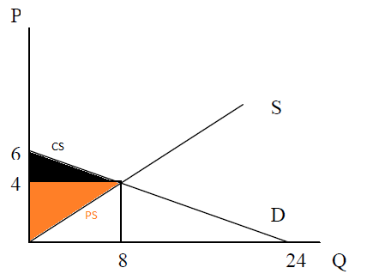

CS = ½*(6-4)*8=8; PS = ½*4*8=16.

e) Is the equilibrium quantity efficient? Why?

***Answer:*** In the absence of any externality, S=MSC, and D=MSB. Therefore, in equilibrium MSC=MSB, which is the condition for efficiency. Therefore, the equilibrium quantity happens to be efficient. This means social welfare is maximized at Q=8. If output were to go up a bit, the marginal social cost would exceed the marginal social benefit, thus lowering social welfare. If output were to go down a bit, the total social benefit would decline by more than total social cost would decline, thus lowering social welfare. So the point where MSB=MSC maximizes social welfare.

f) Using the efficiency criterion, could the government do any better than the market in allocating goods in this case?

***Answer:*** Nope. If the government knew the MSB and MSC curves, it could do as well as the market, but not better. And if it was wrong, it would likely make things worse (from an efficiency perspective)

**Problem 9:** Now suppose there is an externality associated with pizza slices. Consumers of the pizza have a nasty habit of dropping their paper plate on the sidewalk after eating. This presents a form of visual pollution to everyone else in the area. Assume that, on average, ½ plate is dropped on the sidewalk per slice of pizza consumed. Each plate on the sidewalk causes $2 of collective unhappiness to society.

a) Is this a positive or a negative externality?

***Answer:*** Negative, because it imposes costs on others.

b) What is the marginal external cost of a slice of pizza?

***Answer:*** On average, 1 slice of pizza is associated with ½ plate dropped. Each plate dropped causes $2 of external damage. Therefore the marginal external cost of each slice of pizza is (1/2)*2=$1.

c) Draw the marginal social benefit curve.

***Answer:*** To get this, shift down the MPB curve by $1 to reflect the constant MEC=1.

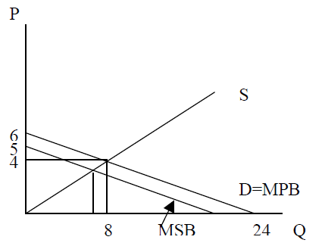

d) Does equilibrium production of pizza change in the face of the externality?

***Answer:*** No. Private markets ignore externalities. This should change neither consumer nor producer behavior. The equilibrium will be at (Q,P)=(8,4)

e) Calculate the total external cost of pizza consumption in equilibrium.

***Answer:*** TEC is $1 per slice for 8 slices consumed. So TEC=$8.

f) What are some policy instruments the government could use to eliminate the loss of surplus?

***Answer:*** The government could tax pizza, it could pay people a reward to use trashcans, it could impose a quota on pizza consumption, or set a price control that would induce the efficient quantity.

g) Now suppose the externality occurs in the following form. The consumers don’t dump their plates on the ground. Instead, the pizza parlors dump their trash (tomato cans, cheese wrappers, etc.) on the street at the end of the day. How would your analysis differ? Which curve would you alter now, to reflect the externality? Supposing the marginal external cost is the same per slice as above, does the efficient equilibrium differ?

***Answer:*** Now we’re talking about a production externality. If we assume the same MEC associated with littering by the owner, we’ll now shift the MPC curve up by $1 to reflect the externality. Notice that if you work through this, shifting the MPC up vertically by $1 yields the same efficient quantity as shifting the MPB down vertically by $1. This points to the fact that if you’re not sure about whether to count something as a production or a consumption externality, just pick one and move forward with the analysis. It will yield the same efficient quantity.

**Problem 10**: Suppose that a monopolist has a total cost of TC(Q) = 16+4*Q. The demand is given by P(Q) = 20 – Q.

1. Find the profit maximizing price and quantity and profit of the monopolist

***Answer***: MR = MC 20 – 2*Q = 4, therefore, Q* = 8 and plugging this into demand function, P* = 12. Profit = Revenue – TC (Q) = P*Q – (16 + 4*Q) = 12*8-(16+4*8)=48.

1. Find the efficient level of production and price.

***Answer***: P=MC P=4 (this is the supply “curve”). Therefore, to find the efficient amount, we should equate demand to supply: 20-Q=4 Q’=16.

1. Find the deadweight loss.

***Answer***: DWL = ½ *(Q’-Q*)*(P*-4) = 32 (you can draw the diagram to better understand calculations).

**Problem 11**: Consider a market in which the inverse demand is given by .

1. Assume that the market is perfectly competitive and that the supply is given by . Compute the equilibrium price, quantity, CS and PS. Illustrate the CS and the PS in a figure.

***Answer***: Demand equals to supply, therefore: . Hence, and . (see fig. below)

1. Now consider a monopoly operates in this market with the cost function of . Compute the profit maximizing output and price and CS, PS and DWL. Illustrate CS, PS and DWL in the figure.

***Answer:*** . Hence, ; and (see figure below).

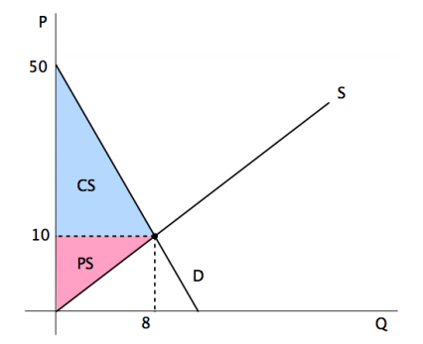

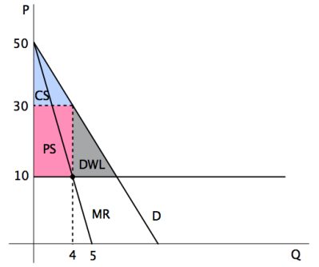

**Problem 12** (**Chicken game)**: Imagine two drivers, Mirek and Martin racing toward each other at high speed on a very narrow road. Each driver has the option to swerve or to race on. If one swerves while the other races on she/he is ridiculed and called a chicken. If both swerve it is a tie and if none swerve it ends in mutual destruction. A payoff table consistent with this game is:

|  |  |  |  |
| --- | --- | --- | --- |
|  |  | Martin | |
|  |  | swerve | race on |
| Mirek | swerve | 1 1 | 2 0 |
|
| race on | 0 2 | -10 -10 |
|

Do any player has a dominant strategy? If so, what is it? Find the Nash equilibrium / equilibria of the game.

***Answer***: None of the players have a dominant strategy, because depending on the action of another player, the best response is changing: for example, given that Martin is swerving, the best response from Mirek is to race on (he gets utility of 2 in this case, compared to 1 had he also swerved); on the other hand, given that Martin is racing on, the best response from Mirek is to swerve this time (he will get utility of 0, which is more than -10, had he also raced on).

Applying similar logic to the game, you can find that there are two (so called “pure strategy”) Nash equilibria: one when Mirek swerves and Martin races on (top left cell of the matrix, with outcomes (0,2)) and another, when Mirek races on while Martin swerves (bottom right, with outcomes (2,0)).

|  |  |  |  |
| --- | --- | --- | --- |
|  |  | Anna | |
|  |  | *H* | *T* |
| Kati | *H* | -1 1 | 1 -1 |
|
| *T* | 1 -1 | -1 1 |
|

**Problem 13 (Matching pennies – *zero sum game*)**: Suppose Anna has a penny that she can show either as head or tail. If both pennies coincide then Kati wins and takes Anna's penny while if they do not, Anna wins and takes Kati's penny. The payoffs are given by

Find the Nash equilibrium of the game.

***Answer***:[1] Let’s start with Anna’s decisions: given that Kati is showing head, the best response from Anna is to show the tail, giving the payoff of (-1, 1). Given that Kati is showing tail, the best response from Anna is to show head, giving each payoff of (-1,1). Using the same logic for Kati, you will see that the best response from Kati is to show always the same side of the coin as Anna. At the end, you will conclude that there is no Nash equilibrium in this game. Here we only consider so called “pure strategies” (playing either strategy with probability of 100%). Therefore, we conclude that this game does not have a pure strategy Nash equilibrium, while it has a mixed strategy equilibrium, which is beyond of the course.

1. The first entry is always the payoff of Jose and second is payoff of Paulina.