Case #12. WindEurope Needs Government Help

https://windeurope.org/ 27 June 2022

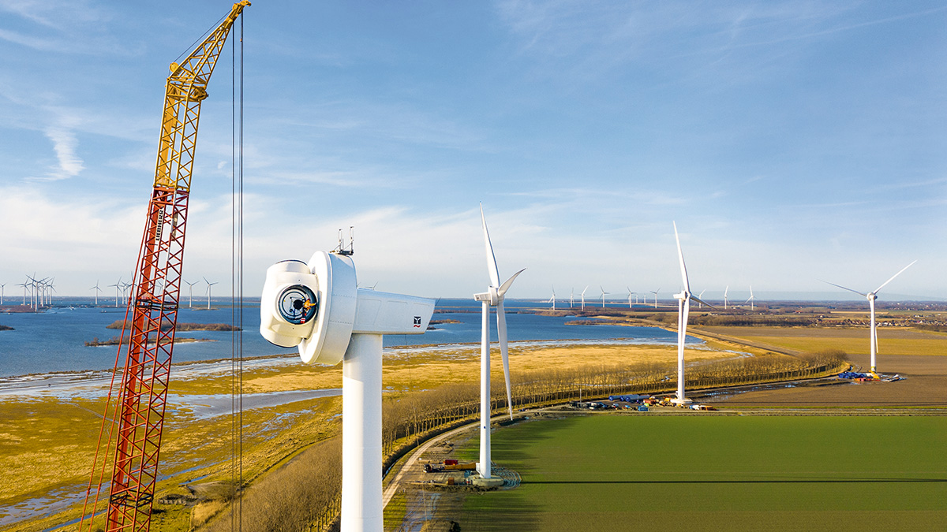
In June 2022, the annual Finance and Investment Trends report of WindEurope, the wind turbine’s trade association in Europe, showed investor confidence in wind energy remains high. Europe invested €41bn in new wind farms in 2021. This is financing 25 GW (gigawatts) of new capacity, a record. But the investments are falling well short of the 35 GW a year of new wind the EU now needs to build to meet its 2030 climate and energy security targets. Most of the new wind farms financed were onshore – 19.8 GW. Onshore wind is slightly cheaper than offshore.
The investments were pretty well spread geographically. Eleven countries invested more than €1bn. The UK invested the most (almost all in offshore wind) followed by Germany, France, Spain, Sweden and Finland. Spain invested the most in onshore wind. Sweden, Finland, Poland and Lithuania all invested more in new farms than they had done in any previous year.
Europe needs much more wind energy
The strong onshore wind investments show that Europe is starting to turn the corner on permitting. But the results are still far off from where Europe needs to be to reach its new climate change and energy security targets. The REPowerEU agenda now wants the EU to expand its wind capacity from 190 GW today to 480 GW by 2030. (REPowerEU is a European Commission proposal to end reliance on Russian fossil fuels before 2030 in response to the 2022 Russian invasion of Ukraine.)
Europe’s wind supply chain
Europe’s wind supply chain could and should be building much more. The fact it’s not, and that the market is only half the size it should be, is undermining the competitiveness of the supply chain. This is compounded by the rising costs of steel, other commodities and components, supply chain disruptions and higher shipping costs. All of Europe’s five wind turbine manufacturers are now operating at a loss. To restore the health of the wind energy supply chain the EU must continue to improve permitting, ensure a strong home market and pursue trade and industrial policies that support the sector.
Market volatilities highlight the benefits of CfDs
A growing number of new wind investments are underpinned by contracts for difference (CfDs) that governments are offering in their renewables auctions. CfDs deliver stable revenues for project developers at low costs to Governments – because Governments only pay out when the electricity price is below the auction price but get paid back when it’s higher. CfDs also reduce finance costs because the clear revenue perspective means banks finance projects at favourable rates of interest.
(CfD is a long-term contract between an electricity generator and Low Carbon Contracts Company (LCCC). The contract enables the generator to stabilise its revenues at a pre-agreed level (the Strike Price) for the duration of the contract. Under the CfD, payments can flow from LCCC to the generator, and vice versa.)
PPAs reach new highs
2021 was a record year for corporate renewable Power Purchase Agreements (PPAs). 6.9 GW of new PPA deals were announced, raising the total amount of renewables under PPA by a massive 58% in one year alone to 18.8 GW. Wind was 60% of the new PPA capacity with 41 new PPAs for onshore wind farms and 11 for offshore wind farms.
(A Power Purchase Agreement (PPA) is an arrangement in which a third-party developer installs, owns, and operates an energy system on a customer's property. The customer then purchases the system's electric output for a predetermined period.)

EU Energy Ministers endorse faster permitting of renewables

https://windeurope.org/ 27 June 2022
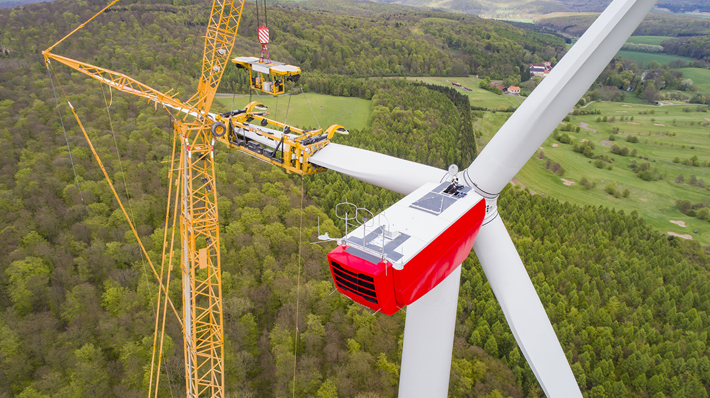
https://windeurope.org/
In June 2022, the EU Energy Ministers, which make up the EU Energy Council have agreed their position on changes to the Renewable Energy Directive and Energy Efficiency Directive, paving the way for faster build-out of renewables and streamlined permitting for wind farms. They agreed the Renewable Energy Directive should now include additional measures as proposed in the REPowerEU Action Plan to increase the EU’s energy security. EU Energy Ministers will now finalise the changes in negotiations with the European Parliament in autumn.
In light of the ongoing war the ministers stressed the need to accelerate the deployment of home-grown renewables in order to strengthen EU’s energy security. They agreed the expansion of renewables and the linked expansion of on- and offshore grid infrastructure in Europe should be considered a matter of “overarching public interest” and “public safety”.
To deliver the necessary build-out of renewables the EU Energy Ministers agreed on clear deadlines for the permitting of new projects and facilitated permitting of repowering projects. For repowering only the environmental impacts that are additional to the already existing turbines will be subject to environmental impact assessments. To ensure that wind energy development goes hand in hand with biodiversity protection the European Council now encourages a population-based approach to biodiversity that will help maintain and improve the health of endangered bird populations. (The European Council is the EU institution that defines the general political direction and priorities of the European Union.)
To achieve 510 GW of wind energy by 2030, up from 190 GW today, EuroWind argues that Europe will only achieve that goal if it speeds up permitting and EU Energy Ministers have now agreed to do precisely that. All new wind farms should be permitted in maximum two years. Governments should ensure this deadline covers all permits, including the environmental impact assessment and grid permits.”, says WindEurope CEO Giles Dickson.
Today electricity is only one quarter of all energy consumed in the EU. By 2050 it will be three quarters, 57% of the EU energy system will be electrified directly, another 18% will be electrified indirectly via renewable hydrogen and its derivates. With the adoption of specific sector targets, the EU Energy Ministers further strengthened the position of renewable hydrogen. They agreed a mandatory renewable hydrogen target in industry of 35% by 2030 and 50% by 2035 as well as an indicative renewable hydrogen target in transport of 5.2% by 2030.
Member States are now ready to start discussions with the European Parliament on the revised RED. The next step is for the European Parliament to vote its position on the Directive in its Industry and Energy Committee this 13 July. Final negotiations could then begin in autumn.

Crunch time for Member States to act on renewables permitting and nature protection

https://windeurope.org/ 27 June 2022

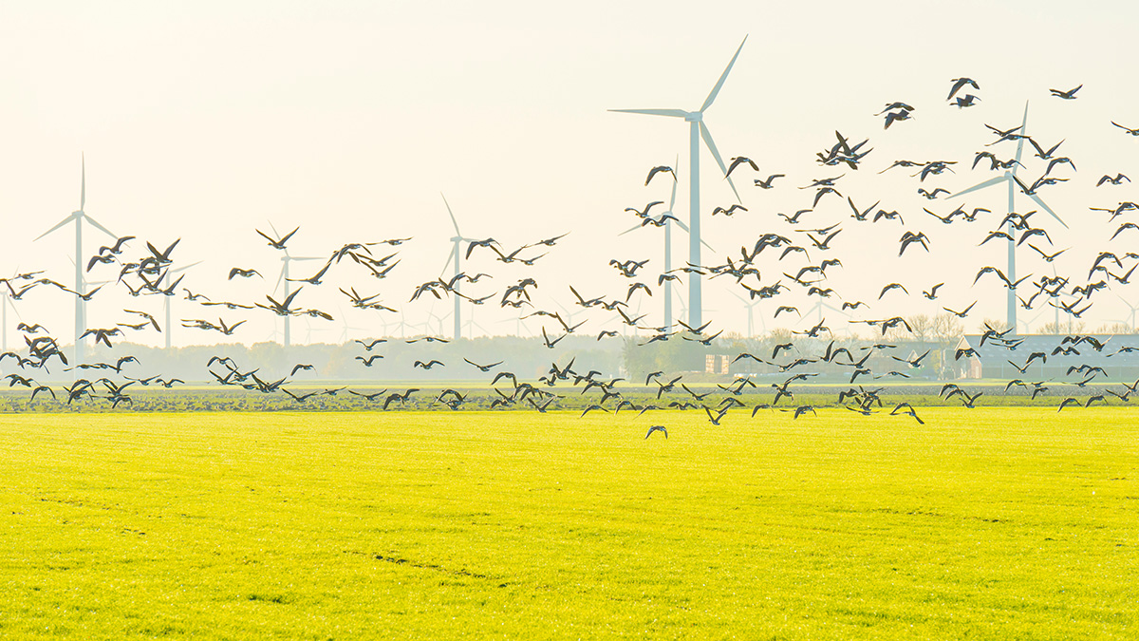
The European Commission has published its Nature Protection Package. The package implements the EU 2030 Biodiversity Strategy, part of the European Green Deal. It’s also supporting the REPowerEU Action Plan, the measures to reduce Europe’s dependence on Russian fossil fuels and accelerate the growth of renewables, which the Commission presented on 18 May. The expansion of wind energy needed to meet our climate goals and enhance our energy security goes hand in hand with nature protection. It’s crucial to have a good working balance between these parallel sets of public policy interests
Two years ago the EU 2030 Biodiversity Strategy proposed legally binding EU nature restoration targets and requirements for national biodiversity restoration plans. It introduced protected areas for 30% of the EU’s landmass and oceans. It acknowledged the importance of renewable energies in protecting ecosystems and mitigating the negative environmental effects of climate change.
Today’s Nature Protection Package builds on this. It enshrines in EU law a 20% binding restoration target of European seas and land. It’s a key opportunity to halt and reverse biodiversity loss in Europe. With our NGO and Transmission System Operators colleagues in the Offshore Coalition for Energy and Nature (OCEaN), WindEurope called recently for strong EU restoration targets and a framework to support ecologically-sound offshore wind and electricity grid deployment.
(The Offshore Coalition for Energy and Nature (OCEaN) consists of 26 organisations from across Europe, bringing together NGOs, TSOs (Transmission System Operators) and the wind industry. It works towards a sustainable development of offshore energy infrastructure that protects our marine ecosystems. The Renewables Grid Initiative (RGI) acts as the convener and moderator of the group as well as being a founding member. RGI is a collaboration of NGOs and TSOs from across Europe engaging in an ‘energy transition ecosystem-of-actors’ to promote fair, transparent, sustainable grid development to enable the growth of renewables to achieve full decarbonisation in line with the Paris Agreement.
WindEurope’s CEO Giles Dickson said: “It’s good the Commission is developing Europe’s nature protection rules in line with the REPowerEU strategy. Biodiversity and renewables go hand in hand. The wind industry remains committed as ever to protect biodiversity. We work closely with NGOs to mitigate impacts on wildlife – and with local communities that host our wind farms.”
Climate change is one of the biggest threats to nature and biodiversity. And renewable energy is the most efficient solution to reduce CO₂ emissions and help decarbonise our economy. Using wind to produce energy has fewer effects on the environment than other energy sources. Wind farms produce zero SOx, NOx and PM. They consume hardly any water. Their CO₂ footprint is negligible: a turbine pays off its lifecycle emissions in less than one year of operation.
And the wind industry works actively to protect the local environment where wind farms are built. We do everything possible to prevent, manage and mitigate these environmental impacts: through the planning, siting and design of wind farms; and in the way we build and operate them. Wind farms can also impact positively on their local environment and support biodiversity restoration. They can serve as safe havens for bees and other pollinators. Offshore wind farms can help restore marine life, through aquaculture, artificial reefs and increased fish stocks.
The Nature Protection Package ties in with Europe’s new energy security strategy, REPowerEU. The expansion of renewable energy and nature protection need to have a good working balance. The EU wants wind to be 50% of its electricity by 2050. It wants wind capacity to rise from 190 GW today to 510 GW by 2030. This means building 39 GW of new wind farms every year. Last year we built only 11 GW – because of bottlenecks in permitting.
REPowerEU sets out measures to simplify the permitting of new renewables, and it is essential these are implemented as soon as possible. It proposes enshrining in EU law the principle that renewables expansion is in the “overriding public interest” – so it can be prioritised on a case-by-case basis and until climate neutrality is reached. It envisages faster permitting in all areas where it’s possible to build renewables, and very fast permitting in selected “go-to” areas where biodiversity risks are minimal. It also strengthens the population-based approach to species protection, which is already part of EU law.
The Energy Ministers of the 27 EU Member States meet next Monday 27 June and will have the chance to agree the changes to permitting rules the EU Commission have proposed to the Renewables Directive as part of REPowerEU. It’s a great opportunity for them to inject momentum into the simplification of permitting.
WindEurope CEO Giles Dickson said: “With REPowerEU’s new permitting rules and today’s Nature Protection Package, Member States now have a full picture of the good working balance between biodiversity and renewables expansion. They now need to implement the REPowerEU measures on the simplification of permitting. And EU Energy Ministers need to agree ASAP the new rules on this that the Commission have proposed in the EU Renewables Directive.”

EU electricity market rules must support renewables investments
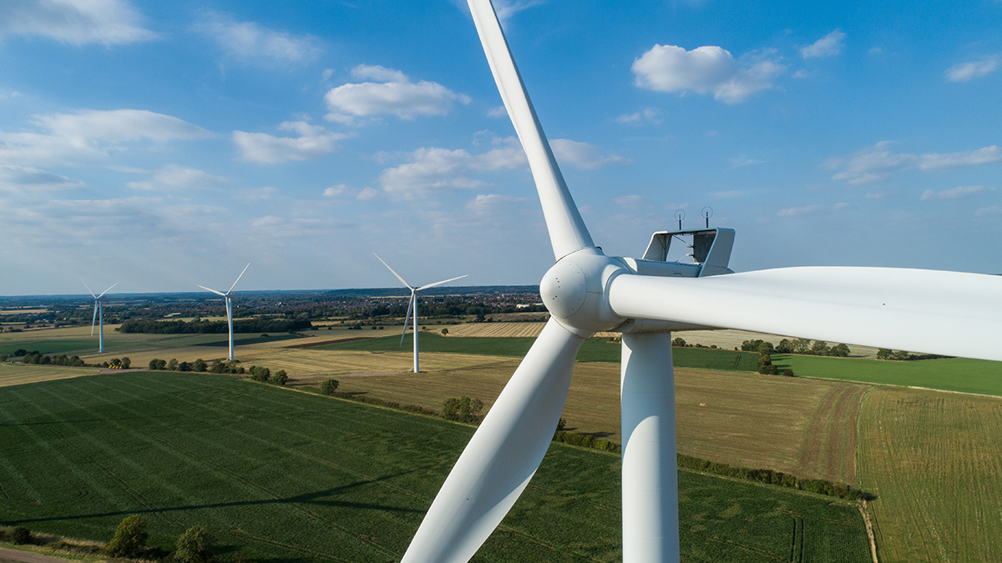
©: Enercon
In June 2022, the EU Agency for the Cooperation of Energy Regulators (ACER) issued its final assessment of the EU electricity market design. It comes at a time of volatile electricity prices and unprecedented supply insecurity linked to Russia’s invasion of Ukraine. Its core message is the EU must maintain its electricity price setting mechanism and preserve the Internal Energy Market, a key asset in dealing with the crisis. Earlier this month WindEurope published a new paper on electricity market design, stressing that investor certainty is essential to mobilise the massive investments needed to improve Europe’s energy security.
The very high electricity prices in Europe were initially fueled by the increase in gas prices that came with the uneven global recovery from COVID. Russia’s invasion of Ukraine and its hostile approach to gas supplies to Europe have now worsened the situation. Europe’s energy consumers are taking a heavy toll.
In response the EU is now diversifying its gas supply and looking to massively ramp up renewables to improve its energy security. Europe still imports 58% of its energy – mostly fossil fuels and often from countries posing serious geopolitical risks. The EU wants to change this. The new REPowerEU agenda aims to end all Russian energy imports by 2027.
It also raises Europe’s wind energy target by 2030. It wants the EU to expand its wind capacity from 190 GW today to 480 GW by 2030. Behind that the EU Commission foresees 1000 GW of onshore wind and 300 GW of offshore wind by 2050.
This huge expansion of wind energy will only be possible if Europe has the right energy market design. Crucially this requires incremental improvements – rather than radical changes – to the current rules for setting wholesale energy prices.
“High electricity prices are really hurting households and industries across Europe. The EU and national Governments must support vulnerable consumers. But the measures they take must avoid tampering with the very rules of the electricity market. Radical interventions won’t address the root of the current problem – an overreliance on imported fossil fuels. Wrong measures will endanger investor confidence and deter investments in renewables, when renewables are the very energy sources we now need to be investing in”, says WindEurope CEO Giles Dickson.
ACER assessment recommends maintaining current price setting mechanisms
In 2021 the European Commission tasked the EU Agency for the Cooperation of Energy Regulators (ACER) to assess the design of the EU electricity market in light of rising electricity prices. Today ACER presented its final assessment. It identifies ways to future-proof market design, keep electricity affordable and ensure the integration of an ever-increasing share of renewables.
The ACER report finds that the EU’s current market design is “worth keeping”. It says governments should first apply targeted, direct support to vulnerable customers, such as cash transfers and VAT reductions. They should avoid distorting the market with measures like price caps, as proposed by Spain and Portugal. The reason for the current high electricity prices is the price of gas, not the market design, the report concludes.
ACER clearly advocates for the least interventionist policy options wherever possible. The report lists different measures according to their potential risk for market distortions. Windfall taxes are not among the most preferred policy options. Windfall taxes are difficult to implement, jeopardise investor confidence and might deter necessary investments in Europe’s energy transition.
The report shows that cross-border trade of energy and the integration of electricity markets brought €34bn a year in benefits over the last decade. A more integrated and interconnected European energy market is more resilient. Cross-border flows of electricity help to avoid curtailment or even blackouts and improve energy security.
The assessment also highlights the need to improve permitting, speed up the roll-out of electricity grids and increase flexibility options, in particular seasonal flexibility.
WindEurope’s position on market design
WindEurope welcomes the ACER assessment and calls on the European Commission to ensure that such input is taken into due account in future decisions. Short-term measures taken today must not undermine the EU’s long-term objective of climate neutrality by 2050. Uncoordinated and ill-designed emergency measures could roll back EU market integration, increase the overall cost of the energy transition and hamper Europe’s energy security.
“Ending Europe’s dependence on imported gas, oil and coal is crucial to ensure energy security and affordable prices in the long-run. As is the rapid expansion of renewables. Europe needs to build 35 GW a year of new wind energy to deliver its energy security and climate goals. This is much more than it’s currently building. We can build more if Europe fixes the overly complex permitting processes for new wind farms. But it’s not doable if Europe now starts fiddling with the basic rules for setting power prices”, says Giles Dickson.
ACTORS IN THE CASE
EU Energy Ministers, which make up the EU Energy Council
European Commission
EU Agency for the Cooperation of Energy Regulators (ACER)
European Parliament
WindEurope
Renewables Grid Initiative (RGI)
Offshore Coalition for Energy and Nature (OCEaN)

CASE QUESTIONS

- (2) If you were WindEurope what would be (a) the two most important issues, and (b) two most important actors (other than the European Governmental entities) you would monitor as you seek to influence EU policy and decision-making regarding expediting approval of additional wind generation?
Format: I’d monitor______ because__________.
(maximum words: 80)

- (3) Summarize the power situation WindEurope faces in the case (maximum 100 words)
- (3) Diagram your most likely scenario on how wind power generation policy will unfold in the EU (without active intervention on your part).
- (2) What public policy model do you think will best describe how the following European bodies will make policy and decision-making regarding wind power generation?
  - EU Energy Council
  - EU Parliament
Explain your choice (maximum words: 30 words)
- (4) Given your power summary, scenario and public policy models, as WindEurope, what will be your strategy going forward to maximize the possibility that the EU governmental entities will accelerate development of wind power generation in Europe? (maximum words: 150)
- (1) In your view, what would WindEurope have to do to meet a standard of “creating shared value” as defined in Module 4? (maximum words: 80)

