Case study Duraflex

## Introduction

1. Duraflex is a German footwear company with annual men’s footwear sales of approximately 1.0 billion Euro (EUR). They have always relied on the boot market for the majority of their volume. In this market they compete with three other major competitors. Together, these four brands represent approximately 72% of the 5.0 billion EUR German men’s boot market. The boots category includes four main sub-categories:

* **Work boots,**
* **casual boots,**
* field and hunting boots, and
* winter boots.

Work boots is the largest sub-category and is geared to blue collar workers, who purchase these boots primarily for on-the-job purposes[1]. Casual boots is the fastest[2] growing sub-category and is geared more towards white collar workersand students who purchase these boots for weekend / casual wear and light work purposes.

The four key competitors in the market are Badger, Duraflex, Steeler, and Trekker.

## Competitor profiles

Badger and Steeler are both well established as work boot companies, having a long history and strong brand recognition and credibility among blue collar workers. At the other extreme is Trekker, a strong player in the casual boot market but a very weak player in work boots. Duraflex, however, is a cross between the other competitors, having a significant share in both work boots and casual boots.

Historically, Duraflex had an even stronger position in the work boot sector. However, since 2011, when the company began selling casual shoes and focusing on the growth opportunity in casual boots, sales of the Duraflex work boot line have steadily declined. Also, around the same time Duraflex shifted its emphasis, Badger became a much more assertive competitor in the work boot market, increasing its market share to 43% in just three years.

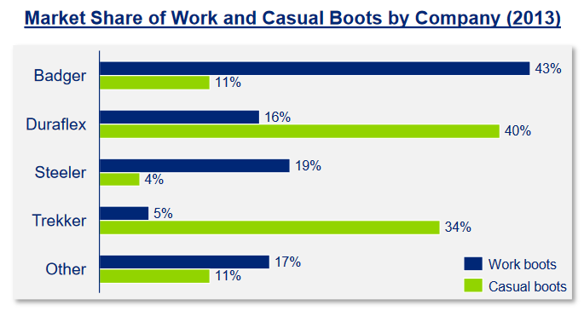

## Consultant´s role

In the fall of 2013, Badger launched a new line of aggressively priced work boots. The strong success of this line has caused Duraflex’s management to re-evaluate their position in work boots.

**With limited additional resources, management must now decide if they should focus their efforts on competing with Badger in the work boot sector, or focus their resources on further strengthening their position with casual boots.**

In January of 2014 Duraflex hired a leading consulting firm to conduct research to help management in its decision making. To make an informed recommendation, the consultants realized they needed to collect information that would enable them to size the market and better understand Duraflex’s competitive position.

What information would you collect and how?

*To begin with, the consultants developed a 20 minute quantitative telephone survey that was conducted among 500 randomly dialed consumers across the country’s 6 primary regions. In addition, the consultants completed some internal cost and pricing analysis for Duraflex’s work and casual boot lines. The market pricing analysis showed Duraflex competing at the premium end of the market for both its casual and work boot lines*

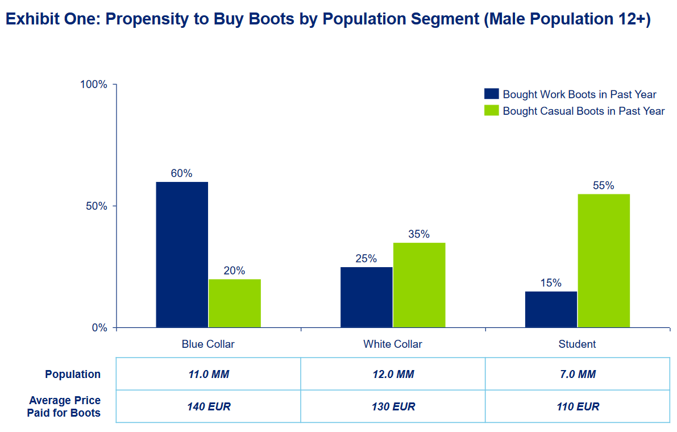

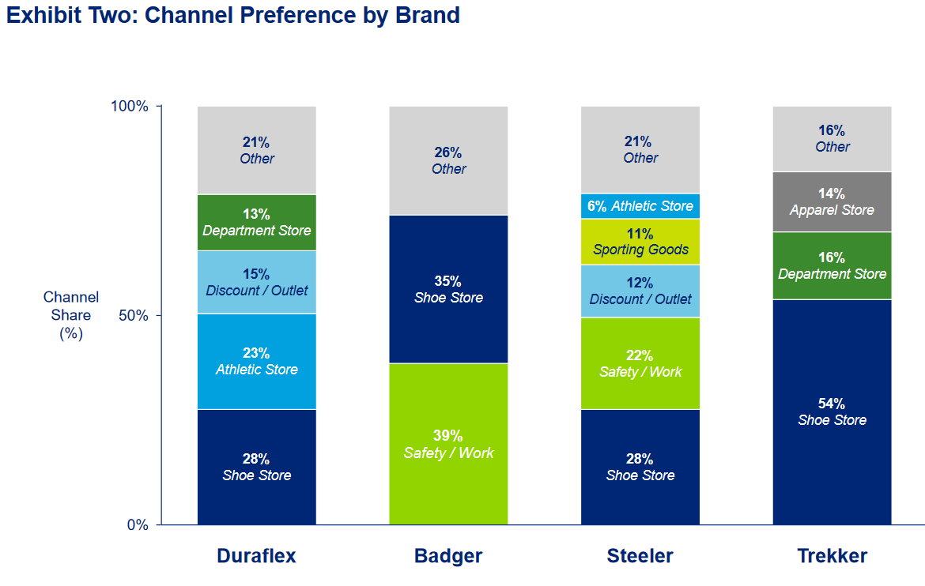

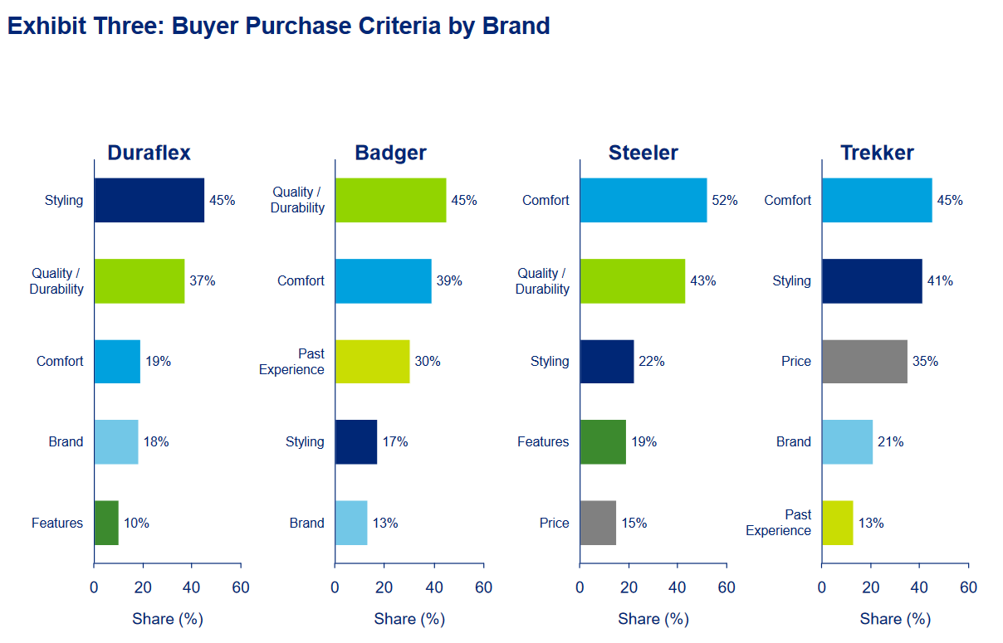

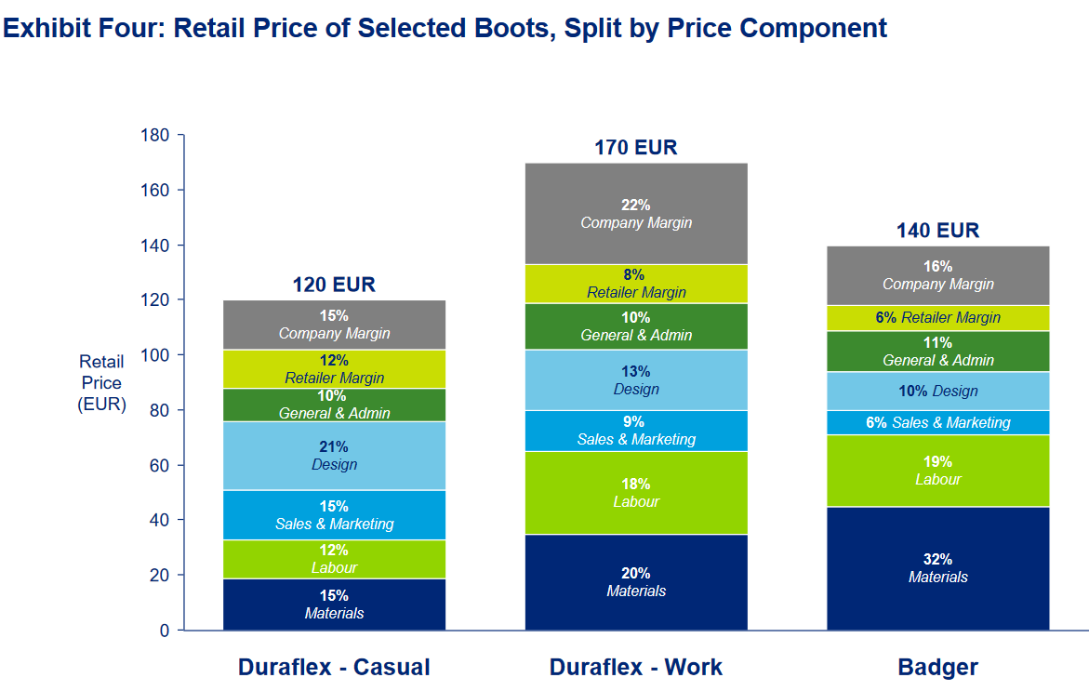

*Work through these questions on your own, using the text and exhibits in the preceding slides.*

1. *„How big is the work boot market (expressed in euros)? Does Duraflex get more of its revenue from work boots or casual boots?*
2. *Explain why Badger is outperforming Duraflex in the work boot market.*
3. *What changes would you recommend to Duraflex’s work boot strategy? Why? Would you recommend them to introduce a sub-branded boot line*

1. Blue collar workers: wage earners who generally work in manual or industrial labour and often require special work clothes orprotective clothing which are replaced approximately every 6 months
2. White collar workers: salaried employees who perform knowledge work, such as those in professional, managerial or administrative positions