IBM Global Services
Innovation Capabilities Program Guide

Sponsored by IGS Strategy
March 11, 2005
Version: 1.1

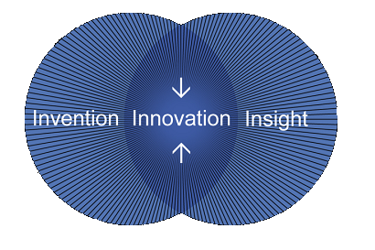

“Innovation occurs at the intersection of invention and insight. It’s about the application of invention – the fusion of new developments and new approaches to solve problems.”
Sam Palmisano, IBM Chairman of the Board of Directors

Document control
Document Statistics
Type of Information | Document Data
Title | IGS Innovation Capabilities Program Guide
Document version # | 1.1
Last date document was updated | March 10, 2005
File name | IGS Innovation Capabilities Program Guide V1.1
Authorized document owner | Brad A Sperbeck/White Plains/IBM

How to Find the Latest Level of This Document
This document will be located on an intranet site to make the latest version available for download. This location is TBD, however, you may contact Brad A Sperbeck/White Plains to obtain the latest version.

Credits
The IGS Innovation Capabilities Program Guide is sponsored by IGS Strategy. The authors, Brad Sperbeck and Ada Ryland, would like to extend their sincere appreciation for the work of the program owners and supporters who have provided the content that has made this guide possible.

Abigail Lewis | Iris Ginzburg | MaryAnn Cino
Alexis Economou | Jeff Weiner | Matthew Porta
Arjun Natarajan | Joachim Stark | Nancy Forbes
Christopher Pedersen | John Teoh | Peter Andrews
Claude Greenguard | John Zuk | Phaedra Kortekaas
Colin Harrison | Karen Keeter | Richard Keany
Deborah DeLosa | Kent Blossom | Theresa (Terry) Marshall
Deborah Dunagan | Leslie Roloff | Tijs Wilbrink
Gwyneth Hampton | Louisa Peluso | Tyron Stading
Ian Adair | Mary Jo Frederich

If you would like to use this information in another document
If you intend to use the content in this guide in other documents, please contact Brad A Sperbeck/White Plains or Ada V Ryland/Austin to obtain the most up-to-date information as well as to get on a list to receive updates to the content.

Due to the extensive use of hyperlinks, this document is being distributed as a MS Word document, and not in pdf format as normally done to protect the content.
Table of Contents

IGS Innovation Capabilities Program Guide Overview 4
Program Guide Structure 4
Criteria for inclusion in this program guide 5
Call to action – We need your help to improve this guide 5
Quick Reference: The Innovation Capabilities Programs 6
Developing Insights 6
Invention and Capability Development 6
Using Innovation with clients 7
Fostering community, morale, and education around innovation 9
Detailed Reference: The Innovation Capabilities Programs 10
Developing Insights 10
IBM Institute for Business Value (IBV) 10
IBM Venture Capital Group (VCG) 12
IGS Marketplace Headlights Program 14
Invention and Capability Development 16
Business Solutions Program 16
Extreme Blue 18
First of a Kind (FOAK) 20
Global Technology Center (GTC) Technology Evaluation 22
Growth through Alliances and Partnering Program (GAP) 24
Incubation Business Line and Emerging Business Opportunities (EBO) Team 26
Using innovation with clients 28
Best of Blue and Innovation Teams (i-Teams) 28
IBM Project Financing with IBM Global Financing (IGF) 30
Industry Solutions Labs (ISLs) 32
On Demand Innovation Services (ODIS) 34
ODIS Innovation Management Micropractice 36
Value Creation 38
Fostering community, morale, and education around innovation 40
Emerging Technology and Business Innovation (ETBI) 40
IBM Executive Business Institute – Innovation Courses 42
IBM Innovators Club 44
IGS Community Program and IGS Communities of Practice (CoP) 46
IGS Innovation Speaker Series 48
The InnovationFlash 50

IGS Innovation Capabilities Program Guide Overview

There are many valuable innovation initiatives and programs available to IBM Global Services (IGS). However, it is difficult to know what is available, when to use a program, and how specifically to engage a program. The Innovation Programs and Capabilities Guide will help you to understand the answers to key questions such as:

- How can I leverage external capabilities such as partners and Venture Capital firms?
- Which programs help in identifying new market opportunities?
- If I have a new market opportunity, which programs can help with development and market experimentation?
- How can I use the existing innovation portfolio to increase sales and customer satisfaction?
- What programs foster the internal IBM innovation network or community? How can I (or other people in my organization) participate?
- How can I find subject matter experts, or help with driving an innovation project?
- Where can I turn for market insights and intelligence to help make a business case for a new idea?

This guide organizes the capabilities that you can use to drive growth through innovation. These are valuable, proven IBM programs and resources that can be leveraged to actively pursue innovation within IGS. The goal is to increase innovation in IGS by making it easier to access the capabilities that are already in place. These programs represent significant effort and investments by our IBM leadership to enhance our ability to drive “Innovation That Matters,” and to support an environment of innovation and collaboration.

The target audience is all IGS employees, including Sales, Delivery, Support and Staff, and Management. Because of the depth and breadth of resources that are available in IBM, employees who are interested in using these programs should be able to find one or more applicable programs in the guide to further their goals - this could be career enhancement, joining a community of innovators, using innovation to sell more with clients, or to build new solutions. The guide can also be useful for other IBM employees, though we have focused on IGS as the target audience. The structure of the guide, as described below, allows for different audiences to find the information and the category of innovation program that relates to their specific interests and needs.

Program Guide Structure
As our IBM Chairman, Sam Palmisano, has stated, “Innovation occurs at the intersection of invention and insight.” We have chosen a similar structure and categorization to describe the capabilities in this guide. The four categories for programs in this guide are as follows:

- Developing Insights – Programs that provide insight and help to identify new market opportunities.
- Invention and Capability development – Programs that can help you to invent the solution or build the capability to address an opportunity, once an opportunity has been identified.
- Using Innovation with clients – Programs that seek to increase sales and customer satisfaction by using the current innovation portfolio (where insight and invention have already merged, and a market driven solution exists).
- Fostering community, morale, and education around innovation - Programs that act as an enabler of the overall process.

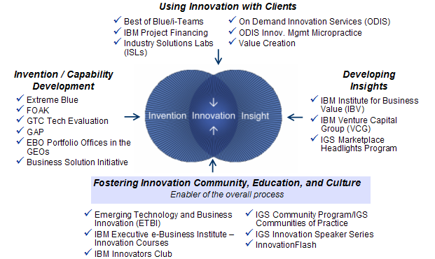

This program guide has two primary sections. The first section is a quick reference that lists all of the programs with a short description and gives a page number to reference for more information. The second section provides additional program detail about each capability and tells you how to engage.

Criteria for inclusion in this program guide
To list a program in the guide, the program must meet the following criteria:

- Can be leveraged by IGS to support and drive growth through innovation.
- Have the capacity, criteria, and process to take on new ideas, projects, or requests.
- List a contact to answer questions who is willing to help the requester access the program or resource.
- Have demonstrated successful implementation of the program and can provide references or examples.

Note that this is not a comprehensive list because there are many programs in IBM that are not directly relevant for services, do not meet the criteria for inclusion in this guide, or were not known to allow for inclusion. What has been listed is a critical mass of many key programs that are relevant to services and that could be assembled at the time of publication.

For up-to-date information and to engage with specific programs, contact the program references listed in the guide. For advice on combining and applying the various capabilities across your organization, contact Brad A Sperbeck/White Plains/IBM.

Call to action – We need your help to improve this guide
We need the help of the users of this guide to make it more comprehensive and more useful. If you are aware of programs or initiatives that should be included in this guide or have feedback or suggestions, please send a note to Brad A Sperbeck/White Plains/IBM.

Specific items we would like to hear about include: what you like about the guide, what you don’t like, how you are using it, and any other feedback or suggestions for future publications.

Quick Reference: The Innovation Capabilities Programs

Developing Insights

The programs that are listed in this section provide insight into identifying key business issues or future trends that are potential opportunities for IBM. By using these resources, IGS employees might find that creative spark and identify the “next big thing” for IGS and IBM.

- IBM Institute for Business Value (IBV) – Business Consulting Services (BCS) has the capability to identify, evaluate and explain the major issues confronting businesses, offering provocative points of view, innovative thinking and real business insight. IBV publications are categorized to address segments or industries and can help in stimulating the creative spark to identify key business issues and potential solutions to address them.
  - Contact: Phaedra Kortekaas, Karen Keeter Details: pg 10

- IBM Venture Capital Group (VCG) – The IBM Venture Capital Group is dedicated to driving the IBM commitment to innovation and thought leadership in the venture capital community. By fostering relationship development and innovation, the VC Group helps to deliver IBM growth, opportunity, and insights in emerging markets. Line of Business and Sector organizations can work with the VC Group to access these capabilities.
  - Contact: John Zuk Details: pg 12

- IGS Marketplace Headlights Program – The Marketplace Headlights Program scans the 3 – 5 year horizon for major trends that have the potential to alter the way business entities operate. Trends are monitored through ongoing scans of published futurist sources as well as discussions with think tanks, futurist pundits, and forward-thinking strategy and business development executives. The information is synthesized and socialized to develop insights for relevant strategic actions, potential new opportunity areas, and portfolio investment decisions.
  - Contact: Nancy Forbes Details: pg 14

Invention and Capability Development
Once an opportunity is identified, how do we invent or create the right solution? This section lists some of the programs that can help. There are many proven and valuable internal IBM programs to help develop and test new business opportunities. These can be used for new markets, solutions, and innovations for productivity or cost savings. Our focus in this section is on the capabilities that are applicable to building solutions that scale across multiple customers.

There are also IBM programs that leverage external capabilities through Venture Capital firms, business partners, and startup companies that can be readily applied and have synergy with our internal IBM capabilities.

An optimal approach to invention and capability development is to know these programs as potential “tools” and be able to apply them individually or in the optimal combination. For example, an IGS Sector or Line of Business organization may identify new alliance or acquisition candidates through the “GAP” program, and validate the technology strengths and integration capability using the Global Technology Center Technology Evaluation.

- Business Solution Program - The Business Solution Program brings together an extensive portfolio of IBM hardware, software, and high value services, and its wide network of ISV partners to address the most prevalent business challenges for customers. The IBM Business Solutions Program represents a joint effort by BCS, S&D, SWG, STG, and ITS to build the best possible business solutions and ensure that IBM can win in high potential areas. Employees in sales roles can access the business solutions for use with customers. Employees with ideas for new business solutions can raise them to solution boards for consideration.
- Contact: Matt Porta (see Details page for specific owners for different solution types)
Details: pg 16

- Extreme Blue – Extreme Blue combines great talent and cutting edge technology to drive innovation for IBM and our clients. Extreme Blue is able to drive these results by leveraging top university talent and passionate IBM employees.
  - Contact: Leslie Roloff Details: pg 18

- First of a Kind (FOAK) – is a unique program that brings IBM Researchers, clients, and business partners together in the marketplace to apply tomorrow's innovative technologies to today’s real business problems and opportunities. The objective is to accelerate the delivery of innovative new technologies and thought leadership from the labs into the marketplace to generate new growth opportunities for the IBM Corporation.
- Contact: Mary Jo Frederich, Alexis Economou, Larry DelSonno Details: pg 20

- Global Technology Center (GTC) Technology Evaluation – New technologies are being developed by innovative companies filling niches that IBM products do not address. The GTC Technology Evaluation role is to identify new technologies with a precisely stated need, understand them, review them, and then decide if they have potential value to help satisfy IBM needs.
- Contact: John Teoh Details: pg 22

- Growth through Alliances and Partnering Program (GAP) - GAP is a fast cycle-time business process that supports the growth needs of the IBM Line of Business and Sector organizations and aids in the identification and selection of alliance, merger, and acquisition targets. The data-driven process requires short amounts of time from an executive sponsor. By initiating a GAP session for your organization, you can increase knowledge of available external business partners to provide the needed capabilities, skills, technologies, and business models.
  - Contact: John Zuk Details: pg 24

- Incubation Business Line and Emerging Business Opportunities (EBO) Team - The Incubation Business Line and Emerging Business Opportunities (EBO) Team has three primary responsibilities:
- Helping the IGS Sectors and Business Lines identify, assess, and nurture new innovation initiatives;
- Driving IGS growth through flawless execution of the current portfolio of EBOs
- Transitioning specific offerings or entire EBOs quickly and effectively to appropriate Sector and Business Line units.
  - Contacts: (further contacts in detail section) Details: pg 26
Americas – Kent Blossom
AP – Ian Adair
EMEA – Jo Stark

Using Innovation with clients
These are programs to leverage the existing IBM innovation portfolio to increase sales and customer satisfaction by applying existing capability to a specific customer account or transaction.

Employees can leverage these programs in any of the following ways:
- Use the existing innovation portfolio, including EBO offerings, research capabilities, partnerships with emerging companies, internal capabilities, and so on, to strengthen relationships and solve customer needs.
- Many of the programs are designed to help account teams leverage the existing innovation portfolio.
- Use IBM research to solve complex customer problems, test new ideas, or as competitive differentiator on a bid.

Programs that you can use to leverage the existing IBM innovation portfolio are listed below:

- Best of Blue and Innovation Teams (i-Teams) – This program differentiates IBM’s largest services opportunities and relationships through development of a strategic partnership that is based on leveraging IBM innovative capabilities to address key client challenges. This is done by developing and delivering a process and content to apply the best global capabilities of IBM to meet the client’s key wants and needs in SO deals and projects (match client needs with IBM capabilities).
  - Contact:
EMEA - Colin Harrison/Zurich
Americas - Howard Sachar/Watson
World-wide - Claude Greengard/Watson Details: pg 28

- IBM Project Financing with IBM Global Financing (IGF) - IBM Project Financing provides single-source, highly-customized financing across a project's entire lifecycle, thus, making it easier for clients to manage both upfront investment and ongoing operating costs. IBM Project Financing integrates all the elements of a total business transformation solution under a single financing umbrella that includes HW, SW, Services, and even the clients own internal implementation costs. This makes the project highly attractive to clients from a cash flow perspective and is a powerful competitive differentiator for IBM.
  - Contact: Varies, see detail section Details: pg 30

- Industry Solutions Labs (ISL) - The Industry Solutions Labs (ISL) are executive-level briefing centers that are collocated with IBM Research labs in Hawthorne, New York and Zurich, Switzerland. These centers provide a unique environment where client executives and IBM Business Partners can discover how innovative solutions can help solve today’s business problems while gaining valuable insights into tomorrow’s technologies. They enable participants to escape daily distractions and focus on how technology can be leveraged to solve business problems and seize new opportunities.
- Contract: Mary Jo Frederich Details: pg 32

- On Demand Innovation Services (ODIS) - ODIS combines the capabilities of IBM Research with the process and industry expertise of IBM consultants to transform business through strategic and technological innovation. Delivered through Integrated Technology Services (ITS) and Business Consulting Services (BCS), ODIS enables IBM clients to work directly with prominent scientists and use their skills and assets to gain a business advantage.
  - Contact: Peggy Kennelly Details: pg 34

- ODIS Innovation Management Micropractice – Innovation Management is a “Micropractice,” or area of specialization, within ODIS. Working together, IBM Business Consulting Services (BCS) and IBM Research now offer consulting services that are based on the IBM expertise in numerous innovation processes, including Research and emerging business opportunities. We introduce our clients to the best innovation practices, design and implement customized innovation processes, explore new technology-based growth opportunities, run innovation workshops and guide our clients by using open collaboration.
  - Contact: Iris Ginzburg Details: pg 36

- Value Creation – Value Creation is the process of proactively identifying client opportunities, rather than merely responding to request for proposal (RFPs). This process leverages the strength of innovation capabilities across the Lines of Business (LOBs) to craft IBM solutions, to take these solutions as new unsolicited business to our clients, to articulate clearly the benefits and value that we will contribute, and to track and monitor the benefits to ensure that the business case is achieved for both the client and IBM.
    - Contact: Kristen Pederson Details: pg 38

Fostering community, morale, and education around innovation
Innovation is one of the IBM core values. Our employees are passionate, driven, and seek to be innovative. We need to encourage, foster, and support this innovative spirit. Many programs and educational materials are available to help to do this. Anyone can get involved, from new hires to accomplished veterans, in any type of job. Here are some of the available programs:

- Emerging Technology and Business Innovation (ETBI) - The ETBI group extends the IBM commitment to invention and new business opportunities while encouraging entrepreneurialism among employees. ETBI achieves this by providing community forums (Web portal, community groups, and so on), a forum to peer-review new ideas, and offers mentorship assistance for people with ideas who are in need of idea coaches. The three pillars of ETBI are education, networking, and invention.
- Contact - Tyron Stading Details: pg 40

- IBM Executive Business Institute – Innovation Courses - At the IBM Executive Business Institute, IBMers and clients are brought to a deeper understanding of innovation and why it matters to business. In addition, through interactive sessions, students can explore the implications of new technologies, work through potential issues and determine how innovation can redirect their strategies and reshape their industries. The emphasis is on practical value, distance learning, open enrollment and custom courses that all include the development of project plans that encourage students to put their insights to work.
- Contact: Peter Andrews Details: pg 42

- IBM Innovators Club – The IBM Innovators Club is an informal community of IBM professionals around planet IBM who are interested in delivering business and technical innovation to our customers. This club includes members from almost all IBM lines of business with a good balance of product and service interest. The club "meets" by a weekly telephone call on Mondays at 12:00-13:00 EST; most of this hour is devoted to a speaker, often a club member, who presents on a topic that is related to innovation.
- Contact: Colin Harrison/Zurich Details: pg 44

- IGS Community Program and IGS Communities of Practice - The IGS Community Program is focused on ensuring that communities are understood and leveraged as enablers of the cultural transformation that is needed to innovate at IBM. There are approximately 90 assigned communities of various types in IBM Global Services. This is a desirable strategy that allows for building and sustaining required competencies and expertise. Practitioners benefit from joining one or more communities in a relevant sector, delivery area, technology, or profession.
- Contact: Deborah Dunagan Details: pg 46

- IGS Innovation Speaker Series – The IGS Innovation Speaker Series highlights valuable and proven resources that are designed to support you in creating business value for IGS. The Speaker Series focus areas are the capabilities that enable growth, new business models, and innovative new business and technology solutions. The objective is to support IGS innovation by providing crisp information on relevant topics, using a 30-minute, bimonthly conference call.
- Contact: Brad Sperbeck Details: pg 48

- InnovationFlash - The InnovationFlash is an e-mail journal that is dedicated to the entrepreneurial spirit at IBM, and highlights projects, initiatives, good ideas, and inspirational comments. Its purpose is to encourage, educate, and inspire individuals to help stimulate a culture of entrepreneurship, growth, and innovation.
- Contact: Tijs Wilbrink Details: pg 50

Detailed Reference: The Innovation Capabilities Programs

Developing Insights

IBM Institute for Business Value (IBV)
Category: Developing Insights

Description of the program: The IBM Institute for Business Value (IBV) is a virtual worldwide organization for developing business though leadership materials, and focuses on both industry and business processes. The IBV reflects IBM’s substantial commitment and investment in business thought leadership. Part of the IBM Business Consulting Services division, the IBV was founded in 2001. The IBV provides senior executives with strategic insights on the critical challenges faced by organizations in their quest for business value in today's rapidly changing, technology-enabled environment.

The IBV is staffed with over 60 dedicated, experienced business consultants, and has primary offices in Boston, Amsterdam, and Melbourne. The IBV researchers are BCS consultants – rotated from the field – leveraged across organization by consulting teams to drive client and IBM value. Research teams develop fact-based studies that are based on significant (primary and secondary) research and analysis. Project types include business trends, competitor implications, best practices, decision-making frameworks, and strategic roadmaps.

The purpose of the IBV is to help fulfill the IBM brand promise and change the client’s perception of IBM. We do this by:
- Delivering to client executives compelling intellectual capital that addresses the intersection of business and technology
- Engaging client executives in an ongoing dialogue that connects them to IBM SMEs and intellectual capital where appropriate
- Empowering and enabling IBM client teams to deliver compelling intellectual capital

Value:
The benefits of the IBV to IBM professionals are as follows:
- Differentiate IBM in the marketplace with clients and analysts
- Enable broadened client relationships that lead to increased sales and more effective delivery
- Lead IBM’s transition to a value-based approach for identifying and delivering client results
The benefits of the IBV to our clients are as follows:
- Clients will be able to make better informed decisions about business direction and technology
- Clients will have more confidence when they engage with IBM concerning their business issues

How IGS employees can use this program: IBV points of view are a great way to demonstrate IBM’s deep Industry and business process expertise. There are numerous ways to work with IBV and leverage our team and deliverables. Some of them are as follows:

1. Learn about the latest business issues and trends in your client's industry
- Understand the best practices and perspectives from around the world.

2. Sell and deliver more
- Use IBV materials in proposals and during client engagements, each study includes 100+ slides of client-ready analysis.
- Identify IBM opportunities at your client by reading the IBV “Blue Paper” that is inserted in every new point of view.

3. Deepen client relationships
- Present IBV materials at client or industry events (or invite an IBV subject matter expert to present).
- Engage clients in IBV research projects.

4. Build the brand
- Publish articles and give interviews to local press on the basis of IBV materials.
- Deploy IBV materials through all available marketing channels.

5. Spread the word
- Join our Thought Leadership (TL) community to allow you to receive new client ready
materials twice monthly.
- Go to (use your intranet user ID and password to gain access) http://w3.ibm.com/communitymap/community_entry.jsp?community_id=ccZTYW
- Click "Join this community" at the bottom of the page. You will be added to the community. To see if you were added successfully, go back to the URL above and see if "Leave this community" displays at the bottom of the page.
- Let your clients know that they can receive monthly newsletters from IBM with these same
materials by subscribing to Ideawatch at www.ibm.com/services/bcs/subscribe.

Scope or Restrictions: IBV materials are available for all IBMers on our intranet site. Non-BCS employees will need to go through a one time registration procedure to access the documents.
IBV executive briefs can be handed out to clients directly. Full-length IBV presentation deliverables are meant to provide a body of content that can be used in revenue-generating business development and engagement delivery. Thus, these documents:
- Can be presented to individual clients as part of your selling efforts
- Can be used with individual clients as part of your engagement delivery efforts
- Can be left with customers in hard or soft copy (preferably in a non-editable form) on request, with reference to the copyright nature of the content
- Cannot be generally distributed to an undefined audience without explicit written permission from the IBV (contact IBV@us.ibm.com)
- Cannot be systematically "given away" – do not simply hand over entire IBV studies to clients
- Cannot be shared with other consulting firms (including McKinsey, Mercer, Deloitte, and so on) – even if they are working for or with IBM

Program Costs, if any: There are no costs associated with the use of IBV materials.
If you want to order hard copies of our executive briefs to hand out to clients you can use the IBM asset management system (http://services.leopardem.com/app/login.jsp). You will be asked to provide your IBM accounting details for printing and shipping costs.

How to Engage/Contact(s):
George Pohle/New York/IBM, Global Leader, Institute for Business Value
Geo contacts:
- Americas Geo: Rebecca Bell/Cambridge/IBM
- Asia pacific: May Lawrence/Australia/IBM
- EMEA: Phaedra Kortekaas/Netherlands/IBM

Web sites:
Internal Web site: w3.ibm.com/services/bcs/ibv/
External Web site: www.ibm.com/iibv

IBM Venture Capital Group (VCG)
Category: Developing Insights

Description:
The IBM Venture Capital Group is dedicated to driving IBM's commitment to innovation and thought leadership in the venture capital community. By fostering relationship development and innovation, we help deliver IBM growth, opportunity, and insights in emerging markets. The mission of the VCG is to accelerate IBM's growth and increase the acceptance of IBM's vision, strategies, standards and architectures in the VC community.

IBM Growth  Build a new ecosystem:  - Clients  - Partners  - Technologies | Opportunity  Identify and introduce best-of-breed start-ups to IBM Business Units | Insights  Share business and technology trends that affect our industry.

Value: The value of this program is in building winning relationships, offering insights, and creating an ecosystem of innovation.

Building win-win relationships: Win-win relations with venture capital firms include sharing and building emerging technology and market roadmaps, working with key portfolio companies to explore the best methods to deliver IT innovations to top customers, and connecting external opportunities to the right groups within IBM to pursue those opportunities.
Offering insights: IBM and venture capitalists exchange business insights in key emerging markets, technological innovation, and integration capability. An essential part of the IBM corporate strategy is to provide strategic headlights, engage as a matchmaker between external innovation and the appropriate IBM business units and emerging business organizations, and serve as a portal into all the of IBM strategic growth initiatives.
Currently, we are focusing in the areas of business resiliency, regulation and compliance, Web services, software-as-a-service, and business process outsourcing.
Creating an ecosystem of innovation: We see great opportunities and potential mutual benefits for not only our enterprise customers, but also for the venture capital community. By creating a strong ecosystem of insight and relationships, together, we can apply innovation to the integration and delivery of new enterprise solutions.
Venture Strategy expertise in key emerging markets and collaborations with preeminent venture capitalists sets the stage for the following:
· | Strategic new technology development
· | Exploring where new technologies can deliver business value and benefit
· | Pioneering the development of new solutions

How IGS employees can use this program/resource: IBM Sector and Line of Business Organizations can use this program to build an ecosystem of partners, clients, and technology, to identify best-of-breed startups to work with, or to understand key business and technology trends (from those investing with “smart money”).

Scope or Restrictions: The VCG has a broad and diverse set of engagement models.

Program Costs, if any: None.

Frequency/Availability: As needed.

How to Engage/Contact(s):
For further information, contact: John Zuk, IGS Strategy – John Zuk/Cambridge/IBM@IBMUS

Web site: http://www-1.ibm.com/businesscenter/venturedevelopment/us/en/index

IGS Marketplace Headlights Program
Category: Developing Insights

Description of the program: The overarching objective of the Marketplace Headlights Program is to scan the 3 – 5 year horizon for major trends that have the potential to significantly alter the way business entities operate. Trends are monitored through ongoing scans of published futurist sources as well as through discussions with think tanks, futurist pundits, and forward-thinking strategy and business development executives. The information is synthesized and socialized to help assure the following:
- Insights for relevant strategic actions – CHQ, R&D, though leadership groups
- Insights for potential new major opportunity areas emerging in this time horizon
- Insights for portfolio investment decisions – where to invest vs. divest

Value: While the trends and insights are shared broadly across IBM, the real value of the work comes through leveraging that information in Future Implication Ideation workshops. The output from these workshops is a list of potential new opportunity areas to explore, as well as lists of what in portfolio becomes more or less important in light of the trends and insights. These two views help with portfolio management and investment decisions, and can be mapped in a strategic vision for achieving unified strategy objectives.

How IGS employees can use this program: Employees can use the Marketplace Headlights white paper in their strategic planning and prioritization efforts for offering development strategies and portfolio balancing efforts.

Complemented with the workshop, output can be more tailored to portfolio management and investment decisions for specific organizations through the derivation of actionable strategic insights sampled below.

Scope or Restrictions: All Marketplace Headlights documentation is IBM CONFIDENTIAL.
The original target audience was IGS, however, the marketplace headlights are applicable to all of IBM because we monitor and interview globally, and broad trends are not a niche.
The future implication workshops can be run for any group, internally or externally, though we have focused them on IGS to date because that is where the resources for the program have resided.

Program Costs, if any: There are no costs for the readership. Groups outside of IGS will have incidental costs that are associated with running Future Implications Workshops.

How to Engage/Contact(s): To get a copy of the deliverables to present Marketplace Headlights to your group, or to discuss a Future Implications Workshop for your group, contact Nancy Forbes/Atlanta/IBM, or 404-487-1487.

Supporting materials: Marketplace trends for 2005 are summarized below. The associated white paper and presentation each provide in-depth tread information, and the Future Implication Workshop helps bring these trends to life for specific organizations for both current and future view.

Invention and Capability Development

Business Solutions Program
Category: Invention and Capability Development

Description: A business solution brings together an extensive portfolio of IBM hardware, software, high-value services, and a wide network of ISV partners, to address the most prevalent business challenges for customers in every industry. There are four types of business solutions:
- Industry-specific solutions - targeted solely to a specific industry
- Cross-industry solutions - for business issues common to multiple industries
- ISV solutions - focus on solving a client issue with a specific ISV solution
- BTO solutions – for where we offer an outsource transformation approach

Business solutions are composed of assets created through the development process or harvested from client engagements. Business solutions are developed, deployed, and managed through business solution boards that comprise representatives from BCS, S&D, SWG, and other LOBs. All business solutions are taken to market through industries and sponsored by industry leadership teams representing lines of business, brands, and S&D at the worldwide and geo levels.

Business solutions are governed by BCS and supported by a worldwide team through the Business Solutions Program. The strategic objectives of the Business Solutions Program are as follows
- Establish a clear business solution portfolio strategy
- Drive the maximum return on our overall solutions portfolio and leverage solution and thought leadership investment
- Maintain a highly efficient and effective process to fund, develop, and manage solutions working within the ISD framework
- Ensure our solutions drive significant measurable benefits to our clients
- Balance our solution portfolio across key industries, services, ISVs, and Emerging Business Opportunities
- Collaborate across and beyond IBM to define, develop, and sell our business solutions
- Create awareness and train sales and consulting professionals in our thought leadership and solutions so they can sell effectively

Value: Business Solutions Program value to IBM and customers:
- Increase sales and profits for IBM by building and selling market-based solutions. Solutions represent two-thirds of IT investment and solutions sales are growing at twice the rate of commodity and technology platforms.
- Increase customer satisfaction and value to customers by combining IBM capabilities (HW, SW, Services, and expertise) with relevant ISV capabilities to create business value for clients.

How IGS employees can use this program/resource:
- All IBM employees can access the IBM Business Solutions Portfolio to increase sales and profits. This portfolio represents a joint effort by BCS, S&D, SWG, STG, and ITS to apply the best of IBM’s capabilities and assure that IBM can win in these high potential solution areas.
- For entrepreneurs within IBM who have innovative ideas for new market-based business solutions, the solution boards have the authority, skill, and funding to support the building of new solutions.

Scope or Restrictions: N/A

Program Costs, if any: N/A

Frequency/ Availability: N/A

Contacts: When a potential solution is identified for development, a request for funding is submitted to a solution board for review. Approval is based on the overall solution strategy. For more information about business solution development and deployment, contact your industry, cross-industry or ISV portfolio manager, or other representative listed below.

Solution Team | Portfolio Manager | Solution Team | Portfolio Manager
Aerospace and Defense | Jim Berry/Armonk/IBM | SMB | Kathleen Piontek/Charleston/IBM
Automotive | Jeby Cherian/Chicago/IBM | AIS | Ted C Poock/Portland/IBM
Banking | May Zia/Columbus/IBM | CRM | Scott M Billadeau/Chicago/IBM
Chemical and Petroleum | Gary A Adams/Houston/IBM | FMS | Lynnette A Zuccala/Cincinnati/IBM
Consumer Products | PATRICIA PREZTUNIK/Paramus/IBM | HCM | Martha H Paul/Denver/IBM
Education | Pat Condon/Bethesda/IBM | SCM | Karen V Butner/Dallas/IBM
Electronics | Dawn M Comer/Los Angeles/IBM@IBMUS | Strategy and Change | Ragna Bell/New York/IBM  Denise Arnette/Charlotte/IBM
Financial Markets | Keith Bear/UK/IBM@IBMGB | Dassault | Karen V Butner/Dallas/IBM
Government | Pat Condon/Bethesda/IBM | Oracle | Rowland Firth/Charlotte/IBM
Healthcare | Pat Condon/Bethesda/IBM | Peoplesoft/JDE | Ellen Shannahan/Tampa/IBM
Insurance | Bonnie Wojtaszak/Southfield/IBM | SAP | Karen V Butner/Dallas/IBM
Media and Entertainment | David A Raig/Los Angeles/IBM | Siebel | Scott M Billadeau/Chicago/IBM
Pharma/ Life Sciences | Doug Dean/Switzerland/IBM@IBMCH | BTO | Eugene Brandon Jr/Mount Pleasant/IBM
Retail | Andrew Strauser/Atlanta/IBM | EMEA representative | Paul Fornadel/Pittsburgh/IBM
Telecommunications | Vanitha Narayanan/Dallas/IBM  Shelia N Hankins/Raleigh/IBM | AP representative | Greg Hill/Australia/IBM
Travel and Transportation | Raul A Arce/Alpharetta/IBM | Research Representative | Elizabeth Lenox/St Louis/IBM
Utilities and Energy | Bridget Meckley/San Diego/IBM | SWG Representative | Mike Kloke/Markham/IBM

Web site: Business Solutions Webpage: The Business Solutions Web page provides information about business solutions. Check the Web page for the latest news and announcements, and links to supporting resources and information.
http://w3-03.ibm.com/services/bcs/news_pubs/features/2005/0225_ibm_solutions.html

Business Solutions Portfolio: The IBM Business Solutions Portfolio represents all business solution offerings across IBM that can be offered to clients. Click the various tabs for a comprehensive list of business solutions, contacts, solution descriptions, and links for more information.
http://w3.ncs.ibm.com/sitelet.nsf/autonomic/JSHW-63SH59?OpenDocument&TableRow=1.1.0#1.1.

Business Solutions Catalog: The Solution Catalog houses solution assets and is an integral part of KnowledgeView. Sales and marketing information, solution snapshots, customer references, thought leadership, sample proposals and other materials are provided across different views. (Note that new users of KnowledgeView must first register to access the link below. Access will be automatically approved for IGS and S&D.)
https://w3-3.ibm.com/services/bcs/km/knowledgeview/marketing.nsf/vISCBSS?OpenView&Navigator=SC

Extreme Blue
Category: Invention and Capability Development

Description: The Extreme Blue TM program combines great talent and cutting-edge technology to drive innovation for IBM and our clients. What began in 1999 as a summer internship in Cambridge, Massachusetts with 25 students has grown into a worldwide program that draws almost 200 top interns and 350 passionate IBM participants for year-round projects that yield impressive results.
In an effort to meet the growing needs of the business, IBM launched Shades of Extreme Blue, a variety of program offerings that are designed to deliver highly targeted objectives and extend the culture of innovation. In these complimentary offerings (Extreme Blue Labs, Speed Teams and BizTech Teams) we're taking the best of the Extreme Blue program and bringing it to new audiences through flexible, on demand delivery models that are based on the winning Extreme Blue formula.
Extreme Blue Labs
This is the industry's premier internship that takes place in IBM labs around the world. Students team with IBMers to form mini-businesses that consider both the business and technical issues when working on a project.
Speed Teams
This is an on demand offering that matches skilled students with IBMers to solve problems, or create solutions, or both for clients at any IBM site, at anytime.
BizTech Teams
Fosters growth for new or early-tenure IBMers by allowing these passionate performers to team across the company on key projects. This requires participants to work approximately 8 hours a week on the project for the 9-12 month project duration

Value: Top Five Reasons for IGS to utilize Extreme Blue:
- Attract and retain top talent, so IGS can remain a leader in driving innovation that matters
- Drive results—Extreme Blue teams have helped create new products and client solutions
- Breeding ground for innovation—more than 200 patent disclosures submitted
- Quick return on your investment—have a dedicated team focused on your key project to help deliver results that make an impact
- Rapidly gain insights about key strategic issues

IGS employees can use this program to:
- Develop innovative ideas
- Lead, sponsor, or champion a project (any shade)
- Become a mentor for an Extreme Blue Labs or Speed Team project
- Apply to participate as a member of a BizTech Team

Recommended types of projects: Extreme Blue has been used to make strategic investment decisions, validate customers’ markets, build solutions, and break down intracompany barriers.

Proof points and Examples: Project results prove that the technology is a good investment for IBM and our customers. For example, the APS system is able to optimize a customers' IT environment at the lowest possible cost through precise data collection and analysis of critical system resources, and is currently in use with GM, Ford, Enterprise, AT&T, and others.

Scope or Restrictions: There is an Extreme Blue shade that can support any GEO or LOB in IGS.

Program Costs: Project sponsorship costs vary by shade: Labs = $95K, BizTech=$45K, Speed Teams=cost absorbed directly by LOB. See the supporting material for additional information.

Program Contacts:
Extreme Blue Labs→ John Graham (jsgraham@us.ibm.com)
Speed Teams→ Jean Barlage (jbarlage@us.ibm.com)
Keri Van Scoyoc (keriv@us.ibm.com)
BizTech Teams→ Debbie DeLosa (delosa@us.ibm.com)

Web site: w3.ibm.com/extremeblue

Supporting materials: Portfolio of program offerings

Focused, short-term innovation
Talent attraction |  | Talent retention | Joint collaboration
Extreme Blue Labs | Extreme Blue Speed Teams | Extreme Blue BizTech Teams | Extreme Blue on Campus | Extreme Blue for Clients
Why: Rapidly delivers high-impact innovation, and attracts top industry talent.  How: Managed and staffed by Extreme Blue in one of 12 lab locations worldwide.  Who: Teams are mix of MBAs and Tech interns; early-tenure IBMers participate in Spring session; Mentors from Business Unit.  When: Limited full-time opportunities for 3 month project rotation following the academic calendar of Geo.  In the U.S: Spring (January-April) and Summer (May-August). Contact our international team members in Asia, Canada and EMEA for local schedules.  Opportunities: Currently accepting project nominations for our Spring 2005 season in one of 12 WW labs. Read details, submit project proposal or contact John Graham for assistance. | Why: Provides a flexible, scalable innovation and talent attraction model.  How: Managed by Business Units at any IBM location; staffed using HR recruiting and placement; Extreme Blue provides the "recipe".  Who: For maximum results, we strongly recommend teams are a mix of MBAs and Tech interns, but early-tenure IBMers may be used; Mentors from Business Unit.  When: If leveraging university talent, project will be linked to academic calendar. However, projects may be held anytime of the year using available talent, interns, or IBMers.  Opportunities: Currently seeking projects for 2005. Recommended submission deadline for U.S. is mid-February for Summer 2005 projects (if staffing with university interns). Also seeking Speed Team Champions. Contact Keri Van Scoyoc or Jean Barlage for details or go to our Web site. | Why: Drives innovation and technical vitality opportunities for early-tenure IBM employees.  How: Managed and staffed by Business Unit; basic program support provided by Extreme Blue staff.  Who: Virtual, cross-unit part time IBM teams are mix of Business and Tech: DEs, Fellows and STSMs are Technical Leaders from cross-units.  When: Unlimited part-time (8 hrs/week) opportunities for 9-12 month project rotation. Pilot project rotation now running until September 2005. Next project rotation to begin in April 2005.  Opportunities: Currently accepting projects nominations and applicants for April 2005 project rotation. Deadline for project submission is March 25, 2005 and for applicants is April 15, 2005. Contact Debbie Delosa for more details. | Why: Collaborates with universities to increase skills and diversity pipeline while producing results.  How: Managed by University faculty, with consultation from IBM and Extreme Blue staff.  Who: Staffed by University, with undergraduate diversity students; IBM provides mentors.  When: Flexible projects following academic calendar will be available on targeted U.S. campuses.  Opportunities: No immediate opportunities currently available. Check back in 2005. | Why: Responds to targeted client needs using customizable projects for short-term results.  How: Managed by Extreme Blue staff with consultation from IGS and Business Unit.  Who: Staffed by IBM client and Business Unit, with mix of diverse candidates and skills.  When: Flexible project opportunities available on demand.  Opportunities: Limited pilot opportunities to be negotiated based on demand. Contact John Graham with your inquiries.
Current program offerings |  |  | Experimental offerings

First of a Kind (FOAK)
Category: Invention and Capability Development

Description of the program: Jointly funded by Sales and Distribution (S&D) and IBM Research, the FOAK program brings IBM Researchers, clients, and Business Partners together to test tomorrow's innovative technologies on today's real-life business problems and opportunities. In the FOAK model, S&D identifies early adopter clients and partners to work side-by-side with IBM scientists to conduct research in the marketplace. The success of a FOAK project may be in the form of early thought leadership and experiences with new technologies; a working prototype of an innovative solution not yet available in the marketplace; the know-how to improve a clients' business; or software components, methodologies and tools for reuse in IBM products and services engagements.
Value: The program provides a rich source of client references and credentials, a pipeline of assets for new asset-based service offerings, a powerful “star burst” tool to drive follow-on engagements, headlights into emerging areas, and a unique differentiator that competitors cannot match.

How IGS employees can use this program: The FOAK program funds 15 to 20 new global, cross-industry projects per year. Candidate projects are jointly identified by the S&D and BCS innovation councils and solution boards, working with IBM Research's relationship managers and sector business managers. The industry two-in-a-box leadership team approves and sponsors all nominated projects. From there it goes to the FOAK board, made up of a cross-IBM executive team. They hold bi-monthly reviews to select projects and allocate funds.

Proof points and Example(s):
- The creation of a scheduler to balance workloads and allocate resources on demand for a compute-intensive, investment management application at Charles Schwab. The project enabled Schwab to run existing applications on a high-performance processing infrastructure maximizing processor efficiency, reducing processing time (from 8 to 10 minutes to less than 20 seconds), improving the quality of services and increasing client satisfaction. Systems Group parlayed that success into a $13M deal with another financial institution.
- Developed mathematical modeling techniques and optimization algorithms to define customer financial profiles and optimize marketing budget allocations across a portfolio of customers to maximize the portfolio's value and risk ratio. The project reduced Finnair’s marketing costs by more than 20% and improved campaign response rates by up to 10%. The project has driven $3.3M in revenue with Finnair and other clients to date.
- Creation of a grid financial valuation tool that uses an optimization model to identify candidate applications and servers for migration to a grid infrastructure that is based on a high level assessment of the expected ROI. Analyzing application performance, grid capacity, cost of ownership and business value-add triggers, the tool facilitates the crafting of grid business cases. Originally piloted with a communications company, the tool has been successfully utilized with clients across multiple industries and became the bases for the Grid@Work Offering.

Scope or Restrictions: Generally, the projects last from six months to a year. Typical funding for the project is $500K to $1 million.

Program Costs, if any: The client must fund the hardware, software, and services to FOAK to enable them to actively participate in the project.

How to Engage and Contacts: Mary Jo Frederich/New York/IBM, Larry DelSonno/Watson/IBM, Alexis Economou/Hawthorne/IBM

Web site: http://w3.research.ibm.com/FOAKS/foak1.html
FOAK Process Overview
Identify
Segment
* When
applicable
Define Solution
Target
Clients
Implement Project and Track Progress
Joint Press
Release
Engage
Brands / Partners
Refine
Scope
Negotiate Contract
Transition
Assets
Create
Project Plan

Global Technology Center (GTC) Technology Evaluation
Category: Invention and Capability Development

Description: New technologies are being developed by innovative companies to fill niches that IBM products do not address. The GTC Technology Evaluation role is to identify new technologies with a precise need stated, understand them, review them, and decide if they have potential value to help satisfy IBM Global Services business needs.

GTC Technology Evaluation delves deeper into the capabilities of specific technologies or sets of competing technologies with the following objectives:
- Evaluate the capabilities of a given technology to meet requirements.
- Evaluate the relative capabilities of competing technologies to meet requirements.
- Partnering with Corporate Procurement to perform a high-level assessment of the development methodologies associated with a technology and identify the level of risk involved in integrating the technology into solutions.

GTC Technology Evaluation is highly adaptable to a broad range of needs, accommodating both paper evaluations and deeper-dive laboratory evaluations, as dictated by business need.

Value: GTC Technology Evaluation uses well defined methodology and process to help IGS employees with technology evaluation projects including a Corporate Disclosure Agreement process to work with external vendors, evaluation data collection, and a scoring template to effectively conduct evaluations.
A structured methodology is used to conduct:
- Assessment of ISV to determine capabilities in development, testing, and product support
- Summarize corporate and SW development methodology strengths and weaknesses:
  - Assess SW development risk, compliance with SEI’s Capability Maturity Model Integration for Software Engineering rating
  - Development effort, product quality, and support analyses
  - Corporate and business viability

How IGS employees can use this program: Employees can take advantage of this program to help with tools selection for adaptation, convergence, development purposes, or expanding offering portfolio.

Recommended types of projects: While many evaluation projects are for new tools technology adaptation in the Strategic Outsourcing area, it is open to any type of evaluation project from IBM.

Project Area Examples: Provisioning and capacity on demand, grid computing, performance monitoring, traffic management, SLA management, application data recovery, billing, and so on.

Scope or Restrictions: This program is focused on IBM Global Services, but is available to all IBM business units.

Program Costs: Typically, the paper evaluation has an average estimated cost of $5-30K and last 1-2 months, while the average physical lab evaluation cost is $20-65K, based on the depth of evaluations.

How to Engage/Contact(s): Contact John Teoh for technology evaluations for all geos.

Web site: http://techcenter.austin.ibm.com/projects/g-n/techeval/index.html
High level process of GTC Technology Assessment and Evaluation
An evaluation project may begin with an optional assessment.

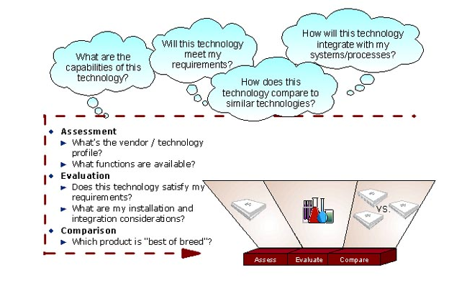

Growth through Alliances and Partnering Program (GAP)
Category: Invention and Capability Development

Description: GAP is a corporate-wide tool that builds equity-based partnerships between IBM and business partners through a reverse-auction format. Its purpose is to aid in the identification and selection of alliance, merger, and acquisition targets that can strengthen IBM capabilities.

GAP is designed to be a short cycle-time business process that can support the dynamic inorganic growth needs of IBM LOB and Sector executives. The process is designed to be data-driven and requires relatively short amounts of time from the executive sponsor. Using a reverse auction format keeps the partner field competitive and supports IBM in achieving optimal value in equity exchanges.

NOTE: This methodology and the frameworks that are applied are considered proprietary and strategic to IBM. Do not share this information outside of IBM without the express consent from IBM Corporate Development.

Value:
Value for executives initiating and sponsoring a GAP session:
- Increased knowledge of available external business partners to provide needed capabilities, skills, technologies, business models.
- Fact-based reverse auction format supports rapid decision making and value optimization.

Value to IBM
- Facilitates alliances, partnerships, mergers and acquisitions
- Provides a unifying framework for acquisition identification

How IGS employees can use this program and resource: When a business executive identifies a capability, technology, or a skill-set is lacking in their offering portfolio, they can initiate a GAP session. The resources from Corporate Development and IGS Strategy will assemble a field of possible external partners and in parallel work with the executive to define evaluation criteria. As criteria are applied and the candidate pool is winnowed, top contenders are invited to participate in a one-day, in-person review. The top candidate firms are provided with a standard set of presentation templates, and the sponsoring executive (and other stakeholders) participates in the review session. The GAP leaders facilitate the session and drive follow-up actions.

Scope or Restrictions: A GAP program requires executive sponsorship to be initiated and conducted.

Program Costs, if any: No program costs. The program is co-sponsored by IBM Corporate Development and IGS Strategy. Costs of travel to the day-long final review are incurred by the sponsoring executive.

Frequency/ Availability: As needed. A GAP can be initiated at any time, with lead times ranging from 1-6 weeks.

How to Engage and Contacts: For further information and to schedule a GAP, please contact:
- Ken Posy – Corporate Development – Kenneth B Posy/Armonk
- John Zuk – IGS Strategy – John Zuk/Cambridge

Web site: Coming soon.

Incubation Business Line and Emerging Business Opportunities (EBO) Team
Category: Invention and Capability Development

Description of the program:
The Incubation Business Line and Emerging Business Opportunities (EBO) Team has three primary responsibilities:
- Helping the IGS Sectors and Business Lines identify, assess, and nurture new innovation initiatives
- Driving IGS growth through flawless execution of the current portfolio of EBOs
- Transitioning specific offerings or entire EBOs quickly and effectively to appropriate Sector and Business Line units

Part of the Incubation Business Line is a new innovation management group, whose role it is to:
- Identify, assess, and develop ideas that impact our current business and future business growth
- Influence the long-term health of the IGS business line portfolio from an "innovation that matters" perspective
- Provide input on investments related to innovation
- Develop and assess business plans for incubation
- Be a think tank together with Research, BCS and the brands on innovation matters

For any questions, or if you have ideas for incubation, please contact your geography representatives as listed below.

Value: This team has extensive experience identifying and developing growth IGS opportunities, and can help the IGS team leverage resources from IBM Research, the IBM product brands, S&D, and IBM Business Partners to develop innovative solutions.

How IGS employees can use this program: IGS employees can engage this team to provide thought leadership with senior client executives, drive business with current EBO solutions, and assess new innovation ideas.

Recommended types of projects: Qualified senior client calls, proposal development for projects that could benefit from EBO solutions, new initiative assessment and business plan development.

Proof point(s)/Example(s): This team illustrated increasing traction in the IGS emerging business areas: Digital Media, Learning Solutions, Grid, Linux, Safety & Security, and Wireless, Broadband and Sensing Solutions. More detailed proof points are available through the SalesOne Web site listed below.

Scope or Restrictions: This team should be engaged when there is a specific services business opportunity or a new services innovation initiative. The team can help drive cross-IBM (including product brands) solutions and proposals, but is ultimately responsible for driving the IGS services business.

Program Costs, if any: This team is structured to minimize or eliminate financial impediments to new business and new innovation development. However, management may require a “cost share” approach to particular requests for assistance depending on the nature of the request.

How to Engage and Contacts:

Americas
Kent Blossom, Director, IGS AG EBO Team and Safety & Security EBO
Steve Boettcher, Director, Digital Media EBO
Natasha Roukos, Director, Learning Solutions EBO
Mark Lippman, Grid / Linux Services EBO Executive
Diana Hage, Director, Wireless Broadband and Sensing Solutions EBO

AP
Ian Adair, IGS Innovation and Transition Team
Fan Yu, Director, Wireless Broadband and Sensing Solutions EBO
Craig Wilson, Director, Digital Media EBO
Tadamasa Takami, Grid/Linux EBO Executive

EMEA
Jo Stark, Incubation Business Line Executive
Karen Gilligan, Digital Media EBO Leader
Andre Pieck, Learning Solutions EBO Leader
John Palfreyman, Grid / Linux Services EBO executive
Robert Chu, Director, Wireless Broadband and Sensing Solutions EBO

Web site: http://w3-3.ibm.com/services/salesone/

For more information - EMEA IGS/BCS EBO Portal. Recommended items to review on this site:
> QuickGuide
> Reference Flash
> Presentation Toolkit
http://w3-5.ibm.com/services/emea/3emgs.nsf/folders/emergingbusinessopportunities

EMEA IGS EBO Newsletter
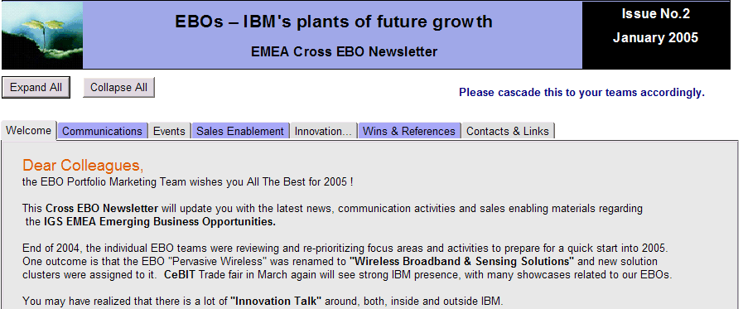

To subscribe to the EMEA IGS EBO Newsletter, contact Elaine Luebkemann/Germany.

Using innovation with clients

Best of Blue and Innovation Teams (i-Teams)
Category: Using Innovation with Clients

Description: The i-Team program is used to engage in joint innovation with large IGS customers under the Innovation SourcingTM sub-brand. The i-Teams serve to differentiate our offerings and are part of an integrated value proposition which takes the relationship to a strategic level beyond operational excellence and cost savings. The teams take the form of 1-3 people embedded at the client. These people focus is on helping clients to align their business and technology strategies and on giving them access to the best innovative capabilities we have in IBM worldwide, in particular a direct access to IBM Research. In addition to helping to sell large deals, this approach helps to keep IGS and customer relationships healthy over the long term.
Best of Blue is an IGS EMEA Strategic Outsourcing program sponsored by Joseph Benaroya, IGS EMEA Cross-Sector General Manager, and led by Colin Harrison. The program enables engagement and delivery teams to discover where the client is seeking value and to exploit IBM's worldwide capabilities to fulfill those needs over the entire lifecycle of SO agreements. The program is delivered by Best of Blue Practitioners who act as innovation facilitators and who become members of the Engagement or Delivery team.
Best of Blue actively supports the EMEA i-Teams, providing them with rapid and easy access to IBM’s worldwide capabilities and enabling them to respond quickly to client requests.
Value: Higher win rate and healthier accounts:
- Value for in Selling: Selling innovation as an integral part of the IBM solution has proven to be a key differentiator for IBM in winning Mega Deals. The i-Team approach has been a tie-breaker frequently cited by the customers in choosing IBM in large IGS transactions closed over the last 3 years.
- Value for Delivering: Innovation is a component of business value selling and adapts IGS to current client expectations. If basic service delivery quality is good and the SO client relationship is not severely damaged, bringing innovation to the client can have a significant impact on client satisfaction, contract extension, and new IBM revenues.

How IGS employees can use this program:
- Business Development: BDEs can call on Best of Blue to develop compelling partnership propositions that are based on deep knowledge of the client and on a deep knowledge of IBM capabilities.
- New Deals: CSEs working on Mega-deals can engage a Best of Blue expert to identify where opportunities exist for IBM to deliver business value to the client. This may include developing a proposal for an embedded I-Team.
- Base Growth Accounts: EMEA & Regional Base Growth leaders, PEs responsible for large accounts can employ Best of Blue to provide client and technology insight in much the same way that an i-Team does.
- I-Team support: Each EMEA i-Team is automatically paired with a Best of Blue practitioner.

Recommended types of projects: Large IGS deals (>$100 Mn TCV).

Scope or Restrictions: This program is used to differentiate large or otherwise strategic IGS deals, where there is a clear scope for joint innovation with the client.

Program Costs, if any: i-Team delivery (1-3 FTEs) must be included in the IGS contract cost case. Best of Blue support for the i-Team is charged to the delivery team on time and material basis.

Frequency and Availability: Best of Blue is selectively available to any IGS opportunity, current or future, however, the team is small and must focus on the most valuable opportunities. Others can be trained in the Best of Blue methods and content.

How to Engage and Contacts:
EMEA - See the Best of Blue Web site and contact the respective Sector Leaders or Colin Harrison/Zurich
Americas - Howard Sachar/Watson
World-wide - Claude Greengard/Watson
Web site: http://w3-05.ibm.com/services/emea/sodel/3sodegs.nsf/folders/sda99isis
Supporting Materials:

Example Reference: Finnair
Finnair, one of the world’s oldest operating airlines, wants to be the travel industry’s digital champion, and estimates that more than half of its passengers will soon be using the Internet for airline services, from making ticket reservations to clearing check-in. To meet this anticipated customer demand, Finnair came to IBM, not only to transform its service chain and IT systems, but to create an innovation center for incubating new solutions for the airline industry, such as wireless check-in, e-ticketing using the Internet, and wireless ticket sales.
"The relationship we've formed with Finnair respresents a new trend IBM is establishing with outsourcing customers," said Bob Zapfel, General Manager, Strategic Outsourcing and Integrated Technology Services, IBM Global Services. "We'll use all of IBM's technology and industry expertise to help Finnair open new revenue streams and establish itself as an e-business innovator."
One of the innovations developed in the context of the IBM/Finnair Innovation Transformation Center (ITC) is the CELM Solution (Customer Equity Lifecycle Management) which offers marketing managers a scientific framework to adaptively target specific customers groups and to re-allocate marketing resources depending on the value and risk profile in order to optimize the overall marketing budget allocation.
CELM is used at Finnair as part of their "Finnair Plus" eLoyalty program. The Research team worked closely with the client's marketing department to deliver not only an excellent technical solution but also to prove the value of the innovation by working with real data from ongoing marketing campaigns. The realization lead to a 20% reduction in marketing costs and improved the response rate by more than 10%. This successful client collaboration received a special mention in the 2003 IBM Annual Report (page 19) and laid the basis for ongoing activities to commercialize the technology as part of IBM's Customer Relationship Analytics (CRA) solutions.

IBM Project Financing with IBM Global Financing (IGF)
Category: Using Innovation with Clients

Description of the program or process: For clients of all sizes embarking on a major business transformation initiative, IBM Project Financing provides a flexible, comprehensive funding solution that's crucial to getting to on demand--and key to winning deals for IBM. IBM Project Financing provides single-source, highly-customized financing across a project's entire lifecycle for deals initiated through IBM Business Consulting Services (BCS), making it easier for clients to manage both upfront investment and ongoing operating costs. IBM Project Financing integrates all the elements of a total business transformation solution under a single financing umbrella, including HW, SW, Services, and even the client’s own internal implementation costs. This makes the project highly attractive to clients from a cash flow perspective and is a powerful competitive differentiator for IBM.

Value:
- For customers – greater business agility to act on opportunities and accelerated ROI through flexible funding, cost benefit matching, and deal structuring.
- For IBM – provides a competitive advantage, helping to strengthen customer relationships and win deals.

How IGS employees can use this program: To assist clients embarking on a major business transformation initiative by providing single-source, highly-customized financing across a project's entire lifecycle. Projects are typically initiated through BCS in collaboration with IBM Global Financing (IGF).

Recommended types of projects:
- Those where Accenture is key competitor, as they have no captive financial partner
- Large BCS Consulting & Systems Integration Opportunities – milestone billings
- Upfront costs in an AMS Opportunity
- Large license fee, or application development Investment, or both, such as: SAP, Oracle, Siebel
- Major investment in transition costs to complete “build” portion of BTO opportunity
- Clients who want to match cost outlays to projected business case benefits
- Clients who are looking to delay or de-scope projects due to affordability

Proof points and Examples: Analyst reports:
- Meta Practice - Enabling Business Transformation: Focus on Financing [http://w3.ibm.com/financing/news/quote/indnewsart_189612.html]
- IDC report: IBM's "Secret Weapon" [http://w3.ibm.com/financing/pdf/emea/IDC_CLS_CaseStudy.pdf]
- Meta Group Brief: IBM: Buying the BPO Business - In a Good Way [http://w3.ibm.com/financing/news/quote/indnewsart_193180.html]
- External references:
- CLS Bank - [http://w3.ibm.com/financing/pdf/ww/cls_customer_reference.pdf]
- Bekins - [http://www.ibm.com/financing/pdf/us/igf4-a197.pdf]

Scope or Restrictions: This program is worldwide and for all credit-qualified customers.

Program Costs, if any: None.

How to Engage and Contacts: Locate an IGF Project Financing Executive (Note – Scroll to the bottom of the screen for the IGF Project Financing search.)
http://w3.ibm.com/financing/sales/ibmrep/index.html#REPSECTION_190337

Web site: http://w3.ibm.com/financing/strategy/growth/stratind_196621.html

Supporting materials: IGF supporting materials are on the Web: Three presentations geared to different audiences:
- CFO; Analysts and IBM Sellers - on IBM Presentation Central: http://w3.ibm.com/financing/resources/prescentral/resind_174653.html
- Sales Collateral: [http://www-1.ibm.com/financing/pdf/us/igf4-a059.pdf]
- Competitive Profile: Accenture can't compete with IGF's Total solution
http://w3.ibm.com/financing/news/topstories/indnewsart_172002.html

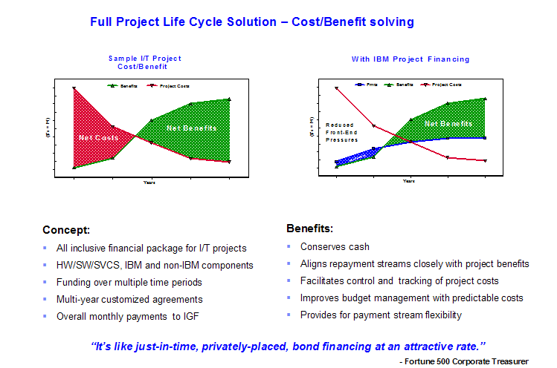

Industry Solutions Labs (ISLs)
Category: Using Innovation with Clients

Description of the program: Hardly your typical briefing centers, the ISLs offer agendas focused entirely on the collaboration among clients, partners, and the top IBM industry experts and researchers from around the globe. The agendas can be focused on an immediate business opportunity or problem or more broadly crafted to explore an array of emerging technologies. These gatherings are a rich interchange to discuss industry and technology trends and the challenges of managing their intersection, risks, and opportunities. Each year over 10,000 people visit the ISLs.

Value: The ISLs provide an excellent springboard for building stronger customer relationships and securing their confidence in selecting IBM as their long-term technology and services partner.

How IGS employees can use this program: An ISL client visit is generally one or two days in duration with each briefing agenda customized to meet the specific objectives of the client. Agendas can broadly look at innovative technologies or be more narrowly focused on a specific technogy or busiess challenge. They can range from formal presentations by IBM scientists and industry / subject matter experts, to collaborative dialogs on specific business issues. Each ISL has a state-of-the-art exhibit floor which showcases over a hundred demonstrations spanning a select range of innovative industry solutions, product offerings and research prototypes. These demonstrations reinforce the content presented formally during the visit.

Proof points and Example(s): “Every time we take our [telecom] client to Hawthorne we find at least three new opportunities to work on. Our YTY growth has been 40%.”

“Based on the experience at Zurich, the client team moved forward on innovation projects. The Research contribution also changed IBM’s position from product supplier to consultant. The client has signed BCS contracts to support them in their strategic project to design their future supermarket.”

“Signed a new BCS engagement concerning a new claims management system, contract worth 1.1M euros ($1.4M) in 2004, TCV 10M euros ($13.1M) over 3 years.”

“The purpose of this briefing for a key influencer in the e-learning market was to increase his understanding of IBM’s capabilities to counter-balance his impression of a recent visit to Accenture. He said that compared to IBM, Accenture’s focus on learning was pretty ‘vanilla.’”

“Following a visit to the ISL, we are about to sign $7M in BCS deals for 2Q2004 and are starting discussions for a sourcing partnership.”

“IBM closed its first BCS engagement with this client in 4Q for approximately $300K, and this has led to another $400K with an outlook of an additional $1M+ of BCS opportunity.”

“The visit to Hawthorne contributed directly to the $1.3M in work we did at the client last year. As the BCS account lead for this client, I am looking forward to reaching out again with more of the client’s extended enterprise.”

Scope or Restrictions: N/A

Program Costs, if any: Catering costs

How to Engage and Contacts: Contact: Mary Jo Frederich

Web site: http://w3-1.ibm.com/sales/isl/

Supporting Materials: Photograph of ISL

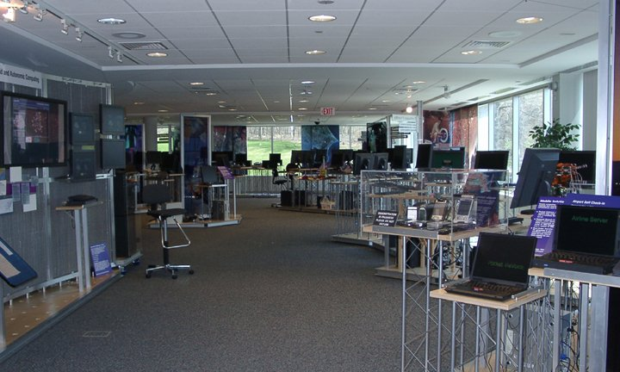

On Demand Innovation Services (ODIS)
Category: Using Innovation with Clients

Description of the program: On Demand Innovation Services (ODIS) combines the capabilities of IBM Research with the process and industry expertise of IBM consultants to transform business through strategic and technological innovation. Delivered through Integrated Technology Services (ITS) and Business Consulting Services (BCS), ODIS allows IBM clients to work directly with prominent scientists and use their skills and assets to gain business advantage.

The IBM Research Division’s diverse set of cutting edge capabilities are organized into cross-industry focus areas. Each focus area brings together leading scientists from IBM Research with an unmatched set of tools, technologies and patents. IBM Research can offer innovative capabilities in the development and delivery of almost any BCS or ITS proposal or engagement.

Value: ODIS can help set your proposal apart from your competitors. No other services organization in the world can bring a research organization to bear with the breadth and depth of capabilities as the IBM Research Division. As the world’s largest private research organization, with 8 labs and over 3,000 scientists worldwide, IBM Research is unmatched.

How IGS employees can use this program: Use ODIS to engage researchers to help you create highly competitive proposals, to differentiate your offering and to deliver your engagements

Recommended types of projects: ODIS can help with any highly competitive opportunity or uniquely challenging problem.

Proof points and Examples:

A Bank in AP: Bank SinoPac needed to improve efficiency and customer service in business units spanning four regions. Aspiring to serve customers in Taiwan, the People's Republic of China, Hong Kong, and the United States, SinoPac faced the challenge of different technical, legal, and regulatory systems in each region where it has branch offices or partner banks. The problem, as outlined in this case study, was particularly acute when it tried to serve high-end customers with accounts in two or more of these regions. The bank needed to be able to present these customers with unified account information and design effective financial products for them. Project executive Cliff Yu explains more:

The CRL [the IBM Research Lab in China] provided team IBM with the model-driven approach — the differentiating elements — to efficiently integrate the diverse processes and reduce the risks associated with transformation.
The project will permit the rapid development of new banking applications and integration with existing ones. Together with SinoPac, we had built a regional services platform using WebSphere to support the bank’s Cross Pacific Account program. This is one of the first systems allowing bank clients to make transactions among multiple accounts in different currencies, and banks in China, Taiwan, Hong Kong, and the U.S. One result of this project is that a publication called Global Finance ranked SinoPac as the world’s most IT-innovative bank — along with Citicorp and Wells Fargo.

A Leading Automotive company in EMEA: This leading European automotive company awarded IBM a project worth $12M for the implementation of a completely new IT solution covering spare parts planning and spare parts logistics execution, using the SAP implementation and project management capabilities in BCS, spare parts planning and optimization capabilities in Research including the Zurich lab's successful Advanced Inventory Management (AIM) asset, and subject matter expertise in IBM Global Parts Logistics. Hansjoerg Fromm comments on the role of Research:
I involved IBM Research in the proposal phase because I knew BCS together with Research could propose a solution unique to this company. IBM Research could provide algorithms for advanced inventory management that complemented the SAP APO solution with otherwise insufficient functional coverage. No other competitor (Accenture, Bearing Point, etc.) could propose such a solution.

A Government Agency in EMEA: The U.K. Department for Environment, Food and Rural Affairs (DEFRA) recently announced a seven-year agreement with IBM to provide IT and business change services to DEFRA as part of its program to modernize service provision to staff and the public. IBM is working closely with it to deliver an IT-based strategy for change, revamping the Department’s internal processes and leading to better customer service. Project executive Ian Bradbury comments:
When we’d been short-listed down to the last three in the procurement process, we were invited to respond to DEFRA on new ideas and potential areas of innovation relevant to them. By involving IBM Research at this stage, we were able to propose and develop several innovative technical ideas as well as to back them with business process and business model innovations too. Armed with a good understanding from our Chief Architect of the issues DEFRA faces, IBM Research was able to rapidly put forward stimulating ideas our competitors found it very difficult to match.

A Global Provider of Executive and Group Transportation in AG: Perhaps the most famous of the early ODIS engagements is Boston Coach, which needed to increase fleet utilization, reduce service refusals, increase same day/immediate business, vary capacity to meet demand, and quickly invoke affiliates when necessary. So it turned to IBM for a dispatch optimization system. Peter Poulin, project executive, explains that Research was in at the birth:
From the outset Research was involved. The project took a couple of turns early and Research was integral to defining what Boston Coach really wanted and needed — which was much different from their original articulation to us. Research delivered the mathematical algorithms that are the guts of the system. It was uniquely qualified to inject the sophistication that maked this system so valuable.

Hear more from your BCS collegues at: http://w3.ibm.com/news/w3news/top_stories/2004/11/bcs_odis.html

Read more ODIS case studies at:
http://reswat2.research.ibm.com/projects/odis/w3_odis.nsf/pages/index.html
http://domino.research.ibm.com/odis/odis.nsf/pages/index.html

Scope or Restrictions: ODIS is available worldwide with 8 labs and BCS contacts in each geography: http://reswat2.research.ibm.com/projects/odis/w3_odis.nsf/pages/contact.html

Program Costs, if any: Researchers work on your proposals and client engagements on a cost-recovery basis.

How to Engage and Contacts: Contact ODIS at odisvcs@us.ibm.com or by contacting an ODIS representative directly: http://reswat2.research.ibm.com/projects/odis/w3_odis.nsf/pages/contact.html

Web site: http://reswat2.research.ibm.com/projects/odis/w3_odis.nsf/pages/index.html
http://domino.research.ibm.com/odis/odis.nsf/pages/index.html

Supporting materials: An ODIS presentation can be found at:
http://reswat2.research.ibm.com/projects/odis/w3_odis.nsf/pages/micropractices.html
Sales support can be found at: http://reswat2.research.ibm.com/projects/odis/w3_odis.nsf/pages/sales.html

ODIS Innovation Management Micropractice
Category: Using Innovation with Clients

Description: Working together, IBM Business Consulting Services (BCS) and IBM Research now offer consulting services based on IBM’s expertise in numerous innovation processes, including Research and emerging business opportunities. We introduce our clients to the best innovation practices, design and implement customized innovation processes, explore new technology-based growth opportunities, run innovation workshops and guide open collaboration. We help our clients create new research and innovation activities to drive new growth opportunities; we also work with clients to increase the effectiveness of their current innovation practices in support of broader business transformation. Our clients can create new technology-based, market-driven opportunities, forecast future technologies and manage forward-looking research that is driven by the market. By managing their innovation, clients can expedite the development of innovative products and lead new markets, systematically generating growth opportunities.

Clients in many industries are very interested in innovation management, and we already have engaged with several of them to advance their research capabilities and to explore joint activities. These interactions draw on IBM Research’s expertise, which has been focused on delivering value to IBM’s brands, making the electronics industry a natural target for our initial efforts.

Value:
Value to our clients:
- Collaboration Innovation
One the of the key success factors of IBM Research has been its gradual transformation from focusing on internal research that is centralized and funded by the corporate structure, to an organization that is focused on working with clients to bring innovation to the marketplace.
- Innovation Analytics
To achieve long-term success and constant growth, market leaders systematically invest in emerging initiatives and innovative projects, part of a balanced portfolio. Because many of these activities are risky, they hold the potential of generating hyper-growth business success.
- Innovation Diagnostics
As clients are interested in advancing their innovation capabilities, they are faced with new challenges and unknowns.
- New Business Development and Market Innovation
Successful innovations are those that find their way to the marketplace through new products, processes or services, and, as a result, generate new business opportunities. The systematic development of new business opportunities requires innovative market understanding, creative culture, corporate commitment and established processes.
- Research Management
IBM has been developing methodologies for research management by working with clients and drawing on IBM's experience in managing its own research and development. Managing the development projects offers more control and minimizes the risk of unexpected outcomes.
Value to IBM
- New revenue generation through consulting engagements
- Door opening to clients that are interested in bringing in new technologies or methodologies that can foster innovation
- Substantiate the positioning of IBM as the 'Innovation Company'

How IGS employees can use this program: IGS employees can use this program to engage with customers that are interested in advancing their innovation practice. This offering can be part of BCS, AMS, ITS, or SO deals, it typically involves Innovation experts from IBM research and BCS consultants. In addition, we are developing IP in the Innovation Management domain which together with client experience can be leveraged to discuss IGS' own innovation practices

Scope or Restrictions: The original target audience was IGS, however, innovation and entrepreneurial concepts naturally span across organizational boundaries and all of IBM is welcome to participate. There are some editorial restrictions on content and length of articles.

Program Costs, if any: Similarly to other BCS and ODIS engagements, billable resources are available.

Frequency/ Availability: Innovation Management experts are available to help identify client needs, craft proposals and engage in delivery.

How to Engage/Contact(s): To further engage with this emerging practice please, contact the global leader, Iris Ginzburg/Haifa/IBM@IBMIL

Web site: http://reswat2.research.ibm.com/projects/odis/w3_odis.nsf/pages/mp.innovation.html

Supporting Materials – Proof points and Client Projects
The research lab is not contributing enough to innovative products
A leading electronics company has performed a supply chain management project, through which it realized that its research lab was not well linked with the innovative products of the company and was not contributing enough innovation.
The client asked BCS to identify and transform the research practices that needed change, looking to extend the integrated product development based consulting and the product innovation methodology into early stages of research and development. Enhancing the innovation brought out of their research lab was recognized by the client as essential for maintaining the rapid business growth.
Enter IBM powered by IBM Research.
IBM Research teamed with BCS to develop a new methodology for technology innovation management by using a business transformation methodology of BCS and the knowledge and previous experience of IBM Research in client engagements.

Central research and development needs to develop breakthrough technologies.
A global electronics company has been pursuing new technology-based growth opportunities, looking to become a world-class leader by creating and leading new markets. In order to realize the new strategy, the company needs to master processes for the development of breakthrough technologies, as opposed to its present research and development practice of developing competitive technologies for existing markets. The company's central research and development realized that it had to improve its innovation capabilities and approached IBM BCS for help, as it has always looked up to IBM Research as a role model.
Enter IBM powered by IBM Research.
Working together, BCS and IBM Research have engaged with the client to develop customized innovation management methodologies that draw on IBM Research best practices, benchmarks and experiences. As a result, the client will likely enhance its ability to forecast future technologies and to manage forward-looking research activities that are market driven, as well as risky.

New research and development function – how do we get started?
A leading telecommunications company has decided to transform part of its IT organization into a new research and development function, with the intent to increase its innovation activities. The client needed to identify key technology domains and potential projects to start the research and development activity, a task that required selecting a few technology directions from a wide range of new technologies that are relevant to the telecommunications industry. Starting such a function from scratch, the client needed guidance in defining the new organizational structure, skills, management, and processes. BCS responded to this challenge by proposing a joint project with IBM Research.
Enter IBM powered by IBM Research.
IBM Research partnered with BCS to provide benchmarking of the related research and development activities, technology context, and initial guidance to the client when designing this new innovation function.

Value Creation
Category: Using Innovation with Clients

Description of the program:
Value Creation is a differentiator, a methodology, and a way of doing business that leverages the “Full Equation of IBM” that can be used on any client deal. As a differentiation strategy, Value Creation places IBM in a Category of One, as IBM is the only company that provides the span and breadth of solution offerings, including STG, SWG, BCS, IGS, IGF, and Research. As a methodology, Value Creation is a 4-step proactive approach designed to transform selling and delivery for any IBM deal. The 4-step methodology includes:
- Value Identification: Qualifies client opportunities through identification of performance gaps and pain points.
- Value Solutioning: Identifies solution areas through diagnostic tools, such as the Component Business Model (CBM) and is fueled by innovative problem solving capabilities from across IBM, including On Demand Innovation Services (ODIS), the Center for Business Optimization (CBO), Intellectual Property and Asset Commercialization (IPAC), and IBM Transformation Efforts.
- Creative Value Dealmaking: Adds client value, strengthens partnerships, and shares in benefits by proposing creative commercial structures that not only deliver value but also enable IBM to demonstrate its commitment to partnership and share in the risks and rewards.
- Value Delivery: Leads to real business outcomes for our clients by accelerating our ability and capacity to achieve business case objectives, monitor results, reinforce relationships, discover new opportunities, reinforce solutions, and promote Delivery Excellence.

The Value Creation methodology is consistent with GS Method. Integration into GS Method is in process.

Value: The value of applying this methodology that provides one voice of IBM provides the following values:
- Value Creation eliminates the occurrence of different lines of business in IBM competing with each other with for the same client engagement.
- Value Creation expands the scope that is offered on each client deal by including all of the IBM capabilities.

How IGS employees can use this program: The Value Creation methodology should be used on every client deal to optimize what IBM provides to the client. Education on this methodology is available on Global Campus (see the Supporting Materials section.) For more information and assistance, see the How to Engage section.

Recommended types of projects: The Value Creation methodology can and should be used on every client deal, regardless of which business unit is leading the engagement. Value Creation projects have ranged in duration from months to years, in revenue from hundreds of thousands to billions of dollars, and in deal scope from strategy engagements to systems implementations to BTO.

Proof points and Examples: 15 Value Creation deals closed in late 2004, including: Bharti, Department for Environment Food and Rural Affairs, Department for Work and Pension, Disney, Dongbu Corporation, eArmyU, Egg, Goodyear, Phillips, SEB, Sprint, Surrey County Council, US Bureau of Customs and Border Protection, US Department of Agriculture Forest Service, and Verizon. February 2005 Value Creation pipeline includes over 100 projects with a Total Contract Value of over $3B.

Scope or Restrictions: None. Value Creation is a mindset and a methodology that can be used on all client deals.

Program Costs, if any: There is no cost associated with requesting assistance with Value Creation for any client deal. The program supporting Value Creation is funded through the Institute for Business Value (IBV) and the Geo Leads.

How to Engage and Contacts: For assistance with Value Creation, contact the following Geo leads:
Global/Americas - Kristen Pederson
EMEA - Likhit Wagle
AP - Suhyon Im

Web site: In development.

Supporting materials:
Education available: instructor-led courses and Web-based courses on Global Campus.
- Instructor-led courses are scheduled for delivery throughout 2005 in each of the three Geos and include:
Value Creation Masterclass for Partners
Value Dealmaking for Partners
Navigating IBM for Partners
Value Creation Masterclass for Practioners
Value Creation Tools for Practitioners
- Web-based courses include:
Value Creation including Value Identification & Value Solutioning, Value Dealmaking, and Value Delivery. This is a 3-course, 10-hour series to be completed Q1 2005.
A series of Value Creation QuickViews including Overview, Value Identification Tools, Value Solutioning Tools, Value Dealmaking Tools, and Value Delivery Tools. To be completed Q2 2005.

Access to the Value Creation KnowledgeCard can be made via the Strategy & Change Network of Excellence Interface.

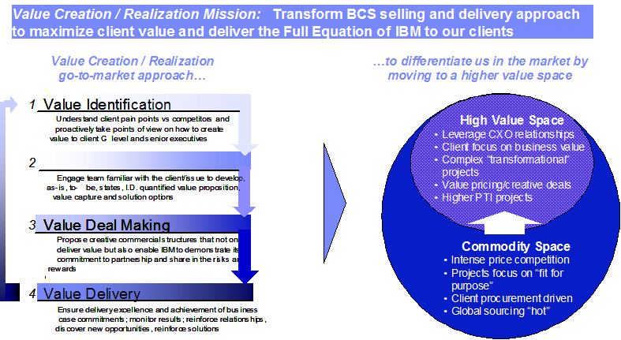

Fostering community, morale, and education around innovation

Emerging Technology and Business Innovation (ETBI)
Category: Fostering community, morale, and education around innovation

Description: The Emerging Technical and Business Innovation (ETBI) group extends the IBM commitment to invention and new business opportunities while encouraging entrepreneurialism among employees. ETBI achieves this by providing community forums (Web portal, community groups, and so on) for IBM employees to network and collaborate on new technologies and seminars that explore both the technical and business aspects of each of the Emerging Business Opportunities that are identified by IBM. ETBI also provides a forum to peer-review new ideas developed by new hires to take advantage of the unique background and perspectives of IBM's new hire community. Finally, ETBI offers mentorship assistance for people with ideas in need of idea coaches. The three pillars of ETBI are education, networking, and invention.

Value:
Value for employees in contributing to Emerging Technology and Business Innovation:
- Increased knowledge of available events and news that is related to their entrepreneurial interests.
- Increased awareness of other people and communities with similar interests and goals that are related to innovation.

Value to IBM:
- Helps to encourage and support our core value of innovation.

How IGS employees can use this program and resource: IGS employees can use this community to find new resources, network with other members and contacts, and read up on the latest postings related to the intrepreneur. This program can also serve as a good launching pad to being a commercialization process by leveraging members and their contacts.

Scope or Restrictions: This was originally focused on the Austin community, but has since expanded worldwide. Anyone (new hire, senior technical person, business executive and so on) is welcome to contribute and participate in the community. Please use the Community Tools features wisely.

Program Costs, if any: None.

Frequency and Availability: ETBI is a continually updating community. The Web portal is updated dynamically with user submissions. Newsletters are sent out every month (sometimes more frequently). Events are held throughout the year.

How to Engage and Contacts: To subscribe to the mailing list, send a note to Tyron J Stading/Austin/IBM@IBMUS.
To get connected with the community:
Connect through the ETBI portal (http://etbi.ausitn.ibm.com). The more you post, the more everyone will benefit.
Use Community Tools Blue Groups (group name: ETBI)

Contact Tyron Stading about mentorship opportunities.

Web site: http://etbi.austin.ibm.com/

Supporting Materials - Example Content From ETBI Web Portal

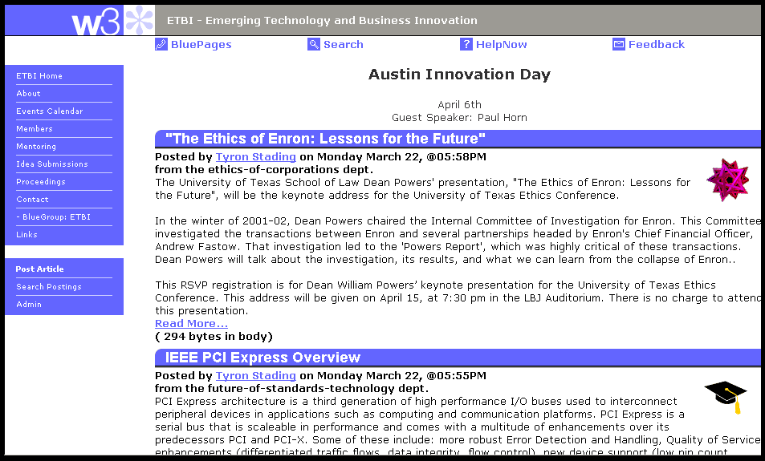
Dynamic “Slashdot-like” posting for user community

IBM Executive Business Institute – Innovation Courses
Category: Fostering community, morale, and education around innovation

Description of the program: The Executive Business Institute offers courses that enable both IBMers and IBM clients to understand, plan, evaluate, and execute on innovation for the benefit of the organization. Currently there are five courses offered in this general area:
- Future Value – Determining the potential for high-value innovation in emerging technologies
- Business Futures – Value in emerging technologies and incorporating then into your business plan
- Innovation Roles and Frameworks – Finding the right path for innovation by putting together the most effective teams and responding to the changes in opportunity and business environment
- Strategic Innovation – Exploring innovation through scenarios that enable your organization to use game-changing innovation to drive strategy and create sustainable competitive advantage
- Deep Innovation – Using intensive work with narrative prototypes to gain insights into emerging trends, analyze their impacts, and find a route to competitive advantage

In addition, custom engagements can be arranged, aimed at specific interests and available at a time and a location of mutual convenience.

Value: For IGS itself, IBMers can speed up and improve the quality of innovation activities. New ideas and ways to overcome common barriers provide new routes to a competitive advantage. When IGS employees attend with their clients, new opportunities can be unearthed and practical ways to make them happen can be developed. This can result in more value for clients and better satisfaction ratings.

How IGS employees can use this program: IGS employees can take the courses individually, in teams, or with clients. Both open enrollment and custom offerings are available.

Scope or Restrictions: No practical limits because custom opportunities are available.

Program Costs, if any: Costs for open enrollment classes range from $450-$2250 per student. (IBMers attend tuition-free if they bring a client.) Custom programs vary, but generally are $5,000-$10,000 per day, plus expenses.

Frequency/Availability: The dates open enrollment courses are offered are specified on the events calendar (see http://www-03.ibm.com/ibm/palisades/html/calendar-abi-date.html). Custom courses are available by individual agreement.

How to Engage and Contacts: Contact Peter Andrews (pja@us.ibm.com)

Web site: www.ibm.com/abi

Supporting materials: For further information, see http://www-03.ibm.com/ibm/palisades/abi/index3.html

Here is a list of IBM Executive Business Institute Innovation Courses:

Business Futures
This seminar introduces you to the Futures Technique -- an analytical process developed for IBM. IBM has successfully used this technique to help firms in insurance, chemical production, car leasing, and other businesses to make better technology investment decisions.

Students will be invited to explore those technologies in terms of their strengths and weaknesses in fulfilling their promise and delivering on the needs of society, individuals, and corporations. As they continue their analyses, they will discover hidden value in technologies and identify the specific barriers that need to be overcome to realize this value and gain a competitive edge.

Future Value
With scores of new technologies appearing every year, even trained engineers, computer scientists, and strategists have difficulty deciding which ones are important. This Distance Learning course, drawn from Business Futures, introduces you to the Futures Technique -- an analytical method that IBM has successfully used to help insurance companies, chemical producers, car leasing firms, and other businesses to make better technology investment decisions. Students will be invited to explore those technologies in terms of their strengths and weaknesses in fulfilling their promise and delivering on the needs of society, individuals, and corporations.

Innovation Roles and Frameworks
It's an axiom that innovation drives competitive advantage and growth, but most great ideas never have a chance in business. This workshop helps student to identify and choose the best pathways for innovation, then determine what talents and skills are required to move an idea forward. Using real examples, the class will develop value propositions, learn to anticipate barriers and setbacks and make alliances that increase the value of an innovation. In addition, the class will explore example pathways that have been used for success, and how they might be complemented by innovation management processes and an enabling culture.

Strategic Innovation
The instructors for Strategic Innovation have helped many companies take advantage of IBM's experience in finding the best ideas and putting them to work to stay ahead of the pack. To do innovation that really matters and get the benefits it promises, creative people of all types need to be given focus and direction. They need processes that are both supportive and demanding. They need to connect with team members who can turn an idea into a whole new market that meets customer needs and builds profits. Strategic Innovation provides the practices, models, and processes that make innovation successful again and again.

Deep Innovation
In this two-day session you will explore business development within the context of some of the most important emerging technologies and business trends. The workshop is based on the findings of the IBM Enterprise of the Future team, which brought together a host of Distinguished Engineers and other thought leaders from across the company for nine months of brainstorming, analysis and projection. You will develop an integrated view of future business possibilities that are directly related to your own objectives, issues and markets.

“Roles for innovation: The right people at the right times.”
http://www-1.ibm.com/services/us/index.wss/mp/imc/xt/a1003097?cntxtId=a1000401

“Passport for innovation: Seven questions on the road to success.”
http://www-1.ibm.com/services/us/index.wss/mp/imc/xt/a1001938?cntxtId=a1000401

“Flash in the pan or true innovation? Twenty questions to evaluate new technology.”
http://www-1.ibm.com/services/us/index.wss/mp/imc/xt/a1000605?cntxtId=a1000401

“Informal routes to innovation: Stealth and trickery?”
http://www-1.ibm.com/services/us/index.wss/mp/imc/xt/a1000639?cntxtId=a1000401

“Open innovation: Using research from everywhere for new product and service development.”
http://www-1.ibm.com/services/us/index.wss/mp/imc/xt/a1000655?cntxtId=a1000401

“Actual experience: Putting customers onto your innovation team.”
http://www-1.ibm.com/services/us/index.wss/mp/imc/xt/a1006206?cntxtId=a1000074

IBM Innovators Club
Category: Fostering community, morale, and education around innovation

Description of the program: The IBM Innovators Club is an informal community of IBM professionals around planet IBM who are interested in delivering business and technical innovation to our customers. This community includes members from almost all IBM lines of business with a good balance of product and service interest. The club "meets" by a weekly telephone call on Mondays at 12:00-13:00 EST; most of this hour is devoted to a speaker, often a club member, who presents on a topic related to innovation.

Value: The purpose of the club is to support a community of people who are interested in a wide range of activities under the heading of “innovation” both inside and outside IBM. It serves especially as a forum to seek validation and support for wild ideas and bold initiatives that are subsequently developed elsewhere. The origins of the Club go back to the development by IBM of the CBI Guide to Innovation; this was lead by Abigail Tierney and was published at the beginning of January 2003.

The IBM Innovators Club teamroom is a rich resource of information on innovation. Recent contributed documents:
Breakthrough Ideas for 2005 (HBR)
Services Innovation – European Communities
IBM Innovation video
IBM Research - The Evolution of Innovation at IBM
All issues of the InnovationFlash (see page 50 for more information.)

How IGS employees can use this program:
- As a place to test ideas and to see if any one else has tried and has learned from the idea.
- As a place to learn about others’ experiences in trying to be innovators.
- As a place to locate resources and experiences that are required for an innovation initiative.
- As a place to see documents on innovation across the world.

Scope or Restrictions: Membership is open to any IBM employee.

Program Costs, if any: No cost to participate.

Frequency/ Availability: Weekly calls except during holiday periods. Access to TeamRoom.

How to Engage/Contact(s): e-mail to Colin Harrison/Zurich/IBM.

Web site: None.

Supporting materials:

Recent talks:
28 Feb05 Innovation is not a business process / Mandy Chessell (IBM UK Hursley Lab)
21 Feb05 Disruptive Innovation for EBOs / Neil Katz (CHQ Emerging Business)
14 Feb05 Extreme Blue Client / Paul Baffes (Extreme Blue)
07 Feb05 Extreme Blue BizTech / Deborah Delosa (Extreme Blue)

31 Jan05 AoT Brand Study / John Bosma & Chris Gammill
24 Jan05 Secure Trade Lane / Stefan Reidy (BCS)
17 Jan05 Simulation, Social Play and Learning / Chuck Hamilton (Vancouver Inno. Centre)
10 Jan05 Innovation Pathways / Currie Boyle (Vancouver Inno. Centre)
03 Jan05 Services Science / Jim Spohrer

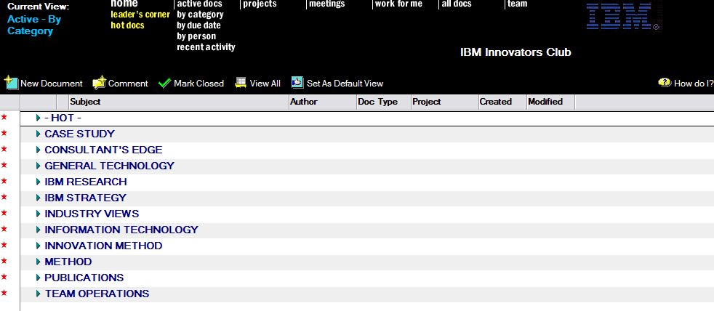

IGS Community Program and IGS Communities of Practice (CoP)
Category: Fostering community, morale, and education around innovation

Description of the program: The GS Community Program is focused on ensuring that Communities of Practice are building capabilities that are needed by the business and the individual members, and that communities are well understood and leveraged as enablers of the cultural transformation that is needed to innovate at IBM. By driving community standard business practices and user experiences across IBM, the GS Community Program emphasizes the importance of growing and maturing communities as an asset portfolio that is managed to enable business performance strategies.

There are approximately 90 assigned Communities of Practice of various types in IBM Global Services: technical, industry, competency, profession, and so on. This is a desirable strategy which allows for building and sustaining required competencies and expertise. Practitioners benefit from joining more than one community in a relevant sector, delivery area, technology, or profession

A Community of Practice (CoP) is an informal organization of highly functioning subject matter experts (SMEs) who share a particular interest and identity themselves to work voluntarily within a specific domain. A CoP is designed to include IBMers across all stakeholder groups in a collaborative environment in which members share a passion for their domain, and a commitment to each other to build reciprocity and trust. CoPs are usually global by definition, but at the same time, are “grass roots” and local in orientation and context.

Value: In Global Services, the Community is where learning, method, expertise, knowledge and assets work in concert to build competencies and to enable business and individual performance.

Communities enable our practitioners to nurture, sustain and build on expertise; build skills, competency and capability; socialize knowledge, learn about new opportunities; perform better and faster delivery; and innovate and share new ideas.

In a recent GS Community Program study of the business impact of fifteen communities across IBM Global Services in 2003 – 2004, the majority of respondents agreed that being active in a community has helped their ability to innovate at IBM.

How IGS employees can use this program:
- Join a primary competency community, or a technology community or both, an industry or profession CoP.
- Participate in community activities as a way to build social networks, to enhance working relationships, and to build your professional reputation.
- Obtain a better understanding of the IBM go-to-market strategy and opportunities.
- Participate in stimulating and interesting topics, solving problems with like-minded individuals.
- Innovate and learn.
- Boost your job satisfaction through a sense of belonging to a group of like-minded individuals who value your ideas and contributions.

Scope or Restrictions: No restrictions. Non-IGS membership is permitted in IGS Communities at the discretion of the individual Community Leader.

Program Costs, if any: None

Frequency and Availability: IGS Communities are available on a virtual basis at all times.

How to Engage and Contacts: For more information, please contact:
- Deborah Dunagan, Global Leader, IGS Community and Method Programs (Deborah Dunagan/White Plains/IBM@IBMUS)
- Louisa Peluso, IGS Community Program Manager (Louisa Peluso/Atlanta/IBM@IBMUS)
- ➔ID: Communities of Practice/Waltham/IBM@IBMUS

Web site: The Community Zone ➔ http://gcd.ibm.com/zone/communityzone.nsf

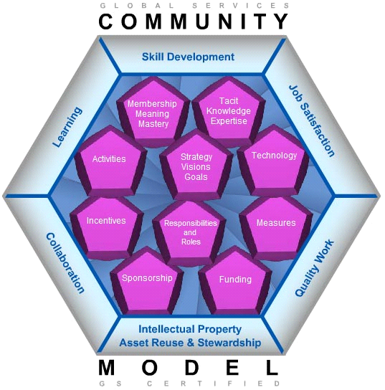

Community Value Statement

The communities are an important performance enabler for Global Services because of their ability to work together as a system across organizational silos. Communities engage in specific activities to enable performance capabilities for our practitioners and our business by fostering innovation and building rapid deployment and delivery capabilities.

Through the use of community resources and assets, our capability to configure products, services, and assets, drawing upon expertise that can be realized in the marketplace, is enhanced.

The Community is a trusted advisor to the business providing input for continuous strategy development based on its capabilities to sense and respond as a pulse of the marketplace. Members are passionate and future-oriented about their domain. The Community is a source of Innovation beyond what happens on engagements.
Communities of Practice have been identified as the primary engine for achievement in learning, collaboration and innovation and are a key vehicle for delivering value to clients, enabling growth in IBM and improving morale and capabilities*
IBM Methods
Assets
Communities
Assets
Method Methods
Communities
* GS Community Program
Communities enable our practitioners to:
- Nurture, sustain and build expertise
- Build skills, competency and capability
- Socialize knowledge
- Learn about new opportunities
- Perform better and faster delivery
- Innovate and share new ideas

Communities enable our business to:
- Locate and deploy expertise
- Leverage and apply knowledge
- Sense and Respond (Mobilize) to new ideas, emerging threats and opportunities
- Improve performance in time-to-market delivery of new products and service offerings
- Operationalize a sustainable competitive business model including adaptive, OnDemand capabilities

IGS Innovation Speaker Series
Category: Fostering community, morale, and education around innovation

Description: The purpose of the speaker series is to highlight valuable and proven resources that can support you in creating business value for IGS, with special focus on capabilities that help to develop new markets, new business models, and innovative new business / technology solutions. The objectives are to:
- Increase awareness and usage of key innovation capabilities in IGS
- Encourage a culture of innovation by bringing forward ways to execute innovation and demonstrate that there is strong, tangible support available for the recent IBM focus on innovation.

The target audience: Those in IGS who focus on revenue generation and enhancement, cost reduction, and increasing productivity. Select target groups and roles include: Marketing and Strategy, EBO teams, Solutions, Offerings, Portfolio Management, Business Development, Market Development, and Sector and Industry leaders. Others are invited to subscribe as well.

The format is a 30 minute call, to view a crisp, net 15 min presentation and have time for questions. A replay is also available.

Value: IGS employees can gain increased knowledge of key innovation programs and capabilities, helping them to develop new markets, business models, or solutions more effectively.

How IGS employees can use this program and resource: IGS employees can use this speaker series as a short learning event that may help them with their immediate work. Depending on the topic, they may discover that the program featured can help them or others they work with to develop a new approach to current or planned projects.

Scope or Restrictions: No restrictions apply. Any IBMer can participate in this speaker series by subscribing.

Program Costs, if any: None for the participants. The IGS Innovation Speaker Series is sponsored by the IGS Strategy.

Frequency/ Availability: The IGS Innovation Speaker Series has sessions every other month – Jan, Mar, May, July, Sept, and Nov.

How to Engage and Contacts: To subscribe to this speaker series, contact Brad A Sperbeck/White Plains/IBM

Web site: Coming soon.



You are invited to participate in the IGS Innovation Speaker Series. The speaker series highlights valuable and proven resources that can support you in creating business value for IGS, with special focus on capabilities that help to develop new markets, business models, and innovative new business and technology solutions. The speaker series meetings are only 30 minutes in length and will provide crisp, expert, and interactive insight on relevant topics for IGS innovation.

Topic: The topic of the March series is the GAP program (Growth Alliance Program)

Abstract: GAP is a fast cycle-time business process that supports the dynamic inorganic growth needs of the IBM Line of Business and Sector organizations and aids in the identification and selection of alliance, merger, and acquisition targets that can strengthen IBM capabilities. The process is data-driven and requires relatively short amounts of time from an executive sponsor. The reverse auction format keeps the partner field competitive and supports IBM in achieving optimal value in equity exchanges.

By initiating a GAP session for your organization, you can increase knowledge about the available external business partners who can provide the needed capabilities, skills, technologies, and business models. This call will describe the details of the GAP process and explain how interested organizations can take advantage of it to drive profitable revenue growth.

Sound interesting? Attend this short presentation to learn how GAP can benefit you and your organization.

Please forward this invitation to others in your organization.

The InnovationFlash
Category: Fostering community, morale, and education around innovation

Description: The InnovationFlash is an e-mail journal that is dedicated to the entrepreneurial spirit at IBM and highlights projects, initiatives, good ideas, and inspirational comments. Its purpose is to encourage, educate, and inspire individuals to help stimulate a culture of entrepreneurship, growth, and innovation.

The InnovationFlash is intended to be a thought-provoker and a forum for sharing concepts in short, easy-to-read articles. The design point is to be short enough to read through in the time it takes for one cup of coffee, an afternoon tea, or a short mental break from the work day.

Value:
Value for employees in reading the InnovationFlash:
- Increased knowledge of available innovation projects, capabilities, and resources that can be used to help drive innovation in your daily work.
- Increased awareness of other people and communities with similar interests and goals that are related to innovation.

Value to IBM
- Encourages and supports our core value of innovation.

How IGS employees can use this program and resource:
IGS employees can use this journal to find new resources, network with the authors and program contacts, and to take a moment from their work to read something inspiring from other IBMers. It is also a forum to contribute ideas on commercialization, or news of resources that others can use. Anyone can add their name to the subscription list, submit articles, or volunteer to be an author or editor.

Scope or Restrictions: The original target audience was IGS, however, innovation and entrepreneurial concepts naturally span across organizational boundaries and all of IBM is welcome to participate. There are some editorial restrictions on content and length of articles.

Program Costs, if any: None for the readership or contributors. This journal is sponsored by IGS Strategy.

Frequency and Availability: The InnovationFlash publishes every other month – Feb, April, June, Aug, Oct, and Dec.

How to Engage and Contacts: To subscribe to this journal or to send content submissions, send a note to Tijs Wilbrink/Netherlands/IBM@IBMNL.

Web site: Coming soon.
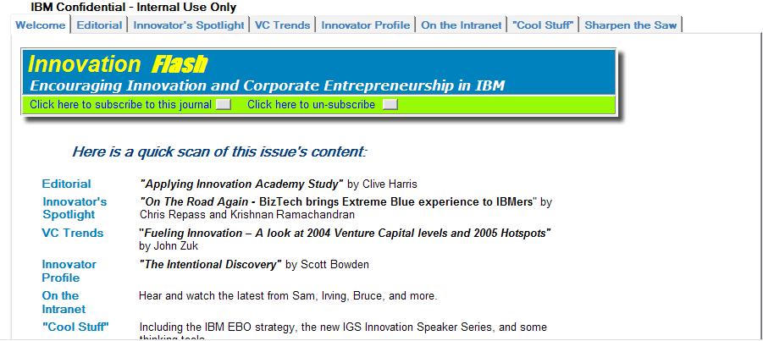

Comments from the readers:

"This is far and away the most interesting and readable internal newsletter I have seen (and I receive several)."
IBM Global Services, Portfolio Management
"Excellent and thought-provoking edition, especially Colonel Boyd!"
VP Assets Innovation, IBM Global Services
"… (S)eeing that there is a #4 made my day!!"
Reader in Spain

"Thank you - interesting read !"
Global Services Systems & Storage Sr IT Architect

"This is a very useful piece of work…"
Director, Venture Capital Group

"I think this initiative is great. It is the only newsletter I read entirely."
Open Source & Middleware Service Center

"Like everyone else, I seem to get more newsletters and other "fyi" type email than I care to read, but InnovationFlash has managed to capture my attention with each issue."
Process Architect, Process and Quality

