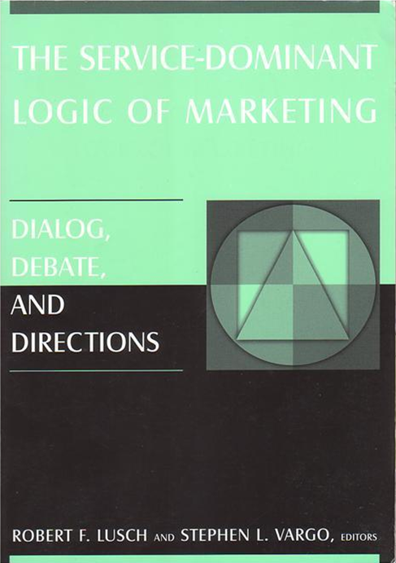
Lusch, R.F., Vargo,S.L. (eds) (2006). The Service-Dominant Logic of Marketing: Dialog, Debate and Directions, ME Sharpe, Armonk.
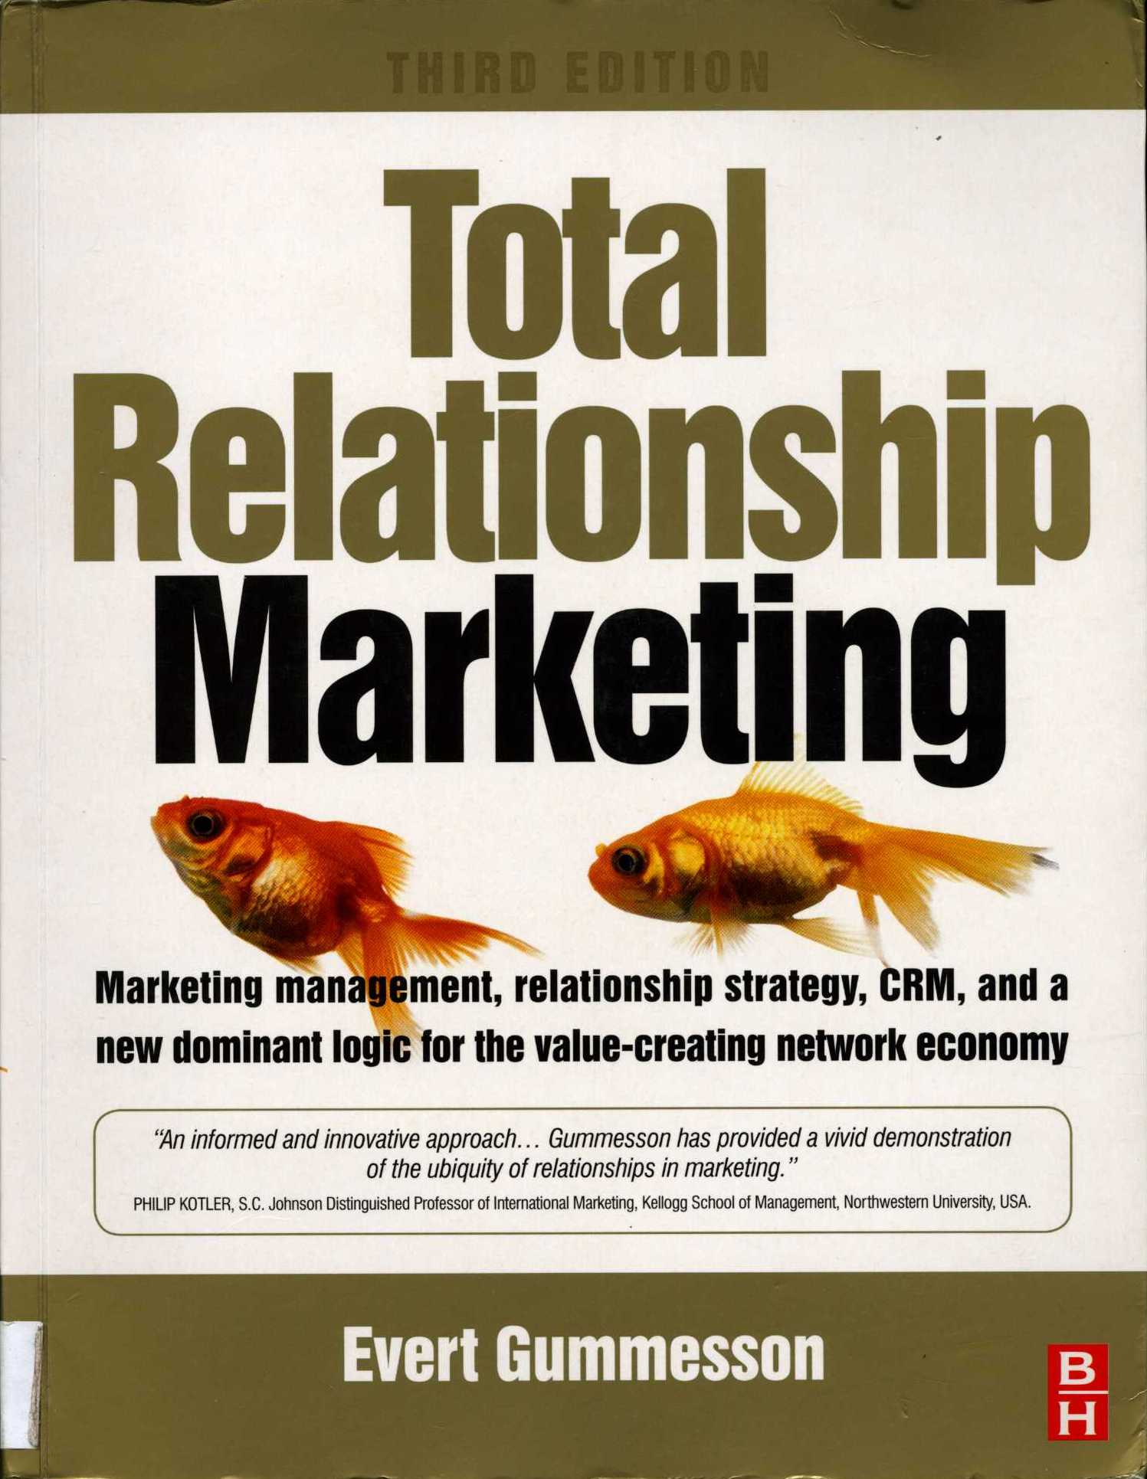

Gummesson, E. (2008), Total Relationship Marketing, III ed., Butterworth-Heinemann, Burlington;

Demirkan, H., Spohrer, J., Krishna, V. (eds) (2011), The Science of Service Systems, Springer, New York

