Lab 1.3.1: Review of Concepts from Exploration 1

Topology Diagram

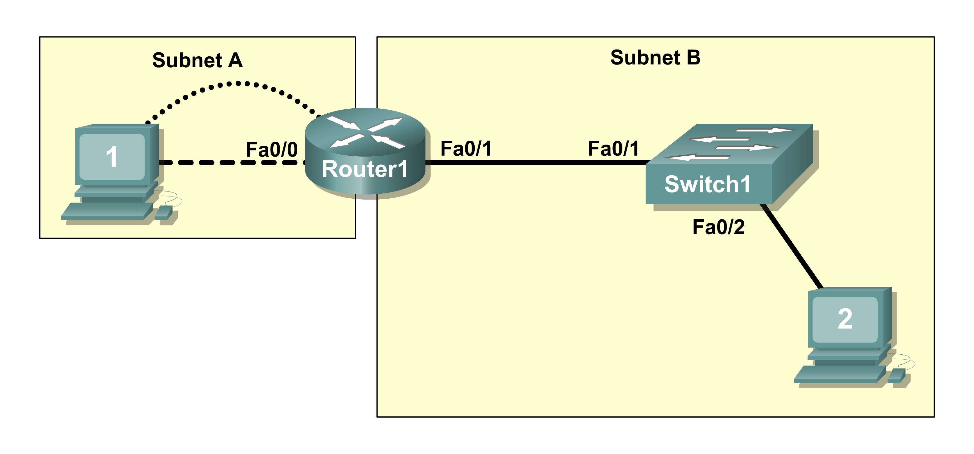

Learning Objectives
Upon completion of this lab, you will be able to:
- Create a logical topology given network requirements
- Create subnets to meet host requirements
- Configure the physical topology
- Configure the logical topology
- Verify network connectivity
- Configure and verify passwords

Scenario
In this lab, you will design and configure a small routed network and verify connectivity across multiple network devices. This requires creating and assigning two subnetwork blocks, connecting hosts and network devices, and configuring host computers and one Cisco router for basic network connectivity. Switch1 has a default configuration and does not require additional configuration. You will use common commands to test and document the network. The zero subnet is used.

Task 1: Design a Logical LAN Topology
Step 1: Design an IP addressing scheme.
Given the IP address block of 192.168.7.0 /24, design an IP addressing scheme that satisfies the following requirements:

Subnet | Number of Hosts
Subnet A | 110
Subnet B | 54
The 0 subnet is used. No subnet calculators may be used. Create the smallest possible subnets that satisfy the requirements for hosts. Assign the first usable subnet to Subnet A.

Subnet A
Specification | Student Input
Number of bits in the subnet
IP mask (binary)
New IP mask (decimal)
Maximum number of usable subnets (including the 0 subnet)
Number of usable hosts per subnet
IP subnetwork address
First IP host address
Last IP host address

Subnet B
Specification | Student Input
Number of bits in the subnet
IP mask (binary)
New IP mask (decimal)
Maximum number of usable subnets (including the 0 subnet)
Number of usable hosts per subnet
IP network address
First IP host address
Last IP host address

Host computers will use the first usable IP address in the subnet. The network router will use the last usable IP address in the subnet.
Step 2: Write down the IP address information for each device.

Device | IP address | Mask | Gateway
Host1
Router1-Fa0/0
Host2
Router1-Fa0/1
Table 1. IP Address Assignments
Before proceeding, verify your IP addresses with the instructor.
Task 2: Configure the Physical Topology
Step 1: Cable the network.
Refer to the figure and table below for the necessary cables.
Cabling | Cable Type
LAN cable between Host1 and Router1 Fa0/0 | Crossover
LAN cable between Switch1 and Router1 Fa0/1 | Straight-through
LAN cable between Switch1 and Host2 | Straight-through
Console cable between Host1 and Router1 | Rollover

Figure 1. Cabling the network

Step 2: Physically connect lab devices.
Cable the network devices as shown in Figure 1. Turn power on to all devices if it is not already on.
Step 3: Inspect the network connections.
Verify the connections visually.
Task 3: Configure the Logical Topology
Step 1: Configure the host computers.
Configure the static IP address, subnet mask, and gateway for each host computer.
Note: The following directions are for Windows XP. To configure hosts using other operating systems, refer to the operating system manual.
To configure the host, go to Start > Control Panel > Network Connections > Local Area Connection. In the Local Area Connection Properties window, select Internet Protocol (TCP/IP) and click the Properties button.

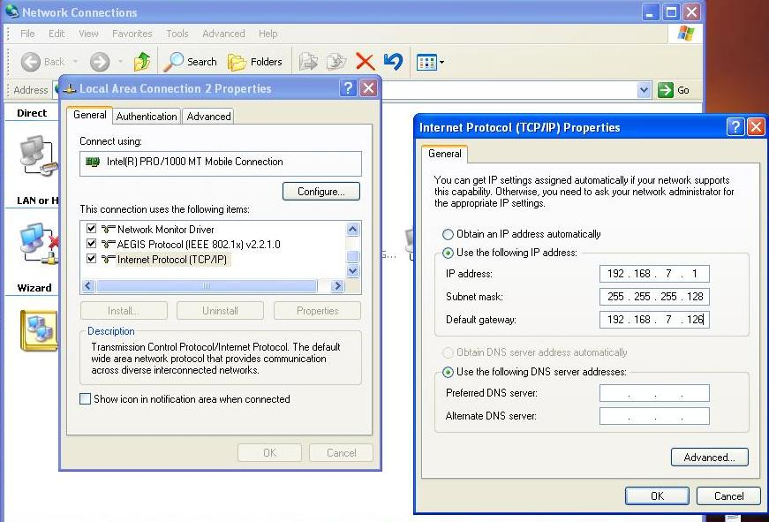
Figure 2. Setting Properties for Internet Protocol (TCP/IP)

In the TCP/IP Properties dialog box for each host, enter the IP address, network mask, and the gateway from Table 1.

After configuring each host computer, open a command window on the host by selecting Start > Run. When prompted to type the name of a program, enter cmd in the text box. From the command window, display and verify the host network settings with the ipconfig /all command. The settings should match those in the tables below:

Host1 Network Configuration
IP address | 192.168.7.1
Subnet mask | 255.255.255.128
Default gateway | 192.168.7.126

Host2 Network Configuration
IP address | 192.168.7.129
Subnet mask | 255.255.255.192
Default gateway | 192.168.7.190

Are the host settings in agreement with the tables? ___________ If not, reconfigure as necessary.
Step 2: Configure Router1.
From Host1, connect to the console of Router 1 and establish a console session. Directions for creating a console connection using HyperTerminal are in Appendix 2.
From the router console, configure the following:

Task | Specification
Router name | Router1
Encrypted privileged exec password | class
Console access password | cisco
Telnet access password | cisco
Router1 interface Fa0/0 | Set the description  Set the Layer 3 address
Router1 interface Fa0/1 | Set the description  Set the Layer 3 address

Enter the following commands on the router:
Router>enable
Router#config term
Enter configuration commands, one per line. End with CNTL/Z.
Router(config)#hostname Router1
Router1(config)#enable secret class
Router1(config)#line console 0
Router1(config-line)#password cisco
Router1(config-line)#login
Router1(config-line)#line vty 0 4
Router1(config-line)#password cisco
Router1(config-line)#login
Router1(config-line)#interface fa0/0
Router1(config-if)#ip address 192.168.7.126 255.255.255.128
Router1(config-if)#no shutdown
Router1(config-if)#description connection to host1
Router1(config-if)#interface fa0/1
Router1(config-if)#description connection to switch1
Router1(config-if)#ip address 192.168.7.190 255.255.255.192
Router1(config-if)#no shutdown
Router1(config-if)#end
Router1#
Task 4: Verify Network Connectivity
Step 1: Use the ping command to verify network connectivity.
You can verify network connectivity using the ping command.
Note: If pings to the host computers fail, temporarily disable the computer firewall and retest. To disable a Windows firewall, select Start > Control Panel > Windows Firewall, select OFF, and then OK.
Use the following table to verify connectivity with each network device. Take corrective action to establish connectivity if a test fails.

From | To | IP Address | Ping Results
Host1 | NIC IP address | 192.168.7.1
Host1 | Router1, Fa0/0 | 192.168.7.126
Host1 | Router1, Fa0/1 | 192.168.7.190
Host1 | Host2 | 192.168.7.129
Host2 | NIC IP address | 192.168.7.129
Host2 | Router1, Fa0/1 | 192.168.7.190
Host2 | Router1, Fa0/0 | 192.168.7.126
Host2 | Host1 | 192.168.7.1

In addition to the ping command, what other Windows command is useful in displaying network delay and breaks in the path to the destination?_________________________________
Task 5: Verify Passwords
Step 1: Telnet to the router from Host2 and verify the Telnet password.
You should be able to telnet to either Fast Ethernet interface of the router.
In a command window on Host 2, type:
telnet 192.168.7.190
When you are prompted for the Telnet password, type cisco and press Enter.
Was the telnet successful? ______________
Step 2: Verify that the enable secret password has been set.
From the Telnet session, enter privilege exec mode and verify it is password protected:
Router>enable
Were you prompted for the enable secret password? ___________
Step 3: Verify that the console is password protected.
Terminate and then re-establish the console connection from Host1 to the router to verify that the console is password protected.
Depending on the Telnet client that you are using, the session can usually be terminated with Ctrl-]. When the session is re-established, you should be prompted for the console password before being allowed access to the command line interface.
Task 6: Reflection
How are Telnet access and console access different? When might it make sense to set different passwords on these two access ports? _____________________________________________
____________________________________________________________________________
Why does the switch between Host2 and the router not require configuration with an IP address to forward packets? _______________________________________________________________
_____________________________________________________________________________
Task 7: Clean Up
Unless directed otherwise by your instructor, erase the configurations and reload the switches. Disconnect and store the cabling. For PC hosts that are normally connected to other networks (such as the school LAN or to the Internet), reconnect the appropriate cabling and restore the TCP/IP settings.

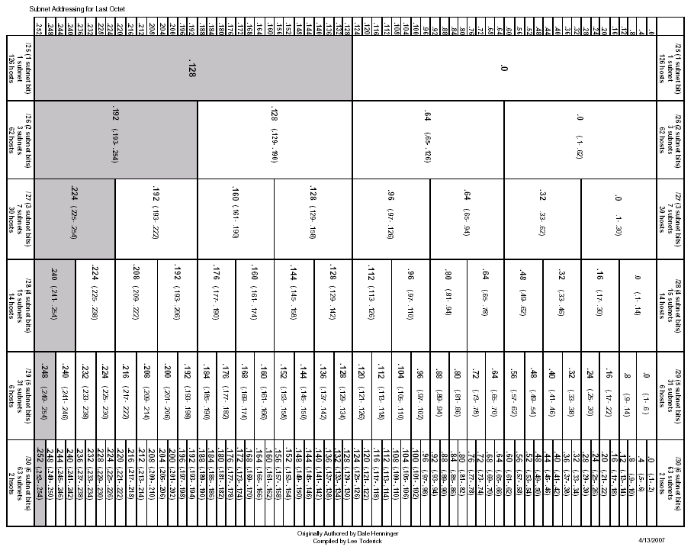
Appendix 1: Last Octet Subnet Chart
Appendix 2: Creating a Router Console Session using HyperTerminal
Task 1: Connect a Router and Computer with a Console Cable
Step 1: Set up a basic physical connection.
Connect the console (rollover) cable to the console port on the router. Connect the other cable end to the host computer with a DB-9 or DB-25 adapter to the COM 1 port.
Step 2: Power on devices.
If not already powered on, enable power to the computer and router.
Task 2: Configure HyperTerminal to Establish a Console Session with a Cisco IOS Router
Step 1: Start the HyperTerminal application.
Start the HyperTerminal program by clicking Start > Programs > Accessories > Communications > HyperTerminal.
Step 2: Configure HyperTerminal.
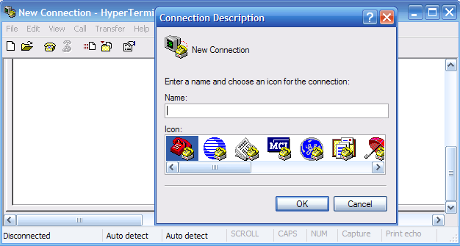
Figure 3. HyperTerminal Name Configuration Window
In the Connection Description window, enter a session name in the Name field. Select an appropriate icon, or keep the default. Click OK.
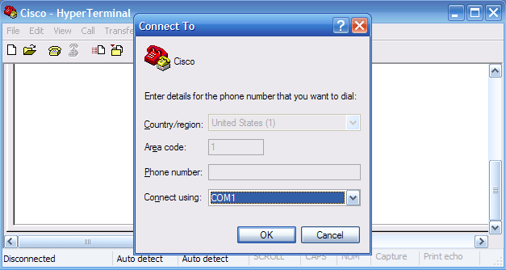
Figure 4. HyperTerminal Connection Type
Enter COM 1 in the Connect Using field, and then click OK. (Depending upon the PC you are using, it may be necessary to use a different COM port. If COM1 does not work, then systematically try the additional COM ports until you are successful.)
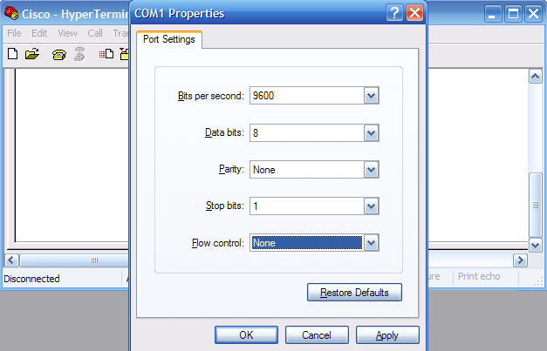
Figure 5. HyperTerminal COM1 Port Settings
As shown in Figure 3, change port settings to the following values, and then click OK:

Setting | Value
Bits per second | 9600
Data bits | 8
Parity | None
Stop bits | 1
Flow control | None

When the HyperTerminal session window appears, press Enter. There should be a response from the router. This indicates that the connection has been successfully completed. If there is no connection, troubleshoot as necessary. For example, verify that the router has power. Check the connection to the COM 1 port on the PC and the console port on the router. If there is still no connection, ask the instructor for assistance.
Step 3: Close HyperTerminal.
When finished, close the HyperTerminal session by choosing File > Exit. When asked whether to save the session, click Yes. Enter a name for the session.
Step 4: Reconnect the HyperTerminal session.
Reopen the HyperTerminal session as described in Task 2, Step 1. This time, when the Connection Description window appears (see Figure 3), click Cancel.
Choose File > Open. Select the saved session and then click Open. Use this step to reconnect the HyperTerminal session to a Cisco device without reconfiguring a new session.
When finished, exit HyperTerminal.

