Lab 1.3.2: Review of Concepts from Exploration 1 - Challenge

Topology Diagram

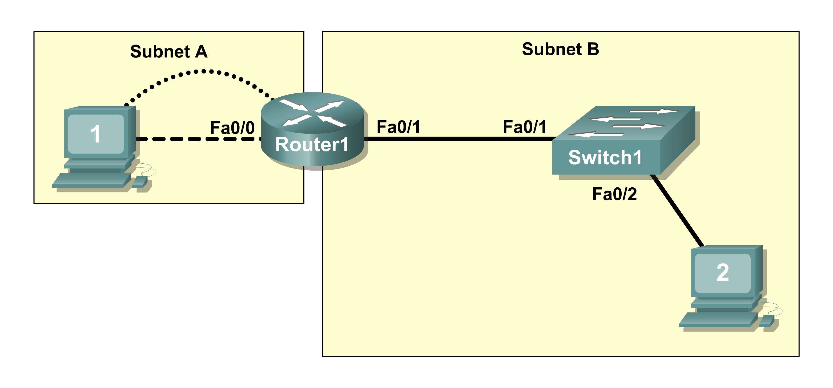

Learning Objectives
Upon completion of this lab, you will be able to:
- Create a logical topology given network requirements
- Create subnets to meet host requirements
- Configure the physical topology
- Configure the logical topology
- Verify network connectivity
- Configure and verify passwords

Scenario
In this lab, you will design and configure a small routed network and verify connectivity across multiple network devices. This requires creating and assigning two subnetwork blocks, connecting hosts and network devices, and configuring host computers and one Cisco router for basic network connectivity. Switch1 has a default configuration and does not require additional configuration. You will use common commands to test and document the network. The zero subnet is used.
Task 1: Design a Logical LAN Topology
Step 1: Design an IP addressing scheme.
Given the IP address block of 192.168.30.0 /27, design an IP addressing scheme that satisfies the following requirements:

Subnet | Number of Hosts
Subnet A | 7
Subnet B | 14

The 0 subnet is used. No subnet calculators may be used. Create the smallest possible number of subnets that satisfy the requirements for hosts. Assign the first usable subnet to Subnet A.

Subnet A
Specification | Student Input
Number of bits in the subnet
IP mask (binary)
New IP mask (decimal)
Maximum number of usable subnets (including the 0 subnet)
Number of usable hosts per subnet
IP subnetwork address
First IP host address
Last IP host address

Subnet B
Specification | Student Input
Number of bits in the subnet
IP mask (binary)
New IP mask (decimal)
Maximum number of usable subnets (including the 0 subnet)
Number of usable hosts per subnet
IP subnetwork address
First IP host address
Last IP host address

Host computers will use the first usable IP address in the subnet. The network router will use the last usable IP address in the subnet.
Step 2: Write down the IP address information for each device.

Device | IP address | Mask | Gateway
Host1
Router1-Fa0/0
Host2
Router1-Fa0/1

Before proceeding, verify your IP addresses with the instructor.
Task 2: Configure the Physical Topology
Step 1: Determine cabling requirements.
Referring to Figure 1, identify each cable type required and document it in the table.
Correct Cabling | Cable Type
LAN cable between Host1 and Router1 Fa0/0
LAN cable between Switch1 and Router1 Fa0/1
LAN cable between Switch1 and Host2
Console cable between Host1 and Router1

Figure 1. Cabling the network.

Step 2. Physically connect lab devices.
Cable the network devices as shown in Figure 1. Turn power on to all devices if it is not already on.
Step 3: Inspect the network connections.
After cabling the network devices, verify the connections..
Task 3: Configure the Logical Topology
Step 1: Configure the host computers.
Configure the static IP address, subnet mask, and gateway for each host computer. After configuring each host computer, display and verify the host network settings with the ipconfig /all command.

Host1 Network Configuration
Physical address
IP address
Subnet mask
Default gateway

Host2 Network Configuration
Physical address
IP address
Subnet mask
Default gateway
Step 2: Configure Router1.
From Host1, connect to the console of Router 1 and configure the following:

Task | Specification
Router name | Router1
Encrypted privileged exec password | class
Console access password | cisco
Telnet access password | cisco
Router1 interface Fa0/0 | Set the description  Set the Layer 3 address
Router1 interface Fa0/1 | Set the description  Set the Layer 3 address

Task 4: Verify Network Connectivity
Step 1: Use the ping command to verify network connectivity.
You can verify network connectivity using the ping command.
Note: If pings to the host computers fail, verify the existence of a firewall program running on the hosts. If a firewall is running on the host temporarily disable it and retest. To disable a Windows firewall, select Start > Control Panel > Windows Firewall, select OFF, and then OK.
Use the following table to verify connectivity with each network device. Take corrective action to establish connectivity if a test fails.

From | To | IP Address | Ping Results
Host1 | NIC IP address
Host1 | Router1, Fa0/0
Host1 | Router1, Fa0/1
Host1 | Host2
Host2 | NIC IP address
Host2 | Router1, Fa0/1
Host2 | Router1, Fa0/0
Host2 | Host1

In addition to the ping command, what other Windows command is useful in displaying network delay and breaks in the path to the destination?________________________________________________
Task 5: Verify Passwords
Step 1: Telnet to the router from Host2 and verify the Telnet password.
You should be able to telnet to either Fast Ethernet interface of the router.
Step 2: Verify that the enable secret password has been set.
From the Telnet session, enter privilege exec mode and verify that it is password protected.
Step 3: Verify that the console is password protected.
Terminate and then re-establish the console connection from Host1 to the router to verify that the console is password protected.
Depending on the Telnet client that you are using, the session can usually be terminated with Ctrl-].
Task 6: Clean Up
Unless directed otherwise by your instructor, erase the configurations and reload the switches. Disconnect and store the cabling. For PC hosts that are normally connected to other networks (such as the school LAN or to the Internet), reconnect the appropriate cabling and restore the TCP/IP settings.

