Lab 4.4.1: Basic VTP Configuration

Topology Diagram

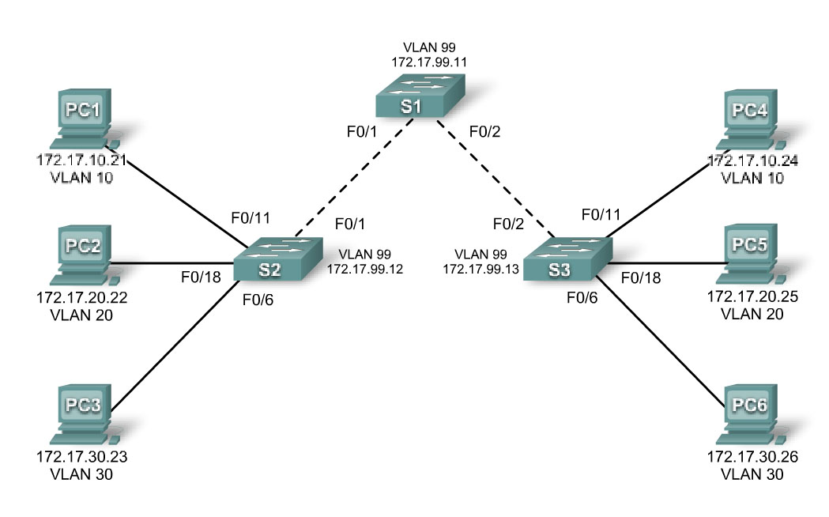

Addressing Table
Device  (Hostname) | Interface | IP Address | Subnet Mask | Default Gateway
S1 | VLAN 99 | 172.17.99.11 | 255.255.255.0 | N/A
S2 | VLAN 99 | 172.17.99.12 | 255.255.255.0 | N/A
S3 | VLAN 99 | 172.17.99.13 | 255.255.255.0 | N/A
PC1 | NIC | 172.17.10.21 | 255.255.255.0 | 172.17.10.1
PC2 | NIC | 172.17.20.22 | 255.255.255.0 | 172.17.20.1
PC3 | NIC | 172.17.30.23 | 255.255.255.0 | 172.17.30.1
PC4 | NIC | 172.17.10.24 | 255.255.255.0 | 172.17.10.1
PC5 | NIC | 172.17.20.25 | 255.255.255.0 | 172.17.20.1
PC6 | NIC | 172.17.30.26 | 255.255.255.0 | 172.17.30.1

Port Assignments (Switches 2 and 3)
Ports | Assignment | Network
Fa0/1 – 0/5 | 802.1q Trunks (Native VLAN 99) | 172.17.99.0 /24
Fa0/6 – 0/10 | VLAN 30 – Guest (Default) | 172.17.30.0 /24
Fa0/11 – 0/17 | VLAN 10 – Faculty/Staff | 172.17.10.0 /24
Fa0/18 – 0/24 | VLAN 20 – Students | 172.17.20.0 /24

Learning Objectives
Upon completion of this lab, you will be able to:
- Cable a network according to the topology diagram
- Erase the startup configuration and reload a switch to the default state
- Perform basic configuration tasks on a switch
- Configure VLAN Trunking Protocol (VTP) on all switches
- Enable trunking on inter-switch connections
- Verify trunk configuration
- Modify VTP modes and observe the impact
- Create VLANs on the VTP server, and distribute this VLAN information to switches in the network
- Explain the differences in operation between VTP transparent mode, server mode, and client mode
- Assign switch ports to the VLANs
- Save the VLAN configuration
- Enable VTP pruning on the network
- Explain how pruning reduces unnecessary broadcast traffic on the LAN

Task 1: Prepare the Network
Step 1: Cable a network that is similar to the one in the topology diagram.
You can use any current switch in your lab as long as it has the required interfaces shown in the topology. The output shown in this lab is based on 2960 switches. Other switch types may produce different output. If you are using older switches, then some commands may be different or unavailable.
You will notice in the Addressing Table that the PCs have been configured with a default gateway IP address. This would be the IP address of the local router which is not included in this lab scenario. The default gateway, the router would be needed for PCs in different VLANS to be able to communicate. This is discussed in a later chapter.
Set up console connections to all three switches.
Step 2: Clear any existing configurations on the switches.
If necessary, refer to Lab 2.5.1, Appendix 1, for the procedure to clear switch configurations and VLANs. Use the show vlan command to confirm that only default VLANs exist and that all ports are assigned to VLAN 1.

Switch#show vlan

VLAN Name Status Ports
---- -------------------------------- --------- -----------------------------
1 default active Fa0/1, Fa0/2, Fa0/3, Fa0/4
Fa0/5, Fa0/6, Fa0/7, Fa0/8
Fa0/9, Fa0/10, Fa0/11, Fa0/12
Fa0/13, Fa0/14, Fa0/15,Fa0/16
Fa0/17, Fa0/18, Fa0/19,Fa0/20
Fa0/21, Fa0/22, Fa0/23,Fa0/24
Gig1/1, Gig1/2
1002 fddi-default active
1003 token-ring-default active
1004 fddinet-default active
1005 trnet-default active

Step 3: Disable all ports by using the shutdown command.
Repeat these commands for each switch in the topology.
Switch(config)#interface range fa0/1-24
Switch(config-if-range)#shutdown
Switch(config-if-range)#interface range gi0/1-2
Switch(config-if-range)#shutdown
Task 2: Perform Basic Switch Configurations
Step 1: Complete basic configuration of switches S1, S2, and S3.
Configure the S1, S2, and S3 switches according to the following guidelines and save all your configurations:
- Configure the switch hostname as indicated on the topology.
- Disable DNS lookup.
- Configure an EXEC mode password of class.
- Configure a password of cisco for console connections.
- Configure a password of cisco for vty connections.
(Output for S1 shown)
Switch>enable
Switch#configure terminal
Enter configuration commands, one per line. End with CNTL/Z.
Switch(config)#hostname S1
S1(config)#enable secret class
S1(config)#no ip domain-lookup
S1(config)#line console 0
S1(config-line)#password cisco
S1(config-line)#login
S1(config-line)#line vty 0 15
S1(config-line)#password cisco
S1(config-line)#login
S1(config-line)#end
%SYS-5-CONFIG_I: Configured from console by console
S1#copy running-config startup-config
Destination filename [startup-config]?
Building configuration...
[OK]
Step 2: Re-enable the user ports on S2 and S3.
Configure the user ports in access mode. Refer to the topology diagram to determine which ports are connected to end-user devices.
S2(config)#interface fa0/6
S2(config-if)#switchport mode access
S2(config-if)#no shutdown
S2(config-if)#interface fa0/11
S2(config-if)#switchport mode access
S2(config-if)#no shutdown
S2(config-if)#interface fa0/18
S2(config-if)#switchport mode access
S2(config-if)#no shutdown

S3(config)#interface fa0/6
S3(config-if)#switchport mode access
S3(config-if)#no shutdown
S3(config-if)#interface fa0/11
S3(config-if)#switchport mode access
S3(config-if)#no shutdown
S3(config-if)#interface fa0/18
S3(config-if)#switchport mode access
S3(config-if)#no shutdown
Step 3: Re-enable the trunk ports on S1, S2 and S3
S1(config)#interface fa0/1 S1(config-if)#no shutdown S1(config)#interface fa0/2 S1(config-if)#no shutdown

S2(config)#interface fa0/1 S2(config-if)#no shutdown

S3(config)#interface fa0/2 S3(config-if)#no shutdown
Task 3: Configure the Ethernet Interfaces on the Host PCs
Configure the Ethernet interfaces of PC1, PC2, PC3, PC4, PC5, and PC6 with the IP addresses and default gateways indicated in the addressing table at the beginning of the lab.
Verify that PC1 can ping PC4, PC2 can ping PC5, and that PC3 can ping PC6.
Task 4: Configure VTP on the Switches
VTP allows the network administrator to control the instances of VLANs on the network by creating VTP domains. Within each VTP domain, one or more switches are configured as VTP servers. VLANs are then created on the VTP server and pushed to the other switches in the domain. Common VTP configuration tasks are setting the operating mode, domain, and password. In this lab, you will be using S1 as the VTP server, with S2 and S3 configured as VTP clients or in VTP transparent mode.
Step 1: Check the current VTP settings on the three switches.
S1#show vtp status
VTP Version : 2
Configuration Revision : 0
Maximum VLANs supported locally : 255
Number of existing VLANs : 5
VTP Operating Mode : Server
VTP Domain Name :
VTP Pruning Mode : Disabled
VTP V2 Mode : Disabled
VTP Traps Generation : Disabled
MD5 digest : 0x57 0xCD 0x40 0x65 0x63 0x59 0x47 0xBD
Configuration last modified by 0.0.0.0 at 0-0-00 00:00:00
Local updater ID is 0.0.0.0 (no valid interface found)
S2#show vtp status
VTP Version : 2
Configuration Revision : 0
Maximum VLANs supported locally : 255
Number of existing VLANs : 5
VTP Operating Mode : Server
VTP Domain Name :
VTP Pruning Mode : Disabled
VTP V2 Mode : Disabled
VTP Traps Generation : Disabled
MD5 digest : 0x57 0xCD 0x40 0x65 0x63 0x59 0x47 0xBD
Configuration last modified by 0.0.0.0 at 0-0-00 00:00:00
Local updater ID is 0.0.0.0 (no valid interface found)

S3#show vtp status
VTP Version : 2
Configuration Revision : 0
Maximum VLANs supported locally : 255
Number of existing VLANs : 5
VTP Operating Mode : Server
VTP Domain Name :
VTP Pruning Mode : Disabled
VTP V2 Mode : Disabled
VTP Traps Generation : Disabled
MD5 digest : 0x57 0xCD 0x40 0x65 0x63 0x59 0x47 0xBD
Configuration last modified by 0.0.0.0 at 0-0-00 00:00:00
Note that all three switches are in server mode. Server mode is the default VTP mode for most Catalyst switches.
Step 2: Configure the operating mode, domain name, and VTP password on all three switches.
Set the VTP domain name to Lab4 and the VTP password to cisco on all three switches. Configure S1 in server mode, S2 in client mode, and S3 in transparent mode.
S1(config)#vtp mode server
Device mode already VTP SERVER.
S1(config)#vtp domain Lab4
Changing VTP domain name from NULL to Lab4
S1(config)#vtp password cisco
Setting device VLAN database password to cisco
S1(config)#end

S2(config)#vtp mode client
Setting device to VTP CLIENT mode
S2(config)#vtp domain Lab4
Changing VTP domain name from NULL to Lab4
S2(config)#vtp password cisco
Setting device VLAN database password to cisco
S2(config)#end

S3(config)#vtp mode transparent
Setting device to VTP TRANSPARENT mode.
S3(config)#vtp domain Lab4
Changing VTP domain name from NULL to Lab4
S3(config)#vtp password cisco
Setting device VLAN database password to cisco
S3(config)#end

Note: The VTP domain name can be learned by a client switch from a server switch, but only if the client switch domain is in the null state. It does not learn a new name if one has been previously set. For that reason, it is good practice to manually configure the domain name on all switches to ensure that the domain name is configured correctly. Switches in different VTP domains do not exchange VLAN information.
Step 3: Configure trunking and the native VLAN for the trunking ports on all three switches.
Use the interface range command in global configuration mode to simplify this task.
S1(config)#interface range fa0/1-5
S1(config-if-range)#switchport mode trunk
S1(config-if-range)#switchport trunk native vlan 99
S1(config-if-range)#no shutdown
S1(config-if-range)#end
S2(config)# interface range fa0/1-5
S2(config-if-range)#switchport mode trunk
S2(config-if-range)#switchport trunk native vlan 99
S2(config-if-range)#no shutdown
S2(config-if-range)#end
S3(config)# interface range fa0/1-5
S3(config-if-range)#switchport mode trunk
S3(config-if-range)#switchport trunk native vlan 99
S3(config-if-range)#no shutdown
S3(config-if-range)#end
Step 4: Configure port security on the S2 and S3 access layer switches.
Configure ports fa0/6, fa0/11, and fa0/18 so that they allow only a single host and learn the MAC address of the host dynamically.
S2(config)#interface fa0/6
S2(config-if)#switchport port-security
S2(config-if)#switchport port-security maximum 1
S2(config-if)#switchport port-security mac-address sticky
S2(config-if)#interface fa0/11
S2(config-if)#switchport port-security
S2(config-if)#switchport port-security maximum 1
S2(config-if)#switchport port-security mac-address sticky
S2(config-if)#interface fa0/18
S2(config-if)#switchport port-security
S2(config-if)#switchport port-security maximum 1
S2(config-if)#switchport port-security mac-address sticky
S2(config-if)#end

S3(config)#interface fa0/6
S3(config-if)#switchport port-security
S3(config-if)#switchport port-security maximum 1
S3(config-if)#switchport port-security mac-address sticky
S3(config-if)#interface fa0/11
S3(config-if)#switchport port-security
S3(config-if)#switchport port-security maximum 1
S3(config-if)#switchport port-security mac-address sticky
S3(config-if)#interface fa0/18
S3(config-if)#switchport port-security
S3(config-if)#switchport port-security maximum 1
S3(config-if)#switchport port-security mac-address sticky
S3(config-if)#end
Step 5: Configure VLANs on the VTP server.
There are four additional VLANS required in this lab:
- VLAN 99 (management)
- VLAN 10 (faculty/staff)
- VLAN 20 (students)
- VLAN 30 (guest)
Configure these on the VTP server.
S1(config)#vlan 99
S1(config-vlan)#name management
S1(config-vlan)#exit
S1(config)#vlan 10
S1(config-vlan)#name faculty/staff
S1(config-vlan)#exit
S1(config)#vlan 20
S1(config-vlan)#name students
S1(config-vlan)#exit
S1(config)#vlan 30
S1(config-vlan)#name guest
S1(config-vlan)#exit

Verify that the VLANs have been created on S1 with the show vlan brief command.
Step 6: Check if the VLANs created on S1 have been distributed to S2 and S3.
Use the show vlan brief command on S2 and S3 to determine if the VTP server has pushed its VLAN configuration to all the switches.
S2#show vlan brief
VLAN Name Status Ports
---- -------------------------------- --------- -----------------------------
1 default active Fa0/1, Fa0/2, Fa0/4, Fa0/5
Fa0/6, Fa0/7, Fa0/8, Fa0/9
Fa0/10, Fa0/11, Fa0/12,Fa0/13
Fa0/14, Fa0/15, Fa0/16,Fa0/17
Fa0/18, Fa0/19, Fa0/20,Fa0/21
Fa0/22, Fa0/23, Fa0/24, Gi0/1
Gi0/2
10 faculty/staff active
20 students active
30 guest active
99 management active

S3#show vlan brief

VLAN Name Status Ports
---- -------------------------------- --------- -----------------------------
1 default active Fa0/1, Fa0/2, Fa0/4, Fa0/5
Fa0/6, Fa0/7, Fa0/8, Fa0/9
Fa0/10, Fa0/11, Fa0/12,Fa0/13
Fa0/14, Fa0/15, Fa0/16,Fa0/17
Fa0/18, Fa0/19, Fa0/20,Fa0/21
Fa0/22, Fa0/23, Fa0/24, Gi0/1
Gi0/2
1002 fddi-default act/unsup
1003 token-ring-default act/unsup
1004 fddinet-default act/unsup
1005 trnet-default act/unsup

Are the same VLANs configured on all switches? ________________________
Explain why S2 and S3 have different VLAN configurations at this point. __________________________
____________________________________________________________________________________
____________________________________________________________________________________

Step 7: Create a new VLAN on switch 2 and 3.
S2(config)#vlan 88
%VTP VLAN configuration not allowed when device is in CLIENT mode.

S3(config)#vlan 88
S3(config-vlan)#name test
S3(config-vlan)#

Why are you prevented from creating a new VLAN on S2 but not S3? ____________________________
____________________________________________________________________________________

Delete VLAN 88 from S3.
S3(config)#no vlan 88
Step 8: Manually configure VLANs.
Configure the four VLANs identified in Step 5 on switch S3.
S3(config)#vlan 99
S3(config-vlan)#name management
S3(config-vlan)#exit
S3(config)#vlan 10
S3(config-vlan)#name faculty/staff
S3(config-vlan)#exit
S3(config)#vlan 20
S3(config-vlan)#name students
S3(config-vlan)#exit
S3(config)#vlan 30
S3(config-vlan)#name guest
S3(config-vlan)#exit
Here you see one of the advantages of VTP. Manual configuration is tedious and error prone, and any error introduced here could prevent intra-VLAN communication. In addition, these types of errors can be difficult to troubleshoot.
Step 9: Configure the management interface address on all three switches.
S1(config)#interface vlan 99
S1(config-if)#ip address 172.17.99.11 255.255.255.0
S1(config-if)#no shutdown
S2(config)#interface vlan 99
S2(config-if)#ip address 172.17.99.12 255.255.255.0
S2(config-if)#no shutdown
S3(config)#interface vlan 99
S3(config-if)#ip address 172.17.99.13 255.255.255.0
S3(config-if)#no shutdown
Verify that the switches are correctly configured by pinging between them. From S1, ping the management interface on S2 and S3. From S2, ping the management interface on S3.
Were the pings successful? ___________________________________________
If not, troubleshoot the switch configurations and try again.
Step 10: Assign switch ports to VLANs.
Refer to the port assignment table at the beginning of the lab to assign ports to the VLANs. Use the interface range command to simplify this task. Port assignments are not configured through VTP. Port assignments must be configured on each switch manually or dynamically using a VMPS server. The commands are shown for S3 only, but both S2 and S1 switches should be similarly configured. Save the configuration when you are done.
S3(config)#interface range fa0/6-10
S3(config-if-range)#switchport access vlan 30
S3(config-if-range)#interface range fa0/11-17
S3(config-if-range)#switchport access vlan 10
S3(config-if-range)#interface range fa0/18-24
S3(config-if-range)#switchport access vlan 20
S3(config-if-range)#end
S3#copy running-config startup-config
Destination filename [startup-config]? [enter]
Building configuration...
[OK]
S3#
Task 5: Configure VTP Pruning on the Switches
VTP pruning allows a VTP server to suppress IP broadcast traffic for specific VLANs to switches that do not have any ports in that VLAN. By default, all unknown unicasts and broadcasts in a VLAN are flooded over the entire VLAN. All switches in the network receive all broadcasts, even in situations in which few users are connected in that VLAN. VTP pruning is used to eliminate or prune this unnecessary traffic. Pruning saves LAN bandwidth because broadcasts do not have to be sent to switches that do not need them.
Pruning is configured on the server switch with the vtp pruning command in global configuration mode. The configuration is pushed to client switches.
Confirm VTP pruning configuration on each switch using the show vtp status command. VTP pruning mode should be enabled on each switch.
S1#show vtp status
VTP Version : 2
Configuration Revision : 17
Maximum VLANs supported locally : 255
Number of existing VLANs : 9
VTP Operating Mode : Server
VTP Domain Name : Lab4
VTP Pruning Mode : Enabled
<output omitted>
Task 6: Clean Up
Erase the configurations and reload the switches. Disconnect and store the cabling. For PC hosts that are normally connected to other networks (such as the school LAN or to the Internet), reconnect the appropriate cabling and restore the TCP/IP settings.

