Lab 6.4.2: Challenge Inter-VLAN Routing

Topology Diagram

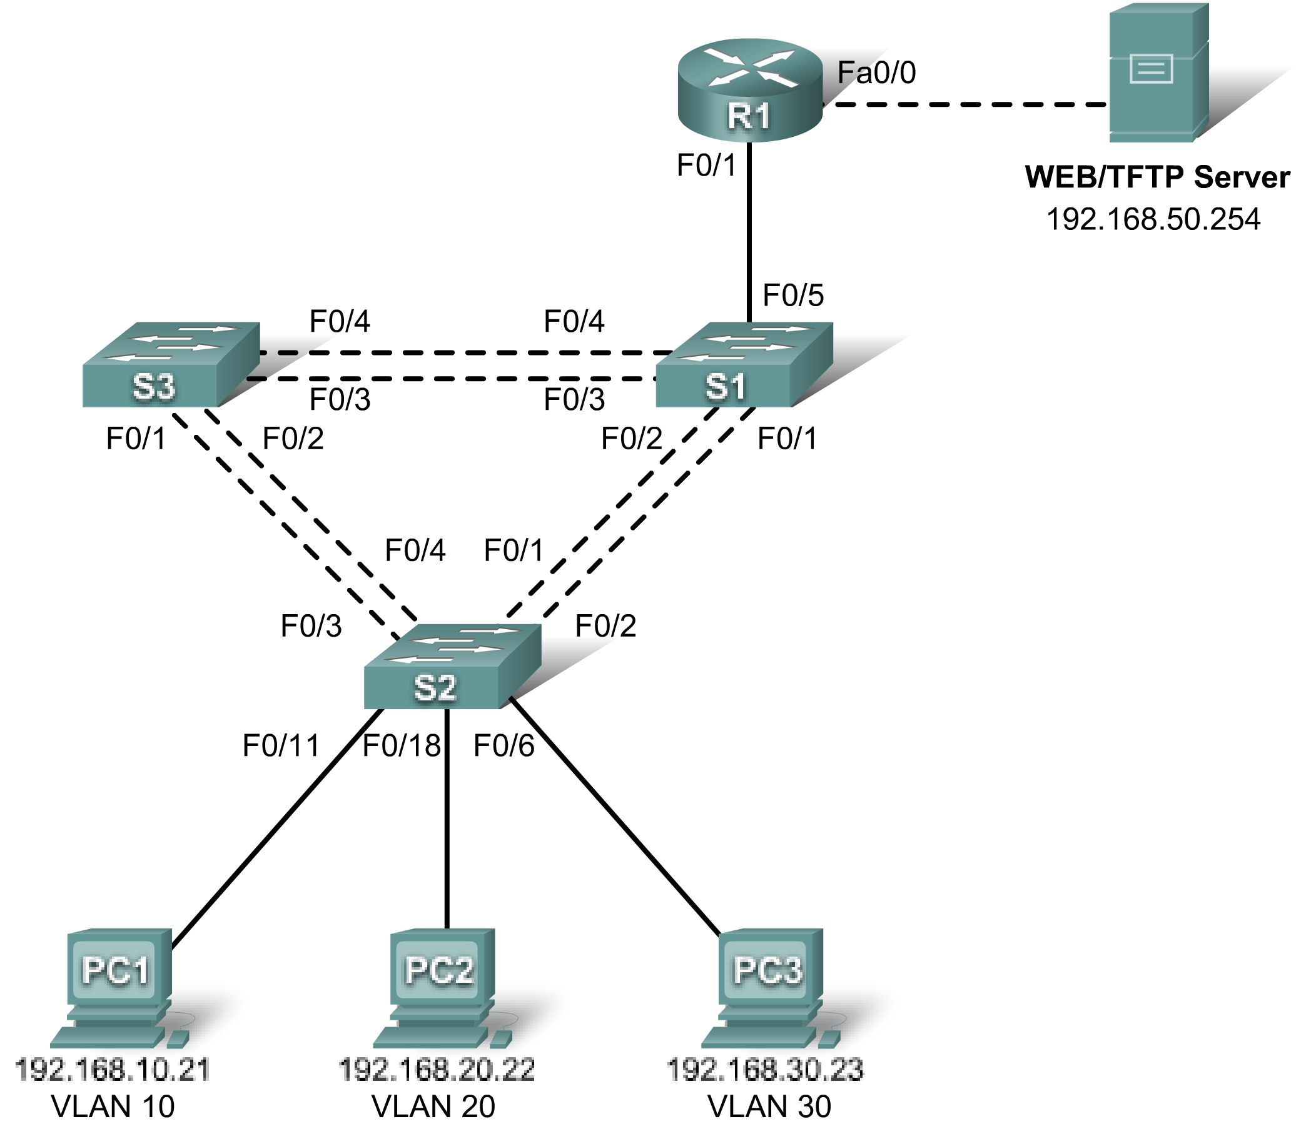

Addressing Table
Device  (Hostname) | Interface | IP Address | Subnet Mask | Default Gateway
S1 | VLAN 99 | 192.168.99.11 | 255.255.255.0 | 192.168.99.1
S2 | VLAN 99 | 192.168.99.12 | 255.255.255.0 | 192.168.99.1
S3 | VLAN 99 | 192.168.99.13 | 255.255.255.0 | 192.168.99.1
R1 | Fa 0/0 | 192.168.50.1 | 255.255.255.0 | N/A
R1 | Fa 0/1 | See Subinterface Configuration Table |  | N/A
PC1 | NIC | 192.168.10.21 | 255.255.255.0 | 192.168.10.1
PC2 | NIC | 192.168.20.22 | 255.255.255.0 | 192.168.20.1
PC3 | NIC | 192.168.30.23 | 255.255.255.0 | 192.168.30.1
Server | NIC | 192.168.50.254 | 255.255.255.0 | 192.168.50.1

Port Assignments – Switch 2
Ports | Assignment | Network
Fa0/1 – 0/5 | 802.1q Trunks (Native VLAN 99) | 192.168.99.0 /24
Fa0/6 – 0/10 | VLAN 30 – Sales | 192.168.30.0 /24
Fa0/11 – 0/17 | VLAN 10 – R&D | 192.168.10.0 /24
Fa0/18 – 0/24 | VLAN 20 – Engineering | 192.168.20.0 /24

Subinterface Configuration Table – Router 1
Router Interface | Assignment | IP Address
Fa0/1.1 | VLAN1 | 192.168.1.1
Fa0/1.10 | VLAN 10 | 192.168.10.1
Fa0/1.20 | VLAN 20 | 192.168.20.1
Fa0/1.30 | VLAN 30 | 192.168.30.1
Fa0/1.99 | VLAN 99 | 192.168.99.1

Learning Objectives
Upon completion of this lab, you will be able to to:
- Cable a network according to the topology diagram
- Clear configurations and reload a switch and a router to the default state
- Perform basic configuration tasks on a switched LAN and a router
- Configure VLANs and VLAN Trunking Protocol (VTP) on all switches
- Configure a router to support 802.1q trunking on a Fast Ethernet interface
- Configure a router with subinterfaces corresponding to the configured VLANs
- Demonstrate inter-VLAN routing
Task 1: Prepare the Network
Step 1: Cable a network that is similar to the one in the topology diagram.
The output shown in this lab is based on 2960 switches and an 1841 router. You can use any current switches or routers in your lab as long as they have the required interfaces shown in the topology diagram. Other device types may produce different output. Note that Ethernet (10Mb) LAN interfaces on routers do not support trunking, and Cisco IOS software earlier than version 12.3 may not support trunking on Fast Ethernet router interfaces.
Set up console connections to all three switches and to the router.
Step 2: Clear any existing configurations on the switches.
Clear NVRAM, delete the vlan.dat file and reload the switches. Refer to Lab 2.2.1 if necessary for the procedure. After the reload is complete, use the show vlan command to confirm that only default VLANs exist and that all ports are assigned to VLAN 1.

Step 3: Disable all ports using the shutdown command.
Ensure that the initial switch port states are inactive by disabling all ports. Use the interface-range command to simplify this task. Remember to repeat the process on each switch in the topology.
Task 2: Perform Basic Switch Configurations
Step 1: Configure the S1, S2, and S3 switches.
Use the addressing table and the following guidelines:
- Configure the switch hostname.
- Disable DNS lookup.
- Configure an EXEC mode password of class.
- Configure a password of cisco for console connections.
- Configure a password of cisco for vty connections.
- Configure the default gateway on each switch.
Step 2: Re-enable the active user ports on S2 in access mode.
Enable ports Fa0/6, Fa0/11, and Fa0/18 on S2 using the no shutdown command, and configure them as access ports.
Task 3: Configure the Ethernet Interfaces on the Server and Host PCs
Configure the Ethernet interfaces of PC1, PC2, PC3 and the remote TFTP/Web Server with the IP addresses from the addressing table. Connect these devices using the correct cables and interfaces.
Task 4: Configure VTP on the Switches
Step 1: Configure VTP on the three switches.
Use the following table to configure the switches. Remember that VTP domain names and passwords are case-sensitive.
Switch Name | VTP Operating Mode | VTP Domain | VTP Password
S1 | Server | Lab6 | cisco
S2 | Client | Lab6 | cisco
S3 | Client | Lab6 | cisco

Step 2: Configure trunking ports and designate the native VLAN for the trunks.
Configure Fa0/1 through Fa0/5 as trunking ports, and designate VLAN 99 as the native VLAN for these trunks. Use the interface range command in global configuration mode to simplify this task.
Step 3: Configure VLANs on the VTP server.
Configure the following VLANS on the VTP server.
VLAN | VLAN Name
VLAN 99 | Management
VLAN 10 | R&D
VLAN 20 | Engineering
VLAN 30 | Sales

Verify that the VLANs have been created on S1 with the show vlan brief command.
Step 4: Verify that the VLANs created on S1 have been distributed to S2 and S3.
Use the show vlan brief command on S2 and S3 to verify that the four VLANs have been distributed to the client switches.
Step 5: Configure the Management interface address on all three switches.
Refer to the addressing table at the beginning of the lab to assign the management IP address on all three switches.
Verify that the switches are correctly configured by pinging between them. From S1, ping the Management interface on S2 and S3. From S2, ping the Management interface on S3.
Were the pings successful? ________________________________
If not, troubleshoot the switch configurations and resolve.
Step 6: Assign switch ports to VLANs on S2.
Refer to the port assignment table at the beginning of the lab to assign ports to VLANs on S2.
Step 7: Check connectivity between VLANs.
Open command windows on the three hosts connected to S2. Ping from PC1 (192.168.10.21) to PC2 (192.168.20.22). Ping from PC2 to PC3 (192.168.30.23).
Are the pings successful? __________________________________________________
If not, why do these pings fail?

Task 5: Configure the Router
Step 1: Clear the configuration on the router and reload.
Step 2: Create a basic configuration on the router.
- Configure the router with hostname R1.
- Disable DNS lookup.
- Configure an EXEC mode password of class.
- Configure a password of cisco for console connections.
- Configure a password of cisco for vty connections.
Step 3: Configure the trunking interface on R1.
Configure the Fa0/1 interface on R1 with five subinterfaces, one for each VLAN identified in the Subinterface Configuration Table at the beginning of the lab. Configure these subinterfaces with dot1q encapsulation, and use the first address in each VLAN subnet on the router subinterface. Specify VLAN 99 as the native VLAN on its subinterface. Do not assign an IP address to the physical interface, but be sure to enable it. Document your subinterfaces and their respective IP addresses in the subinterface table.
Step 4: Configure the server LAN interface on R1.
Refer to the addressing table and configure Fa0/0 with the correct IP address and mask.
Step 5: Verify the routing configuration.
At this point, there should be six networks configured on R1. Verify that you can route packets to all six by checking the routing table on R1.
If your routing table does not show all six networks, troubleshoot your configuration and resolve the problem before proceeding.
Step 6: Verify inter-VLAN routing
From PC1, verify that you can ping the remote server (192.168.50.254) and the other two hosts (192.168.20.22 and 192.168.30.23). It may take a couple of pings before the end-to-end path is established.
Are the pings successful?
If not, troubleshoot your configuration. Check to make sure the default gateways have been set on all PCs and all switches. If any of the hosts have gone into hibernation, the connected interface may go down.
At this point, you should be able to ping any node on any of the six networks configured on your LAN, including the switch management interfaces.
Task 6: Clean Up
Erase the configurations and reload the switches. Disconnect and store the cabling. For PC hosts that are normally connected to other networks (such as the school LAN or to the Internet), reconnect the appropriate cabling and restore the TCP/IP settings.

