DTEDI Schedule – Spring 2019
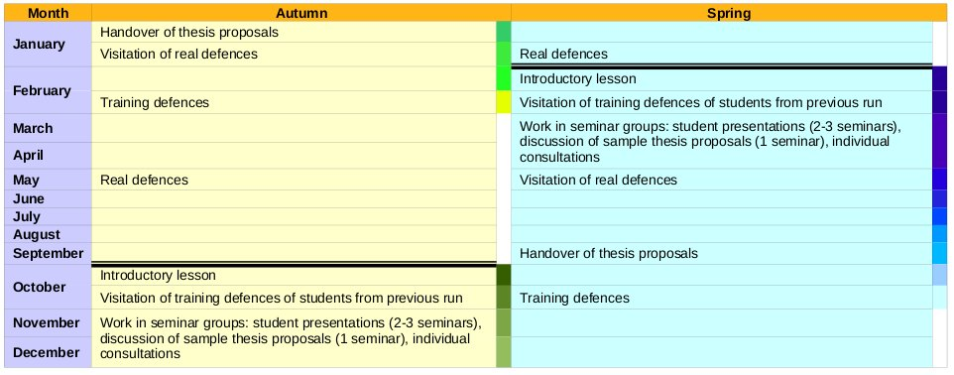
Introductory lesson:
- 6. 3. 2019 12:00 – 14:00, C417
- Introduction, motivation, DTEDI content, thesis proposal guideline, …
- Formal requirements (Ada Nazarejová)
- Assignment to seminar groups
- Schedule of the semester, plan of students introductory presentations

Training defenses of students from previous semester:
- You are welcome to attend training defenses of your colleagues from previous run and became a member of “scientific committee” for this moment.
- Schedule:
  - 02. 05. 2019 14:00 – 16:00, C417: Presentation of ...
  - 09. 05. 2019 14:00 – 16:00, C417: Presentation of …
  - 16. 05. 2019 14:00 – 16:00, C417: Presentation of ...

Habilitation talks (voluntarily :-)
- 19. 3. 2019 14:00 – 15:00, D2: Radek Ošlejšek: Semantic data modeling – conceptual view
- 23. 4. 2019 14:00 – 15:00, D2: Vojta Řehák:

Work in seminar groups
- Student presentations: Introduction to research topics. 20 min. of presentation + 10 min. of discussion. The goal is to present your research area and PhD activities to the general public.
- Discussion of sample thesis proposals.
- Individual consultations. At any time.
- Schedule:
  - 04. 04. 2019 14:00 – 16:00, C417: Presentation of Klaška, Peschel, Troják, Doležal
  - 25. 04. 2019 14:00 – 16:00, C417: Presentation of Špaček, Tušil, Sedláček, ...

Attendance at real defenses
- Last week of May 2019 (will be specified)
- Attendance at real defenses followed by discussion.

Handover of your thesis proposal
- October 2019

Your training defenses
- will be specified

Enrolled students:
- Milan Doležal
- Ondřej Herman (opak)
- David Klaška
- Henrich Lauko (stáž)
- Michal Měchura (opak)
- Jakub Pešl
- Vladimír Sedláček (stáž)
- Stanislav Špaček
- Matej Troják
- Jan Tušil

