Vulpinic acid inhibits the growth of murine melanoma cells in vitro

Ibrahima H. Q. Ba, Mamadou F. A. Diop, and Babacar G. B. Sall
University Research Hospital of Dakar, Dakar, Senegal

Summary:

We test the effects of vulpinic acid, secondary metabolite of the lichen Letharia vulpina, on the growth of murine melanoma cells in vitro. We find that vulpinic acid is a potent inhibitor of growth. We also find that vulpinic acid increases sensitivity of cells to radiation, and this effect is significant at a radiation intensity lower than the standard intensity of cancer radiotherapy. On the basis of this study, vulpinic acid shows promise for combined-modality cancer treatment.

Introduction:

Reinfection of tissue with cancer cells with acquired radioresistance during treatment is the grand challenge for cancer radiotherapy [1]. For this reason, radiotherapy is applied in combination with chemotherapy. The most effective of chemotherapeutic drug combinations inhibits growth of the cancer cell and also increases sensitivity of cancer cells to radiation. The radiosensitizing effect enhances radiotherapy at low radiation intensity. For this reason, radiotherapy in combination with chemotherapy (combined-modality treatment) is the best standard of care for most cancers [2]. However, the discovery rate of effective anti-cancer drugs is very slow [3]. We must turn to the secondary metabolites of the lichens as a domain of search for such compounds. This study explores the biological activity of vulpinic acid, a secondary metabolite of the lichen Letharia vulpina.

The lichens are a symbiotic assemblage of plant and fungus. Because of this social arrangement, and because of the diversity and the complexity of their ecological niches, the lichens produce so many chemicals for unique colors, signaling between symbionts, manipulation of UV light, and defense against the foragers. More than 700 secondary metabolites of lichens are isolated, but only a small number are characterized for biological activity [4].

Cancer is a complex disease that begins with the uncontrolled growth of the cell. The cancer cell does harm by forming tumors, absorbing tissues, and spreading through the body by metastasis. The highest probability of survival from cancer is with strong inhibition of proliferation of the cancer cells at the beginning of this progression [5].

Therefore, the establishment of the inhibition of proliferation of cancer cells in vitro is the critical first step for drug discovery. In our method to determine the biological activity of vulpinic acid, we test the effect on the growth of murine melanoma cells in vitro. In addition, we test the effect in combination with irradiation with a range of intensity.

Materials and Methods:

Chemicals. The chemical structure of vulpinic acid is shown in FIGURE 1. Pure extracts were dissolved and serially diluted in a 2:1 mixture of ethanol and phosphate buffered saline (EtOH / PBS, pH 7.4). These solutions were added as aliquots of 0.01 ml to 0.99 ml of cell culture to achieve the final concentrations of vulpinic acid: 10 uM, 1 uM, 0.1 uM, 0.01 uM, 0.001 uM, and 0.0001 uM. The control group received 0.01 mL of growth medium.

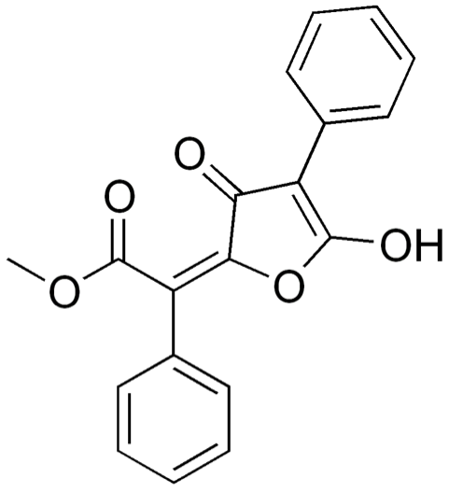
Figure 1. The structure of vulpinic acid.

Cells and cell culture. Murine melanoma cells were grown in Roswell Park Memorial Institute (RPMI) 1640 medium supplemented with 2 mg/ml N-2-hydroxyethylpiperazine-N'-2-ethanesulfonic acid, 100 U/ml penicillin G, 0.1 mg/ml streptomycin, 2 mg/ml sodium bicarbonate, and 5% fetal bovine serum (FBS). Cell cultures were washed with PBS, then treated with 0.2% trypsin/PBS, and then washed with RPMI 1640 medium and centrifuged. The cell pellet was resuspended in RPMI 1640 medium and washed with more medium and the cells were counted. Vulpinic acid solutions were aliquoted to cells in 24-well plates. The treated cells were then cultured in 100-mm plastic tissue-culture dishes at 37 C with 5% CO2 under high humidity. The final cell counts were measured after 5 days growth.

Irradiation. Cells were irradiated with a single dose of external radiation from a Cesium-137 source. Doses in the range of 0.5 to 15 Gy were used. The dose rate was 1 Gy per 4 seconds. A control group received no radiation.

Data analysis. Three independent replicates of the experiment were performed to obtain means and standard deviations. Mean cell counts were normalized to control cells grown in parallel. Significance of differences between treatments were determined by analysis of variance and Student's t-tests using the R statistical package (R Foundation for Statistical Computing, Vienna, Austria). A p-value of <0.01 was accepted as significant.

Results:

Dose-dependent effect of vulpinic acid on the growth of the murine melanoma cell. We cultured the cells in parallel with doses of vulpinic acid at different concentrations. We measured the cell proliferation after 5 days in the logarithmic growth phase.

FIGURE 2 shows the results of the first experiment. All concentrations of vulpinic acid had a similar level of effect. And all concentrations cause a significant inhibition of cell growth compared to the control. Cell growth is inhibited with treatment at the lowest concentration of vulpinic acid (0.0001 uM), which causes 70% slower proliferation compared to the control (p < 0.001).

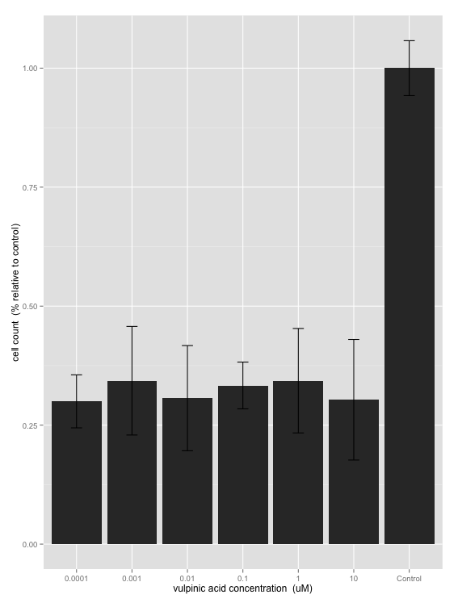
Figure 2. Dose-dependent effect of vulpinic acid on the growth of the murine melanoma cell. The X axis is concentration (uM) vulpinic acid in culture tubes before growth. The Y axis is cell count after 5 days of growth, normalized to cell count of the control. Confidence intervals at 95% are indicated. The difference between 0.0001 uM vulpinic acid treatment and control is significant (p < 0.001).

Effect of vulpinic acid in combination with irradiation on the growth of murine melanoma cells. With the results of the first experiment, we test the lowest concentration vulpinic acid (0.0001 uM) in combination with gamma radiation. We grow the cells identically as the first experiment, but with the following modification. Again, pure extracts were dissolved and serially diluted in a 2:1 mixture of ethanol and phosphate buffered saline (EtOH / PBS, pH 7.4). These solutions were added as aliquots of 0.01 ml to 0.99 ml of cell culture to achieve the final concentration of vulpinic acid (0.0001 uM). The control group received 0.01 mL growth medium and no irradiation.

FIGURE 3 shows the results of the second experiment. Lower than nanomolar concentration of the vulpinic acid powerfully enhances the inhibition effect of radiation on cell growth. This effect is significant at 0.5 Gy, the lowest level of radiation (p = 0.0012).

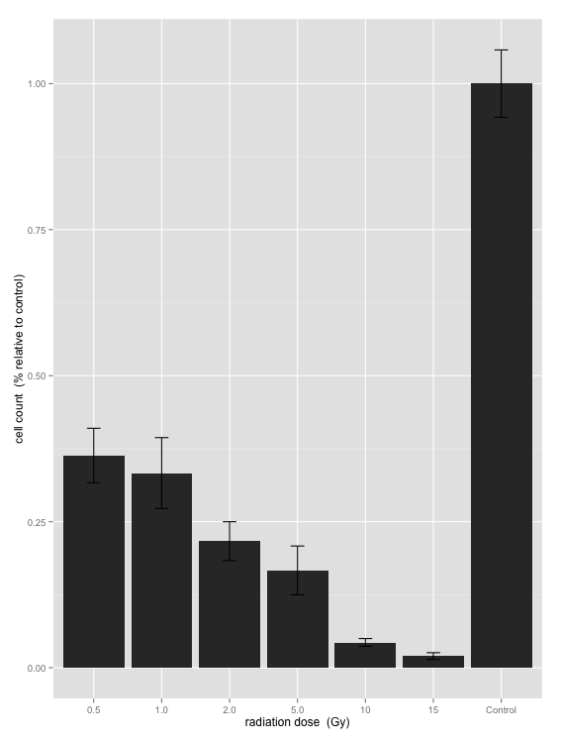
Figure 3. Effect of vulpinic acid in combination with irradiation on the growth of murine melanoma cells. The X axis is intensity (Gy) of radiation. The Y axis is cell count after 5 days of growth, normalized to cell count of the control. Cells were irradiated after treatment with 0.0001 uM vulpinic acid. Confidence intervals at 95% are indicated. The difference between 0.5 Gy and control is significant (p = 0.0012).

Discussion:

In this study, we test the biological activity of vulpinic acid, secondary metabolite of the lichen Letharia vulpina. Specifically we measure the effect on growth of murine melanoma cells in vitro.

Our results show that vulpinic acid inhibits cell growth. The mechanism of action is unknown, but the effect is potent. Even at the lowest dose (0.0001 uM), vulpinic acid has a significant negative effect on cell growth in vitro after 5 days of logarithmic growth compared to the control.

To determine if the inhibition effect interacts with gamma radiation, we test the murine melanoma cell with 0.0001 uM vulpinic acid and a range of radiation intensity. The result proves that vulpinic acid is also a radiosensitizer. Vulpinic acid enhances the inhibition effect of radiation on the growth of cancer. This effect is significant at 0.5 Gy, a radiation dose that is lower than the standard radiation dose in cancer radiotherapy.

We propose the biological activity of vulpinic acid is related to lichen ecology. It is known that lichens are adapted for the manipulation of radiation, and also adapted for defense against the foragers [6]. Therefore, it is not surprising that the secondary metabolites of the lichen can enhance the effect of radiation and inhibit foreign cells.

Our study is the first to demonstrate that vulpinic acid is a radiosensitizer with anti-cancer activity. In the next step, we will prove that vulpinic acid is effective against cancer in animal and human. We conclude that vulpinic acid is a promising new drug for the combined-modality treatment of cancer.

Acknowledgements:

This work was supported by a graduate thesis research grant for I.H.Q.B. We thank H. J. N. Hanno-Boon for help obtaining chemicals and K. N. Arenovai for helpful comments.

References:

1. M. Baumann, M. Krause, and R. Hill. (2008) Exploring the role of cancer stem cells in radioresistance. Nat Rev Cancer, 8, 7: 545-554

2. R. J. Prestwich, D. Shakespeare, and S. Waters. (2007) The rationale and current role of chemoradiotherapy. J. Radiotherapy. Prat. 6: 11-19

3. A. Kamb, S. Wee and C. Lengauer. (2007) Why is cancer drug discovery so difficult? Nat Rev Drug Discovery, 6: 115-120

4. J. Boustie and Grube (2005). Lichens: a promising source of bioactive secondary metabolites. Plant genetic resources: characterization and utilization, 3: 273-287

5. K. Vermeulen, DR Van Bockstaele and ZN Berneman. (2003), The cell cycle: a review of regulation, deregulation and therapeutic targets in cancer. Cell proliferation, 36: 131-149

6. J. D. Lawrey. (1986) Biological Role of Lichen Substances. The Bryologist, 89, 2: 111-122

