Oral Interaction
Dialogue / Conversation / Discussion

1. Social Aspects of Oral Interaction

2. Introducing people

2. Other Aspects of Oral Interaction

3. Presentation Follow-Up Discussion Principles

4. Structure
The following points can make your handling questions more effective. Explain why?

INVITE QUESTIONS

LISTEN CAREFULLY RIGHT TO THE END

WELCOME THE QUESTION

REPEAT, PARAPHRASE, OR CLARIFY IF NECESSARY

TAKE TIME TO THINK BEFORE ANSWERING

ANSWER THE QUESTION RELEVANTLY

CHECK WHETHER THE QUESTIONER IS SATISFIED

5. Functions
It is important to identify a purpose of the question in order to apply an effective strategy for your reaction. What would you do or say if a member of the audience:

1. disagrees with you

2. pays you a compliment

3. questions the accuracy of your sources

4. interrupts you

5. asks for clarification

6. asks an irrelevant question

7. asks for repetition

8. asks for some proof

9. is showing off

10. asks strings of questions

CRITICAL LISTENING and EVALUATION

JOHARI WINDOW
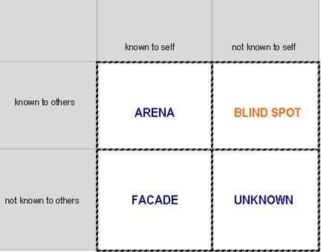

FEEDBACK GIVING & ACCEPTING

FEEDBACK GIVING  • GIVEN ON REQUEST  Feedback is effective when it is given on request. Both ends should agree with feedback giving.  • THE RIGHT TIME AND PLACE  Feedback giving needs at least basic privacy and adequate time – it should never be given in a hurry.  • DESCRIPTION NOT EVALUATION  Feedback describes what a person has done or said, it does not evaluate if it is right or wrong.  • BE CONCRFETE, NOT GENERAL  Concrete observed situation should be described, feedback does not generalise form the particular situation.  • CONSEQUENCES  Feedback summaries all reactions of the people involved and/or consequences of a person’s behaviour in the given situation.  • BALANCE  Positives and negatives should be in balance. | FEEDBACK ACCEPTING  • LISTEN ACTIVELY  It is important to listen carefully and remember (even take notes) the information.  • MAKE SURE YOU UNDERSTAND  Open questions or asking for more examples can help you to clarify unclear and vague information.  • DO NOT DEFEND YOURSELF  There is no need to explain why you have done certain thing the way you have.  • TAKE TIME FOR EVALUATION  It is important to take enough time to think about the information and analyse critically which areas are to be changed and why.  • SAY “THANK YOU”  Honest and well-given feedback is a useful gift that deserves acknowledgement, even if negatives prevailed.

