Karel Vaculik
Mining Graph Data
- Introduction
- Application domains
- Graph Mining Algorithms

Graph: G = (V_{f}E)
- V... set of nodes,
- E Q V x y„. set of edges

■ Graph: G = (V_{f}E)
- V... set of nodes,
- E Q V x y... set of edges,
- w: £ —> M... weight function,
- \i: y—► Lv... node labeling function,
- v.- E —> Le ... edge labeling function,

Chemical data analysis Computational biology Social networking Web link analysis Computer networks

- Clustering
- Classification
- Frequent pattern / substructure mining

■ Data properties
- One large graph vs. set of (smaller) graphs (also transactions)
- Size
■ Streaming of massive graphs (they are too large to fit in the main memory and random access is slow in large capacity storage devices)
- Static vs. dynamic
- Node clustering

- Based on distance functions for nodes
- Related to minimum cut (polynomially solvable) and graph partitioning (NP-hard) problems
- Applications: determining dense regions (=> summarization, dimensinality reduction),...
- Graph clustering
- Based on structural behavior
- Applications: molecular biology, chemical graphs, XML data,...

Node classification

:-d It1'

s
/
(-1)
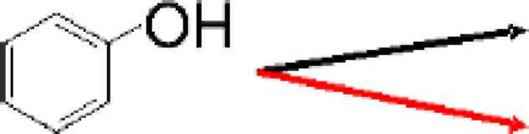
Toxic Non-Toxic

Graph classification

- Pattern * subgraph
- Single-graph setting

- Frequency: number of pattern occurrences in the single graph.
Examples of algorithms: SUBDUE, SEuS, GREW, SIGRAM, GBI
Not discussed further
- Graph-transaction setting
- Frequency (of a pattern): number of graph transactions in which the pattern occurs
Apriori-like algorithms
- Basically two steps:

- Generation of frequent substructure candidates
■ Based on adding nodes, edges or paths
- Checking the frequencies of candidates
- Examples of algorithms : AGM, F5G

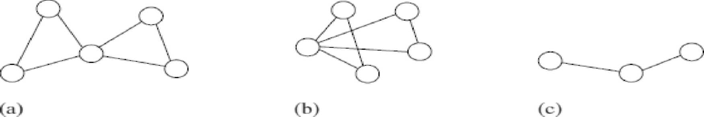
Checking the frequencies of candidates: ■ (Sub)graph isomorphism
■Canonical labeling
■ Unique code for the set of graphs with the same topological structure and the same labeling
■Both problems are not known to be either in P or in NP-complete —► relaxed problems

Pattern growth algorithms
- gSpan
- Gaston

gSpan
- Without candidate generation
- Minimum DFS code as canonical label

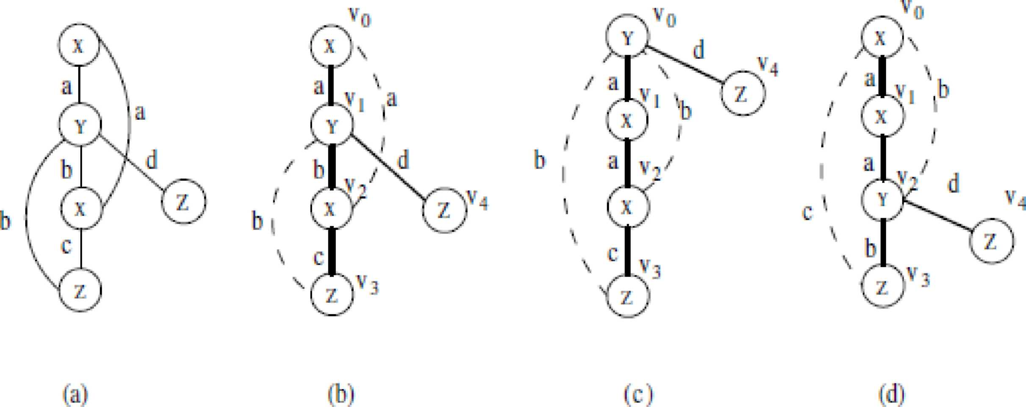

gSpan
- Without candidate generation
- Minimum DFS code as canonical label
- DFS lexicographic orderering on DFS codes —► DFS code tree

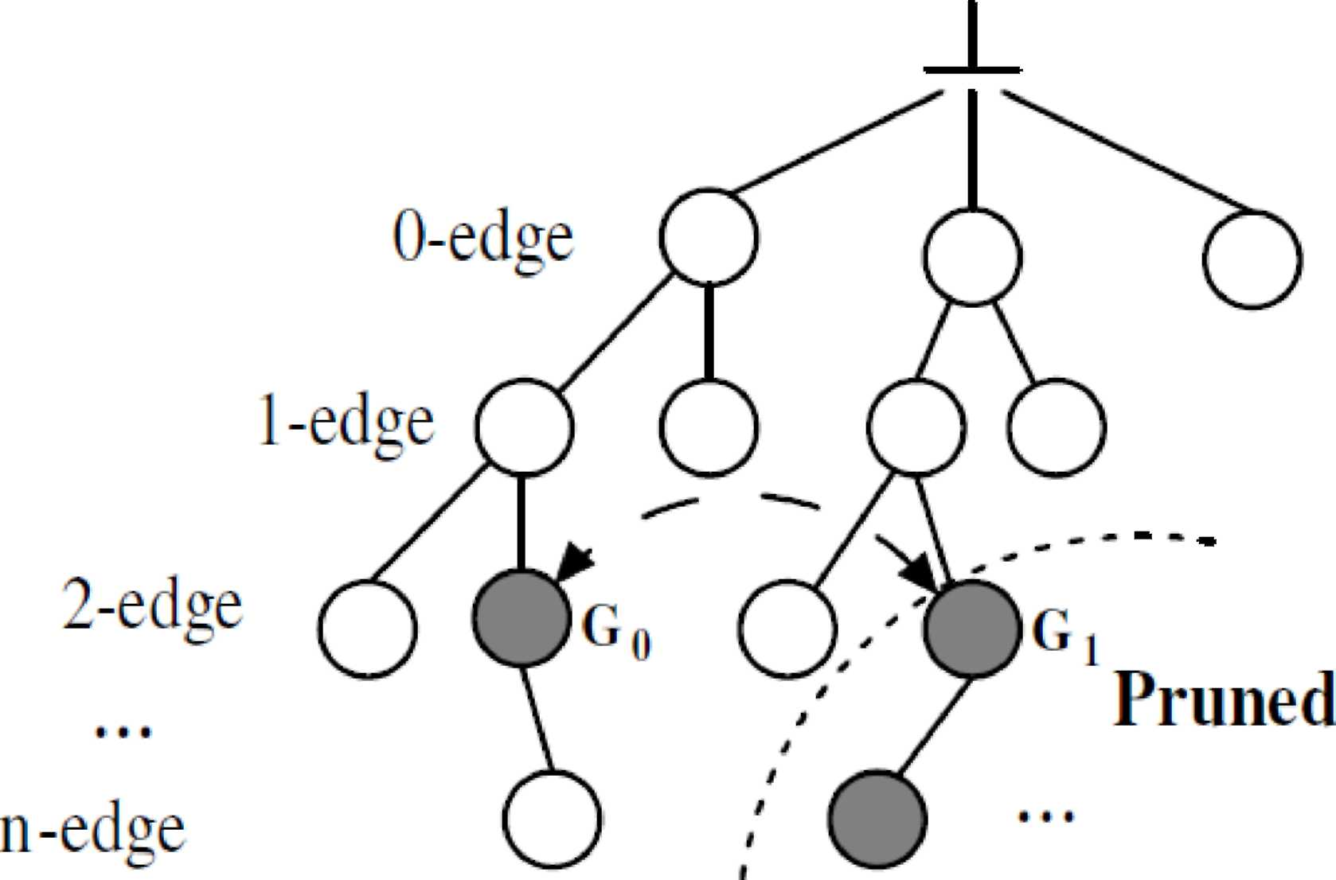

gSpan
- Without candidate generation
- Minimum DFS code as canonical label
- DFS lexicographic orderering on DFS codes —► DFS code tree
- Searching frequent patterns: traversing DFS code tree
- Diane J. Cook, Lawrence B. Holder. Mining graph data. John Wiley and Sons, 2007.
- Charu C. Aggarwal, HaixunWang. Managing and Mining Graph Data. Springer, 2010
- X. Yan and J. Han. gSpan: Graph-based substructure pattern mining. In Proceedings of 2002 IEEE International Conference on Data Mining (ICDM), pp. 721-724, 2002.

