Download links to functional packages to install iDempiere (primarily for students of the course PV045). All mentioned versions are tested to work together!

* Installation iDempiere - Version 1.4
  + on page idempiere.org
  + a local stored files - not the newest, but they operate in a given configuration for teaching Windows (64b)
* Database PostrgeSQL - tested version 9.3 or 9.6
* Java JDK 8 64b Developer Kit
* For possible adjustments and editing files (demonstrated at the end of the course PV045)
  + Eclipse about LUNA - you need to download the version of Java EE Developers
  + Tortoise on HG - tested with version 3.7.3, however you need to have installed the latest

The installation procedure iDempiere:

1. First we assume that you have downloaded all installation packages listed above for your operating system.
2. Install Postgres database - pay attention to rights to write data. We recommend you to create a data directory elsewhere than in the Program Files - eg. C: \ PostgreSQL \ data. Stack driver does not need to be installed.
3. Install Java. All settings you can leave the default.
4. Install iDempiere - ie copy the idempiere-server where you want them. An ideal place is in root folder :-)
5. Now we have everything you need, we can begin to work. The entire system is needed to be set first. Add the following two variables into System variables:
   1. JAVA_HOME and set its value to the directory where Java is installed (eg. C: \ Program Files \ Java \ jdk1.7.0_79)
   2. IDEMPIERE_HOME - set the folder where you installed iDempiere
   3. Next, add to the PATH variable component of Java runtimes - typically C: \ Program Files \ Java \ jdk1.7.0_79 \ bin
6. Set the database
   1. Start pgAdmin (should be installed together with the database)
   2. Log on to our server - see figure parameters. 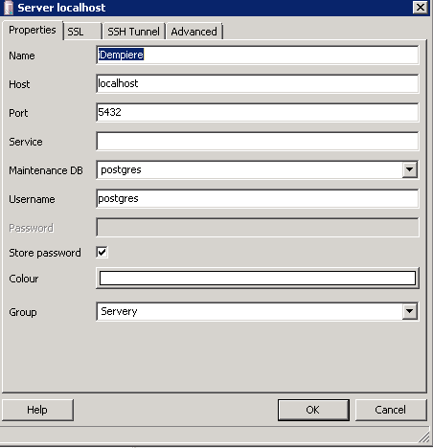
   3. Create a user adempiere and its password. Variables tab, set the variable search_path to ADempiere, pg_catalog. Database field blank. 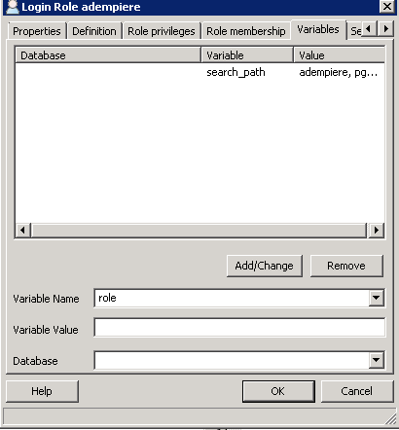
   4. Create a database adempiere with the owner adempiere
7. Set iDempiere
   1. Go to the IDEMPIERE_HOME - ie where you installed iDempiere (typically C: \ idempiere-server)
   2. Run the batch, identified as setup.bat. If you've installed everything well, the dialog system settings. 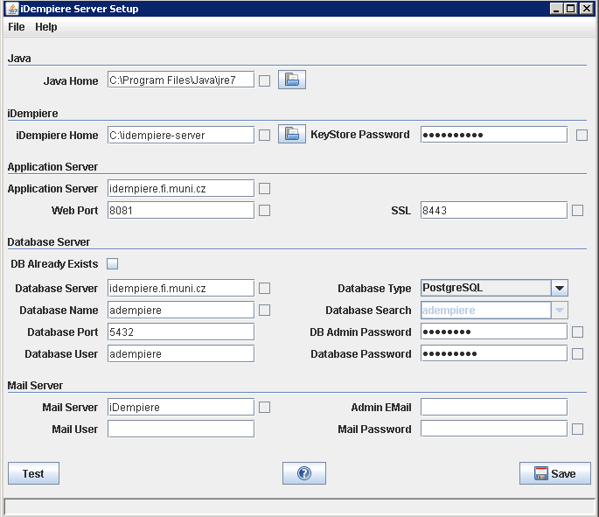
   3. Press Test. When you first start, you must fill out the initial value of the server - see picture. Fill discretion.
   4. If the program finds an error, it reports it and interrupts. Field where the error occurred, it will be marked in red. Where the test is OK, the green box appears. Errors may occur particularly at ports - there must select those that are not occupied by another application. 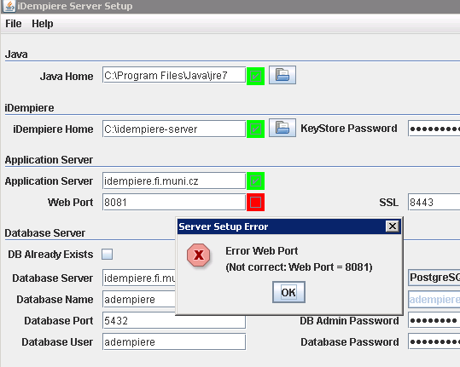
   5. If the test reports that cannot connect to the database, change the server name in the "Database Server" on localhost
   6. If, after pressing Test this screen appears, we won :-) 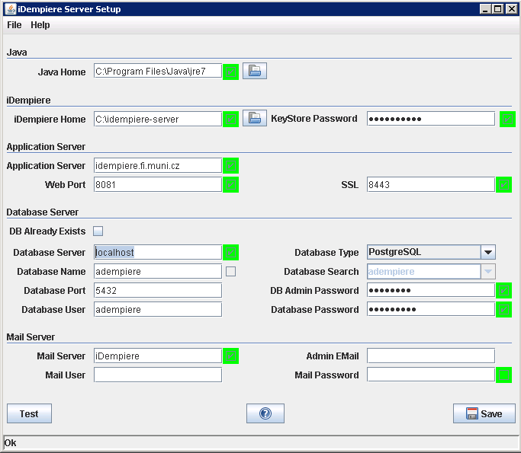
   7. Press the Save button to the configuration ordered. Wait for storing configuration and quit.
8. Import the data into the database
   1. Go to the IDEMPIERE_HOME \ utils
   2. Run RUN_ImportIdempiere.bat
   3. If everything is set up correctly, will import the database iDempiere even with demostračními data
   4. You can verify this by using pgAdmin - reconnect to the database. In adempiere database should be added the new scheme adempiere with 847 tables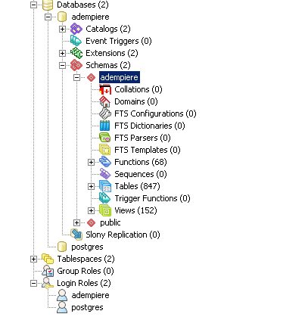
   5. Run the ninth iDempiere server
9. Go to the IDEMPIERE_HOME
   1. Run idempiere_server.bat
10. Access to iDempiere
    1. First run any Web browser
    2. Type the name of the computer specified in the configuration (the Application Server), complete address of the domain, if needed (not specified localhost). Following a colon enter the port name Web port for connection via http or SSL port for connection via https.
    3. 3. You will get to the homepage iDempiere. If so - congratulations, iDempiere is installed!!! 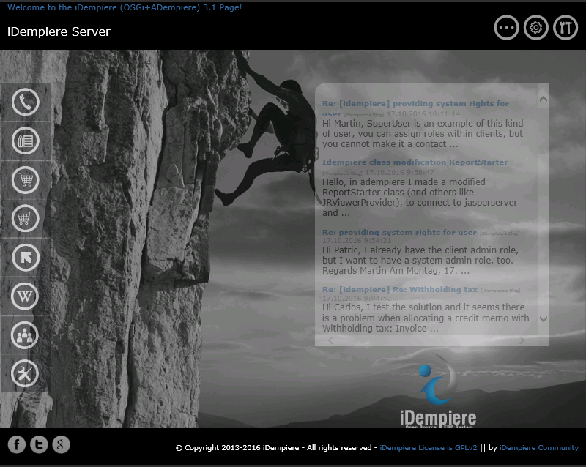

client iDempiere

iDempiere provides two options to access the system - thin and thick client. The thin client runs in a browser - clicking on the logo iDempiere. Thick client must be installed according to the following guidelines:

1. On the page <https://sourceforge.net/projects/idempiere/files/v3.1/daily-swing-client/> you can find the appropriate client for your operating system. It will be a zip file.
2. expand this file after downloading - ideally again to the root directory. The default folder is ADempiere-client. After copying the contents of the folder appears as illustrated.
3. Start file ADempiere-client.exe. After a while the login window opens. You need to configure the connection to iDempiere server. 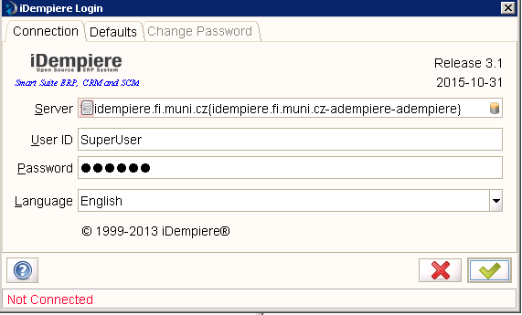
4. Click on the line Server. It will open the configuration window to connect to the server. Here we have two options - to connect through an application port (default is port 0) or only connect to the database. These two options are so that we could join the system, even if that application port is not functional or is for some reason blocked.
5. First, try to connect through an application port - Fill Line Application host data that we entered when configuring the server. Application to enter the port address of the SSL port - eg. 8443. Click Test Application Server. 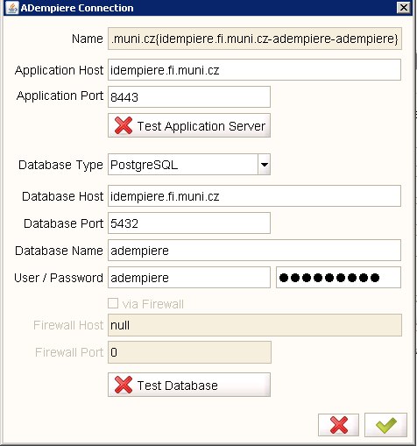
6. dialog box appears asking you to enter your username and password. Either leave, what is the default, or enter a login and password GardenAdmin and GardenAdmin. When all is done, the test is "tick off" and the database details already filled in automatically. Then be sure to click on the Test Database, which is verified database access - Ideally, the test ends with a positive result. 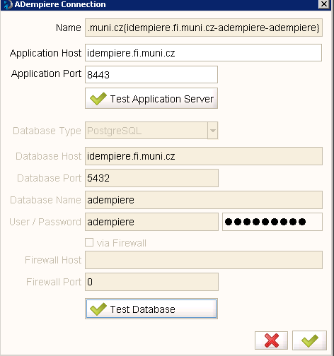
7. If for any reason unable to connect to an application server, all is not lost. The client is able to work only on the basis of access to the database - not only communicate with the application server. This means that all actions must exert itself, which in particular for activities requiring downloading large amounts of data, can mean a time delay. In this case, manually configure database access and test - if succeeds, you can work with the system.

If you want your installation iDempiere was also accessible from the Internet - not only from your local computer, you must make the following changes in the configuration of the system:

1. Edit Configuration PostgreSQL - and specifically in the file pg_hba.conf - located in the data directory, in our case C: \ PostgreSQL \ data
2. In the table at the end of the file type in the section IPv4 local connections row:  
   host all all 0.0.0.0/0 md5
3. It will arrange it to your database will be connected anywhere on the Internet using encrypted password. After changing the PostgreSQL server must be restarted or give him a command to reload the configuration!
4. Then close idempiere-server, if running, and run the setup.bat
5. Here, the items Application Server and Database Server, replace localhost domain or IP address of your computer.
6. Let the test run - ideally it should be fine
7. Save configuration and then rerun idempiere-server.bat
8. Try that runs Web access - beware, localhost will not work now
9. Subsequently try to access the thick client from your desktop or from anywhere on the Internet. Ideally, everything should work so that only a specific Application Server address and port number and everything else will be loaded automatically.
10. You can try to set the machine at the Faculty of Informatics:  
    Application Server: idempiere.fi.muni.cz  
    Port: 8443