# Creating a window

### Window for type of event

1. We need to log in as System Administrator
2. Open Window, Tab & Field in Application Directory menu
3. Create New Window and name it Type of Events
4. Create a new Tab for the Window
5. Name the Tab as Type of Event
6. Select the table **fi_type_events**
7. Click on the button **Create fileds**

### Window for the Events

Do exactly the same, but use the name Events for the Window and Tab and use the table fi_events. Windows are ready to be used – see pictures.

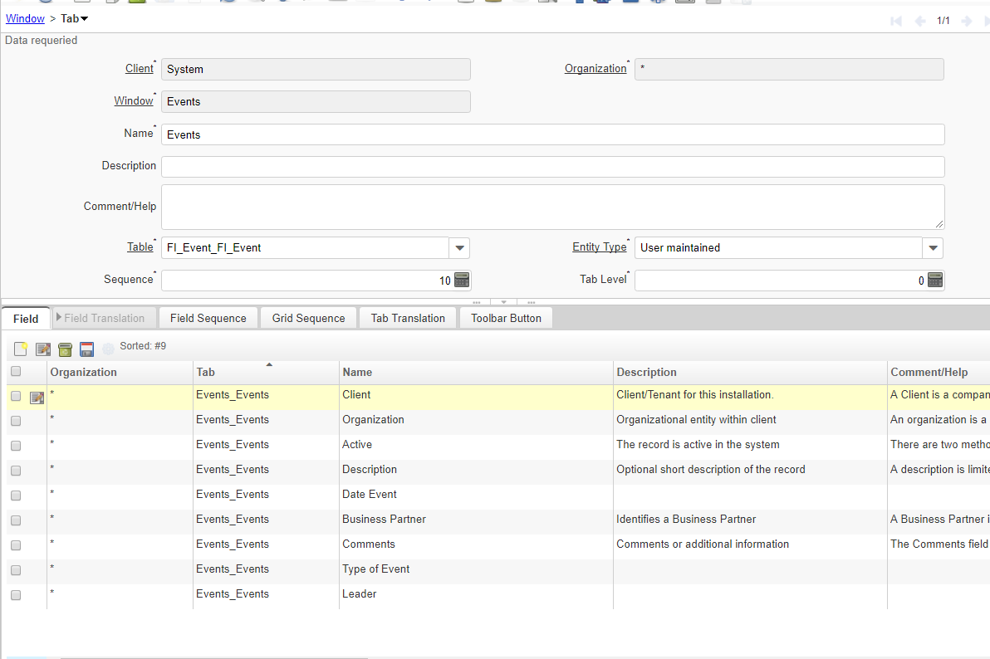

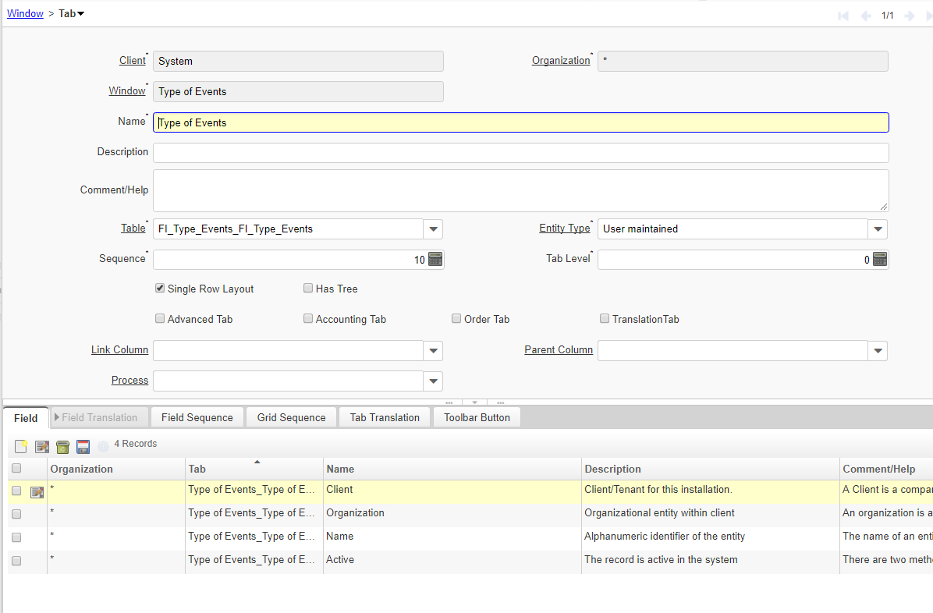

We can also modify the existing window. We will add a new functionality into the Business Partner tabs.

There are two possible modifications:

* To see all events the business partner participated
* To see all events the business partner led or supervised

## Events tab

1. We need to log in as System Administrator
2. Open Business Partner Window in Window, Tab Filed
3. Add a new Tab – Events and connect it with the table Events and Column C_BPartner_ID  
   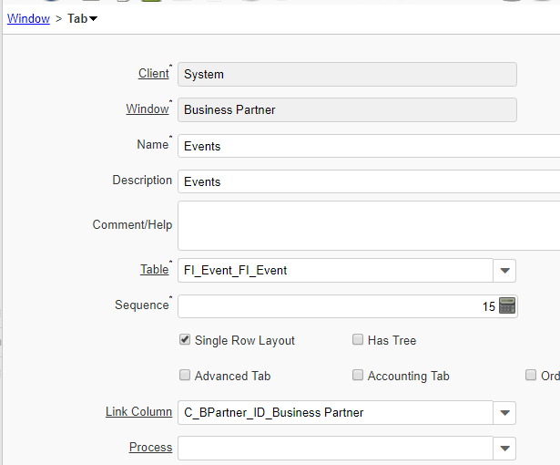
4. To place your Tab in the first place, **modify** the Sequence number – to 15 for example.
5. Click on the Process Button and select Create Fields option  
   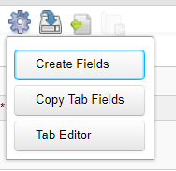
6. The Columns in Tab are created after you confirm the dialog:  
   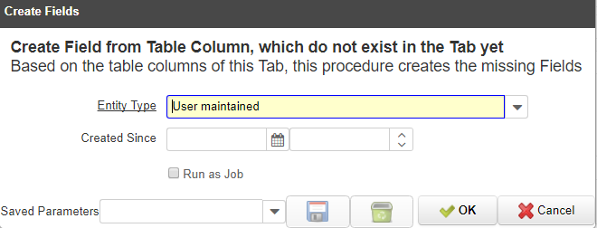
7. If everything is OK, you will obtain following message:  
   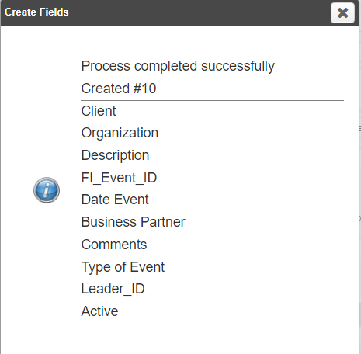

## Supervisor Tab

* + - 1. Create a new Tab in Business Partner Window – the process is even similar to the previous one. You just need to select the right linking column – Leader_ID – see the picture:  
         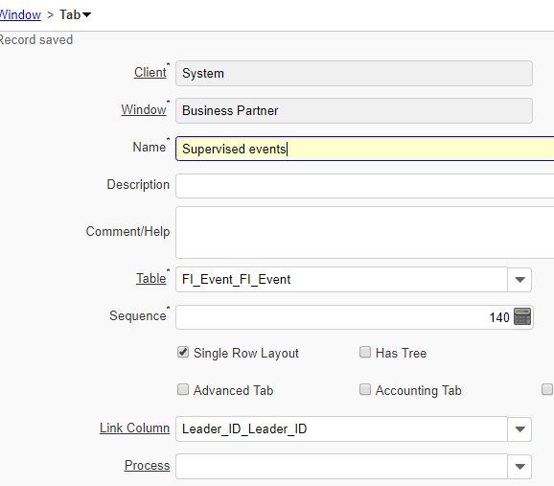
      2. Do not forget to modify Sequence number – to 17 for example
      3. And create fields again
      4. We are done!

Now log in as normal user and see the results:

