# Exporting and importing the functionality

iDempiere enables you to export or import the new functionality (tables, windows, menus, info windows) very easily. This functionality is implemented via packages you can install or rewrite by new version.

## Exporting your functionality

1. Log in as System Administrator
2. In Menu, go to the Application Dictionary, there find Application Packaging   
   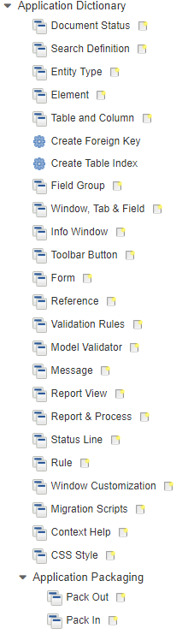
3. Select **Pack Out**
4. Here create a new package by pressing New button.
5. Enter mandatory and/or other data as shown on the picture (version numbers are up to you):  
   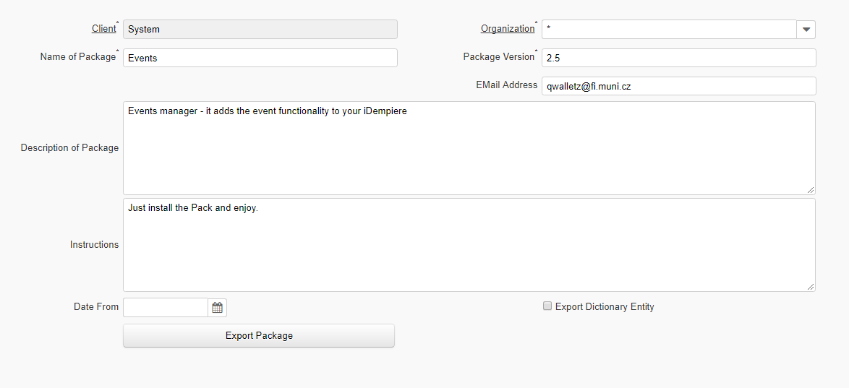
6. After saving this record move to **Package Details**
7. Here create new record. As **Type** select Application or Module and to **Type** select your Summary menu item of your functionality:  
   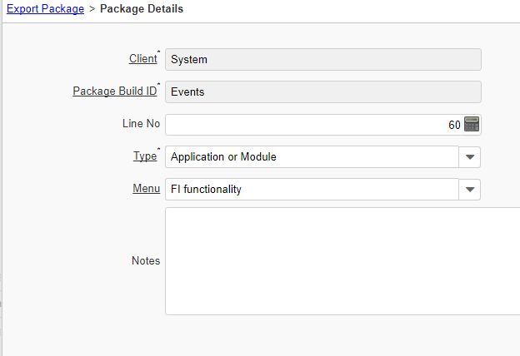
8. Save it and this is all! Move back to Export Package
9. Click on the **Export Package** button and start the process  
   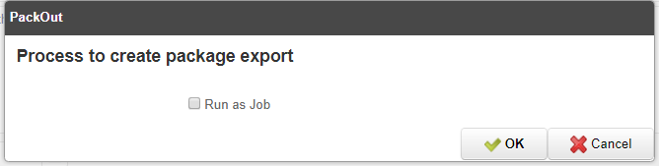
10. You obtain the window with the link to your package. By clicking on this link you can download it  
    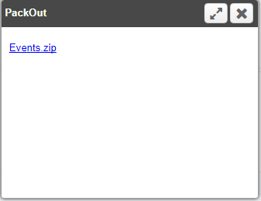

### Problem of Info window

You can not export info window (this functionality is not implemented yet). You need to export info window as the data from two system tables (*AD_InfoWindow*and *AD_InfoColumn*). For this you need to know ID of your Info Window.

**How to find your Info Window ID?**

1. Go to the Info Window in Application Directory  
   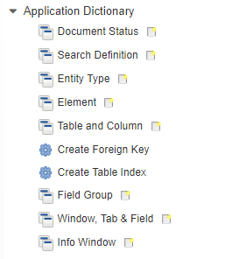
2. Find your info window
3. Click on the Record info – the record number:  
   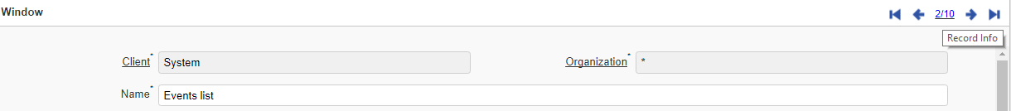
4. You will see the dialog with system information about particular record:  
   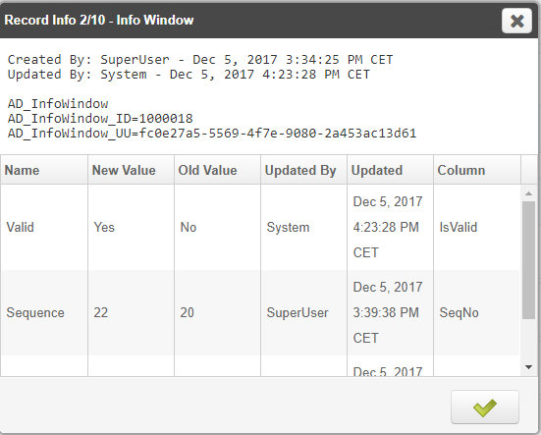
5. Remember the ID (AD_InfoWindow_ID) value

**How to add your info window into the Pack?**

1. Find your pack in Pack Out.
2. Go to the package details (where you should already have your Application or Module export defined)
3. Create new package details
4. In the Type field select **Data**
5. In the Table find **AD_InfoWindow_InfoWindow**
6. To the SQL Statement insert:  
   SELECT * FROM AD_InfoWindow WHERE AD_InfoWindow_ID=[your ID]  
     
   where you **replace** [your ID] with the value of ID you have found in the previous chapter. It should look like this:  
   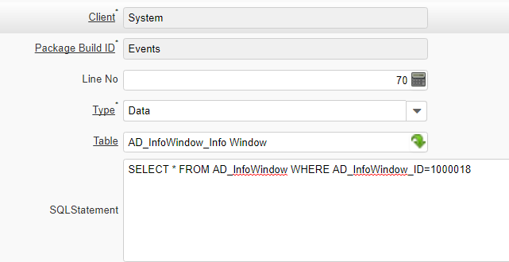
7. Click Save.
8. OK – we have the info window, but we need to export also columns of info window! So create a new record (the third one) and do the same with the table *AD_InfoColumn*. It should look like this:  
   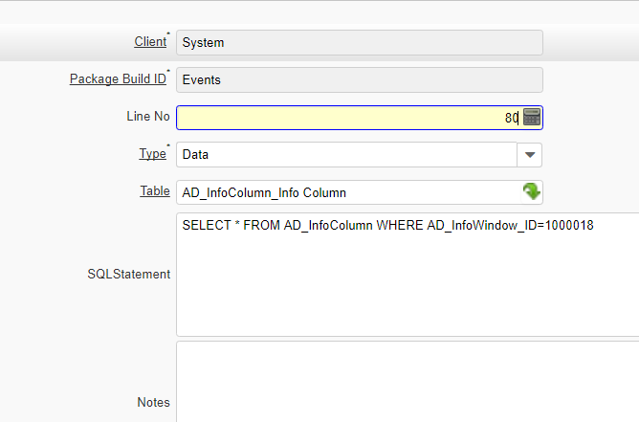  
   Be aware!!! We are working with **AD_InfoColumn** table, but there is **AD_InfoWindow** after WHERE in the SQL statement!
9. Save it – and we are done!
10. Try to export your package – it should export all functionality including info window!

**What if I changed functionality of window that is currently installed in iDempiere (like Business Partner window)?**

It is easy – just create new package detail and set the Type as Window and in Window put the name of your changed window – line this:  
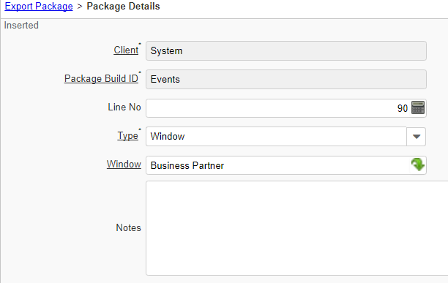

And you can export it as well!

## Importing the package

Importing package is much easier.

1. Log as System Administrator
2. Go to the Application Dictionary – Application Packaging
3. Select Pack In
4. Create new record and fill the Name  
   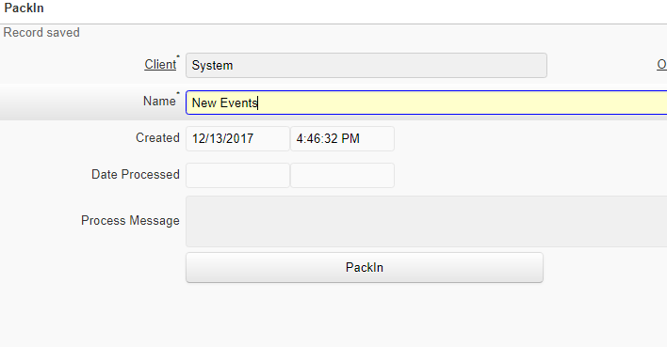
5. To add your package, click to the Attachement button:  
   
6. 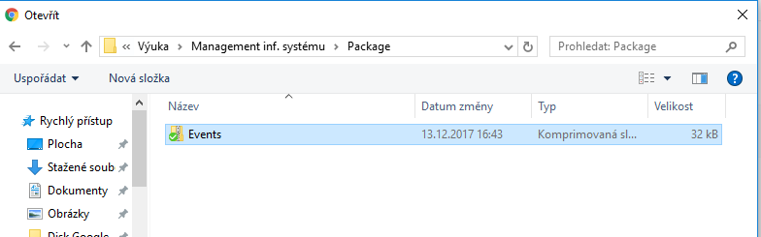In the dialog, specify location of your package  
   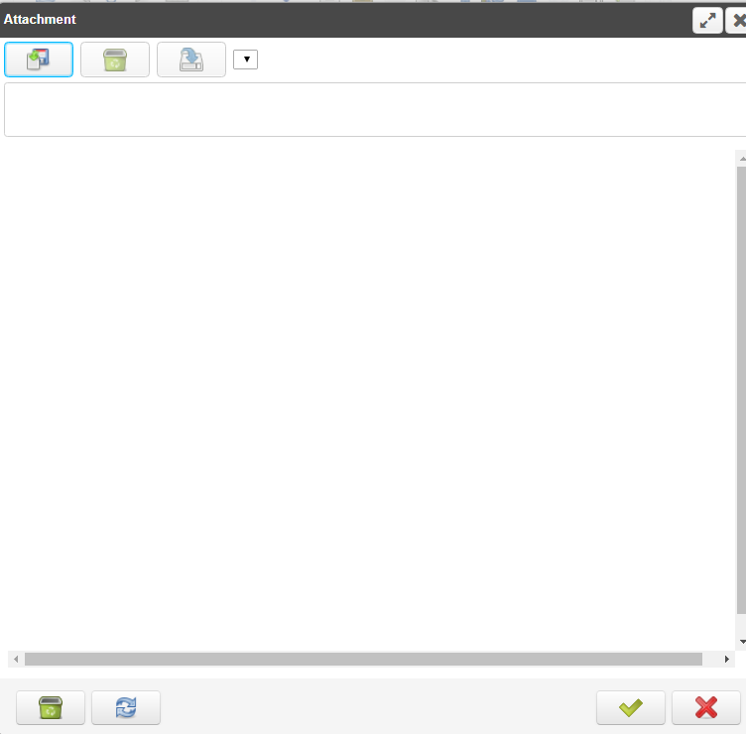
7. Confirm the dialog.
8. Press the button **Pack In** – the package will be installed  
   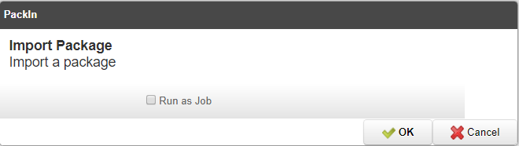
9. If everything is OK, you will get the picture like this:  
   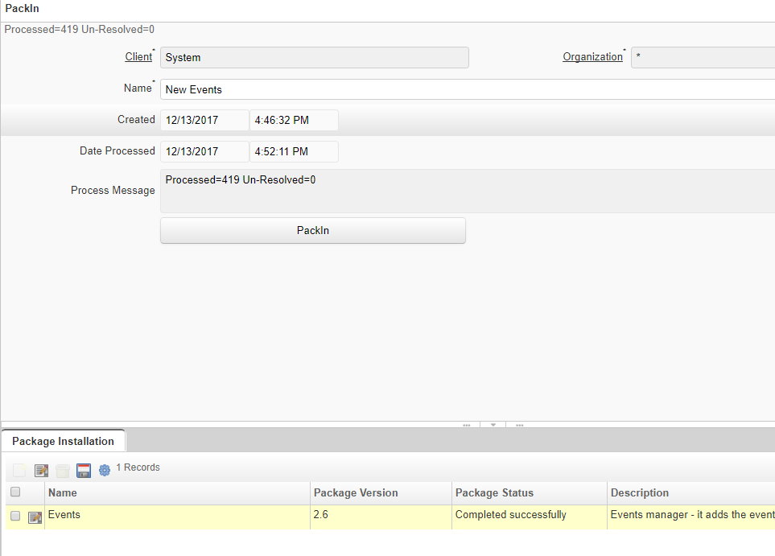
10. Your pack is installed and ready to use 😊