# Working with view

There are several View windows. In the systém you can define more Views if you like.

## Basic View Menu

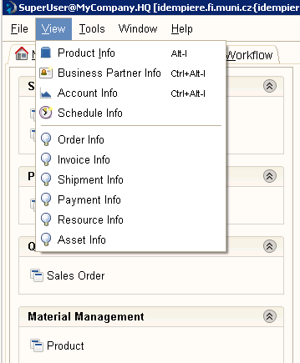

## Product Info

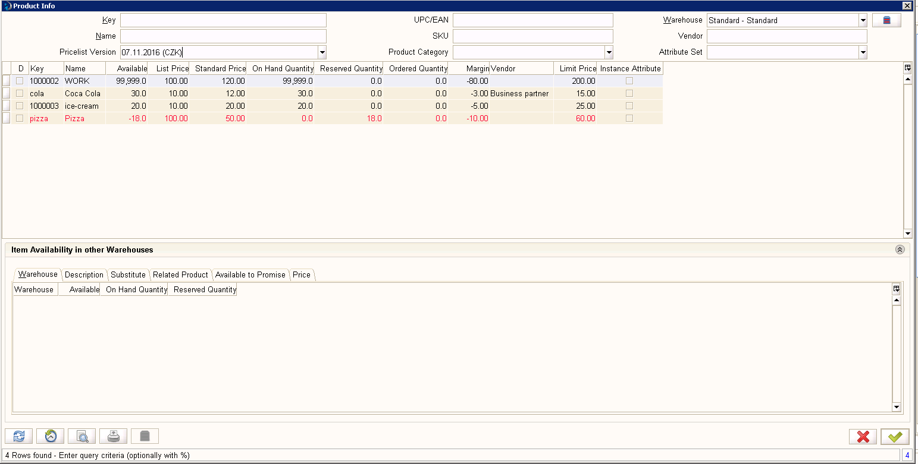

## Working with Business Partner Info

## 

1. History :

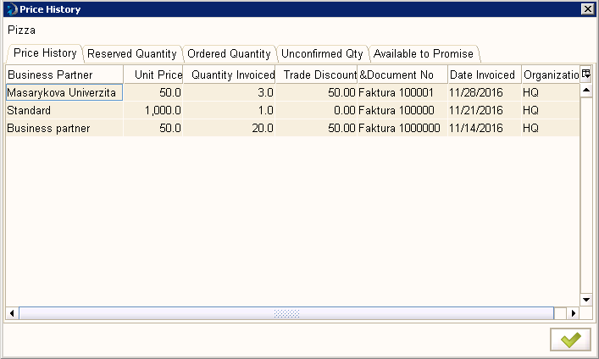

Using Zoom   
It opens the basic window of Product  
Here we can use Zoom Accross 

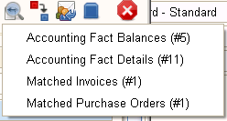

1. History:   
   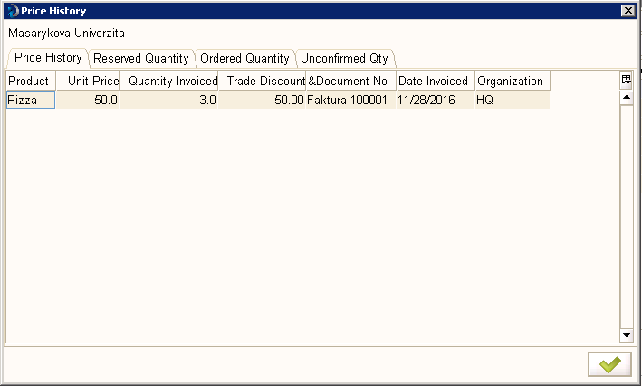
2. Using Zoom   
   It opens the basic window of Business Partner  
   Here we can use Zoom Accross   
   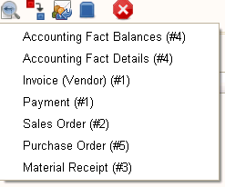  
   and we can see all documents related to specific business partner

# How to make my Info Window?

1. Task: I want the info window that list for me the all employees
2. Log as System
3. Find Info Window in Application Dictionary  
   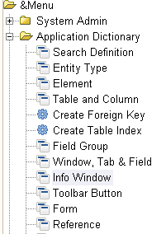
4. Open Info Window and click on New Record and
   1. In Name write **Employees list**
   2. In Table select **C_BPartner**
   3. In SQL FROM it is automatically written C_BPartner a
5. Than define columns
   1. In System Element write **Name** – all informations are written. Save and click New
   2. In System Element write **IsEmployee** – all informations are written. Check **Displayed**. Save.
6. Put your info window to menu:
   1. Find Menu in System Admin – General Rules – System Rules  
      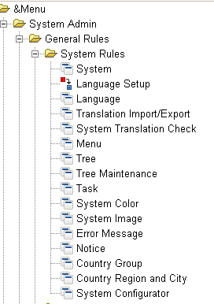
   2. Open Menu with all records  
      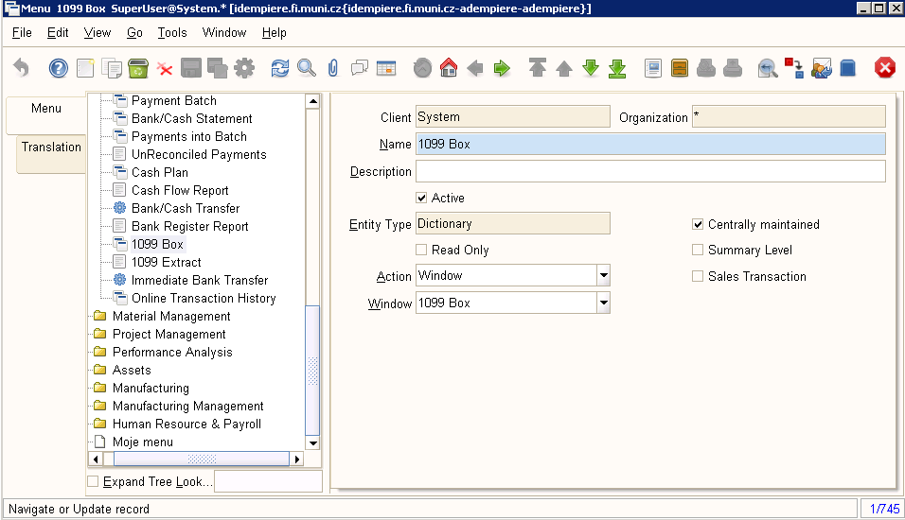
   3. Click New and:
      1. Into the Name put Employee list
      2. Into Action – Info
      3. Into Info Window select Employee list
7. Loq as normal user of the company (in thick client!!!)
8. Try your info window ☺

## Modifications

1. Employee as filter criteria
   1. In Column (Info Windows settings) IsEmployee select Query Criteria
   2. Set Query Operator to “=”
   3. Save
   4. See the difference
2. Employee as default parameter of the query
   1. In Window (Info Widow settings) into the field Sql WHERE write “a.IsEmployee='Y'”
   2. In Column IsEmployee deselect Query Criteria
   3. See the difference