# System Menu of iDempiere

To understand the architecture and concept of the iDempiere framework we need to explore the System menu of iDempiere. In the log-in window enter following values into Login and Password fields: System / System

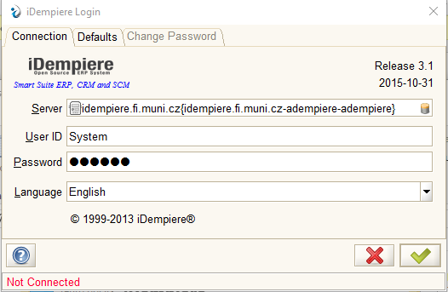

In the next window control if you have value “*” in Organization field:

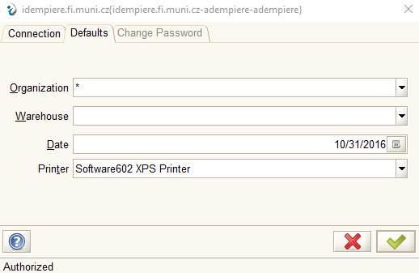

If everything is correct you should see completely different menu on the left side – the menu of Application Dictionary

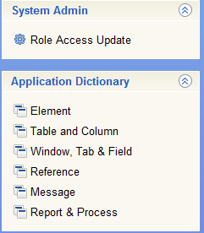

## Elements

Menu of elements contains the basis of all information stored in iDempiere. All data in the database must be defined first as the element here and iDempiere has a several tools to control the data consistency. As you can see there are about 5563 already defined elements. Therefore we filter the by the Name – entering the value Name: 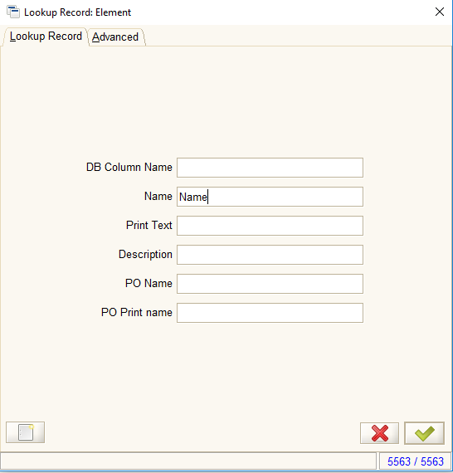

Than we can see all information about element named „Name“:

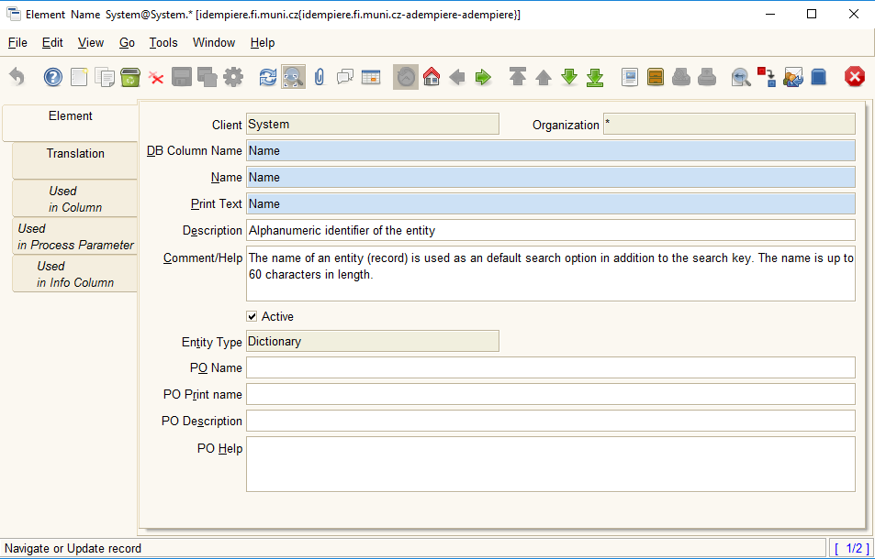

Let´s navigate to the bookmark Used in Column and switch into table view mode: 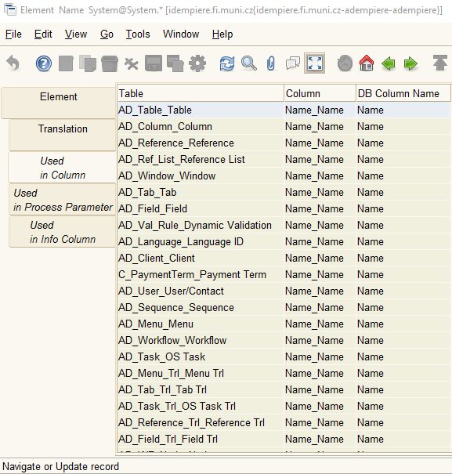

We can see in what table we have elment Name presented. Find the table C_BPartner_Business Partner and change the view into the Record detail:

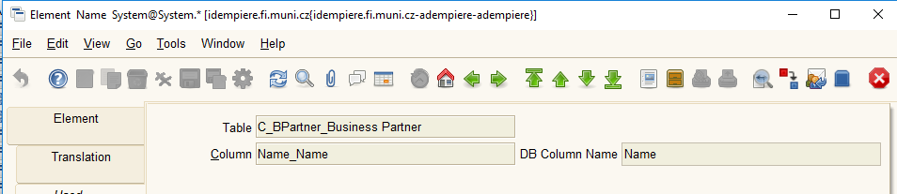

Right-click on the field Table and choose the option Zoom to see the detail of the table definition:

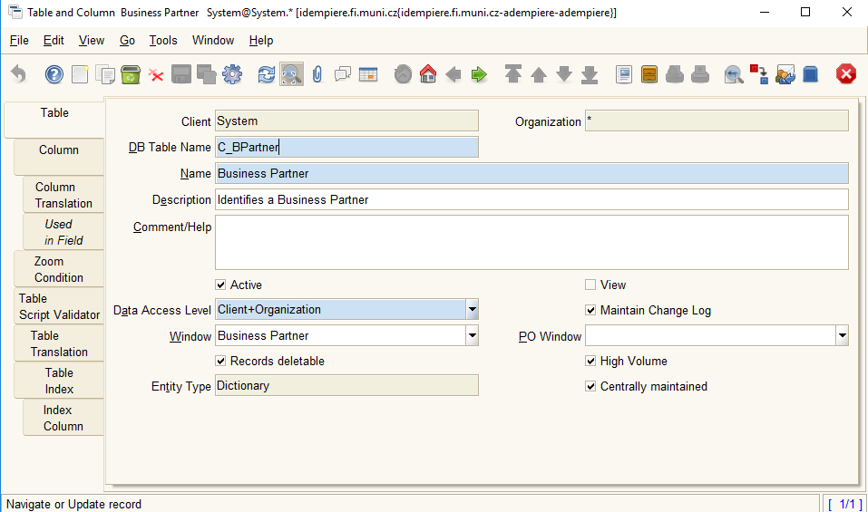

Switch to bookmark Column and find column named Name and see the detail:

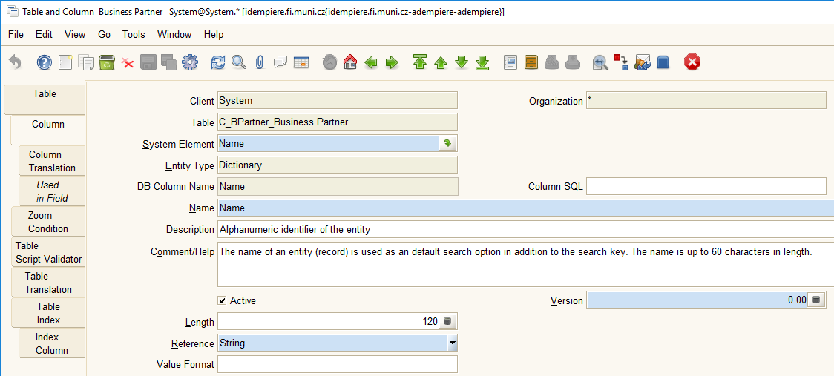

Can we do it faster? Yes! Close the window by pressing . Than select Zoom in Column field in Element window:



We are directly there!

## How can we work with database?

Via this part we are directly connected to database. To apply any changes, we can work here and we do not need to work directly with the database. Furthermore, it is highly recommended to work here!!!

**Task:** Change the name of column Name to BP_Name and enlarge its length to 150.

1. Open pgAdmin to see the effect of our work. Navigate to the database Adempiere and find table C_BPartner and unpack the columns. Find column named “Name” 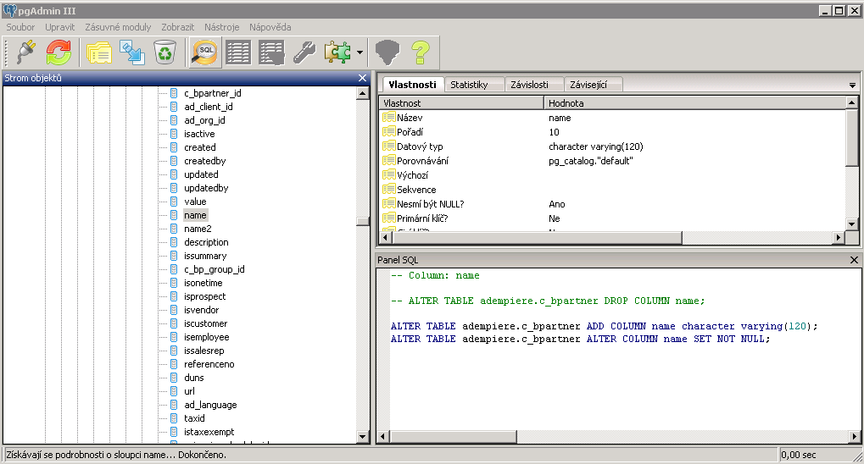
2. Go to iDempiere Column window and change the Name to BP_Name and its length to 150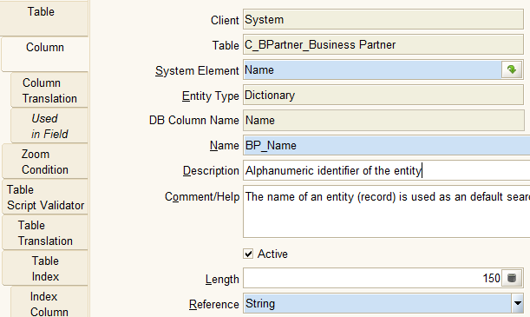  
   and click to Save button . If it is not available, you need to move from the field you have changed.
3. Click to Reload button in pgAdmin . Nothing happened? Well, we need to update our changes! In Table and Column window click to  confirm the question 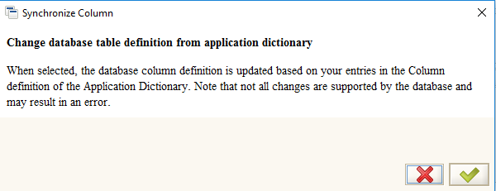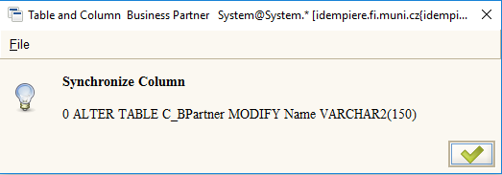and see the pgAdmin again! 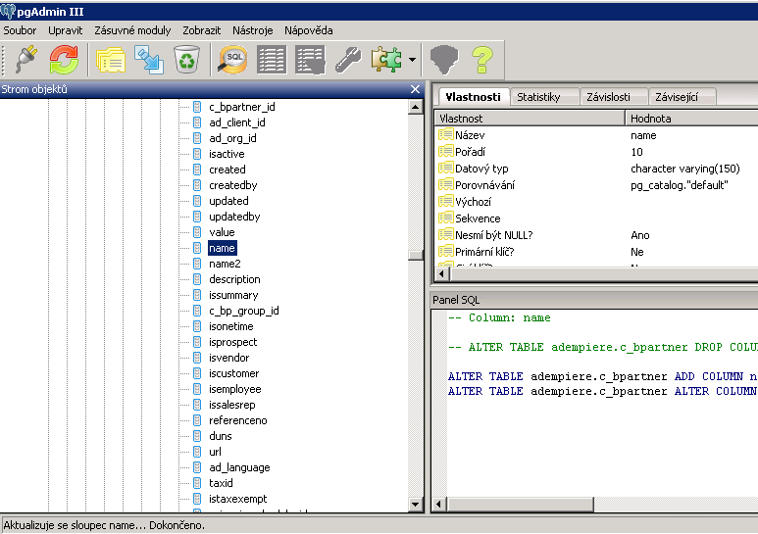
4. Why the name is still “name”? Because we cannot change the name of the field in database – it is in DB Column Name, but we can still change its features!

## Windows definition

Windows are the basic user interface elements. As usually, they can be defined on the tables that are defined in the previous items.

1. Click to Window, Tab & Field shortcut
2. In the filter window write into the filed Name “Business Partner” 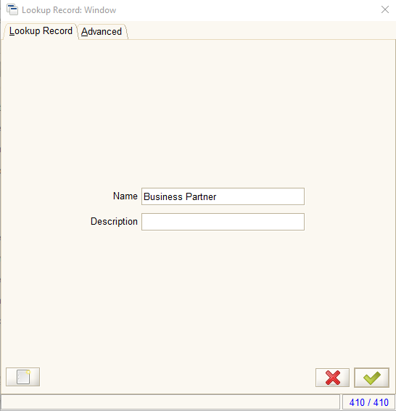
3. You will see the Business Partner widow definition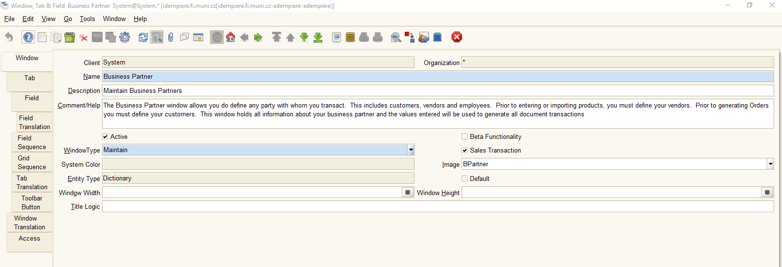
4. Control our link to BP_Name field. Go to Tab bookmark – there you define all bookmarks of the window: 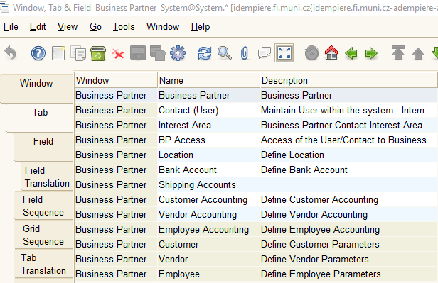  
   compare: 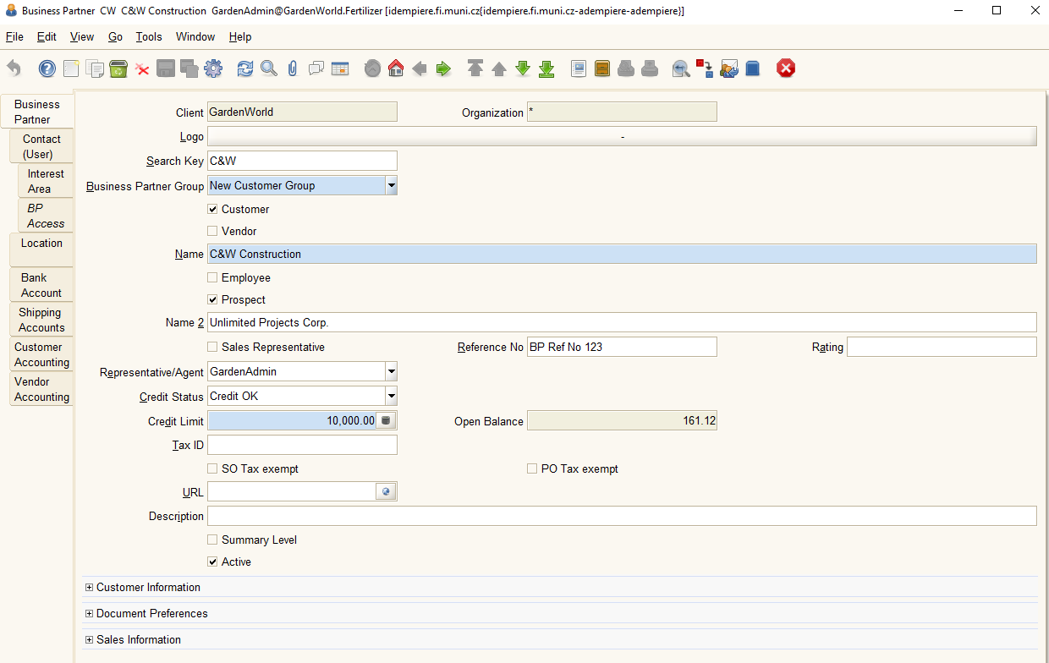
5. Choose Business Partner Tab and click to Field. Find the record for the column Name: 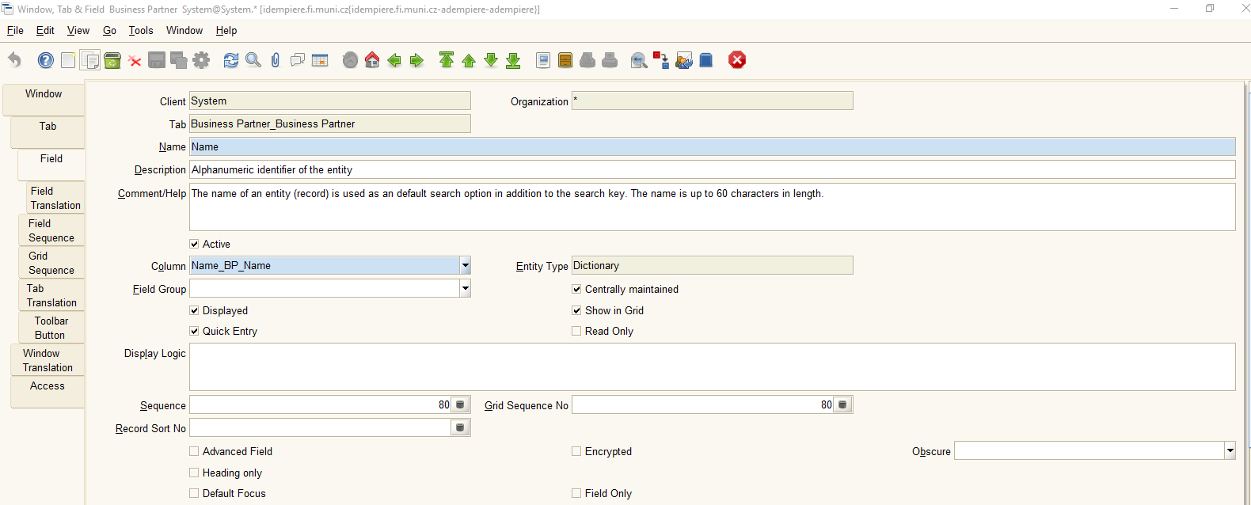

**Task**: Change the name of the field to Partner Name and Name2 to Additional Name

1. Change the Name to Partner Name and Save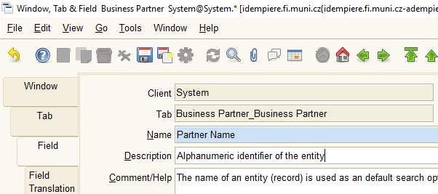
2. Than find field Name2 and change it into Additional Name and Save 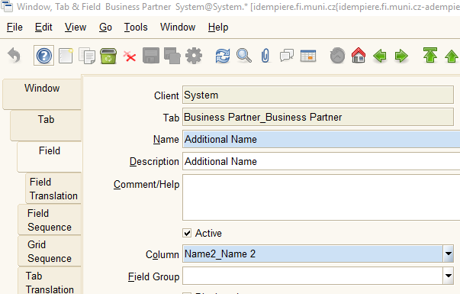

To control if it works:

1. Log out and Log in as GardenAdmin
2. Open the window of Business Partner 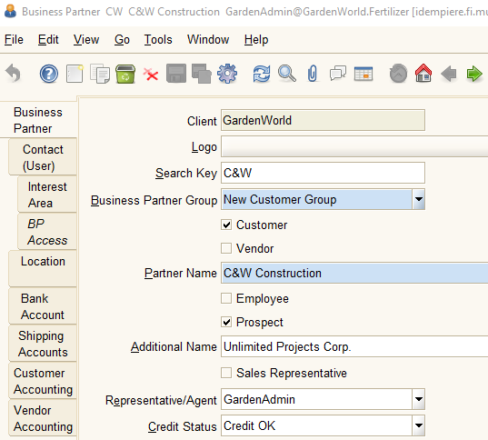

# Log into iDempiere with universal role

To be able to switch all roles, log as SuperUser with password System. Than you will be able to switch any role more quickly:

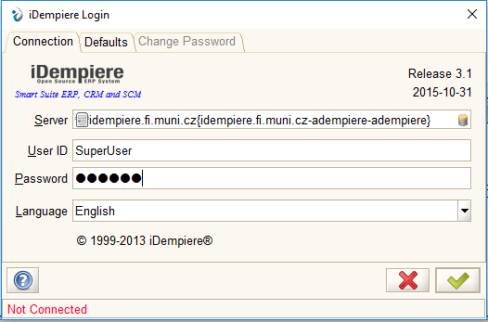

Than you can choose also client and role in the client:

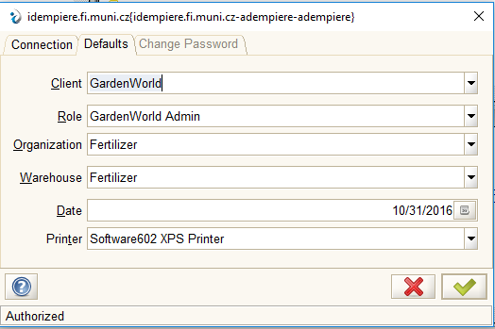

For System client, select System and you can work immediately.

# System translations

How to teach iDempiere to speak Czech? There are several possibilities how to import translations.

1. Log as System
2. Download the file idempiereCZ.zip from Information system
3. Unpack it in any folder you like
4. In the menu go to Language 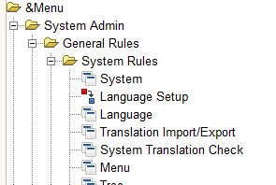
5. In the window opened find Czech language 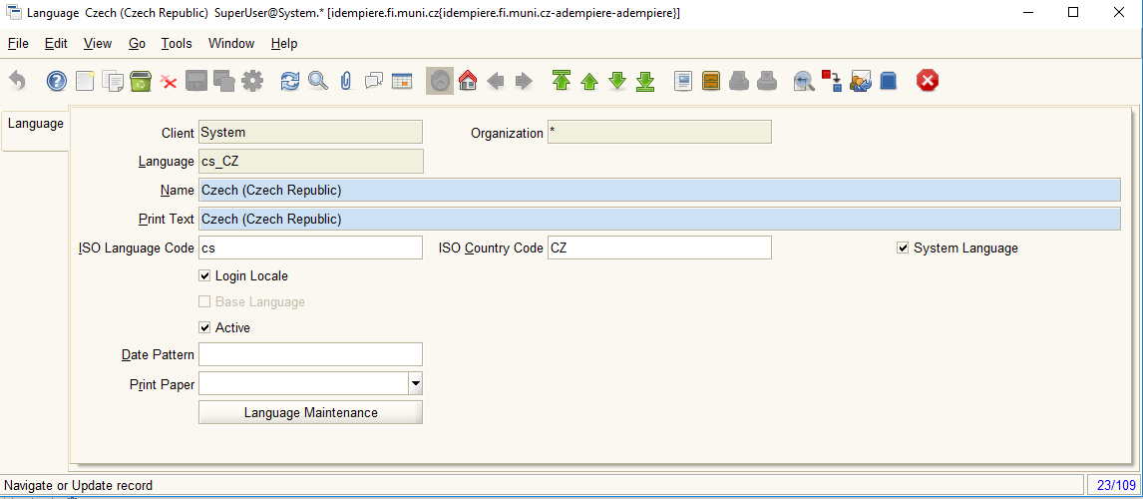 and check Login Locale and System Language
6. Save and than open Translation Import/Export. Select Systém in Client field and click Import 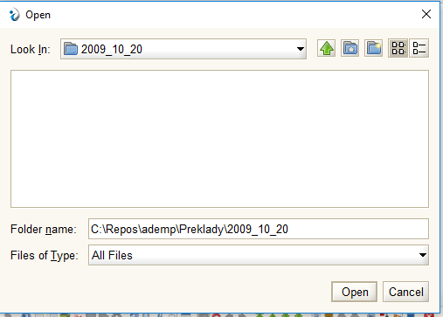Select the folder where your translations are located and click Open. Nothing will happend for a while – be patient!
7. After you will be able to work with iDempiere, go to Systém Translation Check 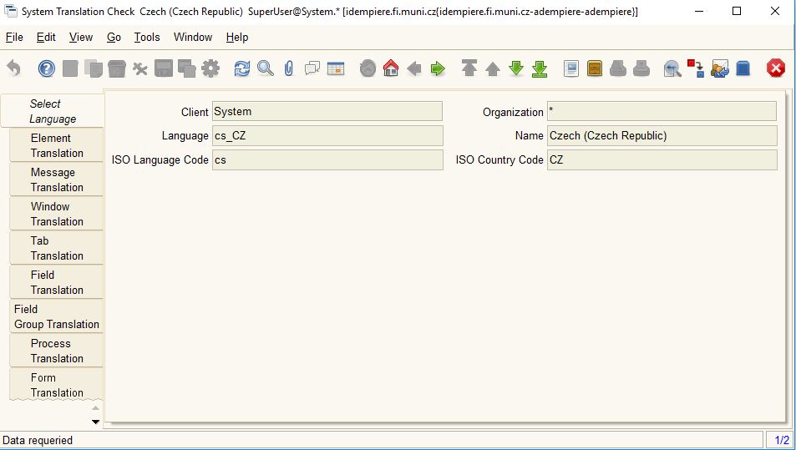
8. Thank go through the bookmarks – you should see the Czech translation 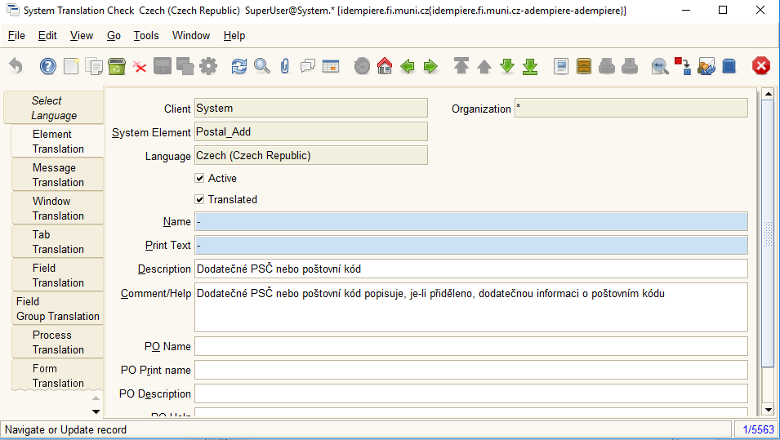
9. Then log out and log as SuperUser with Czech language: 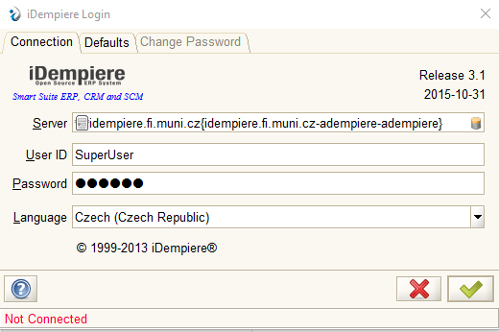
10. Does not metter if you log into Garden World or Systém – you should see the Czech menu: 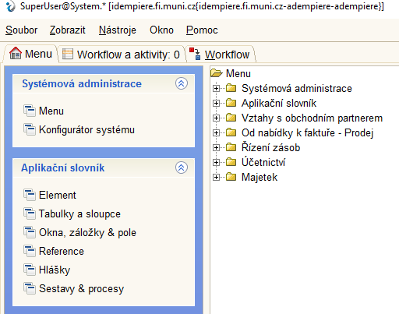  
      
    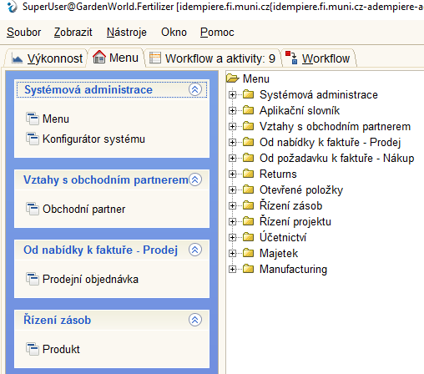
11. If some elements are not translated, they will be still in English