# Increasing marketing efficiency with Google Analytics

**Table of content:**

**Advertising and analytics market, its players.**

**Main concepts.** The functioning principles of Google Analytics

**Administrator area.** Reviewing Google Analytics Settings: accounts, properties, views. Administration of users, creating new profiles, using main data filters.

* Practical task: Creating profile. Application of basic filters

**Standard reports.** Review of main reports: Audience, Acquisition, behaviour. Who are our visitors, where they come from, what are they doing in the website.

* Practical task: Brief analysis of users: returning versus new visitors, efficiency of media sources, popular pages of website.

**Goals and ecommerce.** Observing and evaluating user activities- possibilities of setting and using goals, defining goals and their preview, extended goal statistics: Funnels and Goal flow. Ecommerce settings, defining indicators and their preview.

* Practical task: Set the Goal

**Channels and their interconnections.** Multichannel funnels statistics shows the interplay among different sources of user flows. Concept of Assisted conversions. Channels with different aims: for increasing awareness or generating conversions (i.e. branding versus performance)

* Practical task: Setting assisted conversions and their analysis

**Management of flow sources.** Analysis of the performance principles of the flow, reflection of different marketing activities in statistics, effective separation and identification of necessary data. Defining links to different flow sources.

* Practical task: Setting strategy for link definition for the sample advertising campaign

**Reporting.** Exporting different reports, creating additional segmenting for data, making adjusted reports according to own purposes, configuring Dashboards. Data export. “Advanced segments”- additional extended segmentation of data. Functions of Custom reports and Dashboards. Presenting important data in one place.

* Practical task: Creating Segment, adjusted Custom report, and Dashboard

**Some data about Google activities**

**Advertising and analytics market, its players.**

Market participation features:

The capacity of visibility in the market can be evaluated by the speed of acquiring customers. It took different time for acquiring the same number of 80 mln customers for various can be attractive as advertising channels, namely :

* Facebook – 3 years
* Twitter- 4 years
* Google – several months. The social network Google+ has about 4 billion users (80% of them are not active ☺ but they can be addressed by companies here.

The main formal indicator for improvement in the advertising activities CPA (clicks per ad). The maximum profitable CPA shows how much more is it worth investing in advertising.

In Lithuania the Google analytics and Google Adwords market participants:

* Digital Academy
* Google partners
* Advertising agencies

In USA – Digital Analytics Association

Digital Academy (LT) provides learning courses- 4 specialists are currently employed as trainers. However the self-learning package is available as well. One of the goals for learning is certification.

Priority area for training is Google Adwords (paid advertising platform).

The Advertising agencies specialize in reporting. The current return on investment ROI to advertising market is evaluated as 1.45 USD return for 1 USD invested. The agencies take about 10-20% for their work. They also can take responsibility to pay to Google on behalf of the company (by meeting payment system of Google), and then regularly charge the company for full service. On the other hand if the advertising agency is small and it does not have sufficient turnover, the advertising payment to Google directly is transferred to the company. The VAT tax is applied. Recently in LT there are about 34 agencies.

The organizations can do their analytics and advertising with Google platforms by themselves as well.

Payment to Google has threshold principle (automatic payment): either 30 days or limit threshold “stairways” (depending which is achieved quicker). The threshold means that the payment is made by fixed sums: first balance to be covered is 50 USD (or EUR by choice of company). The money should be assigned in the account. If the money is missing the campaign will stop and after replenishment company should initiate payment and pay a little more. Then the threshold value can be set as 100, 200, 300 or 500 USD (or 30 days condition remains).

Professional specialists seek for certification. In LT their number is increasing: in the beginning of 2014 there were only 4 certified specialists, and on January 1, 2015 – there were 101 certified specialists.

The learning opportunity for student is participation in Google Online Marketing challenge (GOMC). Total duration in international challenge is approx. 5 weeks. Advertising budget awarded by Google is 250 USD, real company (business or non-profit) is advertised online by Google Adwords for 3 weeks)

**Certification:**

Different certificates for Google Analytics and Google Adwords.

The certification for Google partners is free. Register [www.google.com/partners](http://www.google.com/partners)

For certification you need to answer 70 questions during 80 minutes with 80% correct answers. The form of awarding certificate is the online link. Certificate is valid for 18 months.

The Google certification:

* AdWords certified professional certificate is awarded for passing 2 of the AdWords certification exams— the AdWords Fundamentals exam and one of the following: Search Advertising, Display Advertising, Mobile Advertising, Video Advertising, or Shopping Advertising.
* Analytics certified:   
  <https://www.google.com/partners/#p_overview>  
  <https://www.google.com/partners/#p_analyticscertification>  
  Exam study guide : Use these video courses provided by the Google Analytics Academy to help you study for the Google Analytics Individual Qualification Exam  
  CONTINUE READING: Digital Analytics Fundamentals (provided by GOMC)

**Main concepts.** The functioning principles of Google Analytics

The Website can be tracked by Google analytics tool. In order to start tracking the website should be registered in Google analytics account of the analyst (he can have up to 100 accounts) and the tracking code should be embedded into the website itself. There are several ways of embedding tracking code depending on the website design technology (either insert generated code number to blogger, or insert html code to each webpage, or insert code to template for php pages).

The **website** tracking is just one option- other data, such **as PC java script**, **mobile presence, POS, data import from door cards, credit cards, vending machines** can be tracked as well.

The Google analytic tracking starts form the moment of registering. The Standard analysis and reports is readily available, and custom reports can be made by analyst – all reports start collecting data only from the moment of setting particular request without rearrangement of historical info, and without recovery possibility in case of deleting it. The analytic settings are processed in separate Views (up to 25). Each view can have different filters and settings. One View should always contain full statistical data.

**Administrator area.** Reviewing Google Analytics Settings: accounts, properties, views. Administration of users, creating new profiles, using main data filters.

* Practical task: Creating profile. Application of basic filters

1. Observe settings of the profile: Account, Property, View.
2. Leave standard view and create new view (MyFilter) for filtered information
3. Attach new user to the account level and the view level
4. See the main menu of standard accounts:
5. HOME menu- Left side menu board: nine menu items. Google is constantly changing the functions.

The newest ones and most efficient are:

* 1. Dashboard (selection of statistics for constant monitoring)
  2. Shortcuts (the path of all steps which were needed to create custom report are memorized as one –click link) for future immediate report generating
  3. Intelligence (Events) – automated Google service showing unusual rare occurrences (especially useful for mobile), good place to start analysis.
  4. Real-time statistics. General lag for Google analytics statistics is 18-48 hours, Paid analytics 1-2 hours lag.

The classical menu items are:

* 1. Audience
  2. Acquisition
  3. Behaviour
  4. Conversions – goals,
  5. Ecommerce

All the menu items have submenus, filtering possibilities, graphical visualisation, standard set of evaluation metrics and their extended selection.

**Standard reports.** Review of main reports: Audience, Acquisition, Behaviour. Who are our visitors, where they come from, what they are doing in the website.

* Practical task: Brief analysis of users: returning versus new visitors, efficiency of media sources, popular pages of website.

**Goals and ecommerce.** Observing and evaluating user activities- possibilities of setting and using goals, defining goals and their preview, extended goal statistics: Funnels and Goal flow. Ecommerce settings, defining indicators and their preview.

* Practical task: Set the Goal

**Channels and their interconnections.** Multichannel funnels statistics shows the interplay among different sources of user flows. Concept of Assisted conversions. Channels with different aims: for increasing awareness or generating conversions (i.e. branding versus performance)

* Practical task: Setting assisted conversions and their analysis

They explore how the flow sources interplay among themselves; what are the assisting conversions. increasing awareness versus conversion rate.

Conversion is any action of the visitor which shows his inclination to further buying or expressing awareness :

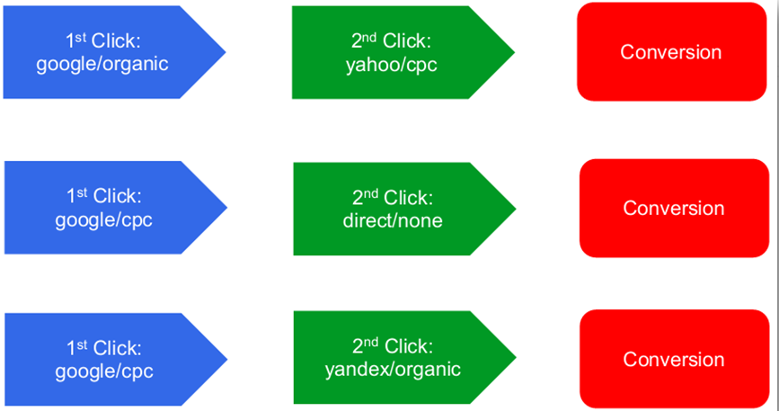

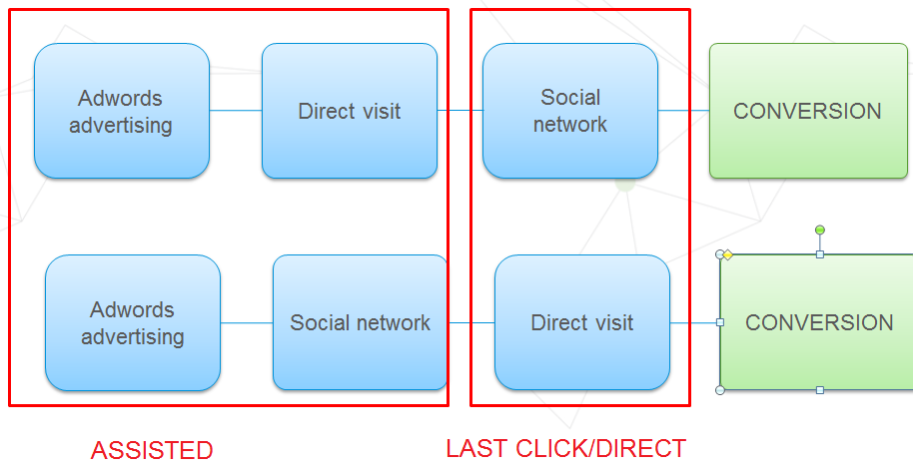

About Multichannel analysis purpose:

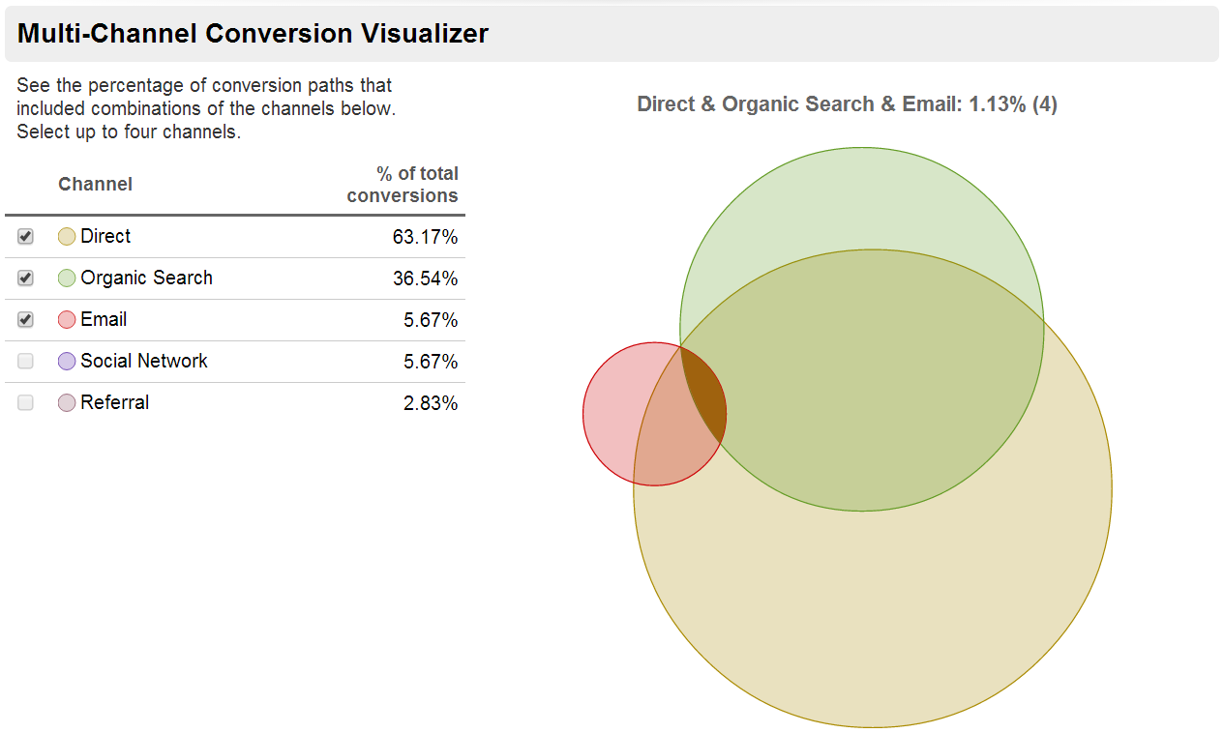

Assisted conversions :

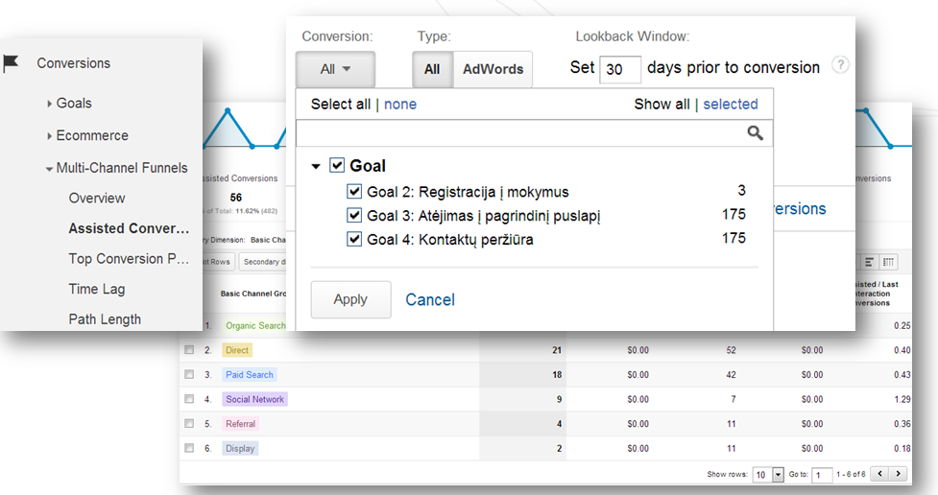

Some channels help to sell, the others make impact to improve user awareness and recommend.

Coversion paths are visualized and give us insight:

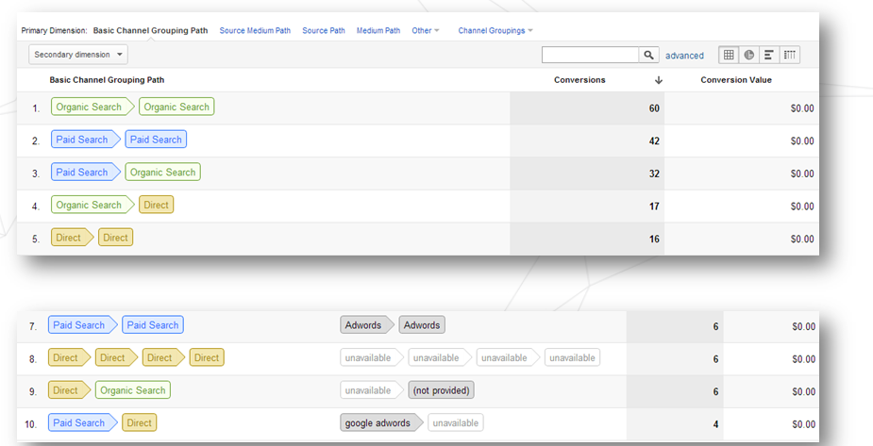

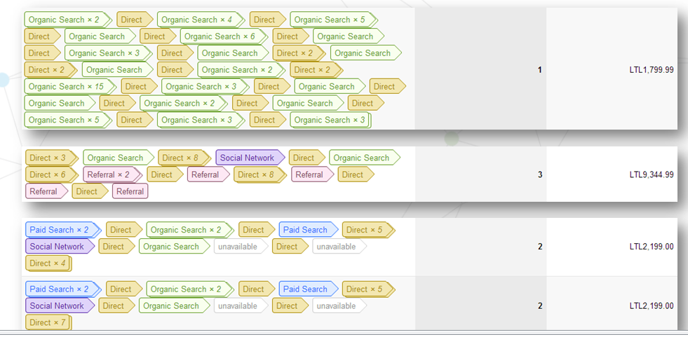

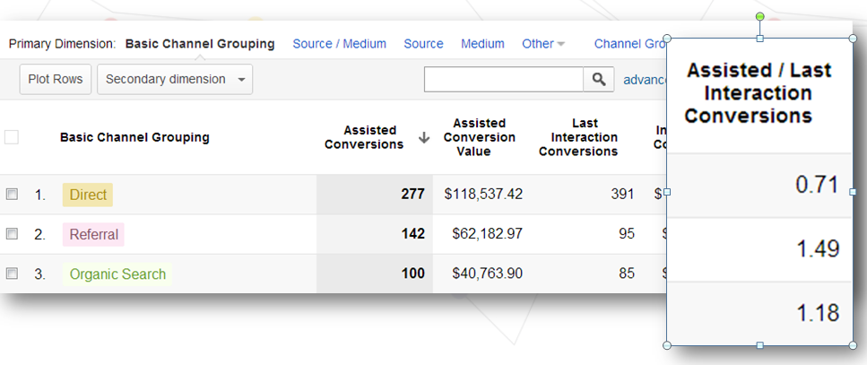

**Management of flow sources.** Analysis of the performance principles of the flow, reflection of different marketing activities in statistics, effective separation and identification of necessary data. Defining links to different flow sources.

* Practical task: Setting strategy for link definition for the sample advertising campaign

Management of flow sources (The functioning of flow sources, cases for data identification and separation, assigning links to particular flow sources)

Visitor flow management is used for accurate evaluation of efficiency of different flow sources, compare them, optimize and prioritize expenses, and increase conversions.

Referrals , add new segment, by Traffic sources

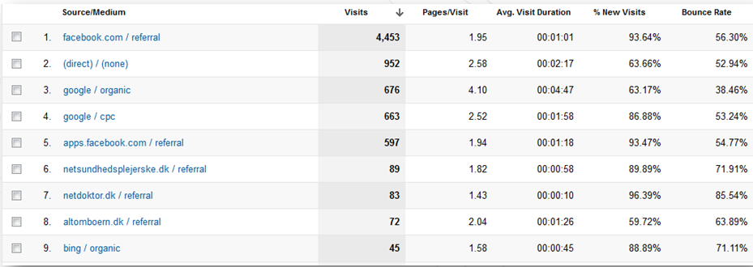

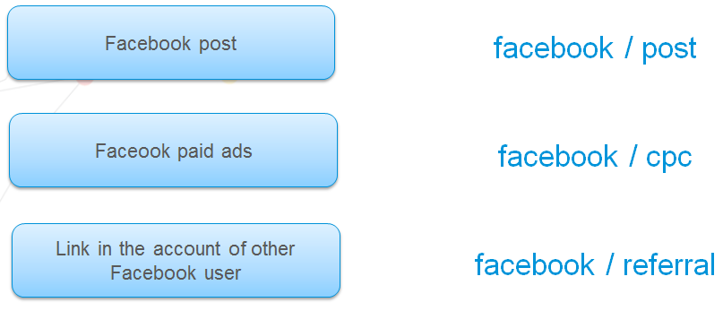

Viewing sources by means of tagging:

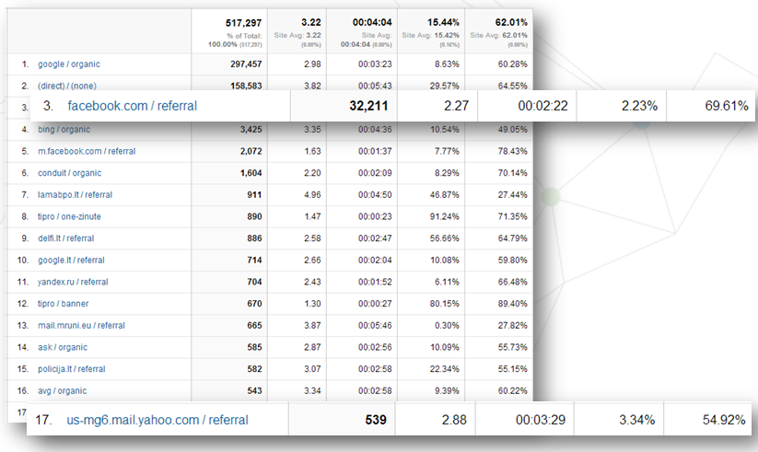

Google Analytics tracking URL consists of different compounds:

* utm_source* - identifies sources of the coming visitor (newsletter, website, facebook).
* utm_medium* - identifies channe (e.g. email, affiliate, banner).
* utm_term – is used to define keyword which does not belong to the paid Adwords search flow (not obligatory parameter)
* utm_content – additional parameter (not obligatory parameter) used to define additional information about the content (e.g. banner1, textlink2, bottom link).
* utm_campaign* - identifies particular advertising campaign (e.g. Newsletter April, Banner Spring Sale).

Example of the compound description of tracking URL:

**digitalacademy.lt/?utm_source=lrytas.lt&utm_medium=banner&utm_content=160x600&utm_campaign=kovo%20kampanija**

Tracking URL can be simply generated by tool “Analytics URL Builder”:

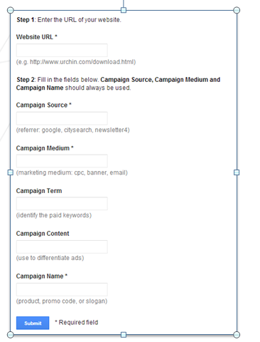

The outcome: http://[goo.gl/HSKQsh](http://goo.gl/HSKQsh)

And the structure of the link:

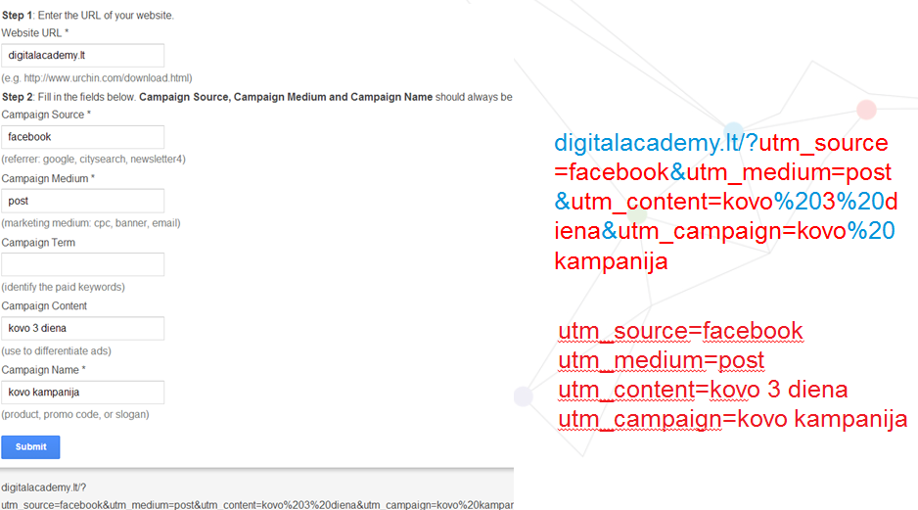

Important advice: check the task sequence: First step: generate a link with tracking parameters; Second step: use the link for your advertisement, social communication, newsletter, etc. Never do it in an opposite way

If we make a mistake :

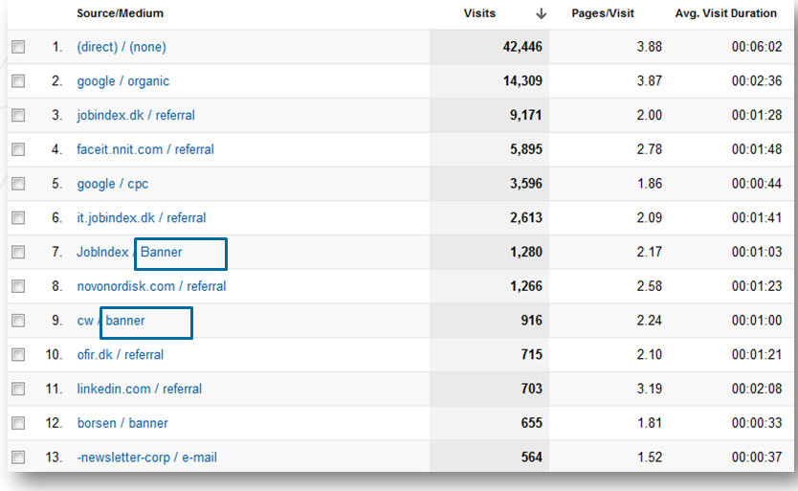

We can assign parameters:

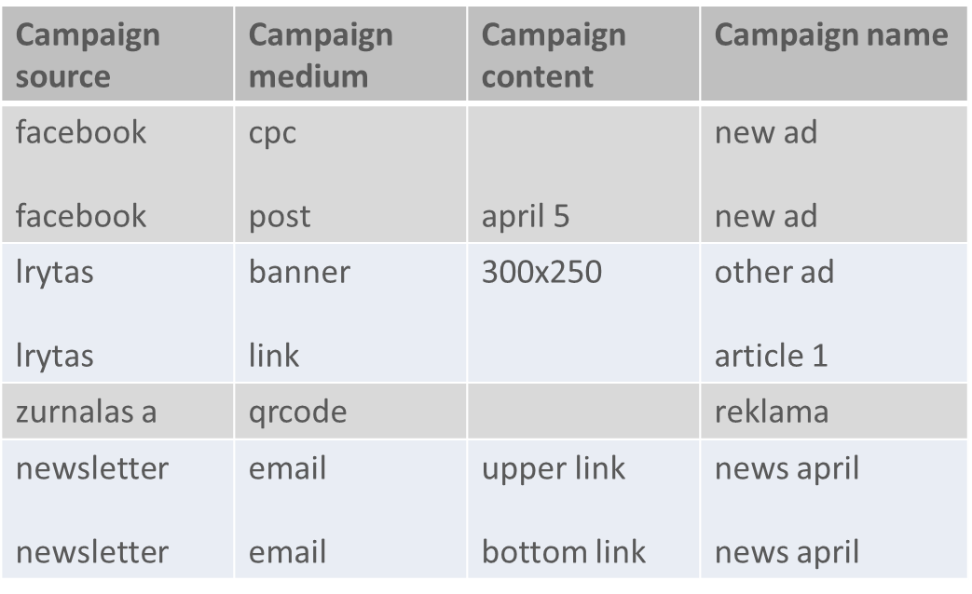

Defining the referrals:

E.g.

utm_source=name_surname

utm_medium=offline

utm_campaign=Registration

Resulting link:

www.digitalacademy.lt/?utm_source=Domas_Vysniauskas&utm_medium=offline&utm_term=&utm_content=&utm_campaign= Registration

This way we can create a procedure “Bonus for registration (10% discount)” for the referring person, registered by his name and surname:

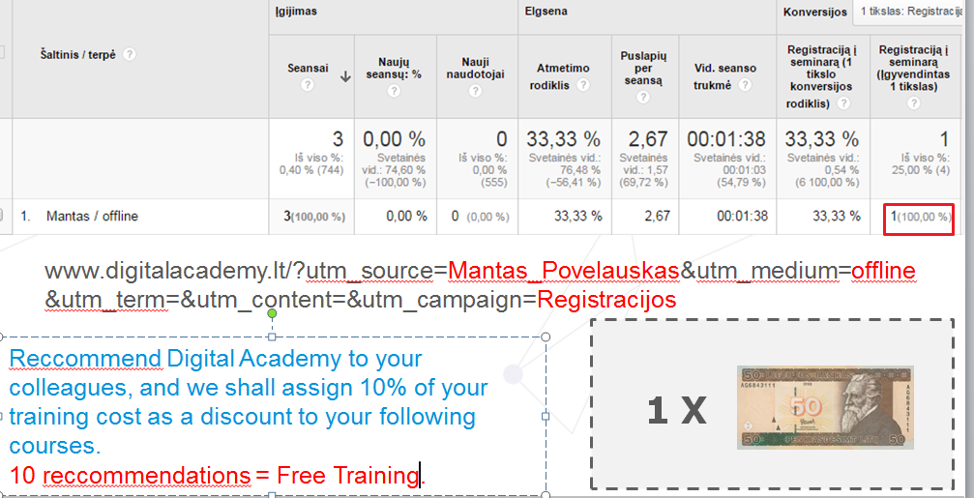

**Reporting.** Exporting different reports, creating additional segmenting for data, making adjusted reports according to own purposes, configuring Dashboards. Data export. “Advanced segments”- additional extended segmentation of data. Functions of Custom reports and Dashboards. Presenting important data in one place.

* Practical task: Exporting reports, creating Segment, Custom report, and Dashboard

Exporting reports:

All data from Analytics from all sectors can be exported to Excel, Pdf , also email immediately.

The regular export and email of reports can be set-up.

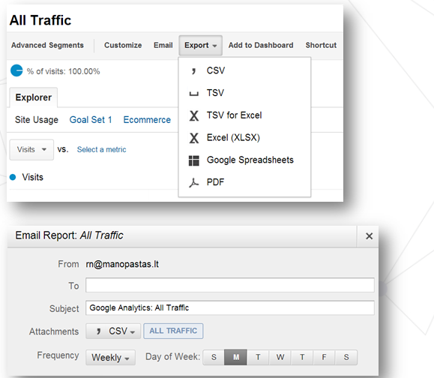

Segment: TASK: Create segments:

* iOS
* Android

Examples:

Switching- on segments:

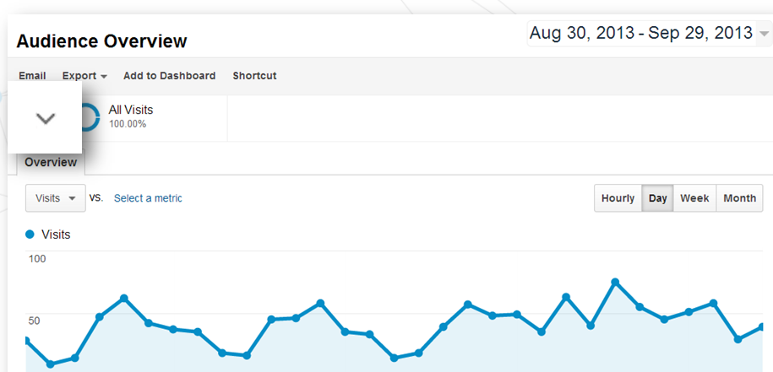

Segment view:

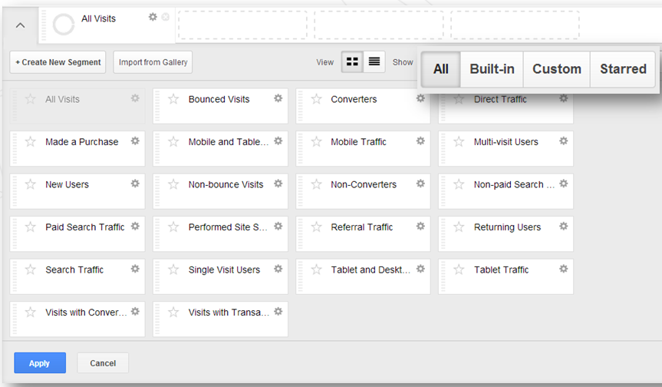

Segment example:

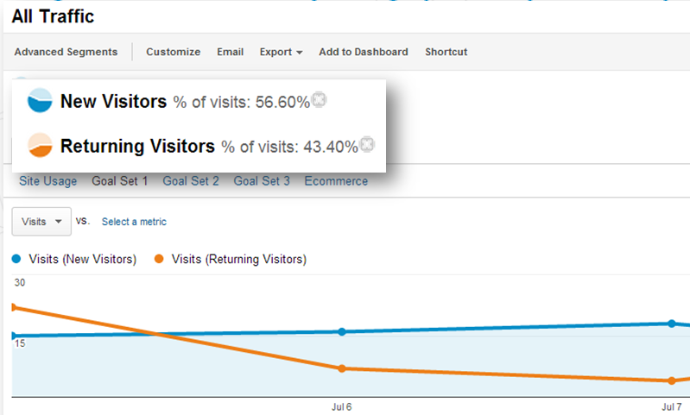

Create our own segments:

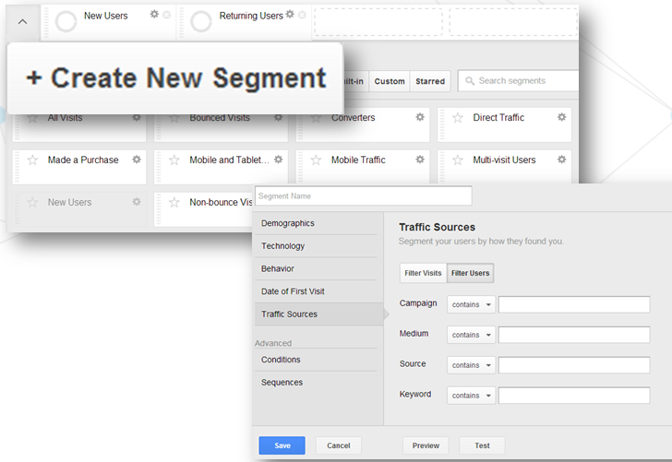

Example of geographical segment:

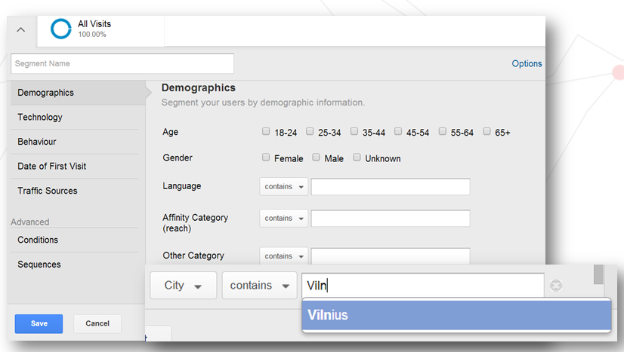

Example of measuring loyalty-based segment:

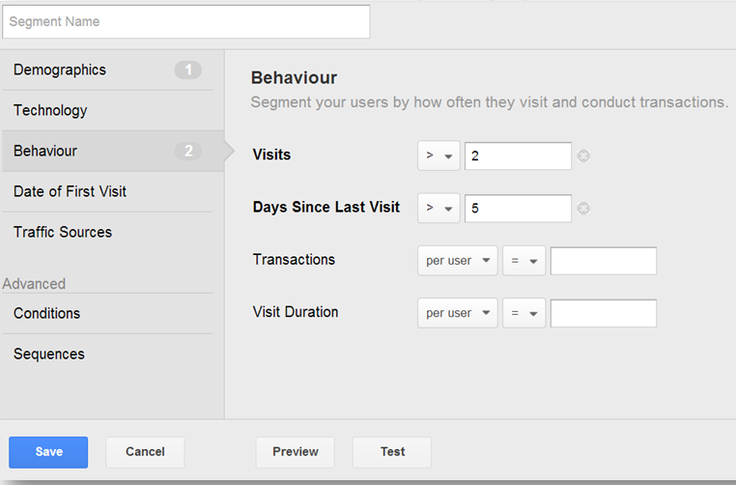

If Analytics is joined to Google Adwords, we can segment its outcomes:

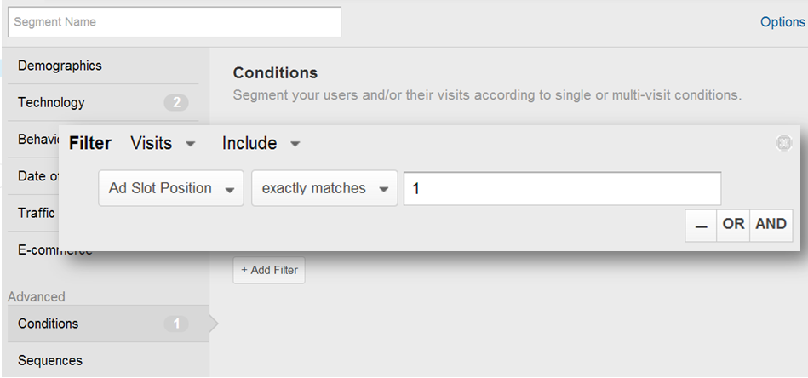

Segmenting by time of the day : working hours versus evening hours:

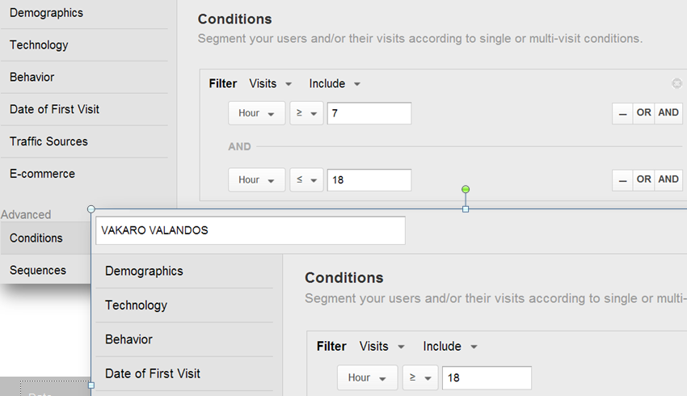

Custom report : TASK

Create Custom report:

* Dimensions: countries and distribution by towns
* Metrics: % new sessions, new users, bounce rate.

Usefulness of custom report- providing integrated insights:

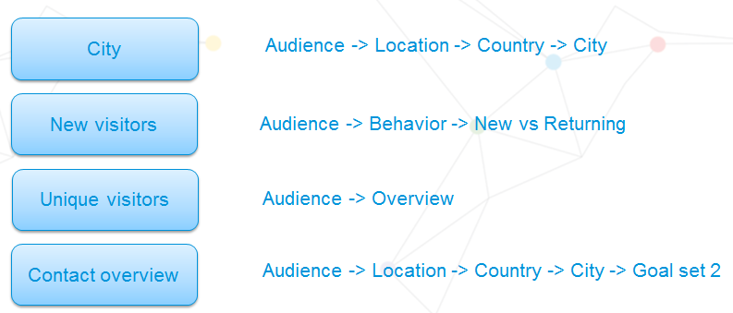

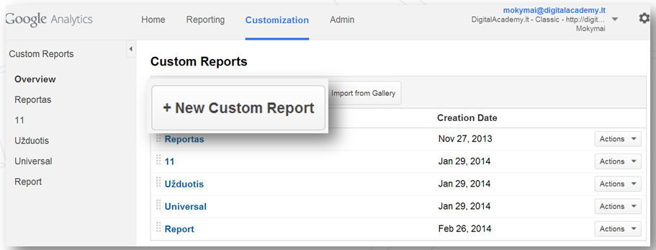

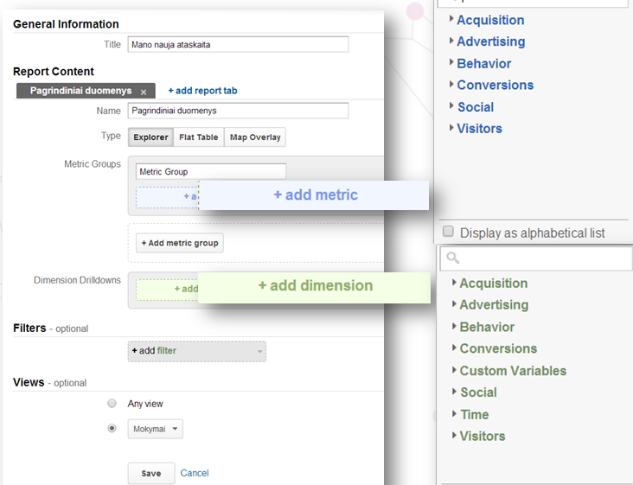

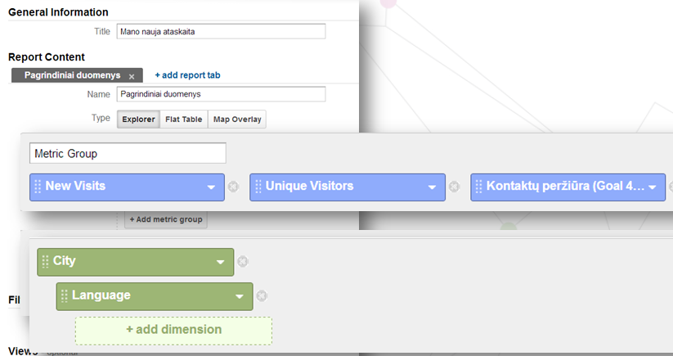

Result:

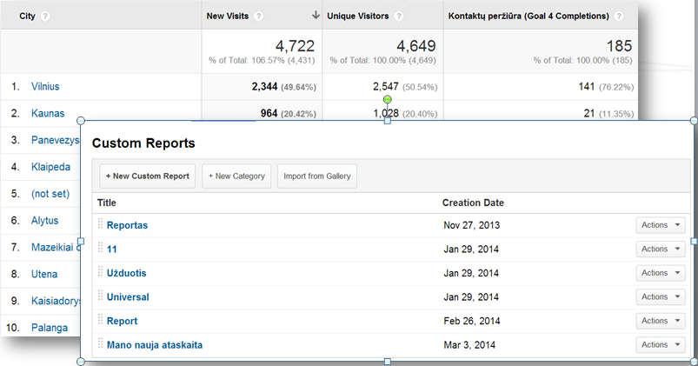

Dashboard

Dashboard organizes all reports of analytic data in one place, see example below:

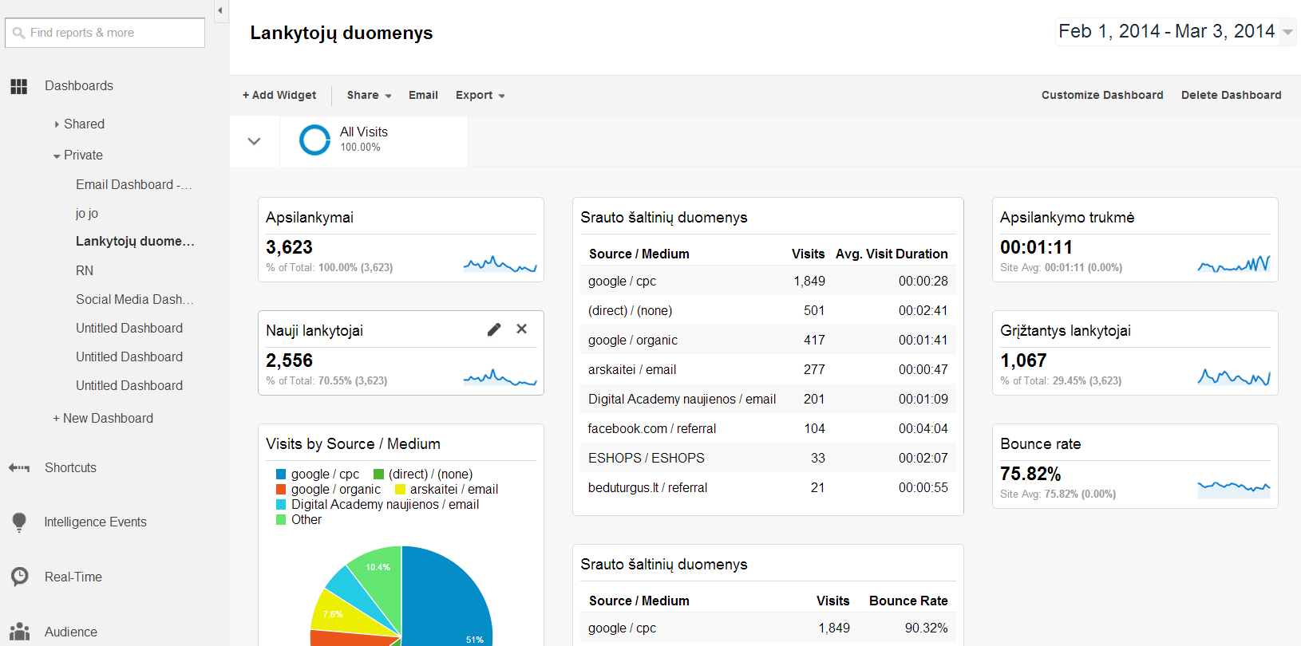

Dashboard TASK:

Create *Dashboard* which will show if our website is visited by users from mobile devices:

* Widget type: Table
* Dimension: Mobile device info
* Metrics: Sessions & Bounce rate.

Creating dashboard:

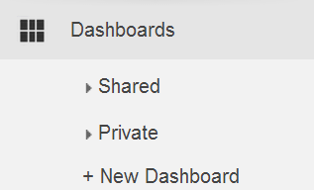

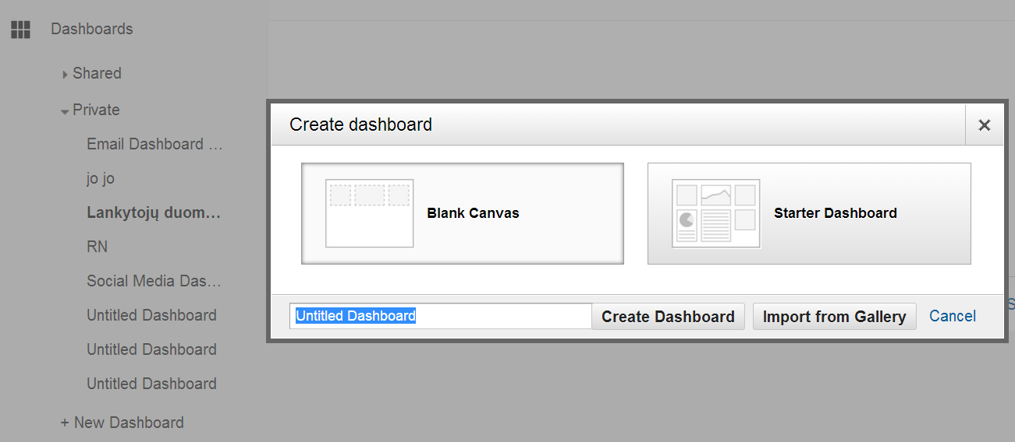

New Widget:

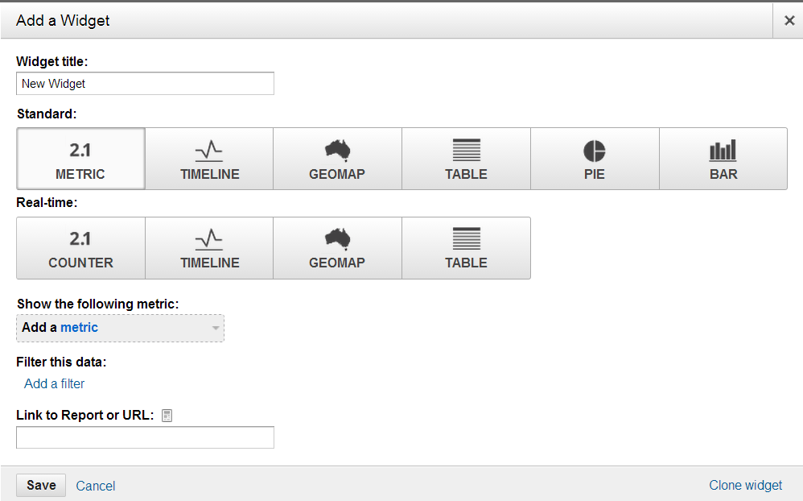

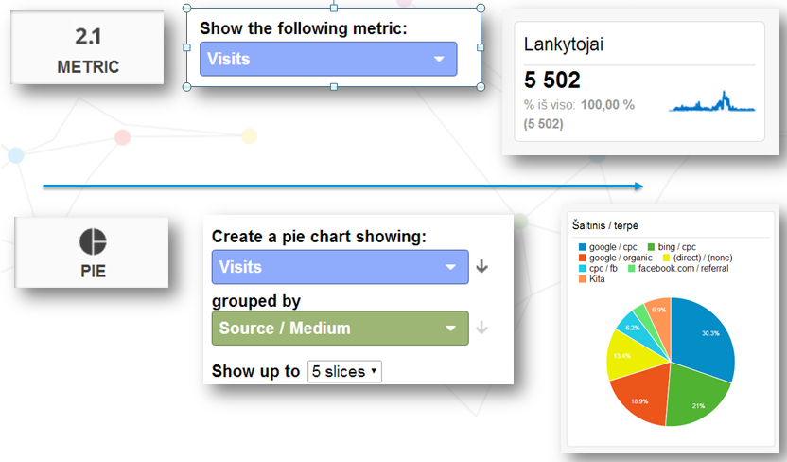

Check if you made it correctly:

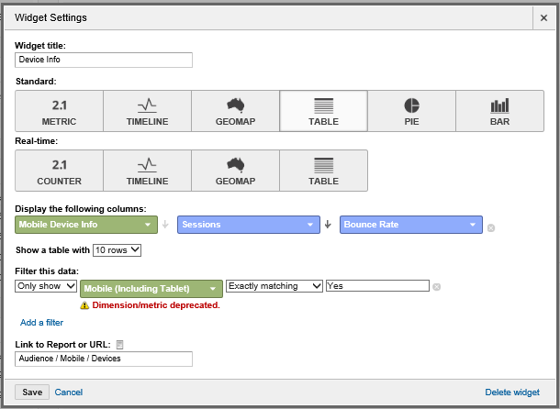

And

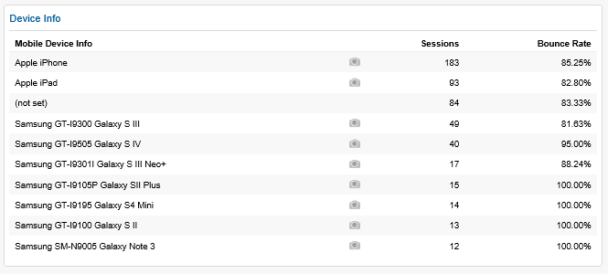

Then you can share it:

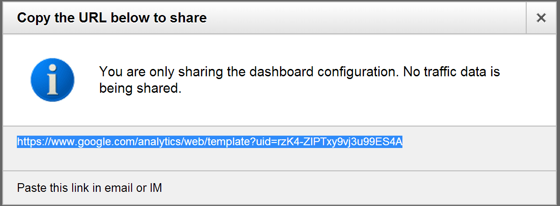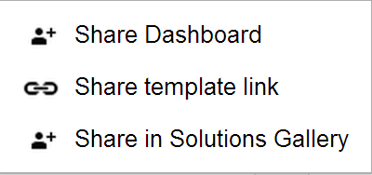 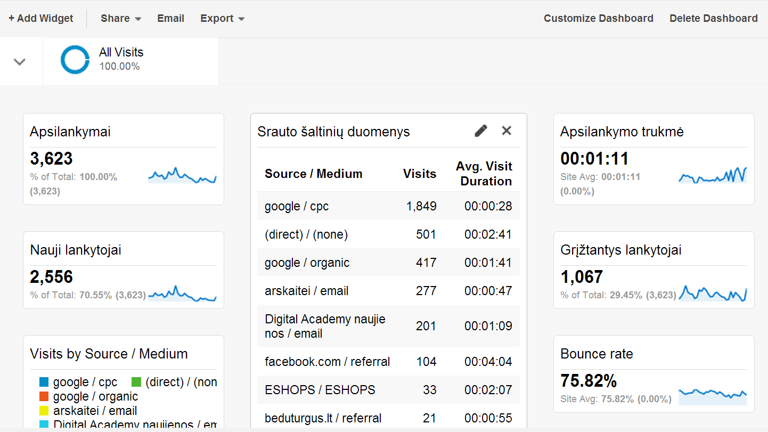

Analytic solution gallery:

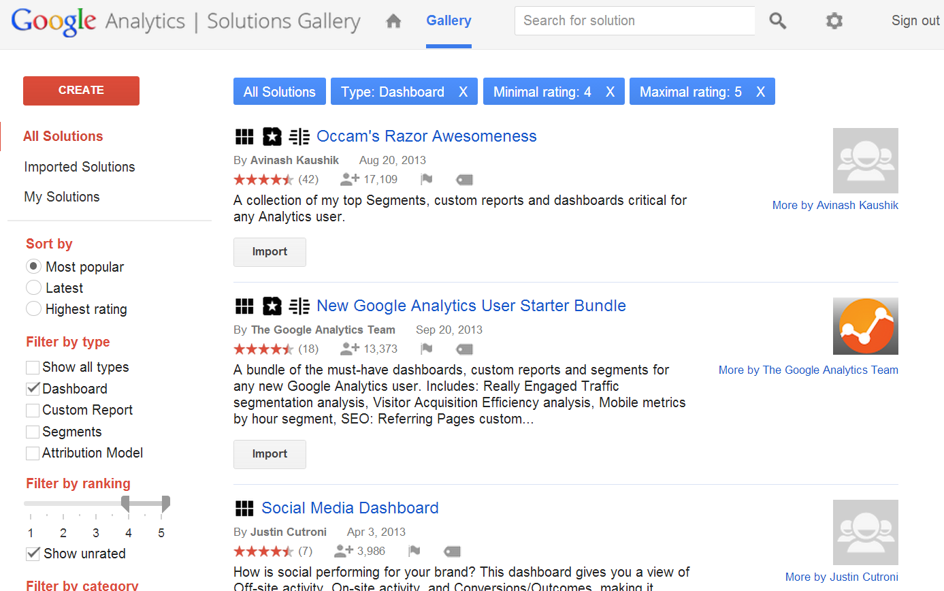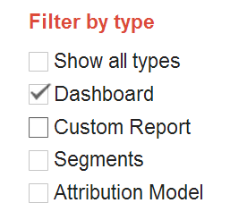

Literature (Adwords):

1. O’Reilly, Anastasia Holdren. Google Adwords
2. Bradd Geddes Advanced Google Adwords (experiments, campaign testing)
3. Google Adwords help (<http://support.google.com/adwords> - explanatory dictionary of terms, concepts and procedures

Literature (Analytics):

1. <https://google.starttest.com>
2. Google partner
3. Insights: [www.thinkwithgoogle.com](http://www.thinkwithgoogle.com) (many presentations)
4. Google shop – course packs, case studies, agency pitch deck library
5. **Novelty from Google Analytics Academy:** [**https://analyticsacademy.withgoogle.com/preview**](https://analyticsacademy.withgoogle.com/preview)
6. Google Analytics Youtube <http://www.youtube.com/user/googleanalytics>
7. Analytics starter: <http://www.google.com/intl/en_uk/analytics/learn/setupchecklist.html>
8. Analytics IQ: <http://www.google.com/intl/en_uk/analytics/iq.html>
9. Success stories: <http://www.google.com/intl/en_uk/analytics/customers/index.html>
10. Google Analytics blog: <http://analytics.blogspot.com/>