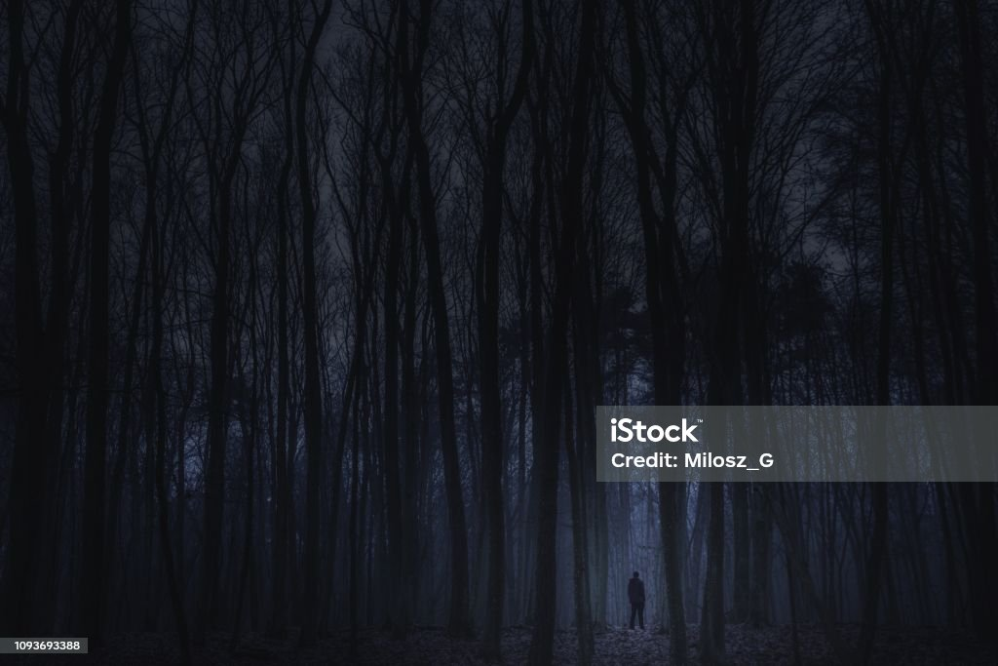

**Nightmare Fuel**

Game Design Document

Ilya Doroshenko:553624

Description:

* A multiview game, from 1st to 2nd person.
* Platform: PC
* Single player, Multiplayer later
* Escape from the nightmare! Get to bed or fight your fears!
* There are 2 sides: the players and the nightmares. The game takes place in a surreal bunker. The gameplay is divided into waves. Each wave is harder than the previous. There is day and night, during the day you can search for resources and bonuses, build barricades, and set up defenses. During night the perspective shifts towards nightmare, and you are given a second person view to control your character, which matches the difficulty of controlling your actions in sleep. There are 2 win conditions for player side – build an exit or defeat the nightmare by overwhelming and destroying its main body. For nightmare there is only one – consume every player.
* At the end of the day, you have 2 options: either to get under the bed and defend passively with doors, barricades and lights or stay awake and take the fight. At the beginning of night, the Spawn appears, along with swarms of rats, spiders, and other nightmare creatures. Most of the creatures are afraid of light, some will ignore you if you hide. If you decided to stay awake, bear in mind, that nightmares become more active, and you must fight with all traps you set up during the day.
* Building the exit is also an option, but you will have to be awake in the night to escape, this will not be an easy walk in the park.

USP:

* Try to escape being chased by nightmare creatures, build barricades, collect resources, gather bonuses. The game supports defensive and offensive gameplay styles.
* Feel the constant pressure of the night, feel yourself like hiding under the bed in childhood. Be strong to overcome the nightmares.

Mood Board

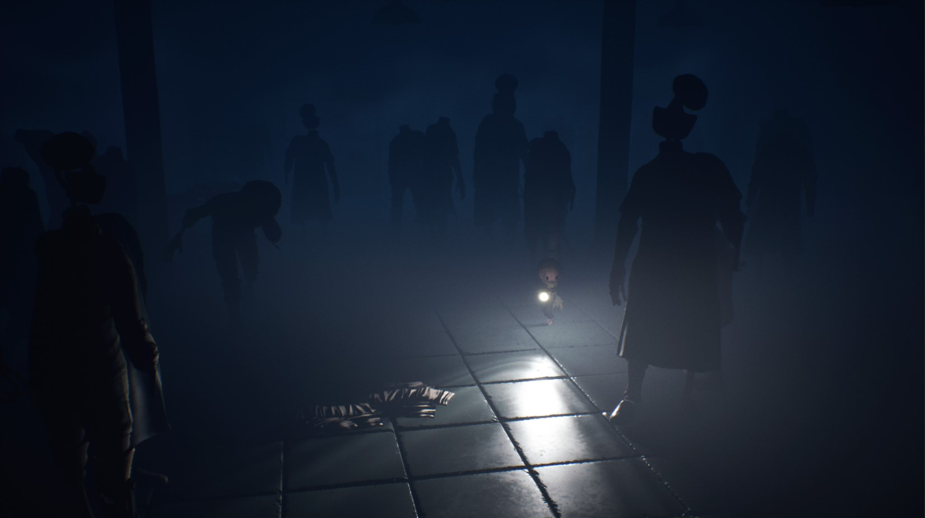

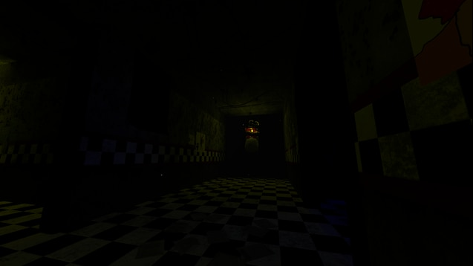

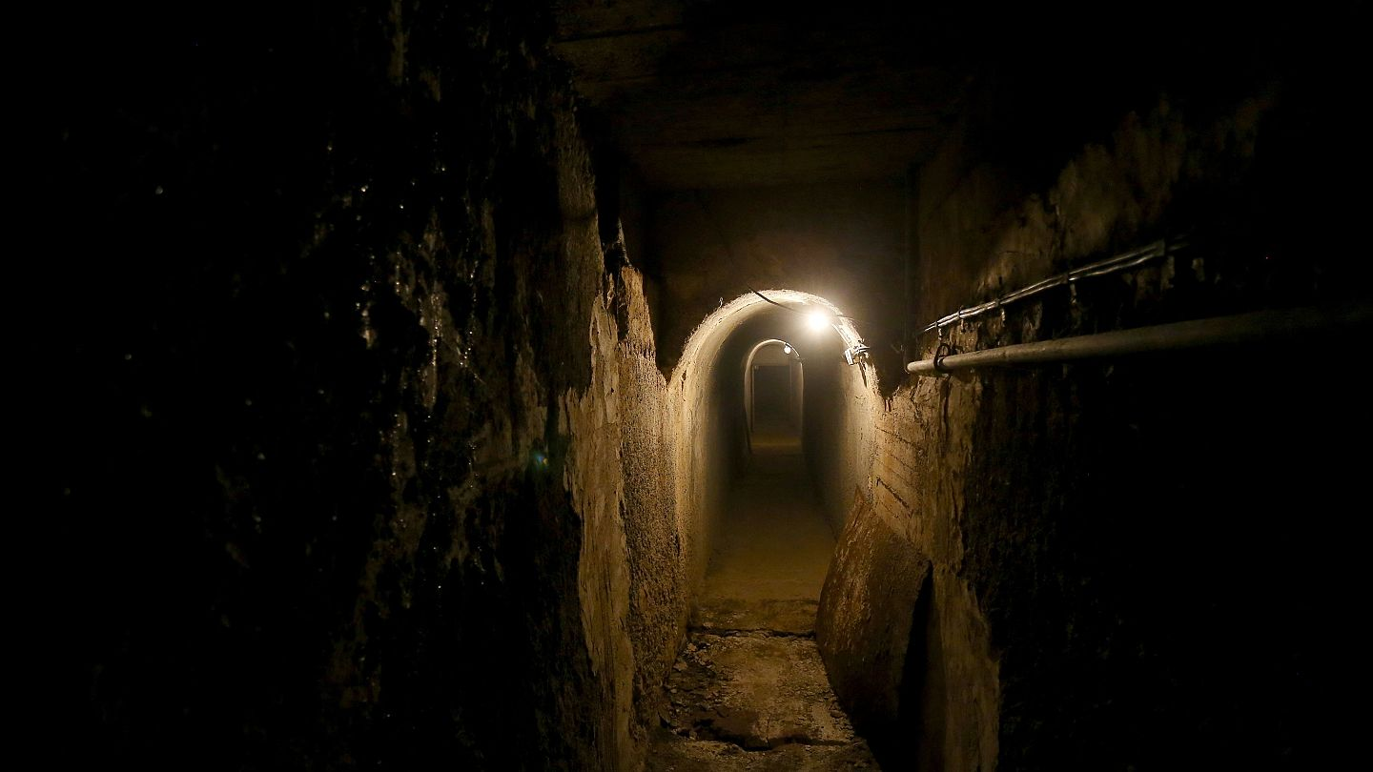

Main Features:

* Basic movement
* Camera Controls
* AI for nightmare creatures
* Nightmarish visuals and audio
* Bonuses and resources for players
* Building mechanic & repairs
* Second-person perspective for night.

Game Loops:

* Major cycles: day and night
* Day mode:
  + Walk around bunker, find resources, build stuff (traps, barricades, lights, etc.)
  + Gather bonuses from inactive nightmares, enhance your characters’ abilities.
* Night mode:
  + Pray, that your defenses won’t break, survive the night until the day.
  + Get through the hordes of nightmares, find the Spawn, defeat it, or survive until the day and get more bonuses.
* Global loops:
  + During the day build defenses, survive the night, build an exit at night 6 and later, escape.

or

* + Bulk up during the day by searching inactive nightmares, survive the nights, after gathering a sword mastery and obtaining a sword from an enemy at 5th night or later, find the Spawn and destroy its main body.