RTime

**Name :** Martin Můčka

**Target Audience:**  casual players looking for logical riddles

**Gamer Type:** explorer, achievers

**Target Platforms:** mobile, pc and even consoles are all valid

**Genre:**  2d platformer with logical riddles containing time shift elements

**Number of Players:** single player

**Projected Realease Date:** 2025

**High Concept Statment**

In an apocalyptic world where due to virus. You are mutated human that got the abilities to control time to some extent, be it to save you from near death situations or only controling time of your environment. Due to your mutation you also became imunne to the virus. Once your love one became ill you started your journey to find out how to cure the deadly virus, how it even came to be, is it mankinds fault, just a plain coincidence or is some higher entity playing with you. On this interesting journey you will be tasked with solving a logical puzzles that will test your new abilites but mostly your understanding of time.

**Core mechanics: Story -> Explore -> Logical puzzles**

**Feature Set:**

* **Story** simple story telling with no dialougues just descriptions about world, how it came to be destroyed, mysteries and so on.
* **Explore** bonus levels that delve deeper into the world
* **Logical** puzzles main principle, controling how fast your environment is / when is your environment

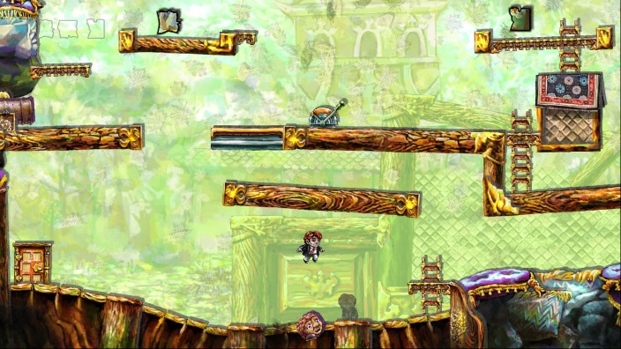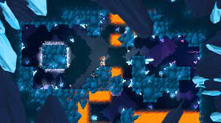+ time control of main character(can rewind time of himself ) to save him from dangerous situacions

**Player experience goals:**

* **Amazed** -> world structure
* **Solving mysteries** -> story, world

**Team Roles**

* Coder(everything)
* Artist(concept,2d,3d,UI,animation,effects)
* Designed/Tester(level design, puzzles with time elements, skills)
* Writer(story, mysteries, world)

**The Competition**

Inspiration comes from game called Braid that introduced some time elements in 2d platformer but is more of a normal platformen than logical puzzle based platformer. From game mechanics its mixture of Black Hole and Braid. From graphics or to say overal look it would based

**Compelling aspects/USP**

The game is interesting mixture of logical thinking but due to introduction of time based elements also very out of box thinking. Also there is not very resembeling game with these mechanics atleast i didnt find any.